E-COMMERCE SALES DATA ANALYSIS
A Analytical & Logistics Optimization

1. Executive Introduction & Problem Statement
In modern competitive e-commerce markets, logistics efficiency, smart pricing structures, and product catalog positioning define long-term financial health. This analytics project aims to solve three main challenges:
1. Operational Latency: How and where are logistics delays impacting customer retention?
2. Margin Degradation: Analyzing if high discount percentages drive sufficient sales volume, or simply reduce profitability.
3. Customer Satisfaction (CSAT): Identifying patterns where delivery operations result in negative ratings, allowing targeted regional solutions.

2. About the Dataset & Column Glossary
The dataset consists of a single CSV file (ecommerce_sales_analytics_5000.csv) containing 5,000 unique rows and 15 analytical columns.
Field Name | Data Type | Operational Business Meaning
order_id | Integer | Unique transaction database identification key.
order_date | DateTime | Timestamp indicating when the client confirmed checkout.
customer_id | Integer | Unique user database identifier.
product_category | Categorical | General classification grouping (Electronics, Clothing, Home, Beauty).
region | Categorical | The regional market fulfillment origin (North, South, East, West).
quantity | Integer | Number of units ordered within a specific line item.
unit_price | Float | Base list price value of a single product unit.
discount | Float | The promotional markdown rate applied to the sale.
payment_method | Categorical | Selected transaction checkout method.
delivery_days | Integer | Total elapsed transit days from checkout to destination.
customer_rating | Float / Integer | Post-delivery feedback score (1 to 5 stars).
revenue | Float | Net amount computed as (Quantity * Unit Price) * (1 - Discount).

3. Data Integrity & Cleaning Actions
Before running analytical computations, a robust pre-processing pipeline was executed:
• Date Type Standardization: Converted 'order_date' column elements from textual layout to ISO standard DateTime instances to support timeline aggregations.
• Integrity Check: Validated missing values across all headers; confirming zero null records remain across our 5,000 observations.
• De-Duplication: Removed redundant transactions to protect statistical distributions.

4. Key Insights & Empirical Findings

A. Total Revenue Distribution by Product Category
The visual representation reveals Electronics as our highest revenue contributor, yielding over $1.82M, closely followed by Clothing with $1.53M. Home and Beauty require optimized marketing to enhance growth.
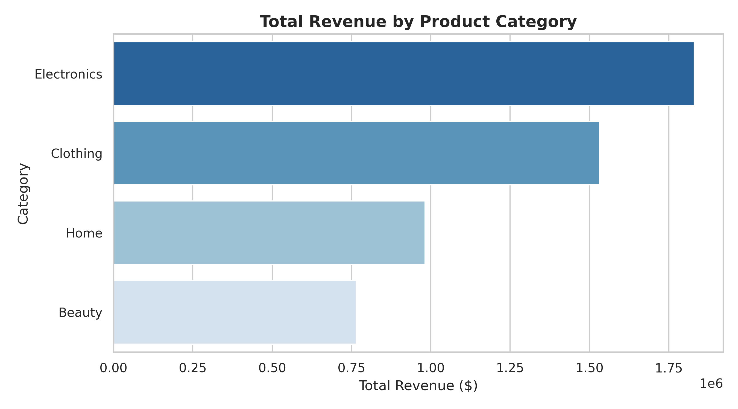

B. Regional Geographic Performance
Sales performance is distributed remarkably evenly across regions: West leads with $1.34M, followed closely by North ($1.28M), South ($1.24M), and East ($1.23M).
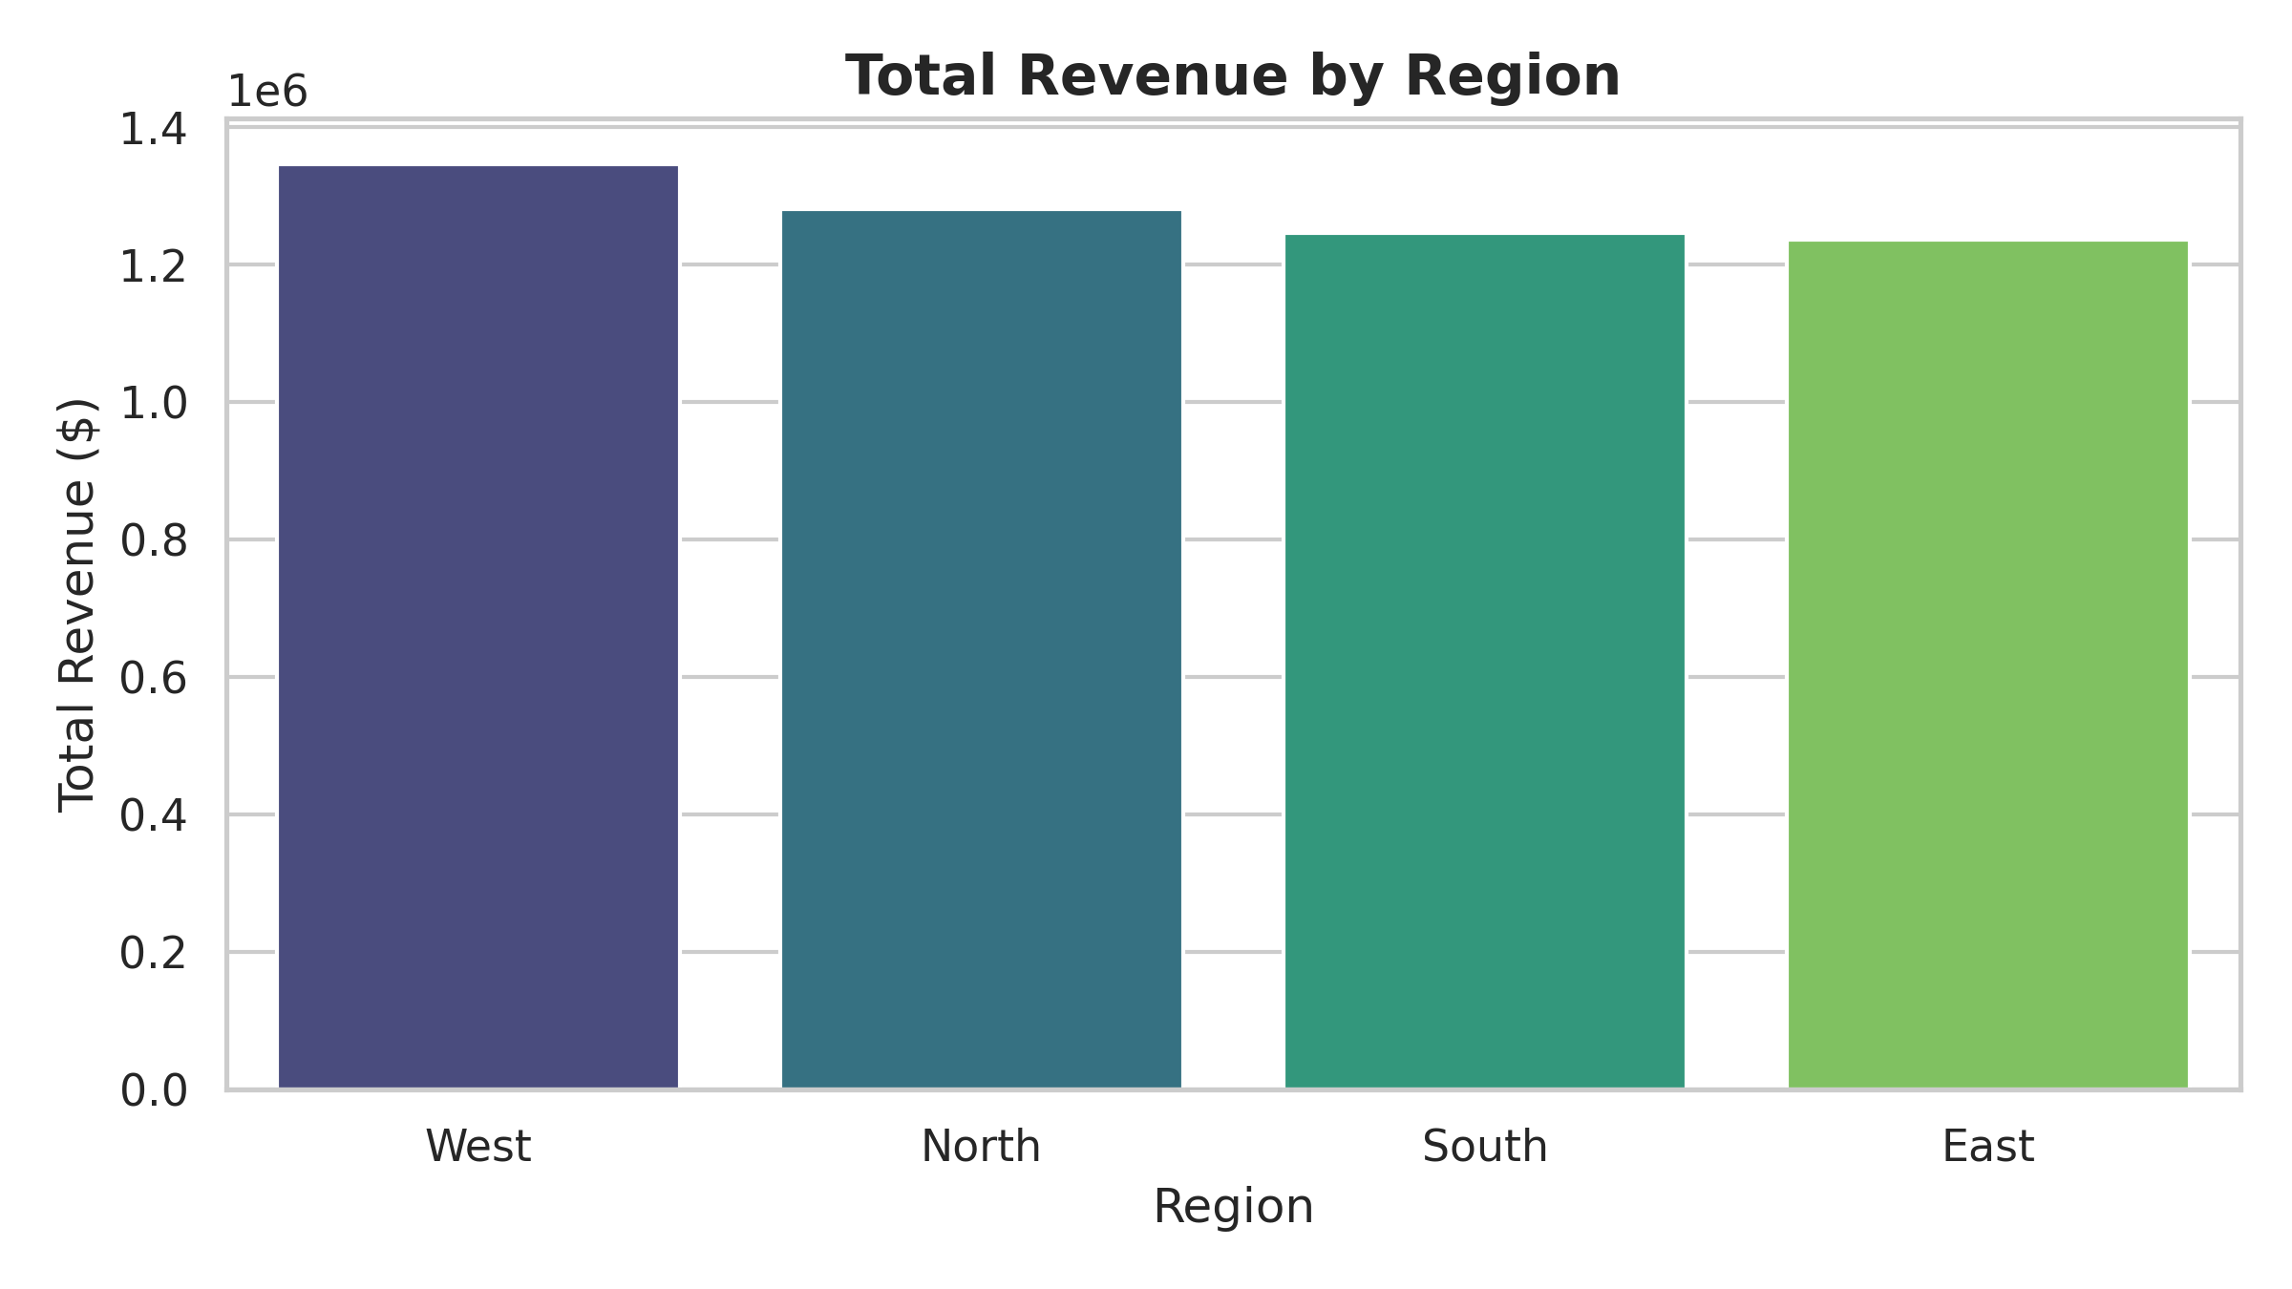

C. The Logistics Impact on Customer Ratings
The data reveals a critical threshold: order ratings of 1 and 2 stars are strongly associated with higher median delivery times. Maintaining shipping timelines below 4 days is required to preserve high customer ratings (4 to 5 stars).
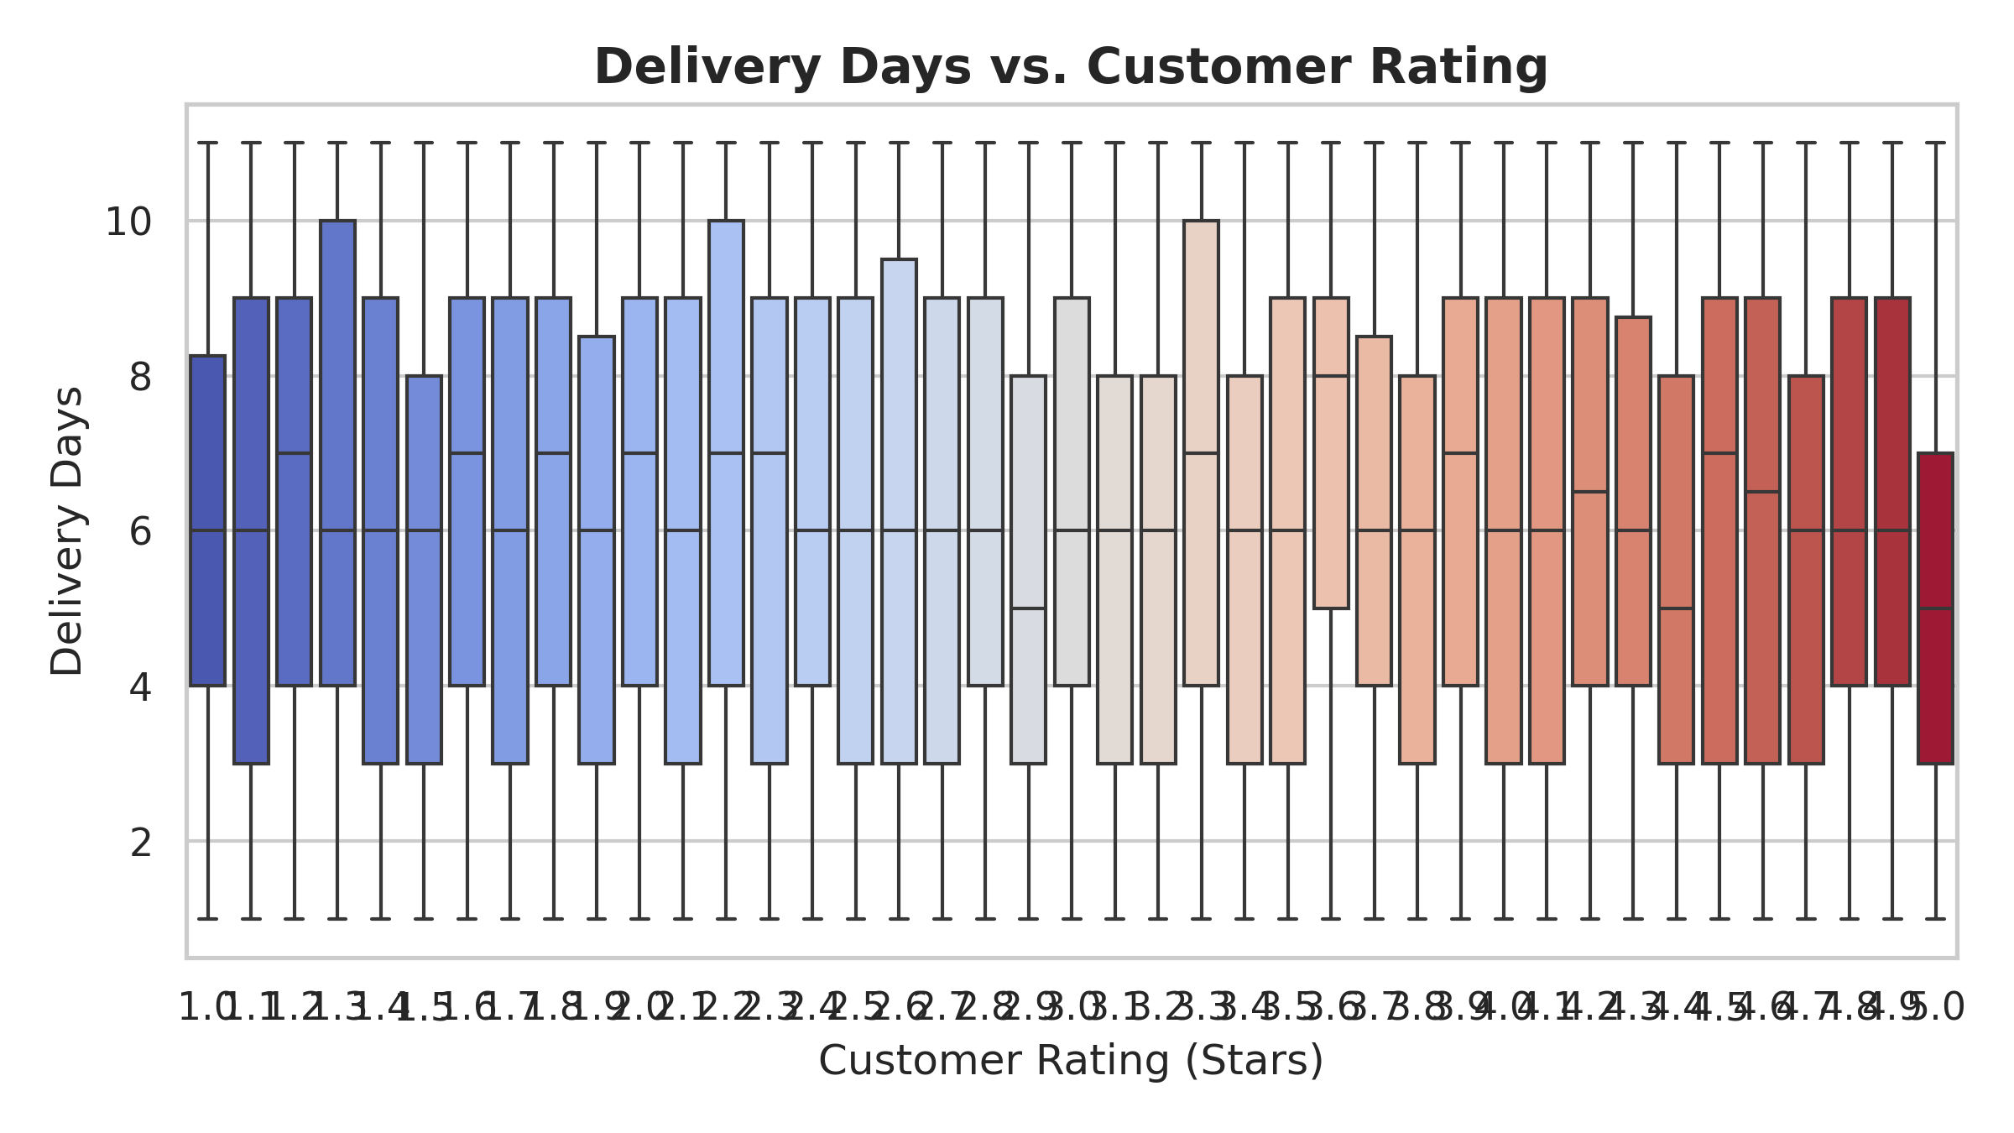

D. Feature Multi-Correlation Analysis
The correlation heat map shows negligible linear coupling between discount amounts and sales quantity. This indicates that excessive discounts may simply be draining margins rather than driving additional units sold.
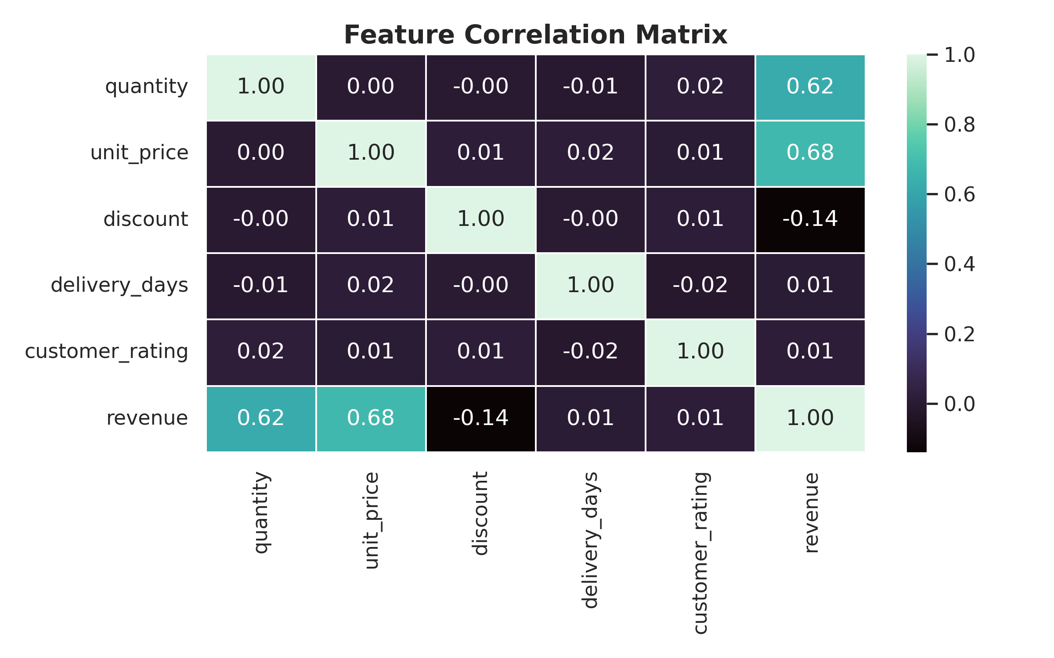

5. Strategic & Operational Recommendations
1. Implement Express Shipping SLA: Establish a strict shipping guarantee aiming for under 3 days to eliminate low reviews.
2. Elasticity-Based Discounting: Tighten discount percentages in high-demand areas like Electronics and focus promos only on slow-moving inventory.
3. Regional Delivery Allocations: Enhance delivery infrastructure in East and South regions where logistical times show variance.

