LAB#08
TASK:01
Create an XML document structuring information for a store. (shopping store of your choice)
<?xml version="1.0" encoding="ISO-8859-1"?>
<store>
<name>The Body Shop</name>
<location>Shop#3 First floor,Boulevard Mall</location>
<employees>3</employees>
<category>
<base>
<item_1>Matte Clay Concealer</item_1>
<item_2>All in one face base</item_2>
<item_3>insta glow CC</item_3>
</base>
<Bronzers>
<item_1>Shimmer waves</item_1>
<item_2>Honey Bronze(Baked to last Bronzer)</item_2>
<item_3>All in one Blush</item_3>
</Bronzers>
<Nail_Paints>
<item_1>Matte Nail paint</item_1>
<item_2>Wooden nail brush</item_2>
</Nail_Paints>
<Lipsticks>
<item_1>Shine lip liquid</item_1>
<item_2>Lip balm pot</item_2>
<item_3>Matte lip liquid</item_3>
</Lipsticks>
</category>
</store>

TASK:02
Create DTD for store XML Document. And validate on http://www.w3schools.com/xml/xml_validator.asp

DTD: (Validation)

<?xml version="1.0" encoding="ISO-8859-1"?>

<!DOCTYPE store
[
<!ELEMENT store (name+,location+,employees+,category+)>
<!ELEMENT name (#PCDATA)>
<!ELEMENT location (#PCDATA)>
<!ELEMENT employees (#PCDATA)>
<!ELEMENT category (base,Bronzers,Nail_Paints,Lipsticks)>
<!ELEMENT base (item_1,item_2,item_3)>
<!ELEMENT item_1 (#PCDATA)>
<!ELEMENT item_2 (#PCDATA)>
<!ELEMENT item_3 (#PCDATA)>
<!ELEMENT Bronzers (item_1,item_2,item_3)>
<!ELEMENT item_1 (#PCDATA)>
<!ELEMENT item_2 (#PCDATA)>
<!ELEMENT item_3 (#PCDATA)>
<!ELEMENT Nail_Paints (item_1,item_2,item_3)>
<!ELEMENT item_1 (#PCDATA)>
<!ELEMENT item_2 (#PCDATA)>
<!ELEMENT item_3 (#PCDATA)>
<!ELEMENT Lipsticks (item_1,item_2,item_3)>
<!ELEMENT item_1 (#PCDATA)>
<!ELEMENT item_2 (#PCDATA)>
<!ELEMENT item_3 (#PCDATA)>
]>
<store>
<name>The Body Shop</name>
<location>Shop#3 First floor,Boulevard Mall</location>
<employees>3</employees>
<category>
<base>
<item_1>Matte Clay Concealer</item_1>
<item_2>All in one face base</item_2>
<item_3>insta glow CC</item_3>
</base>
<Bronzers>
<item_1>Shimmer waves</item_1>
<item_2>Honey Bronze(Baked to last Bronzer)</item_2>
<item_3>All in one Blush</item_3>
</Bronzers>
<Nail_Paints>
<item_1>Matte Nail paint</item_1>
<item_2>Wooden nail brush</item_2>
</Nail_Paints>
<Lipsticks>
<item_1>Shine lip liquid</item_1>
<item_2>Lip balm pot</item_2>
<item_3>Matte lip liquid</item_3>
</Lipsticks>
</category>
</store>
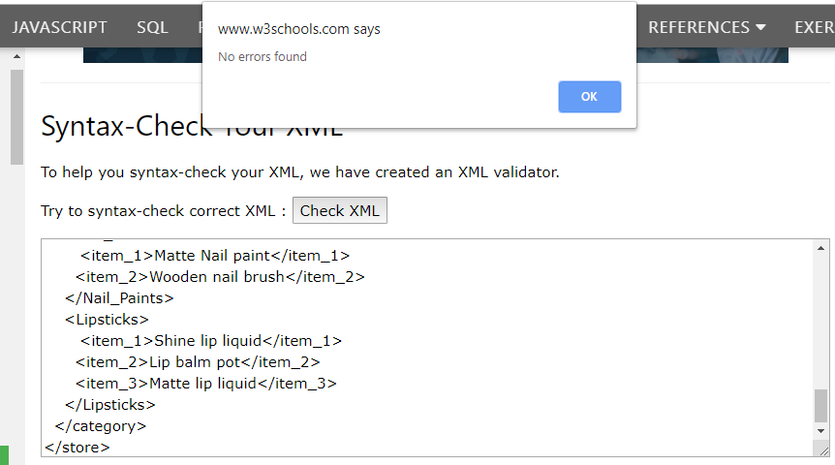

TASK:03
Write XML Schema for the following XML document and then validate the XML document along with its schema on the following website:
http://www.utilities-online.info/xsdvalidation/#.UlFx2tKmhIg

XML

<?xml version=“1.0” ?>
<movies>
<movie genre=“crime">
<title lang="en">The Godfather</title>
<year>1972</year>
<rating>9.2</rating>
</movie>
<movie genre=“horror">
<title lang="en">The conjuring</title>
<year>2013</year>
<rating>7.5</rating>
</movie>
<movie genre=“adventure">
<title lang="en">Everest</title>
<year>2015</year>
<rating>7.4</rating>
</movie>
</movies>

XML Schema:

<xs:schema attributeFormDefault="unqualified" elementFormDefault="qualified" xmlns:xs="http://www.w3.org/2001/XMLSchema">
<xs:element name="movies">
<xs:complexType mixed="true">
<xs:sequence>
<xs:element name="movie" maxOccurs="unbounded" minOccurs="0">
<xs:complexType mixed="true">
<xs:sequence>
<xs:element name="title">
<xs:complexType>
<xs:simpleContent>
<xs:extension base="xs:string">
<xs:attribute type="xs:string" name="lang" use="optional"/>
</xs:extension>
</xs:simpleContent>
</xs:complexType>
</xs:element>
<xs:element type="xs:short" name="year"/>
<xs:element type="xs:float" name="rating"/>
</xs:sequence>
<xs:attribute type="xs:string" name="genre" use="optional"/>
</xs:complexType>
</xs:element>
</xs:sequence>
</xs:complexType>
</xs:element>
</xs:schema>
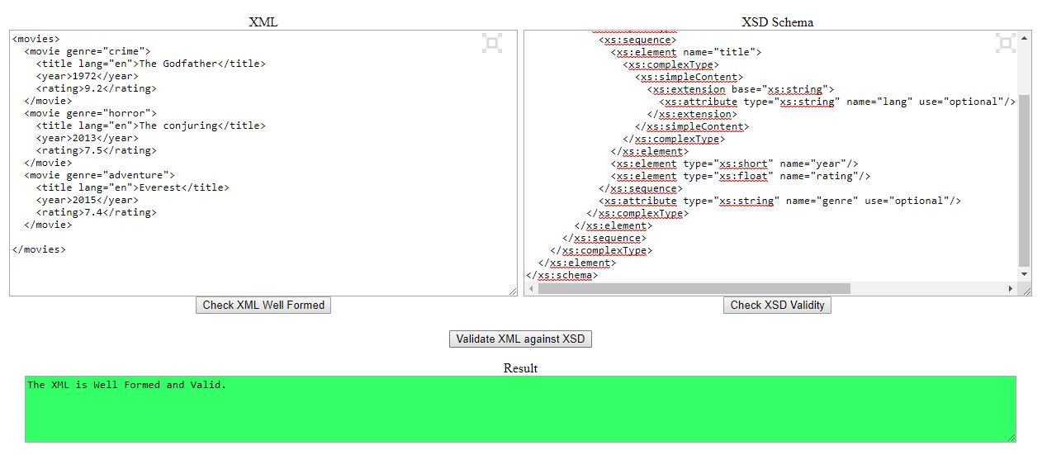

TASK:04

