LAB#06
Task:01
Create RMI IIOP application in which take a sentence at runtime on the client application and let the server return its reverse.
E.g. input could be: subject is distributed computing
output should be: computing distributed is subject.

Text_Interface.javas

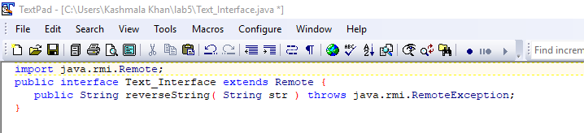

TextImpl.java

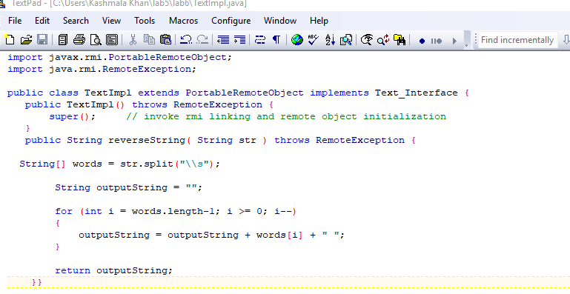

TextServer.java
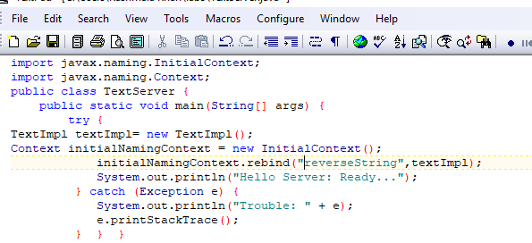

TextClient.java

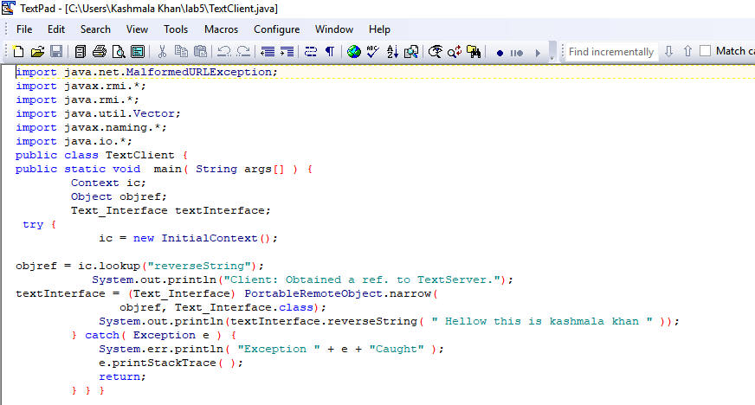

OUTPUT:
