LAB#1
Department of Software Engineering
Mehran University of Engineering and Technology, Jamshoro

Distributed Computing
Instructor | Rabeea Jaffari | Practical/Lab No. | 1
Date |  | CLOs
Signature |  | Assessment Score

Topic | Creating applications using datagram sockets.
Objectives | To learn creation of datagram sockets

TASK:01
Modify the sample code so that the sender uses the same socket to send the same
message to two different receivers. Start the two receivers first, then the sender.
Does each receiver receive the message? Capture the code and output. Describe
he outcome.
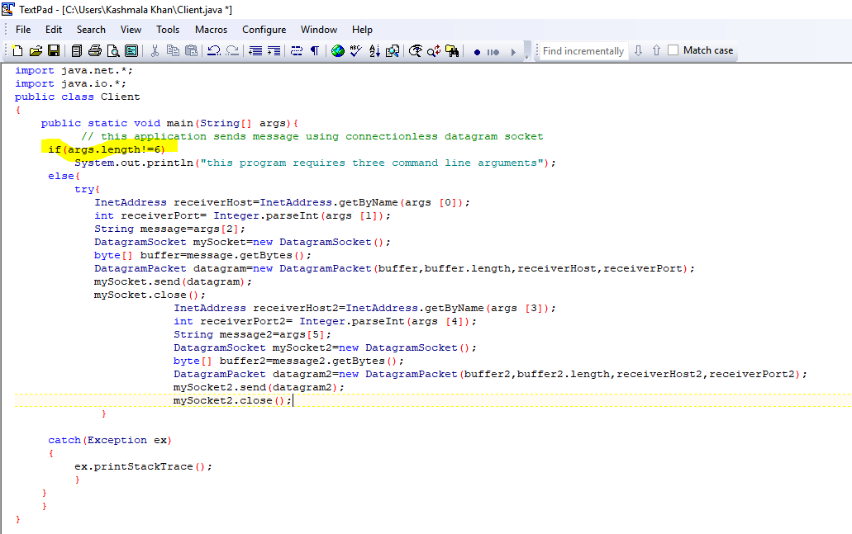
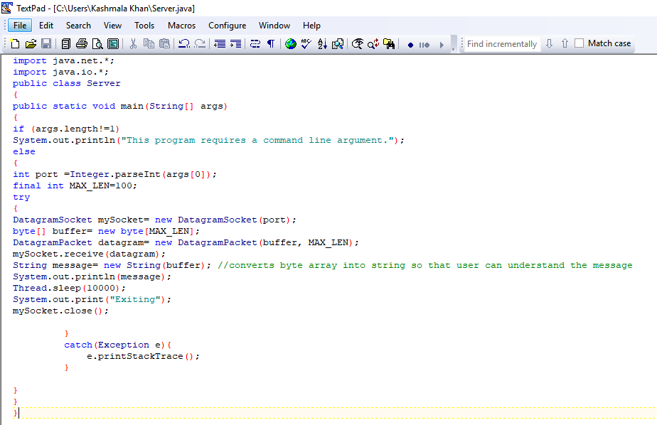

Client
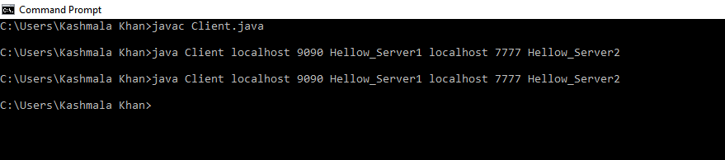
Server1 and Server2:
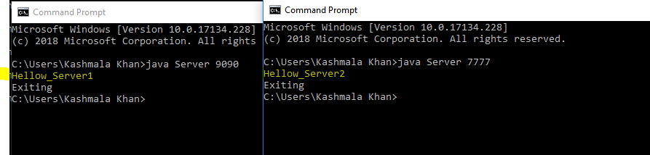
TASK:2
Modify the sample code so that the receiver loops five times to repeatedly receive
then display your bio data (name, roll num etc.) received. Recompile. Then
i. start the receiver
ii. Execute the sender, sending your bio data, and
iii. In another window, start another instance of the sender, sending your friend’s bio data. Does the receiver receive both the messages? Capture the code and output.
Client:
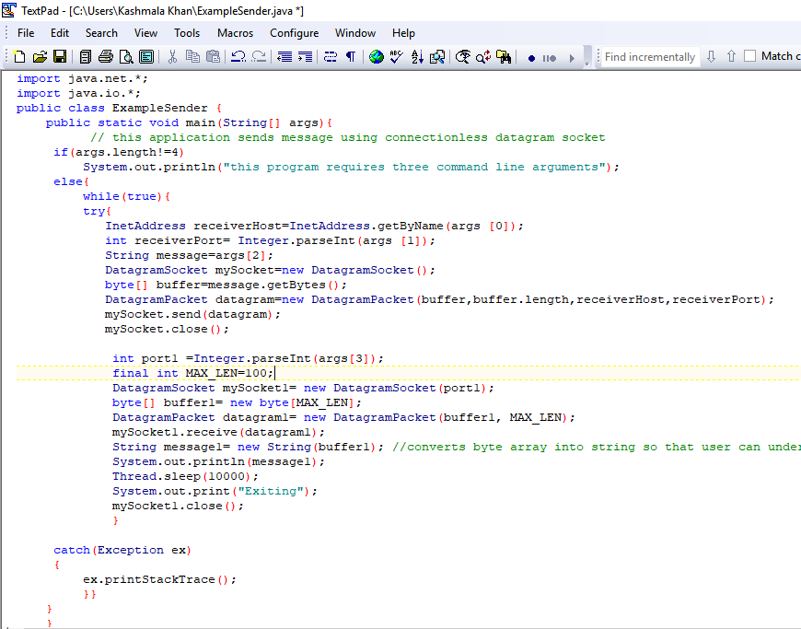
Server
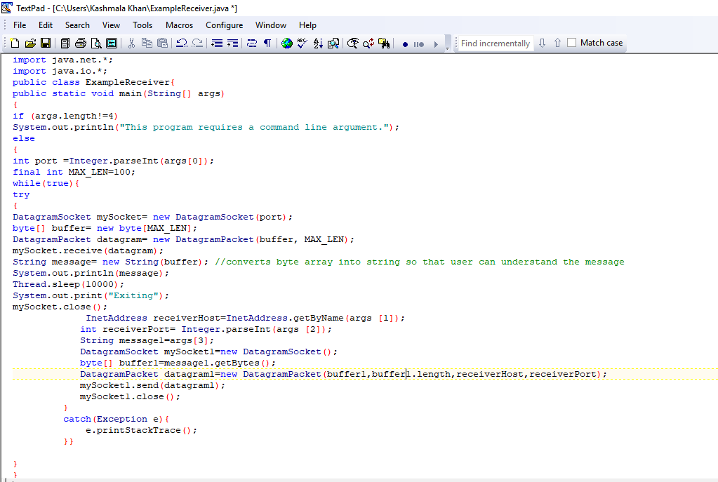

OUTPUT:
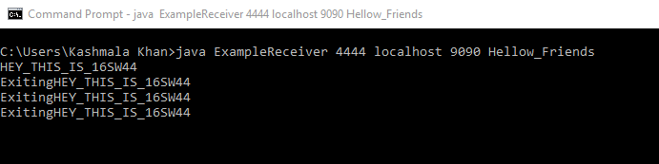
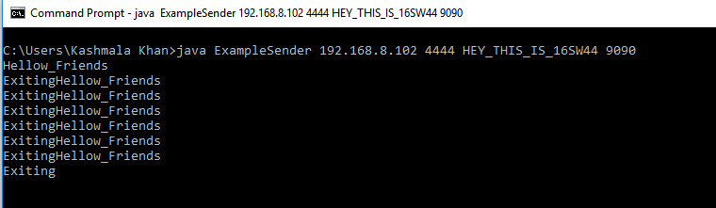

CODE
Client1
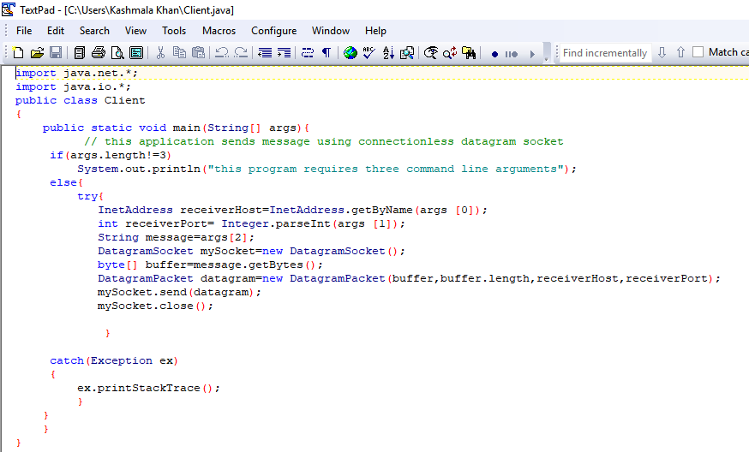

Client2:
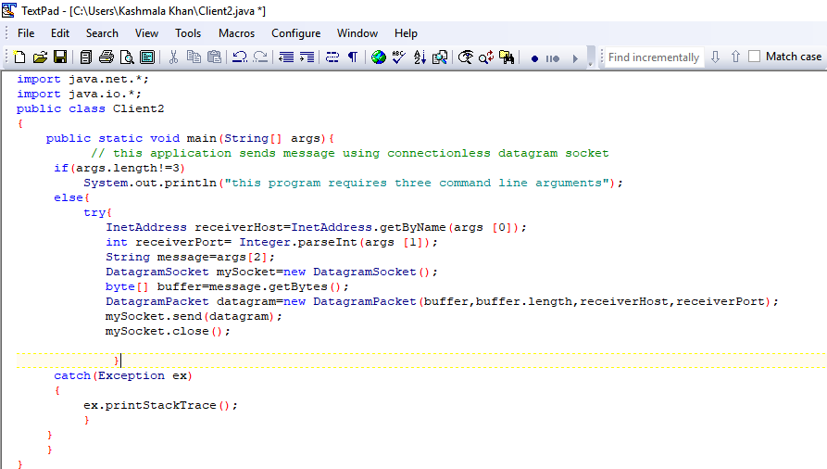

Server:
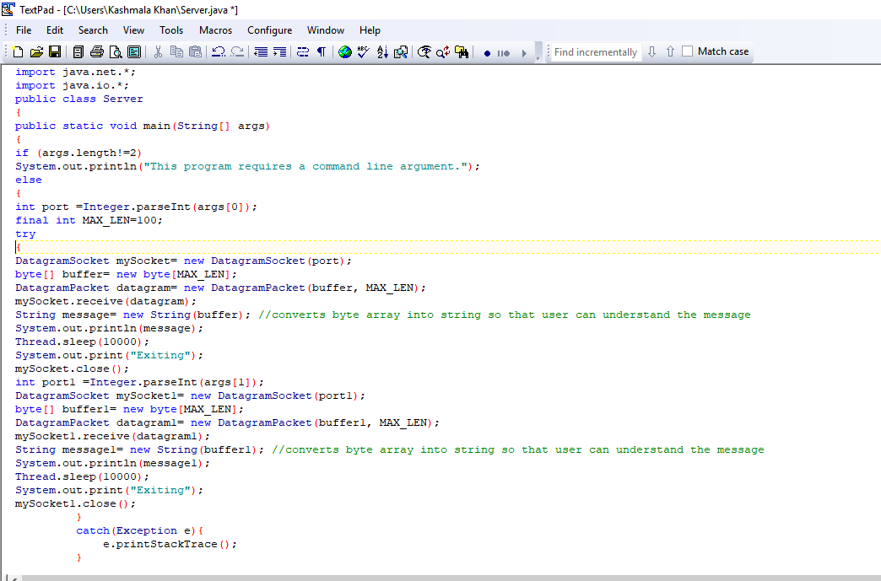

OUTPUT:
(Client1)
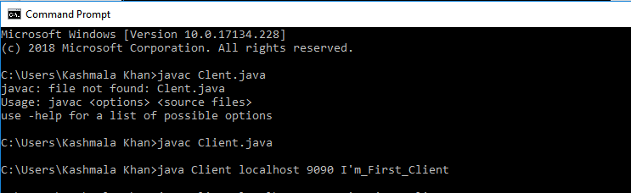
(Client2)
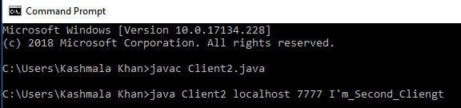

Server:
Server is receiving both the messages(from client1 as well as from client2)
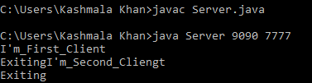

TASK:03
Implement an encoding client-server application. The client sends a sentence to
the server using datagram packet, the server accepts it and then encodes the
sentence using any simple encoding algorithm (for e.g. letters reversal etc.) and
sends the encoded sentence back to the client using a datagram packet.

Client:
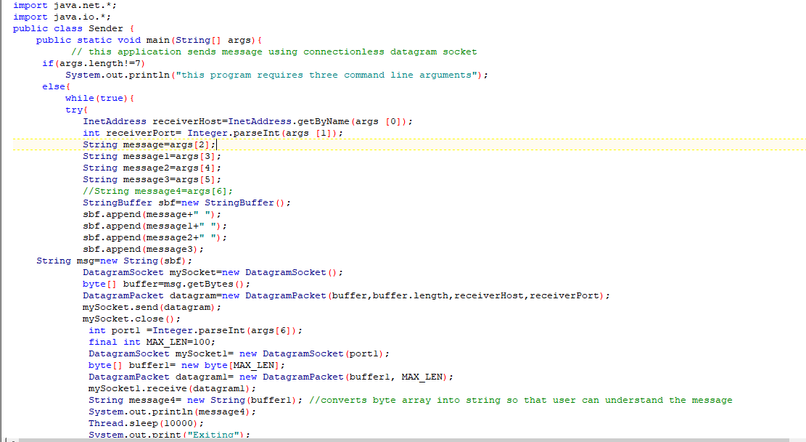
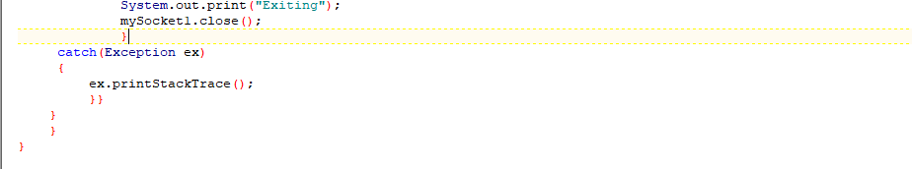

Server
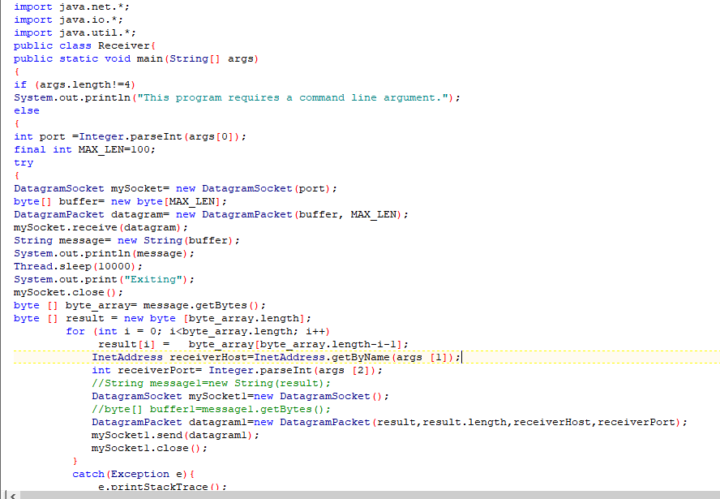

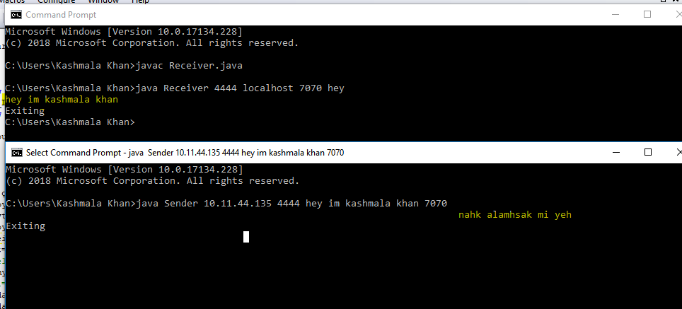

TASK:03
Implement two simple programs using Java datagram sockets, which broadcasts and multicast your roll number to all or selected network nodes respectively

MultiCasting

MulticastSender.java

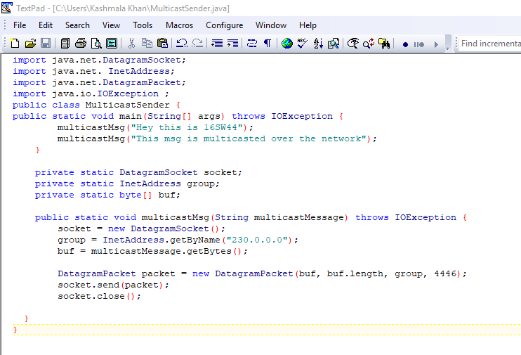

Output:
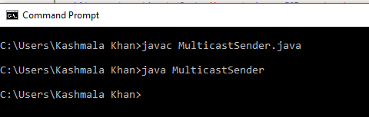

MulticastReceiver.java
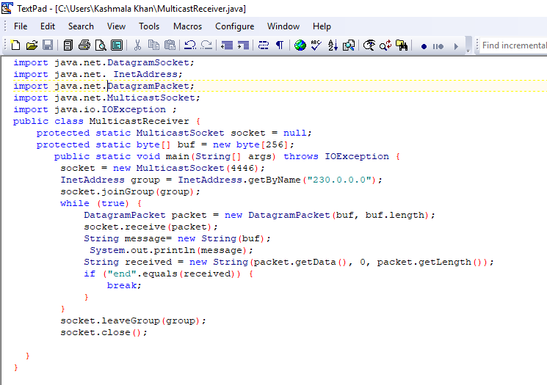

Output:
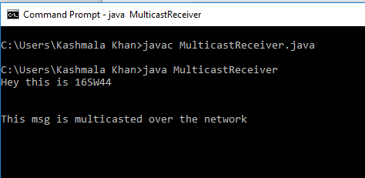

Broadcasting
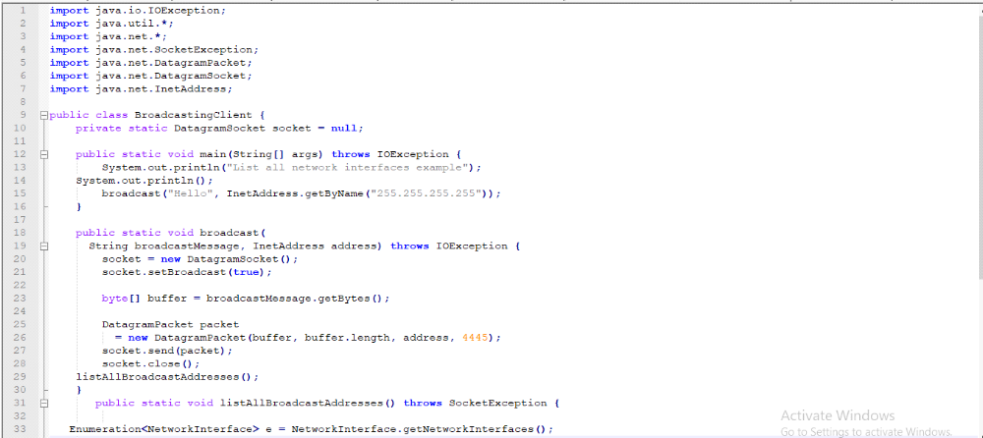
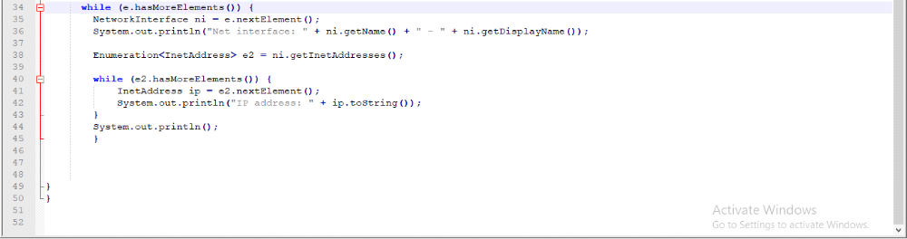
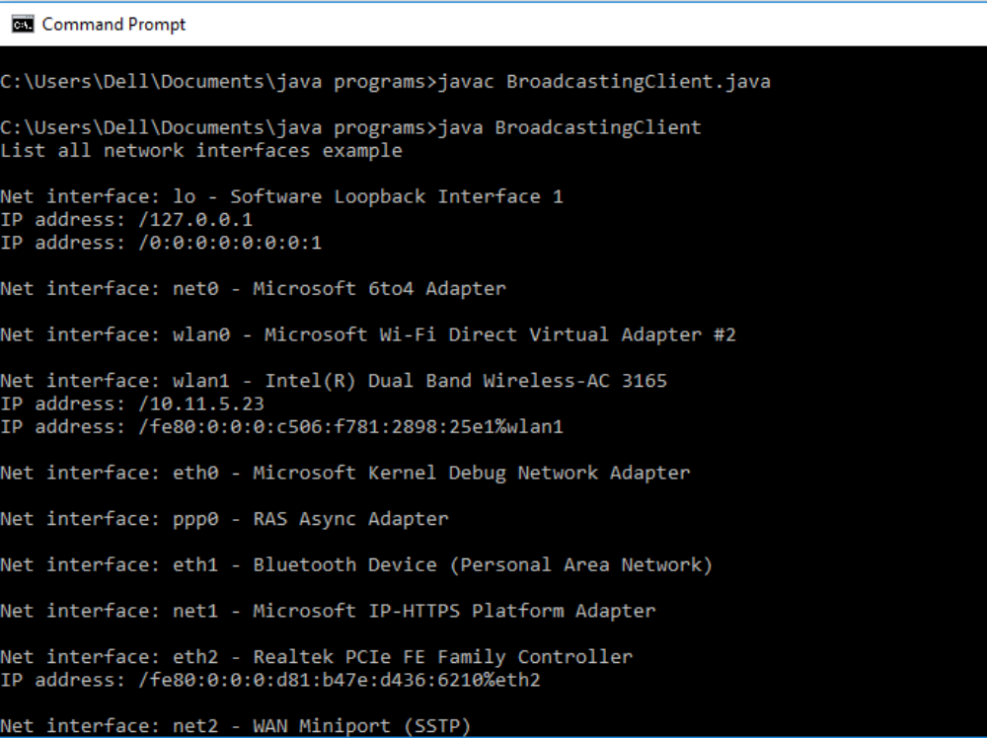

BroadCasting

