LAB#02

TASK:01
Compile and run the above code, but reverse the order of program’s execution.
Start the requestor first and then the acceptor. Describe and explain the outcome.
Client:
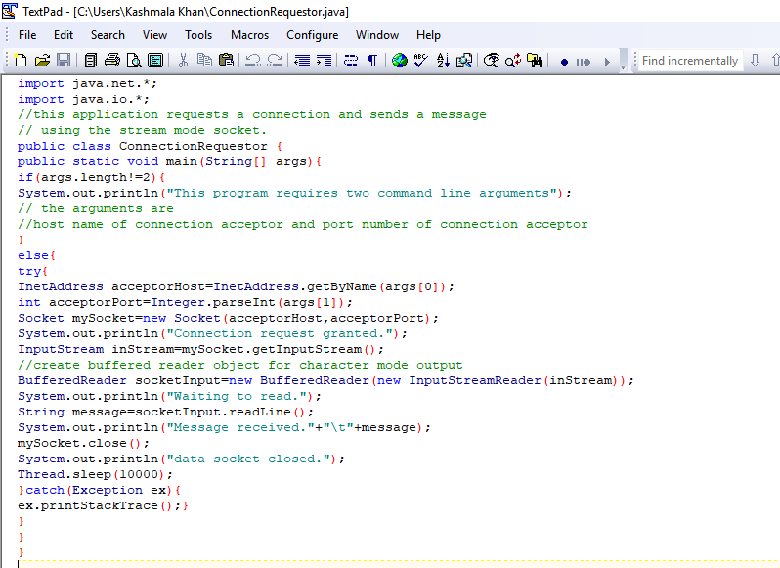
Server:
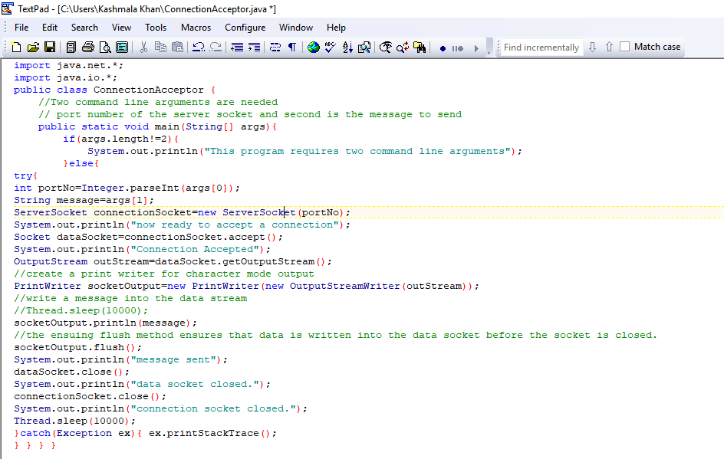

OUTPUT:(when we run the client’s code first)
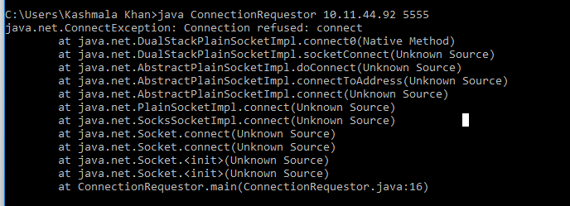
OUTPUT(first server then client)

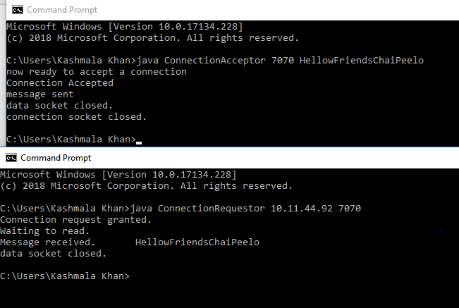

TASK:02
Add a time delay of 10 seconds in the ConnectionAcceptor process just before the
message is written to the socket, then run the program. This will show you the
blocking at the receiver. Show a trace of the output of the processes.
Server:
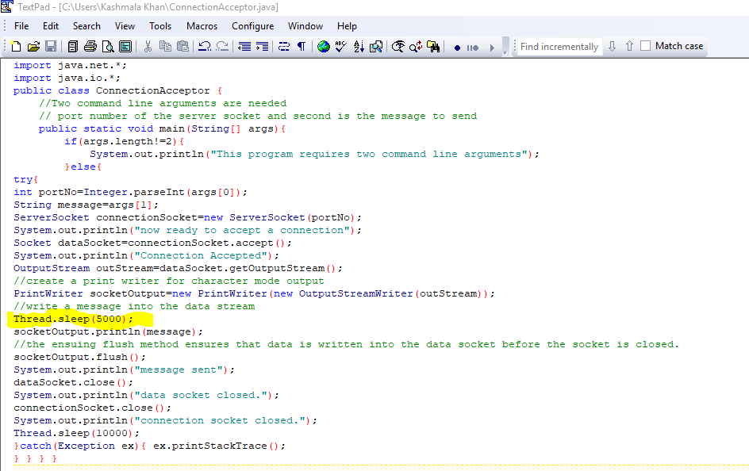

OUTPUT: (Server)
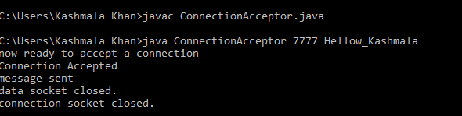

Client:
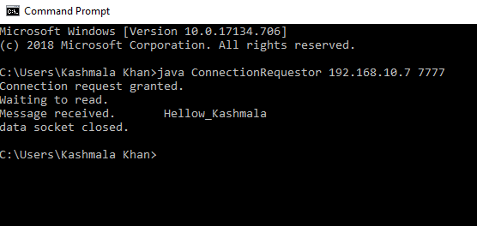

TASK:03
Implement a simple chat program using stream sockets.
Server class:
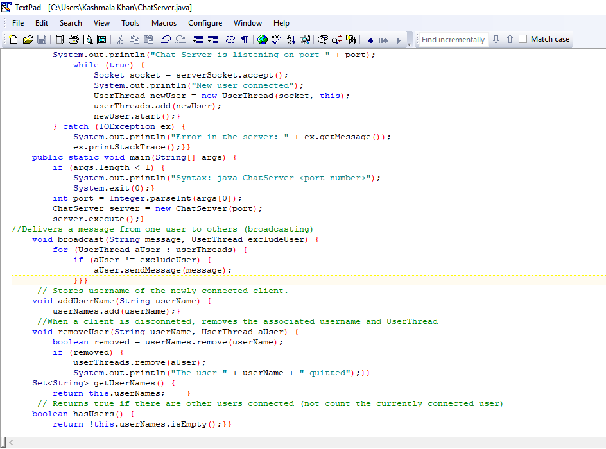
Client:
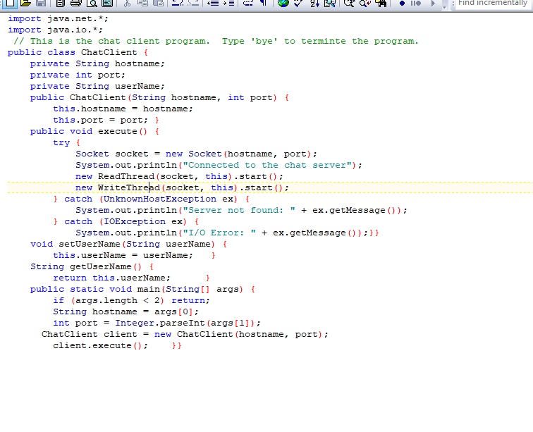

ReadThread.java
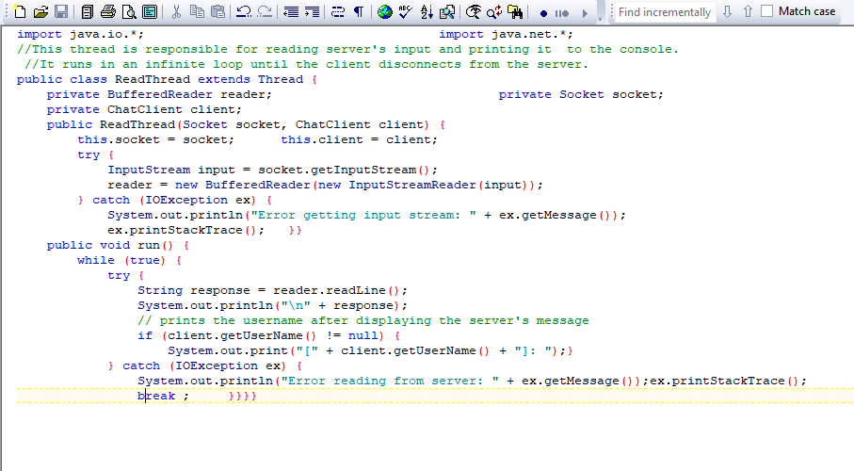
WriteThread.java
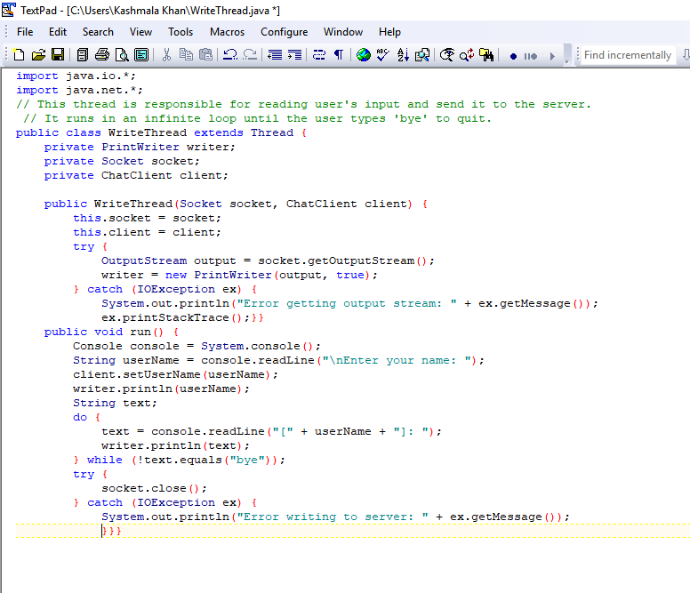

UserThread.java
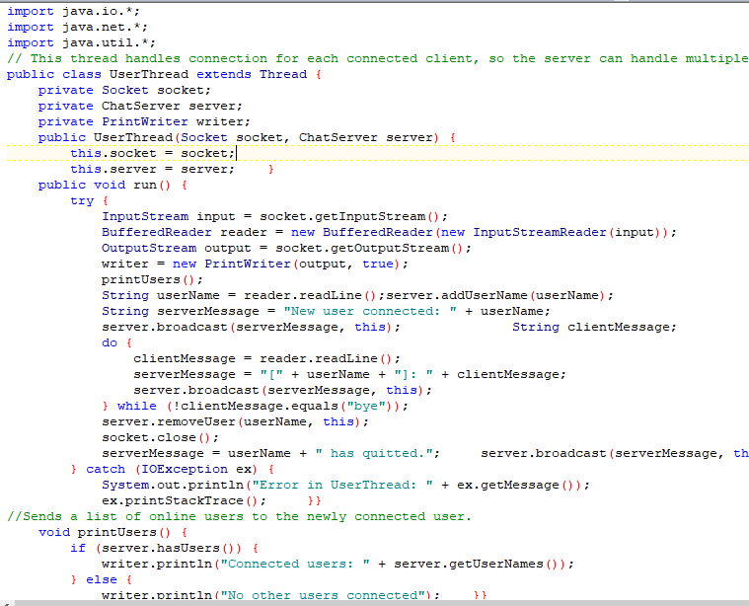
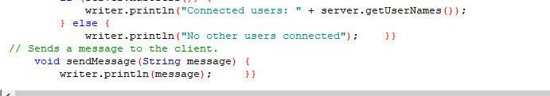
OUTPUT:
Server:
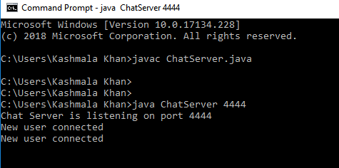

Client1 and Client2(both the clients are connected to same server)
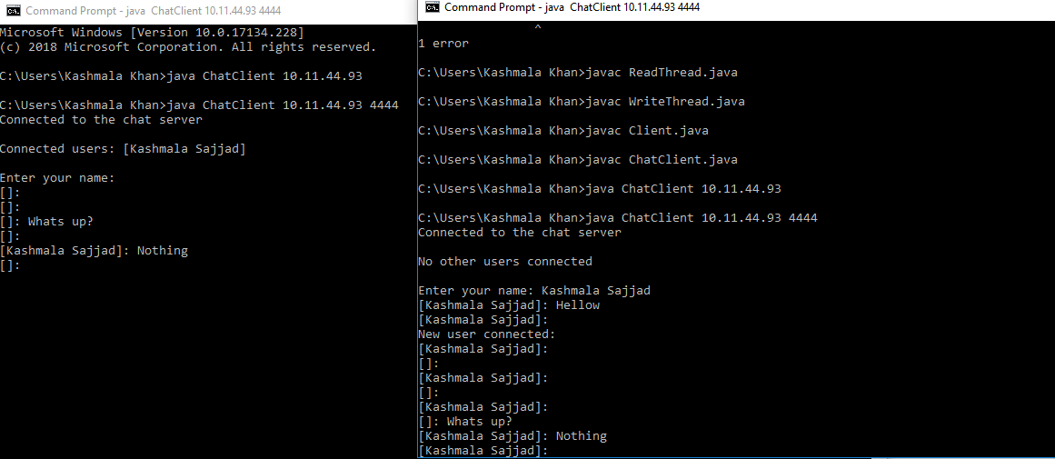

TASK:04
Modify the sample code to include two way communication between the client and the server.
Client Code:
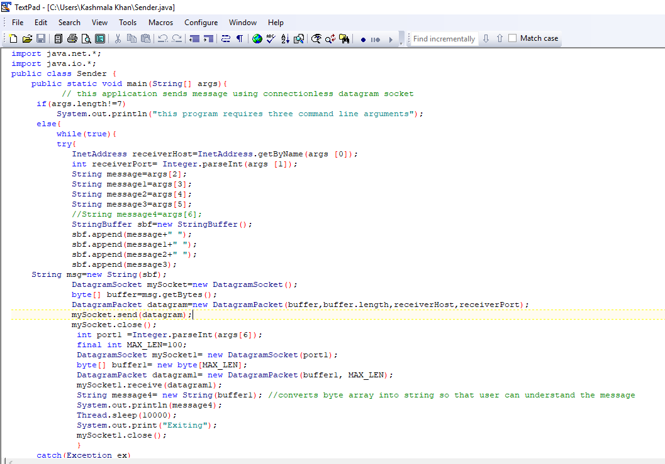
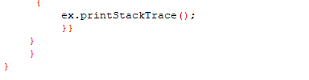
Server Code:
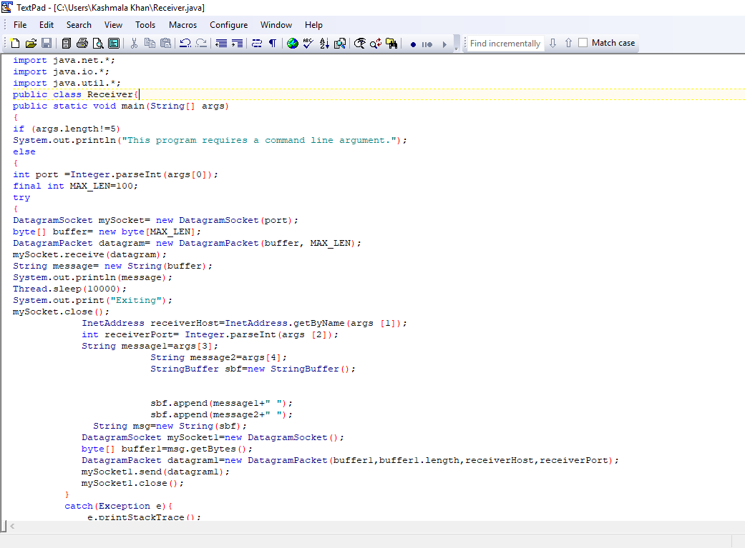

OUTPUT:
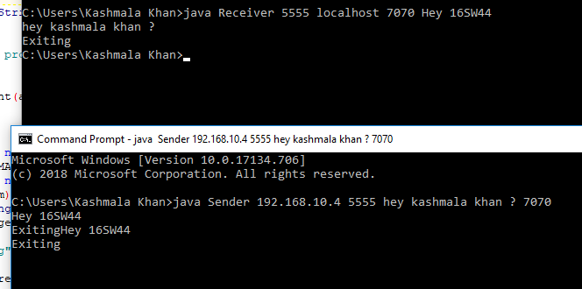
TASK:05
Create 2 programs one for sending the file and second for receiving the file using Stream Sockets.
FileSend.java
import java.io.BufferedInputStream;
import java.io.File;
import java.io.FileInputStream;
import java.io.IOException;
import java.io.OutputStream;
import java.net.ServerSocket;
import java.net.Socket;
public class FileSend {
public final static int SOCKETPORT=Integer.parseInt("7777");
public final static String FILE_TO_SEND="C:/sw.JPG";
public static void main (String [] args ) throws IOException {
FileInputStream fis=null;
BufferedInputStream bis = null;
OutputStream os =null;
ServerSocket serversock = null;
Socket sock =null;
try {
serversock = new ServerSocket(SOCKETPORT);
while (true) {
System.out.println("Waiting...");
try {
sock = serversock.accept();
System.out.println("Accepted connection : " + sock);
File myFile = new File (FILE_TO_SEND);
byte [] mybytearray = new byte [(int)myFile.length()];
fis = new FileInputStream(myFile);
bis =new BufferedInputStream(fis);
bis.read(mybytearray,0,mybytearray.length);
os=sock.getOutputStream();
System.out.println("SENDING "+FILE_TO_SEND+ mybytearray.length);
os.write(mybytearray,0,mybytearray.length);
os.flush();
System.out.println("Done");
}
finally{
if(bis!=null)
bis.close();
if(os!=null)
os.close();
if(sock!=null)
sock.close();
}

}}
finally{
if(serversock!=null)
serversock.close();
}}}
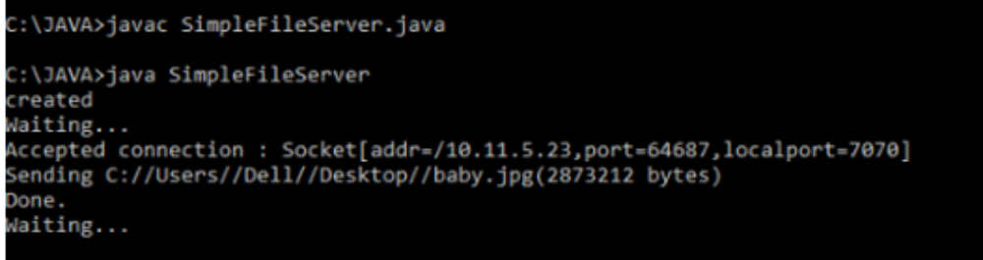
FileReceive.java
import java.io.*;
import java.net.*;
public class FileReceive{
public final static String RECEIVED_FILE="C:/sw.JPG";
public final static int file_size=36864;
public static void main(String [] args) throws IOException{
int bytesRead;
int current=0;
FileOutputStream fos=null;
BufferedOutputStream bos=null;
Socket sock=null;
try{
InetAddress SERVER_HOST=InetAddress.getByName("192.168.10.10");
int SOCKET_PORT=7777;
sock=new Socket(SERVER_HOST,SOCKET_PORT);
System.out.println("Connected");
byte[] mybytearray=new byte[file_size];
InputStream is=sock.getInputStream();
fos=new FileOutputStream(RECEIVED_FILE);
bos=new BufferedOutputStream(fos);
bytesRead=is.read(mybytearray,0,mybytearray.length);
current=bytesRead;
do{
bytesRead=is.read(mybytearray,current,(mybytearray.length-current));
if(bytesRead>=0){
current+=bytesRead;
}

}
while(bytesRead <= 0);
bos.write(mybytearray, 0 ,current);
bos.flush();
System.out.println("File"+ RECEIVED_FILE+ " downloaded "+ current+" bytes read");
}
finally{

if(fos!=null) fos.close();
if(bos!=null) bos.close();
if(sock!=null) sock.close();
}
}
}
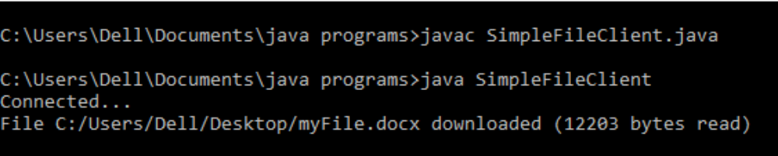
TASK:06

Non-blocking Sockets in Java
Java has TCP and UDP sockets. The methods such as connect(), accept(), read(), and write() defined in the ServerSocket and Socket class are used for blocking socket programming. For example, when a client invokes the read() method to read data from the server, the thread gets blocked until the data is available. This situation is undesirable under some circumstances. Instead, what we can do is use the waiting period to do some other task. The client socket then can notify when the data is available. Another problem is that, in a multi-socket connection, each client is a separate thread. Therefore, there is an overhead of maintaining a pool of client threads.
Blocking sockets are simple due to their sequential execution. Non-blocking sockets, on the other hand, are non-sequential. They require a different perspective to implement them in programming. In a way, non-blocking socket programs are a little complex and a bit more advanced technique of socket communication.

Non-blocking Socket APIs
The classes that support non-blocking socket communication in Java are as follows.
Non-blocking socket classes | Description (*)
ServerSocketChannel | A selectable channel for stream-oriented listening sockets. The channel is created by invoking the open method of this class. This class uses the ServerSocket class behind the scenes. An instance of this class is used to accept a new connection request in a server like the ServerSocket class instance.
SocketChannel | A selectable channel for stream-oriented listening sockets. The channel is created by invoking the open method of this class. This class uses the Socket class behind the scenes. An instance of this class is used to establish connection between the client and the server like the Socket class instance.
Selector | A multiplexor for the SelectableChannel object.
SelectionKey | Used for representing the registration of SelectableChannel with a Selector.

How It Works
The Selector class object acts as an interface between remote clients and the server in the following manner.
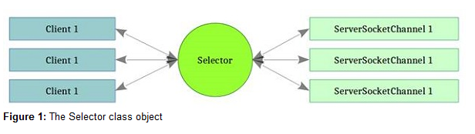

The way to create the selector object is by calling its open() static method:
Selector selector=Selector.open();
The ServerSocketChannel instance, which listens to the new connection request from the client, is created in a similar manner by invoking its static open() method:
ServerSocketChannel serverSocketChannel=ServerSocketChannel.open();
The channel thus created is by default is in a blocking state. We must set it to an unblocking state explicitly in the following manner:
serverSocketChannel. configureBlocking(false);
The server socket channel must be bound to an IP address and a port number so that the client socket can communicate:
InetAddress ip=InetAddress.getByName("localhost");serverSocketChannel.bind(new InetSocketAddress(ip, 1234));
Now, the server socket must register itself with the selector. The selector acts as a multiplexor of selectable channels. This primarily means selectors registration of a specific operation. The SelectionKey class integer constraints to designate each operation. For example:
- SelectonKey.OP_CONNECT: Designates connect operation progress
- SelectonKey.OP_ACCEPT: Designates client request for new connection
- SelectonKey.OP_READ: Designates ready to read some data
- SelectonKey.OP_WRITE: Designates ready to write some data
The registration is done as follows:
ServerSocketChannel.register(selector, SelectionKey.OP_ACCEPT);
The selector is now ready to intercept a client socket connection and relay to the server socket channel.
CODE:
Client:
import java.io.BufferedReader;
import java.io.InputStreamReader;
import java.net.InetAddress;
import java.net.InetSocketAddress;
import java.nio.ByteBuffer;
import java.nio.CharBuffer;
import java.nio.channels.SelectionKey;
import java.nio.channels.Selector;
import java.nio.channels.SocketChannel;
import java.nio.charset.Charset;
import java.nio.charset.CharsetDecoder;
import java.util.Iterator;
import java.util.Set;
public class MainClient {
static BufferedReader userInputReader = null;

public static boolean processReadySet(Set readySet) throws Exception {
Iterator iterator = readySet.iterator();
while (iterator.hasNext()) {
SelectionKey key = (SelectionKey)
iterator.next();
iterator.remove();
if (key.isConnectable()) {
boolean connected = processConnect(key);
if (!connected) {
return true; // Exit
}
}
if (key.isReadable()) {
String msg = processRead(key);
System.out.println("[Server]: " + msg);
}
if (key.isWritable()) {
System.out.print("Please enter a message(Bye to quit):");
String msg = userInputReader.readLine();

if (msg.equalsIgnoreCase("bye")) {
return true; // Exit
}
SocketChannel sChannel = (SocketChannel) key.channel();
ByteBuffer buffer = ByteBuffer.wrap(msg.getBytes());
sChannel.write(buffer);
}
}
return false; // Not done yet
}
public static boolean processConnect(SelectionKey key) throws Exception{
SocketChannel channel = (SocketChannel) key.channel();
while (channel.isConnectionPending()) {
channel.finishConnect();
}
return true;
}
public static String processRead(SelectionKey key) throws Exception {
SocketChannel sChannel = (SocketChannel) key.channel();
ByteBuffer buffer = ByteBuffer.allocate(1024);
sChannel.read(buffer);
buffer.flip();
Charset charset = Charset.forName("UTF-8");
CharsetDecoder decoder = charset.newDecoder();
CharBuffer charBuffer = decoder.decode(buffer);
String msg = charBuffer.toString();
return msg;
}
public static void main(String[] args) throws Exception {
InetAddress serverIPAddress = InetAddress.getByName("localhost");
int port = 19000;
InetSocketAddress serverAddress = new InetSocketAddress(
serverIPAddress, port);
Selector selector = Selector.open();
SocketChannel channel = SocketChannel.open();
channel.configureBlocking(false);
channel.connect(serverAddress);
int operations = SelectionKey.OP_CONNECT | SelectionKey.OP_READ
| SelectionKey.OP_WRITE;
channel.register(selector, operations);

userInputReader = new BufferedReader(new InputStreamReader(System.in));
while (true) {
if (selector.select() > 0) {
boolean doneStatus = processReadySet(selector.selectedKeys());
if (doneStatus) {
break;
}
}
}
channel.close();
}
}
Server:(Main.java)
import java.net.InetAddress;
import java.net.InetSocketAddress;
import java.nio.ByteBuffer;
import java.nio.channels.SelectionKey;
import java.nio.channels.Selector;
import java.nio.channels.ServerSocketChannel;
import java.nio.channels.SocketChannel;
import java.util.Iterator;
import java.util.Set;

public class Main {
public static void main(String[] args) throws Exception {
InetAddress hostIPAddress = InetAddress.getByName("localhost");
int port = 19000;
Selector selector = Selector.open();
ServerSocketChannel ssChannel = ServerSocketChannel.open();
ssChannel.configureBlocking(false);
ssChannel.socket().bind(new InetSocketAddress(hostIPAddress, port));
ssChannel.register(selector, SelectionKey.OP_ACCEPT);
while (true) {
if (selector.select() <= 0) {
continue;
}
processReadySet(selector.selectedKeys());
}
}
public static void processReadySet(Set readySet) throws Exception {
Iterator iterator = readySet.iterator();
while (iterator.hasNext()) {
SelectionKey key = (SelectionKey) iterator.next();
iterator.remove();
if (key.isAcceptable()) {
ServerSocketChannel ssChannel = (ServerSocketChannel) key.channel();
SocketChannel sChannel = (SocketChannel) ssChannel.accept();
sChannel.configureBlocking(false);
sChannel.register(key.selector(), SelectionKey.OP_READ);
}
if (key.isReadable()) {
String msg = processRead(key);
if (msg.length() > 0) {
SocketChannel sChannel = (SocketChannel) key.channel();
ByteBuffer buffer = ByteBuffer.wrap(msg.getBytes());
sChannel.write(buffer);
}
}
}
}
public static String processRead(SelectionKey key) throws Exception {
SocketChannel sChannel = (SocketChannel) key.channel();
ByteBuffer buffer = ByteBuffer.allocate(1024);
int bytesCount = sChannel.read(buffer);
if (bytesCount > 0) {
buffer.flip();
return new String(buffer.array());
}
return "NoMessage";
}
}
OUTPUT:
