Department of Software Engineering
Mehran University of Engineering and Technology, Jamshoro

Course: SWE324 - Data Warehousing and Data Mining
Instructor | Rabeea Jaffari | Practical/Lab No. | 01
Date | 02 April 2019 | CLOs | CLO-4: P3 & P4
Signature |  | Assessment Score | 1 Marks

Topic | To become Familiar with OLTP System Design
Objectives | To learn conceptual and logical Transactional Database Design

Lab Discussion: Theoretical concepts and Procedural steps

TASK:01
The study team identified a preliminary set of 11 entity types that
describe the data required by the hospital in support of the various
business functions: FACILITY, PHYSICIAN, PATIENT, DIAGNOSTIC UNIT,
WARD, STAFF, ORDER, SERVICE/ DRUG, MEDICAL/SURGICAL ITEM,
SUPPLY ITEM, and VENDOR. From discussions with hospital staff,
reviewing hospital documents, and studying existing information
systems,the study team developed a list of business rules describing the
policies of the hospital and nature of the hospital’s operation that govern
the relationships among these entities. Some of these rules follow:

A FACILITY maintains one or more DIAGNOSTIC UNITs (radiology, clinical laboratory, cardiac diagnostic unit, etc.).
A FACILITY contains a number of WARDs (obstetrics, oncology, geriatrics, etc.).
Each WARD is assigned a certain number of STAFF members (nurses, secretaries, etc.); a STAFF member may be assigned to multiple WARDs.
A FACILITY staffs its medical team with a number of PHYSICIANs. A PHYSICIAN may be on the staff of more than one FACILITY.
A PHYSICIAN treats PATIENTs, and a PATIENT is treated by any number of PHYSICIANs.
A PHYSICIAN diagnoses PATIENTs, and a PATIENT is diagnosed by any number of PHYSICIANs.
A PATIENT may be assigned to a WARD (outpatients are not assigned to a WARD). The hospital cares only about the current WARD a patient is assigned to (if assigned at all).
A PATIENT uses MEDICAL/SURGICAL ITEMs, which are supplied by VENDORs. A VENDOR also provides SUPPLY ITEMs that are used for housekeeping and maintenance purposes.
A PHYSICIAN writes one or more ORDERs for a PATIENT. Each ORDER is for a given PATIENT, and a PATIENT may have many ORDERs.
An ORDER can be for a SERVICE such as diagnostic test (lab tests such as lipid profile, CBC, liver function tests; diagnostic imaging such as MRIs and X-rays) or a DRUG.
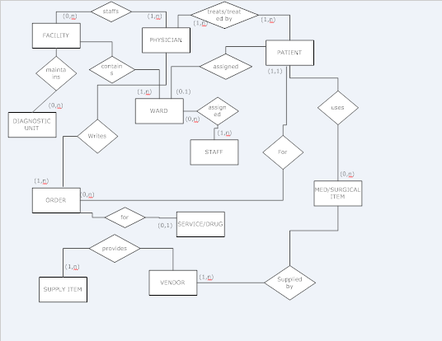

For each of the descriptions below, perform the following tasks:
i. Identify the degree and cardinalities of the relationship.
ii. Express the relationships in each description graphically with a logical design ER diagram.

DEGREE AND CARDINLITIES
- FACILITY TO DIAGNOSTIC UNIT:
Degree:2
Ordinality: 0
Cardinatity: Many

- FACILITY TO WARD:
Degree:2
Ordinality: 1
Cardinatity: Many

- WARD TO STAFF:
Degree: 2
Ordinality: 1
Cardinatity: Many

- STAFF TO WARD:
Degree: 2
Ordinality: 0
Cardinatity: Many

- FACILITY TO PHYSICIAN:
Degree: 2
Ordinality: 1
Cardinatity: Many

- PHYSICIAN TO FACILTY:
Degree:2
Ordinality: 0
Cardinatity: Many

- PHYSICIAN TO PATIENT:
Degree: 2
Ordinality: 1
Cardinatity: Many

- PATIENT TO PHYSICIAN:
Degree: 2
Ordinality: 1
Cardinatity: Many

- PATIENT TO WARD:
Degree: 2
Ordinality: 0
Cardinatity: 1

- PATIENT TO MED/SURGICAL ITEMS:
Degree: 2
Ordinality: 0
Cardinatity: Many

- MED/SURGICAL ITEMS TO VENDOR:
Degree: 2
Ordinality: 1
Cardinatity: Many

- VENDOR TO SUPPLY ITEMS:
Degree: 2
Ordinality:1
Cardinatity: Many

- PHYSICIAN TO ORDER:
Degree: 2
Ordinality: 1
Cardinatity:Many’

- ORDER TO PATIENT:
Degree: 2
Ordinality: 1
Cardinatity: 1

- PATIENT TO ORDER:
Degree: 2
Ordinality: 0
Cardinatity: Many

- ORDER TO SERVICE:
Degree: 2
Ordinality: 0
Cardinatity: 1

TASK:02
A book is identified by its ISBN number, and it has a title, a price, and a date of
publication. It is published by a publisher, which has its own ID number and a
name. Each book has exactly one publisher, but one publisher typically
publishes multiple books over time.

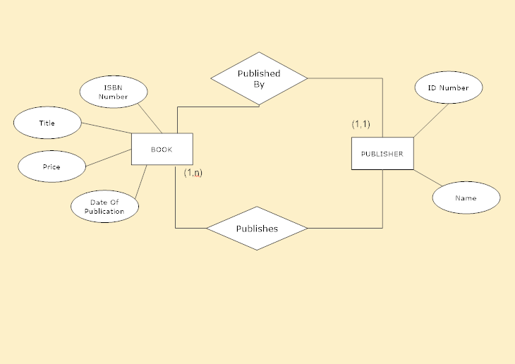

LOGICAL ERD:

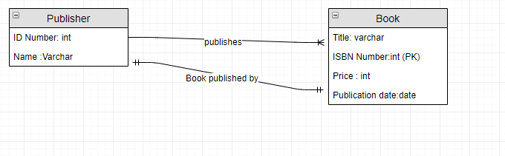

DEGREE AND CARDINLITIES

BOOK TO PUBLISHER:
Degree: 2
Ordinality: 1
Cardinality: 1
PUBLISHER TO BOOK:
Degree: 2
Ordinality: 1
Cardinality: Many

TASK:03
A piano manufacturer wants to keep track of all the pianos it makes
individually. Each piano has an identifying serial number and a
manufacturing completion date. Each instrument represents exactly one
piano model, all of which have an identification number and a name. In
addition, the company wants to maintain information about the designer of
the model. Over time, the company often manufactures thousands of pianos
of a certain model, and the model design is specified before any single piano
Exists.

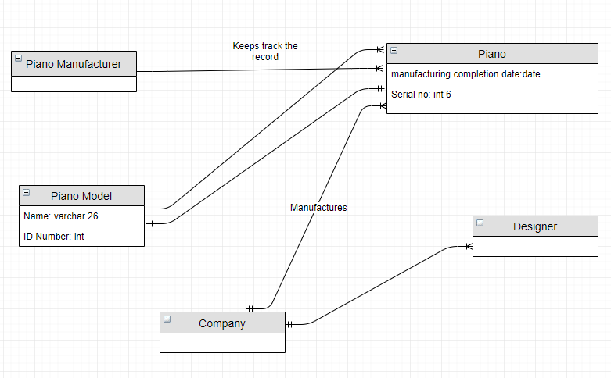

DEGREE AND CARDINLITIES

PIANO MANUFACTURER TO PIANO:
Degree: 2
Ordinality: 1
Cardinality: Many

PIANO TO PIANO MODEL:
Degree: 2
Ordinality: 1
Cardinality: 1

COMPANY TO DESIGNER:
Degree: 2
Ordinality: 1
Cardinality: Many

COMPANY TO PIANO:
Degree: 2
Ordinality: 1
Cardinality: Many

PIANO MODEL TO PIANO:
Degree:2
Ordinality: 1
Cardinality: Many

TASK:04

A piano manufacturer (see above) employs piano technicians who are
responsible for inspecting the instruments before they are shipped to the
customers. Each piano is inspected by at least two technicians (identified by
heir employee number). For each separate inspection, the company needs to
record its date and a quality evaluation grade.

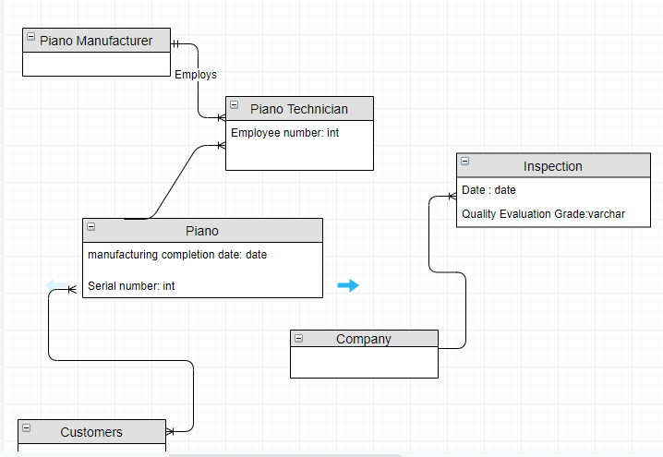\
DEGREE AND CARDINLITIES
PIANO MANUFACTURER TO PIANO TECHNICIAN:
Degree:2
Ordinality: 1
Cardinality: Many
PIANO TO TECHNICIAN:
Degree: 2
Ordinality: 2
Cardinality: Many

COMPANY TO INSPECTION:
Degree: 2
Ordinality: 1
Cardinality: Many

PIANO TO CUSTOMER:
Degree: 2
Ordinality: 1
Cardinality: Many

TASK:06

The entity type STUDENT has the following attributes: Student Name,
Address, Phone, Age, Activity, and No of Years. Activity represents some
campus-based student activity, and No of Years represents the number of
years the student has engaged in this activity. A given student may engage in
more than one activity. Draw a logical ERD for this situation. What attribute
or attributes did you designate as the identifier for the STUDENT entity?
Why?
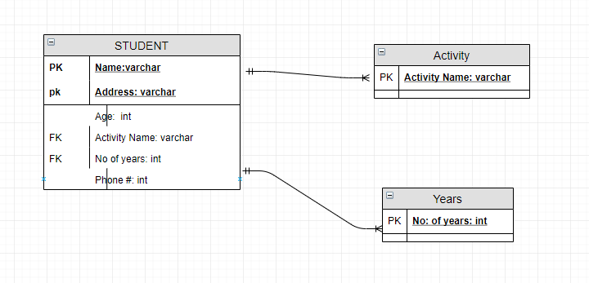
DEGREE AND CARDINLITIES
STUDENT TO ACTIVITY:
Degree: 2
Ordinality: 1
Cardinality: Many
STUDENT TO NO: OF YEARS:
Degree: 2
Ordinality: 1
Cardinality: Many

What attribute or attributes did you designate as the identifier for the
STUDENT entity?
Why?
Ans:
I’ve designated the Address and Name as the identifier for the STUDENT entity, because
it is possible the more than one student have the same name, or address but they can’t have
both the things same (name and address). One can also make the name and phone number
as an identifier for STUDENT entity.

TASK:07

A college course may have one or more scheduled sections or may not have a
scheduled section. Attributes of COURSE include Course ID, Course Name,
and Units. Attributes of SECTION include Section Number and Semester ID.
Semester ID is composed of two parts: Semester and Year. Section Number is
an integer (such as 1 or 2) that distinguishes one section from another for the
same course but does not uniquely identify a section. How did you model
SECTION? Why did you choose this way versus alternative ways to model
SECTION?

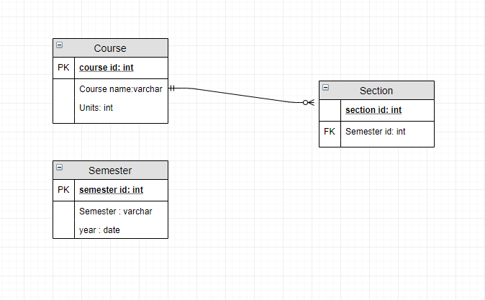

DEGREE AND CARDINLITIES:
COURSE TO SECTION:
Degree: 2
Ordinality: 0
Cardinality: Many

