Department of Software Engineering
Mehran University of Engineering and Technology, Jamshoro

Course: SWE324 - Data Warehousing and Data Mining
Instructor | Rabeea Jaffari | Practical/Lab No. | 02
Date | 02 April 2019 | CLOs | CLO-4: P3 & P4
Signature |  | Assessment Score | 1 Marks

Topic | To become Familiar with OLTP System Design
Objectives | To learn conceptual and logical Transactional Database Design

Lab Discussion: Theoretical concepts and Procedural steps

TASK:01
A book is identified by its ISBN number, and it has a title, a price, and a date of
publication. It is published by a publisher, which has its own ID number and a
name. Each book has exactly one publisher, but one publisher typically
publishes multiple books over time.
Publisher:
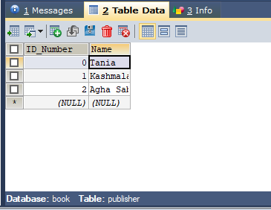

Books:
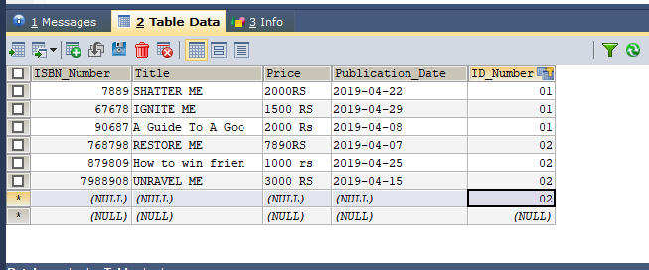
TASK:02
A piano manufacturer wants to keep track of all the pianos it makes
individually. Each piano has an identifying serial number and a
manufacturing completion date.

Piano_Manufacturer:
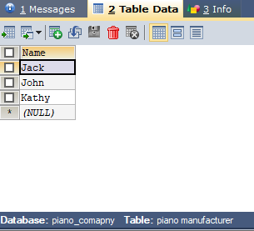

Piano:
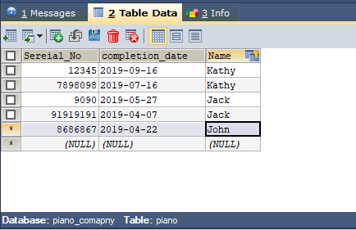

Each instrument represents exactly one
piano model, all of which have an identification number and a name.
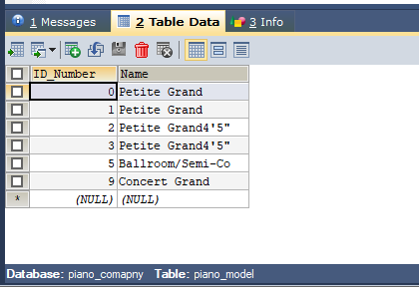

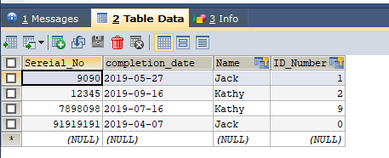

In addition, the company wants to maintain information about the designer of the model.

Company:
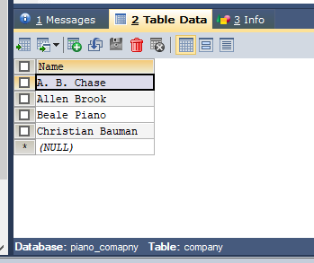
Designer:
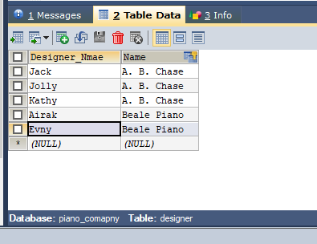

Over time, the company often manufactures thousands of pianos
of a certain model, and the model design is specified before any single piano
Exists.

Company:

Piano:

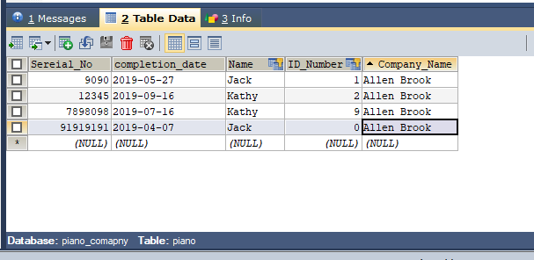

TASK:03

A piano manufacturer (see above) employs piano technicians who are
responsible for inspecting the instruments before they are shipped to the
Customers
Piano_Technician:
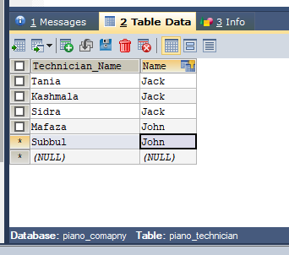

Customer:

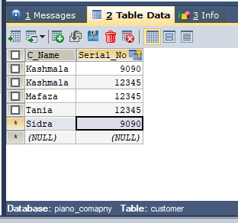

Each piano is inspected by at least two technicians (identified by
heir employee number).

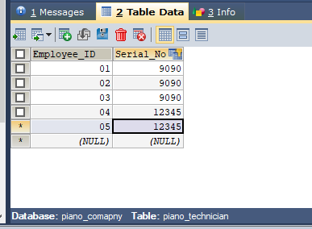

For each separate inspection, the company needs to
record its date and a quality evaluation grade.

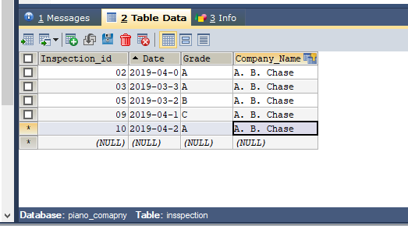\
TASK:04
The piano technicians (see above) have a hierarchy of reporting relationships: Some of them have supervisory responsibilities in addition to their inspection role and have multiple other technicians report to them. The supervisors themselves report to the chief technician of the company.

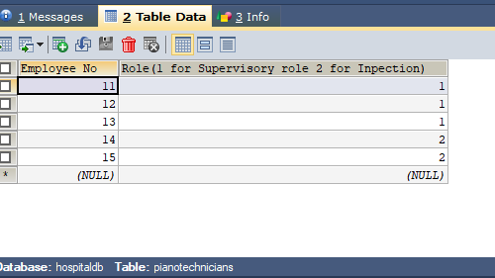
TASK:05

The entity type STUDENT has the following attributes: Student Name,
Address, Phone, Age, Activity, and No of Years. Activity represents some
campus-based student activity, and No of Years represents the number of
years the student has engaged in this activity. A given student may engage in
more than one activity. Draw a logical ERD for this situation. What attribute
or attributes did you designate as the identifier for the STUDENT entity?
Why?
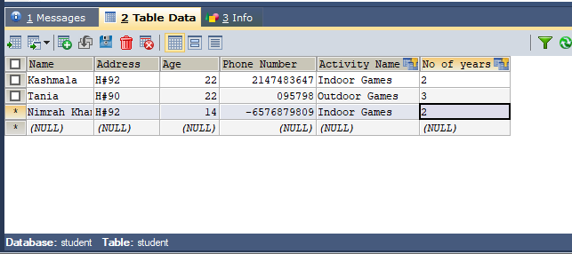

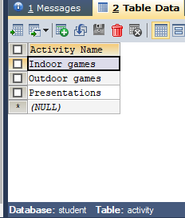

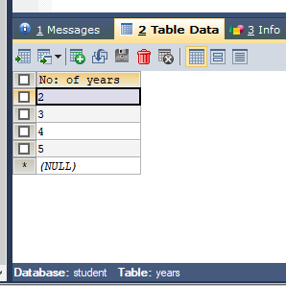

TASK:07

A college course may have one or more scheduled sections or may not have a
scheduled section. Attributes of COURSE include Course ID, Course Name,
and Units. Attributes of SECTION include Section Number and Semester ID.
Semester ID is composed of two parts: Semester and Year. Section Number is
an integer (such as 1 or 2) that distinguishes one section from another for the
same course but does not uniquely identify a section. How did you model
SECTION? Why did you choose this way versus alternative ways to model
SECTION?

