**LAB 05**

**OBJECTIVE:**To learn conceptual and logical DW Design

**Draw M/ERDs for the following scenarios represented by ERDs and business rules to ease your task.**

**Scenario 1: Advertising**

**Business Rules**

1. Advertisements are placed by Agencies.

2. Advertisements are placed by Channels, such as TV or Print.

3. Advertisements can be part of a Marketing Campaign.

4. Invoices are produced and result in Payments.

5. Advertisements result in Responses.

6. Responses can be analysed by Demographics.

**Measure Diagram:**

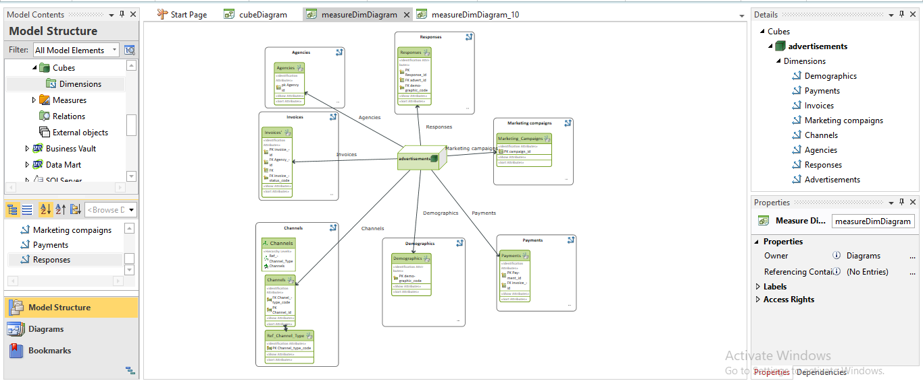

**CUBE Diagram:**

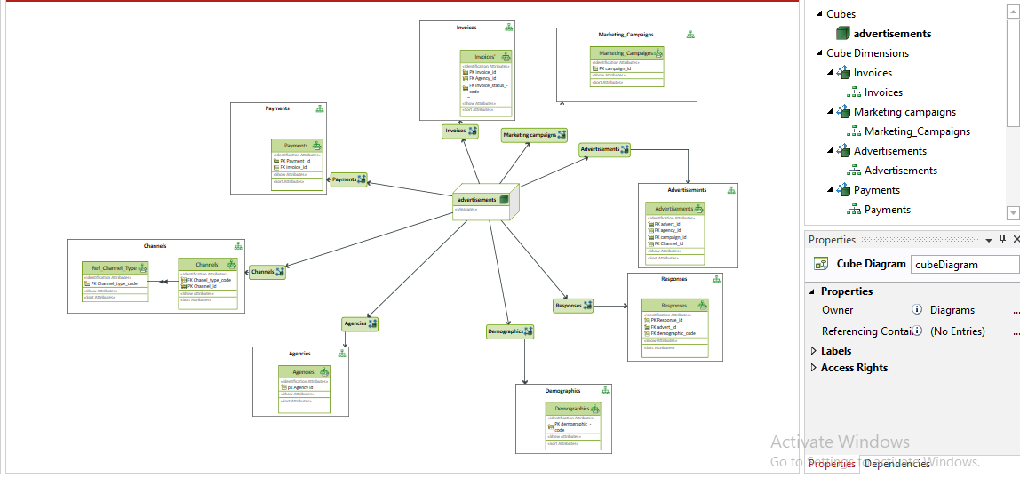

**Scenario 2: Amusement Parks**

**Business Rules**

1. Rides are available.

2. Customers use Credit or Debit Cards to buy Tickets to Ride.

3. Staff operate the Rides.

4. Staff also work on Maintenance Schedules for the Rides.

**CUBE Diagram:**

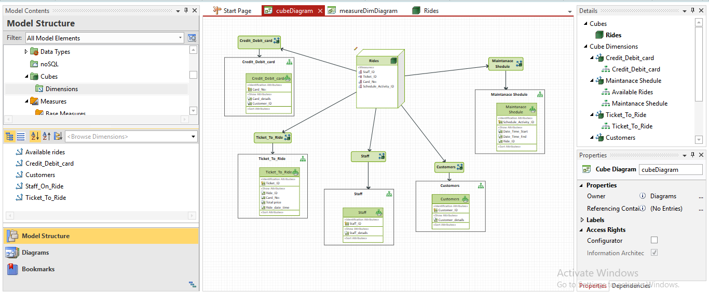

**MEASURE Diagram:**

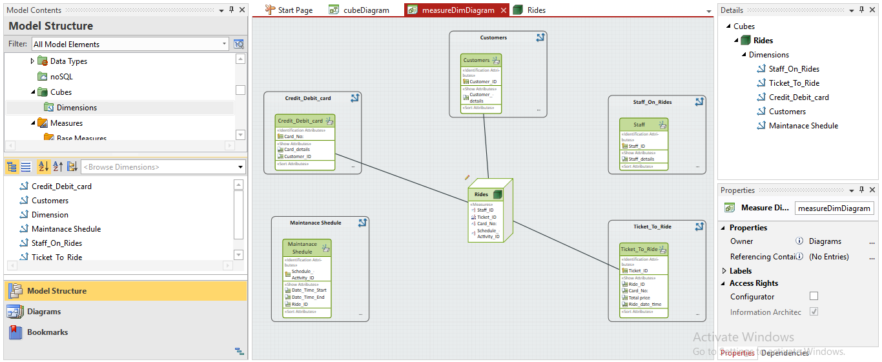

**Scenario 3: Clown registry**

**Business Rules**

1. People registered as Clowns are stored in the Clowns Table.

2. A Clown can have Acts with specific Features.

3. Clowns accept Bookings to perform at specific Locations for specific Customers.

**CUBE DIAGRAM**

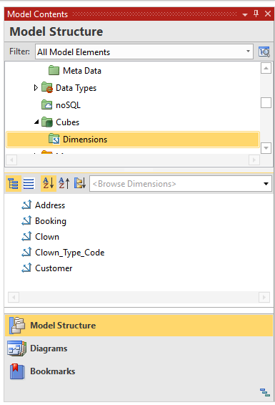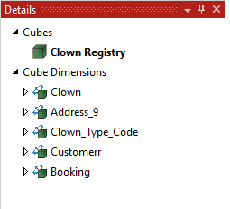

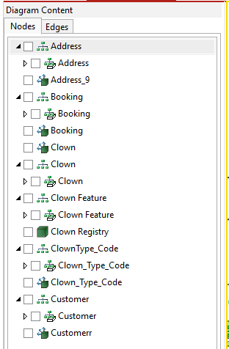

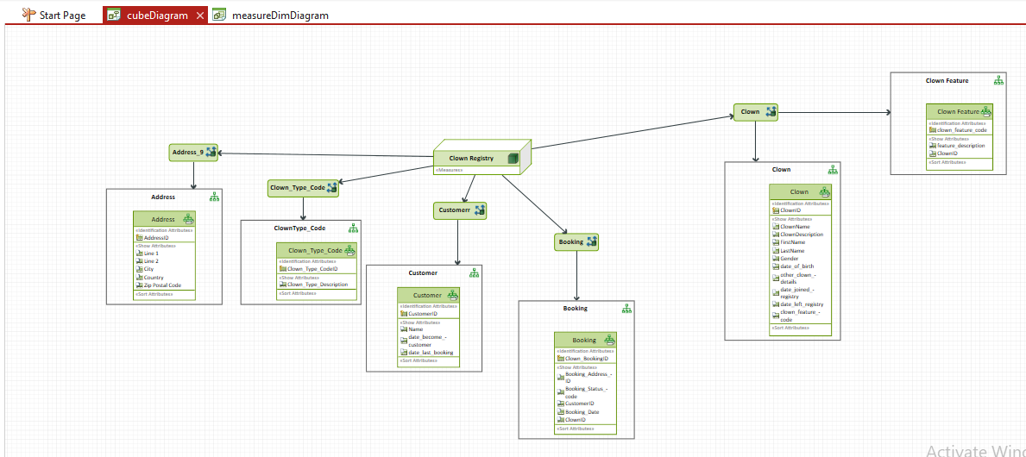

**MEASURE DIAGRAM:**

