AI Job Navigator — Project Schedule and Requirements
Subject document: AI_Job_Navigator_Client_Requirements_Engineering_Specification_EN_Updated.docx Date: 31 August 2026 Version: v5.0

0. Purpose of This Document
This document sets out four things:
- What we require from your side, and at which point in the project each item is needed
- The expected cost of development and of running the service
- The proposed development schedule for the required features
- A separate list of optional features, to be scheduled only after the required work is complete

Required and optional
The features described in this document are divided into two groups.
Required features are those defined across the MVP phases of the requirements specification. These form the product, and are the only features in the schedule in Section 3.
Optional features are additions that may be built once every required feature is complete. They are listed in Section 4 with their own estimates, and are deliberately excluded from the Section 3 schedule so that the timeline reflects only what the product needs in order to function.

Development resourcing
Development is carried out by one developer. The timeline in Section 3 is calculated on that basis.

System overview
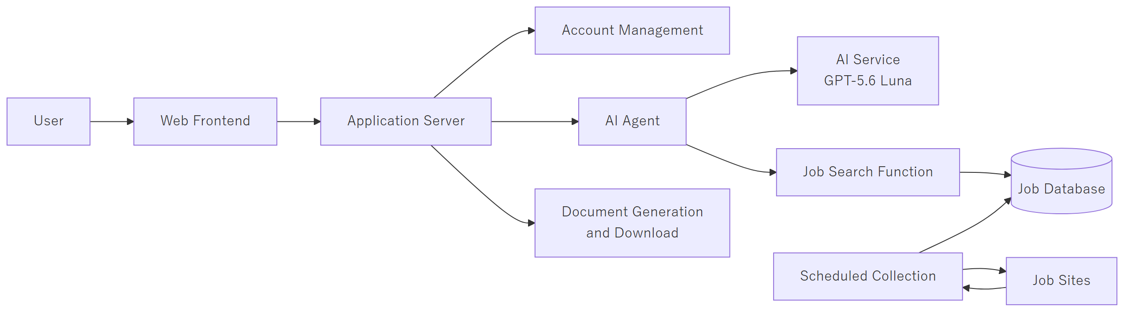

Job data acquisition policy
We have received your guidance that when acquiring data by scraping, care must be taken not to place a load on the other party's servers. This is reflected in the design.
Collection runs on a schedule with a fixed minimum interval between requests, and is never triggered by user activity. The volume of access to each source is therefore determined by our schedule and stays constant, rather than rising with the number of users. Where a source offers a structured data endpoint we will use it in preference to parsing pages, as it is lighter on their servers and more stable in operation.

Current implementation status
Layer | Status
Conversation infrastructure — response streaming, concurrent access safety, data persistence, conversation history summarization | Complete. Production quality
AI agent framework — function invocation loop, context assembly, AI service abstraction | Complete. Currently connected to one trivial function
Web interface — chat screen, conversation list, theming | Complete for chat. No other screens exist
Account management — registration, login, password reset | Not started
Job data — collection, storage, search, duplicate removal | Not started
Document creation — templates, generation, file output, upload | Not started
Payment, human support, admin dashboard | Not started
Approximately 15 to 20 percent of the total build is complete. What exists is the foundation layer that allows a reliable AI conversation to take place. The features that make the product a career service have not yet been built, and the schedule in Section 3 covers them in full.

1. Required from the Client

1.1 AI service — the one item required immediately
This is the only request in this document that is needed now rather than at a later phase.
The application requires a commercial AI service. We propose GPT-5.6 Luna, charged at USD 0.20 per million input tokens and USD 1.20 per million output tokens.
Why the current development environment is not sufficient. Development is presently running against two stopgap options, and neither can carry the project forward:
Current option | Problem
A locally hosted model | Too slow for practical iteration, and the response quality is not sufficient to judge whether a feature works
A free-tier hosted model | Intermittently blocked by usage limits. Automated testing cannot be relied upon to complete
Which parts of the project depend on it:
Phase | Feature requiring the AI service | Without it
Phase 0 | Response quality evaluation framework | No quality baseline can be established
Phase 1 | End-to-end technical validation | The architecture cannot be proven to work
Phase 2 | AI interview, document content generation | This is the substance of the phase. Cannot be developed or verified
Phase 3 | Natural-language condition structuring | Cannot be developed or verified
Phase 4 | Japanese response quality work | This is the purpose of the phase
Phase 5 | Judgement of when to hand over to a human operator | Cannot be verified
Every phase from Phase 1 onward depends on it.

Cost per operation
Measured against the current system configuration:
Operation | Cost
First message of a conversation | $0.0010
A normal conversational turn | $0.0016
A turn that performs a job search | $0.0033
One conversation history summarization | $0.0009
A complete 30-turn consultation | approx. $0.08
A job search costs roughly twice a normal turn because it requires two exchanges with the AI service.
Figure 1 — Example flow: a user asking for job listings
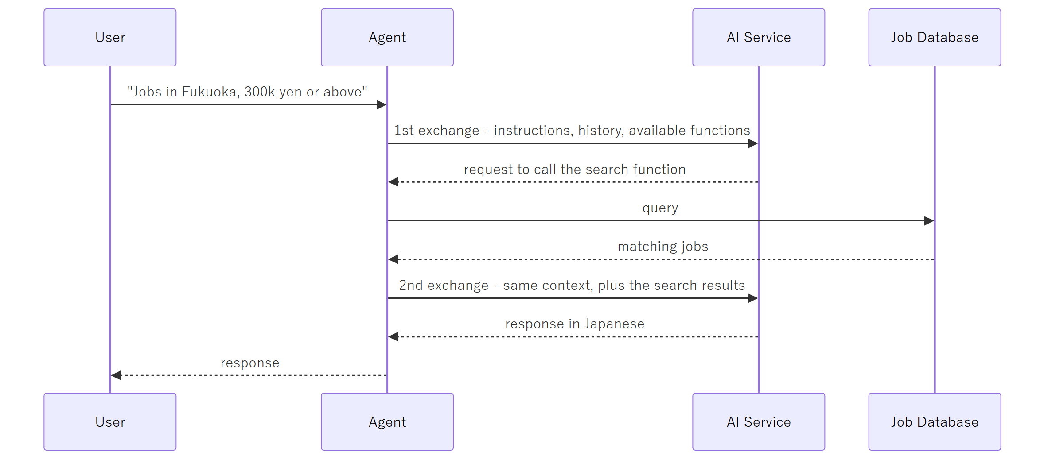

Monthly cost during development
Cost is not constant. It concentrates in the phases where AI behaviour is built and tuned:
Phase | Duration | AI service per month
Phase 0 — Preparation and investigation | 1 week | $8
Phase 1 — Foundation | 4 weeks | $15
Phase 2 — Document creation | 4 weeks | $50
Phase 3 — Job search | 5 weeks | $45
Phase 4 — Quality and refinement | 3 weeks | $40
Phase 5 — Commercial functions | 5 weeks | $10
Phase 6 — Hardening and launch | 3 weeks | $20
Total across the project | 25 weeks | approx. USD 180
We propose a ceiling of USD 50 per month, expected to be reached only during Phases 2 to 4.
For context: reaching USD 100 in a month would require approximately 4,400 full-length AI requests every day. Manual testing by one developer cannot approach that volume, so the limit functions as a safety measure rather than an expected cost.
The principal risk is a software defect rather than usage. A fault causing the AI to call the same function repeatedly would consume approximately USD 5 per hour if left unattended. Two safeguards will be implemented in Phase 0: a hard spending limit on the service account, and a maximum-iteration guard within the agent itself.

1.2 Items required at later phases
None of the following is needed now. Each is listed against the phase at which it becomes necessary, so that it can be prepared in advance rather than requested at short notice.
Required by | Item | Purpose
Phase 2 | Five to ten real 履歴書 / 職務経歴書, with personal details removed | Three separate purposes — see below
Phase 2 | The 履歴書 / 職務経歴書 format to be used as the base | Document template development
Phase 2 onward | A nominated Japanese-speaking reviewer | Ongoing review of AI-generated Japanese. See 1.3
Phase 5 | Payment system credentials and integration details | See 1.4
Phase 6 | Production domain and DNS control | TLS certificates and the production environment
On the request for real documents. These are needed for three distinct reasons, and no invented example can substitute for any of them:
- To build the template. We need to see the actual layout of the format in use — which sections appear, in what order, under what headings, with what spacing. A fill-in template cannot be built from imagination.
- To show the AI what good output looks like. Providing the AI with real, approved examples is the most effective way to make its Japanese read naturally. This is the direct remedy for the register issue described in Section 1.3.
- To measure quality. Judging whether the AI's output is acceptable requires something to compare it against. Without real examples, the question of whether output is good enough has no answer.
Real documents also carry variety that invented ones do not — career gaps, career changes, part-time periods — which is exactly what the system must handle correctly.
Personal details are not needed and should be removed. What is required is the structure and the writing style.

1.3 AI response quality review — begins at Phase 2
This is a request for ongoing involvement rather than a one-off deliverable, which is why it is raised early even though it is not needed until Phase 2.
The AI model produces grammatically correct Japanese. The risk is not correctness but register — whether a 職務経歴書 reads as something a Japanese hiring manager or company officer would find appropriate. This cannot be measured by any automated benchmark.
We therefore ask that a Japanese-speaking reviewer be nominated on your side from Phase 2 onward, to review sample AI output at each demonstration and indicate which responses are preferable. Approximately two hours per demonstration cycle is expected.
How that feedback is used. Reviewer feedback is applied in escalating steps: first by adjusting the AI's written instructions, then by adding approved examples for the AI to follow, and if necessary by retrieving relevant approved examples automatically for each case. Only if those measures reach their limit and quality is still short of acceptable would we recommend moving to a higher-grade AI model. That is a configuration change requiring no modification to the application, though the running cost rises by approximately a factor of ten to fifteen — from approximately USD 0.08 per consultation to approximately USD 0.80–1.20 per consultation. At ten users this remains modest; we would recommend reassessing before any significant increase in user numbers.

1.4 Payment system — required at Phase 5
We understand the payment system to be the environment indicated at the reference provided, which is a GMO Payment Gateway environment rather than a general-purpose international provider.
To size and build this work we will need the following, by Phase 5:
Item | Note
Which integration method is to be used | GMO offers a hosted redirect type (リンクタイプ), a server module type (モジュールタイプ), and a direct protocol type (プロトコルタイプ). The effort involved differs substantially between them
Test environment credentials (shop ID, shop password) | Issued under your GMO contract. No payment code can be written or tested before these are available
Which payment methods are in scope | Credit card only, or also convenience store payment, bank transfer, carrier billing. Each is a separate integration, and non-card methods complete asynchronously rather than immediately
Whether 3-D Secure is required | Adds an additional bank verification step to the payment flow
Pricing plans, free-tier scope, and cancellation rules | Still listed as undecided in the specification
The Phase 5 estimate is provisional until the integration method is known. A hosted redirect integration is approximately two weeks; a direct protocol integration is approximately four. The schedule in Section 3 assumes an intermediate figure.

2. Costs
All figures are in US dollars and assume the AWS Asia Pacific (Tokyo) region. They are estimates and should be confirmed with the AWS Pricing Calculator before being treated as final.

2.1 Development approach — local first
Development is carried out on a local machine, and cloud infrastructure is provisioned only when a feature requires it. Provisioning a full cloud environment from the first week would mean paying for it months before it is needed.
The points at which cloud infrastructure becomes necessary:
Requirement | Phase | Reason
Unattended scheduled collection | Phase 1 | A development machine is not continuously available; the job corpus must accumulate without interruption
Payment gateway callbacks | Phase 5 | The payment provider must be able to reach the application server directly. A local machine cannot receive these
TLS, production domain, session security | Phase 6 | Required before any public use
Load testing at ten concurrent users | Phase 6 | Cannot be measured locally with confidence
A single deployment is also carried out within Phase 1 to confirm that the application deploys correctly, so that any deployment issue is identified at the start of the project rather than at the end.

2.2 Development period cost
Phase | Duration | Environment | AWS | AI service | Monthly rate
Phase 0 — Preparation and investigation | 1 week | Local only | $0 | $8 | $8
Phase 1 — Foundation | 4 weeks | Local + collection instance | $8 | $15 | $23
Phase 2 — Document creation | 4 weeks | Local + collection instance | $8 | $50 | $58
Phase 3 — Job search | 5 weeks | Local + collection instance | $10 | $45 | $55
Phase 4 — Quality and refinement | 3 weeks | Local + collection instance | $10 | $40 | $50
Phase 5 — Commercial functions | 5 weeks | Staging provisioned | $40 | $10 | $50
Phase 6 — Hardening and launch | 3 weeks | Production + staging | $85 | $20 | $105
Total cost of development across the entire project: approximately USD 330. Of this, approximately USD 150 is AWS and USD 180 is the AI service.
Development servers are assumed to run during working hours only and to be stopped overnight and at weekends, which reduces their cost by approximately seventy percent against continuous operation. If they were instead left running continuously, the AWS portion would rise to approximately USD 450 for the project, while the AI portion would be largely unchanged, since AI cost is determined by the volume of testing performed rather than by elapsed time.

2.3 Production at launch
Assumes ten concurrent users, as specified.
Item | Specification | Monthly
Application server | EC2 t4g.small (2 vCPU / 2 GB) | $18
Database | RDS PostgreSQL db.t4g.small, 50 GB, single-AZ | $45
Job data collection | Fargate scheduled task, approx. 24 hrs/month | $3
Document storage | S3 | $1
Frontend delivery | CloudFront + S3 | $1
DNS | Route 53 | $0.50
Logging | CloudWatch | $3
Data transfer |  | $2
Infrastructure subtotal |  | $74
AI service | 10 concurrent users | $5
Total |  | approx. USD 79 / month
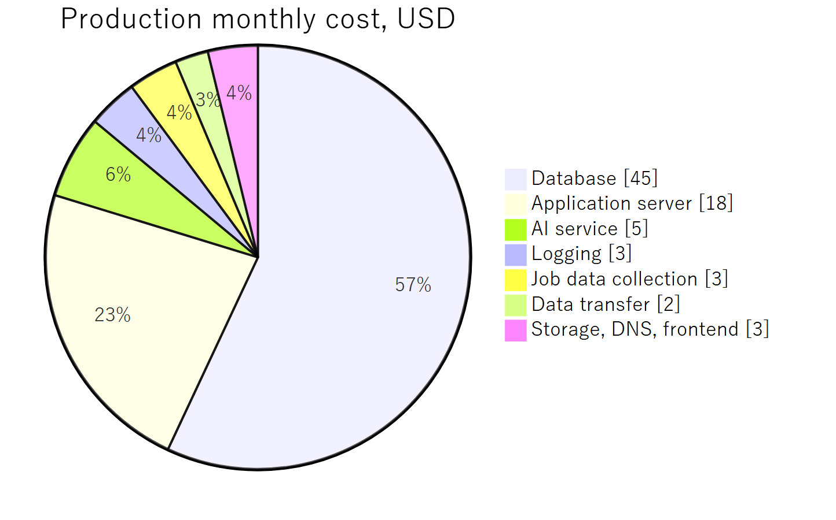
Adding a load balancer for redundancy raises this by approximately USD 20 per month. It is not recommended at ten concurrent users, and is the natural first upgrade once traffic grows.

2.4 On reserved pricing
AWS offers discounts of approximately 30 to 40 percent in exchange for a one-year commitment to a given level of usage.
We recommend against committing at this stage. At ten concurrent users the total infrastructure cost is approximately USD 74 per month, so the saving would be around USD 25. Securing it would require fixing the server configuration for a year, before any real usage has been observed, and while user numbers are expected to change.
We propose running on standard on-demand pricing for the first three to six months after launch, measuring actual usage, and purchasing a one-year commitment against the observed baseline at that point.

2.5 Two cost items to be aware of
NAT Gateway. A commonly used AWS network component charged at approximately USD 32 per month regardless of usage. Many standard reference architectures include it by default. At this scale it is unnecessary, and the design proposed here avoids it. Were it included, it would be the largest single line item in Section 2.3.
Database storage growth. Server capacity will not be strained by ten users, as the AI service performs the processing. Storage will grow: approximately 100,000 job records with search indexes require around 600 MB for the index alone. We recommend budgeting for 50 to 100 GB within the first year. Retaining uploaded and generated documents indefinitely, as currently intended, adds to this over time and is worth reviewing annually.

3. Development Schedule — Required Features

3.1 Method
Development proceeds in seven phases. Each phase concludes with a demonstration of working software and a written progress report.
Phase length varies according to the work involved rather than being fixed, since the phases differ considerably in size. Automated testing is carried out within each phase rather than deferred to a single stage at the end.

3.2 Scope of the initial release
The following are delivered in a defined initial form at launch, with the remainder addressed afterwards. This is set out explicitly so that the scope behind the timeline is clear, and so that any item can be brought forward if you would prefer it included.
Item | At launch | Addressed afterwards
Job sources | Two sources | Remaining two sources added
Duplicate removal | Exact matching on company, title and location | Cross-source matching, once a large body of real data exists
Document format | One 履歴書 / 職務経歴書 format, PDF output | Additional formats and Word output
Admin dashboard | The functions required for operation | Remaining functions, as operational need appears
The principle applied is to limit breadth rather than depth. Additional sources and additional templates are straightforward to add to a working system. Duplicate removal is the one item that becomes harder to address the longer it is deferred, which is why it is reduced rather than omitted, and why data collection begins in the first working phase.

3.3 Two principles in the plan
Job data collection begins in Phase 1 and runs continuously thereafter. Duplicate removal depends on having a substantial body of real data, and that data accumulates over calendar time rather than through effort. By the time duplicate removal is built in Phase 3 and refined in Phase 4, approximately two to three months of collected data will be available to work against. Raw pages are stored before any field extraction, so that when extraction logic is improved it can be re-run over data already held rather than requiring the sources to be accessed again.
Phase 1 concludes with an end-to-end technical validation. Before the individual features are built out, a complete path through the system is proven to work: a user logs in, asks a question, the AI invokes the search function, and real job data is returned. This is deliberately minimal and is not the finished product. Its purpose is to confirm that the architecture holds together, and to identify any integration problem at the beginning of the project rather than at the end, when remedy is most costly.

3.4 The job data pipeline
Figure 2 — Job data flow, from collection through to presentation

3.5 Schedule
Phase | Content | Duration
Phase 0 | Preparation and investigation | 1 week
 | Local development environment
 | AI service configuration, spending limit, iteration guard
 | Japanese quality evaluation framework
 | Investigation of the job sources
Phase 1 | Foundation | 4 weeks
 | Account management: registration, login, sessions, password reset, email verification
 | Security hardening of the existing interface
 | Job data structure and database design
 | Collection framework with request rate control
 | First source collecting continuously
 | End-to-end technical validation
 | Deployment verification
Phase 2 | Document creation | 4 weeks
 | 履歴書 / 職務経歴書 template and generation
 | PDF output and download
 | AI interview refinement
 | Second source added to collection
Phase 3 | Job search | 5 weeks
 | Normalization of salary units, place names, holiday terminology
 | Duplicate removal
 | Natural-language condition structuring
 | Search function and AI integration
 | Document upload and text extraction
Phase 4 | Quality and refinement | 3 weeks
 | Japanese response quality, with reviewer feedback
 | Posting currency verification, acquisition date display
 | User confirmation screen, result presentation
 | Duplicate removal tuning
Phase 5 | Commercial functions | 5 weeks
 | Payment integration, plans, cancellation
 | In-app human support and handover
 | Admin dashboard
Phase 6 | Hardening and launch | 3 weeks
 | Performance, security, load testing at 10 concurrent users
 | Production environment, acceptance testing support
Total |  | 25 weeks
Approximately six months.
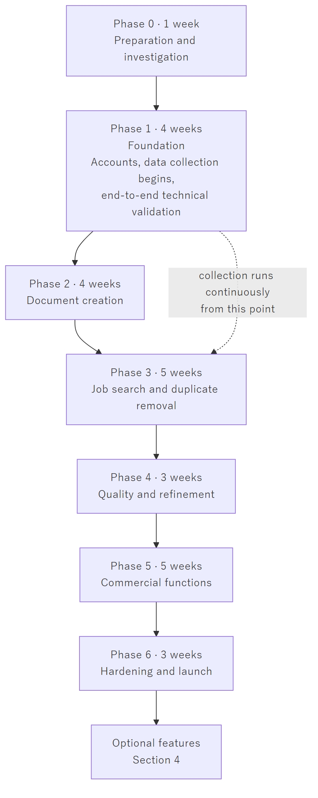
Figure 3 — Phase sequence. Each phase concludes with a demonstration.
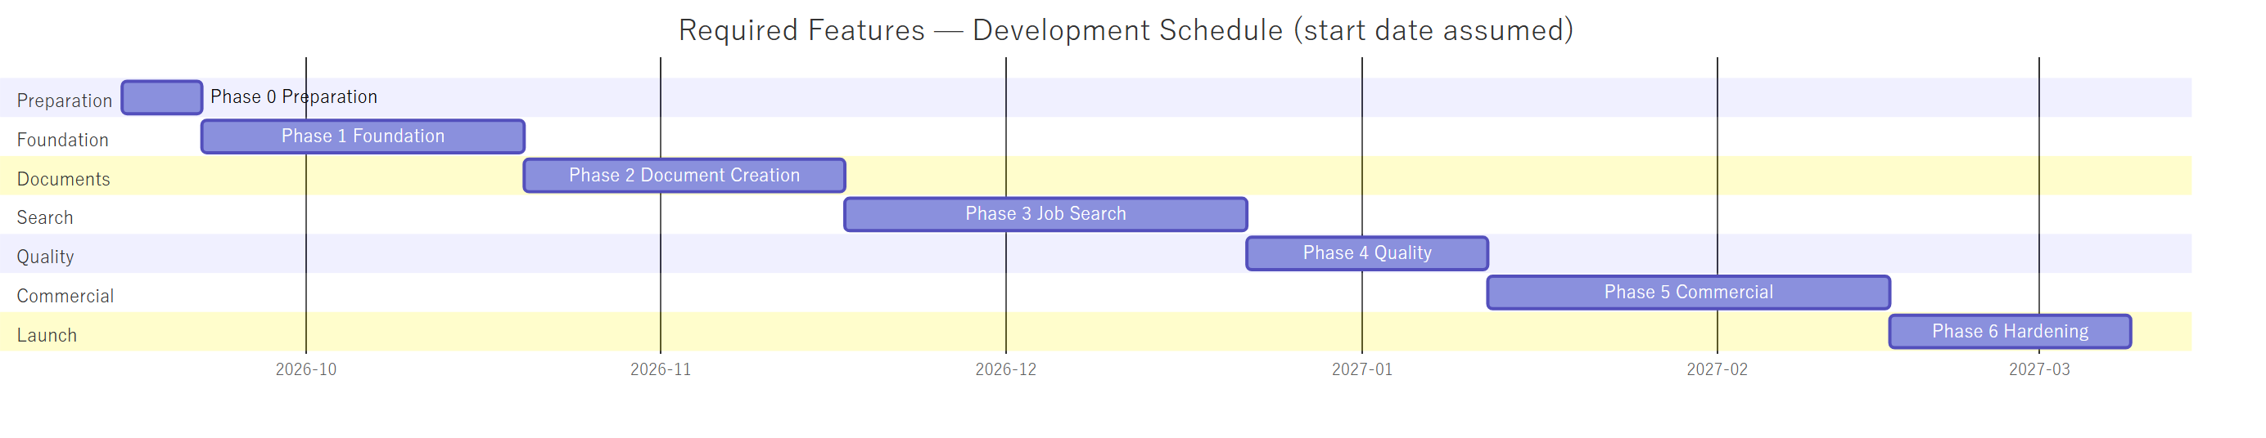

3.6 On the original three-month estimate
The original three-month figure was produced before the requirements specification existed, and covered a smaller scope. The specification as written represents approximately twice that work.
The increase comes from work that was not present in the original outline: account management, payment processing, the administrative dashboard, human support, security hardening, acceptance testing, and the removal of duplicate job listings appearing across multiple sources.

3.7 Schedule confirmation
Two items cannot be estimated with full confidence until real data has been examined: the stability of collection from the job sources, and the accuracy achievable in duplicate removal. A third, the payment integration, depends on the method described in Section 1.4.
We therefore ask that the schedule above be treated as provisional, and that firm dates be agreed at the end of Phase 0. Phase 0 includes investigation of the job sources, and at its conclusion — one week from project start — a confirmed schedule can be provided.
Where a phase runs longer than estimated, this will be reported at the phase boundary rather than at the end of the project, and the scope items in Section 3.2 remain available as adjustments in either direction.
If a shorter timeline is required, the most effective single change is to defer Phase 5 — payment, human support, and the admin dashboard — which brings a complete and demonstrable product forward by five weeks.

4. Optional Features
The following are not included in the schedule in Section 3 and are not required for the product to function. They are recorded here with estimates so that they can be scheduled deliberately, as a separate piece of work, once every required feature is complete.
Feature | Duration | Depends on
Notification system — saved search conditions, daily matching against new postings, email delivery infrastructure, notification preferences | 3 weeks | Phase 3
Remaining two job sources | 2 weeks | Phase 1 collection framework
Refined duplicate removal — cross-source matching rather than exact matching | 3 weeks | A large body of real data
Career Advancement Assessment — assessment of a completed 職務経歴書, with administrator review | 3 weeks | Phase 2 and the admin dashboard
LINE integration — official account, Messaging API, and linking a LINE account to a service account | 2.5 weeks | Notification system
OCR — reading scanned images and photographs of documents | 2 weeks | Phase 3
Full admin dashboard — the remaining functions | 2 weeks | Phase 5
Additional document formats and Word output | 1 week | Phase 2
Document delivery by email | 3 days | Notification system
Social media job sources | 3 weeks | Investigation first; may prove infeasible
Total, if all are built | approx. 22 weeks
These are listed in the order in which we would recommend building them. None needs to be decided now.

4.1 Notes on individual items
The notification system is the item most likely to be wanted first. It is the reason saved search conditions appear in the specification. Until it is built, a user re-runs a search themselves rather than being informed of new matches. The product functions without it; it is less convenient.
Email is not otherwise required. With notifications excluded from the required scope, generated documents are delivered by download from the browser. A minimal email capability is still built in Phase 1 for account functions — password reset and address verification — as an account system without them is not usable in practice. That is infrastructure supporting accounts, and is distinct from the notification feature.
Social media sources may prove infeasible rather than merely costly. For several platforms, no means of searching public posts is made available to third parties. The estimate above assumes a route exists, and investigation should precede any commitment.
Career Advancement Assessment cannot be built earlier regardless of priority. It operates on a completed 職務経歴書 and requires an administrator review flow, so it depends on both document creation and the admin dashboard.

5. Assumptions
Where any of these proves incorrect, the affected figures will change.
- One developer for the duration of the project
- Ten concurrent users at launch
- Two job sources at launch, with the remaining two added afterwards
- Duplicate removal by exact matching at launch, refined once sufficient real data exists
- One 履歴書 / 職務経歴書 format with PDF output at launch; additional formats and Word output added later
- Admin dashboard limited at launch to the functions required for operation
- Everything listed in Section 4 is excluded from the schedule in Section 3
- Human support via in-app chat only
- Generated documents delivered by download; email is used only for account functions
- Uploaded and generated documents retained indefinitely, per current intent
- Development conducted locally, with cloud infrastructure provisioned per Section 2.1
- Phase length varies according to the work involved
- User interface and screen design determined by us, subject to your review
- The Terms of Service and Privacy Policy are produced by your side

6. Next Steps
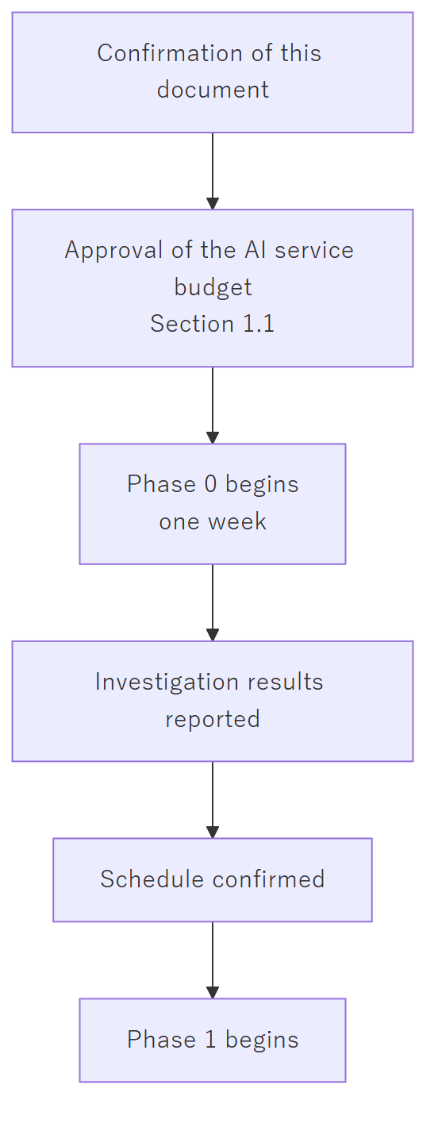
The only item required in order to begin is the AI service approval in Section 1.1. Everything else in Section 1 is needed at a later phase and is listed so that it can be prepared in good time.
We look forward to your confirmation.

