2.1.1. Roots of a Quadratic Equation
Aim: Write a program to find the roots of a quadratic equation, given its coefficients a, b, and c . Use the quadratic formula:
ALGORITHM
Step 1 : Start.
Step 2 : Read the coefficients a, b, and c.
Step 3 : Calculate the discriminant using:- d = b^2−4ac.

Step 4 : If D > 0 Compute:- 1=(− +root )/2a and 2=(− −root )/2 Display two real Step 5 : Else if D = 0 Compute:- 𝑥=−𝑏/2𝑎 Display equal real roots. 𝑏 𝑎 𝐷 and distinct roots.
Step 6 : Else (D < 0) Compute:- Real part = − /2 Imaginary part = root(- )/2a Step 1 :
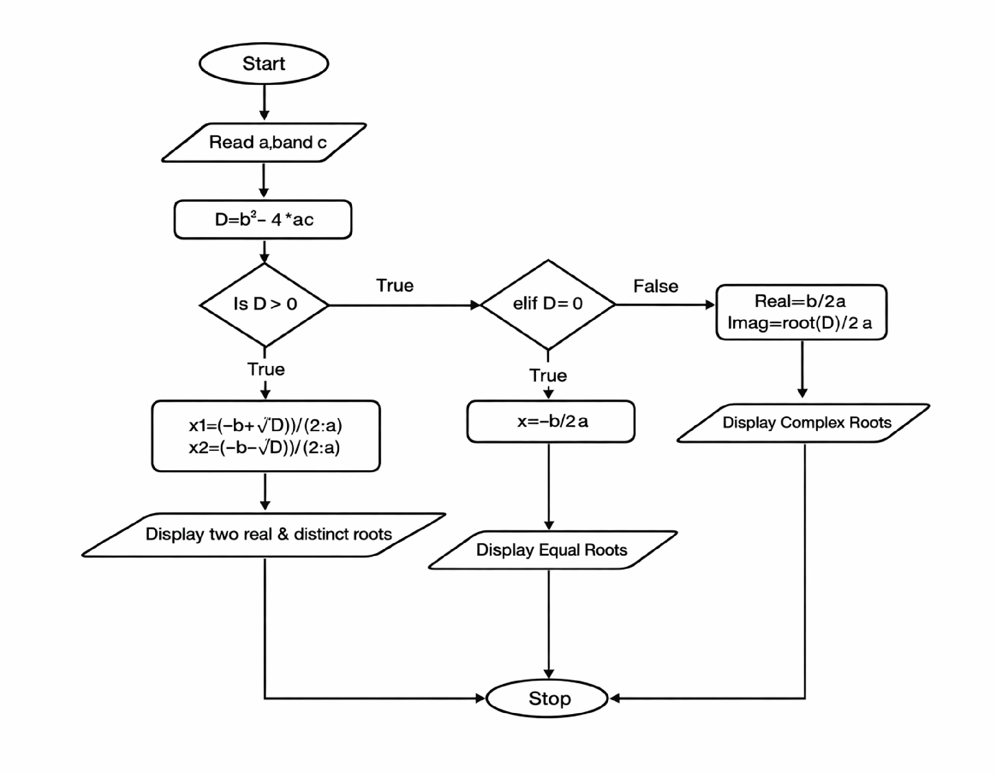
Display complex roots. Step 7 : Stop.

EXECUTION
