3.1.1. Largest of Three Numbers
Aim: Write a Python program that prompts the user to enter three integers. Print the largest of the three integers.

1. ALGORITHM
2.
- Step 1: Start.
- Step 2: Input three integers a, b, and c.
- Step 3: If a ≥ b and a ≥ c → Print a as the largest number.
- Step 4: Else if b ≥ a and b ≥ c → Print b as the largest number.
- Step 5: Else → Print c as the largest number.

- Step 6: Stop
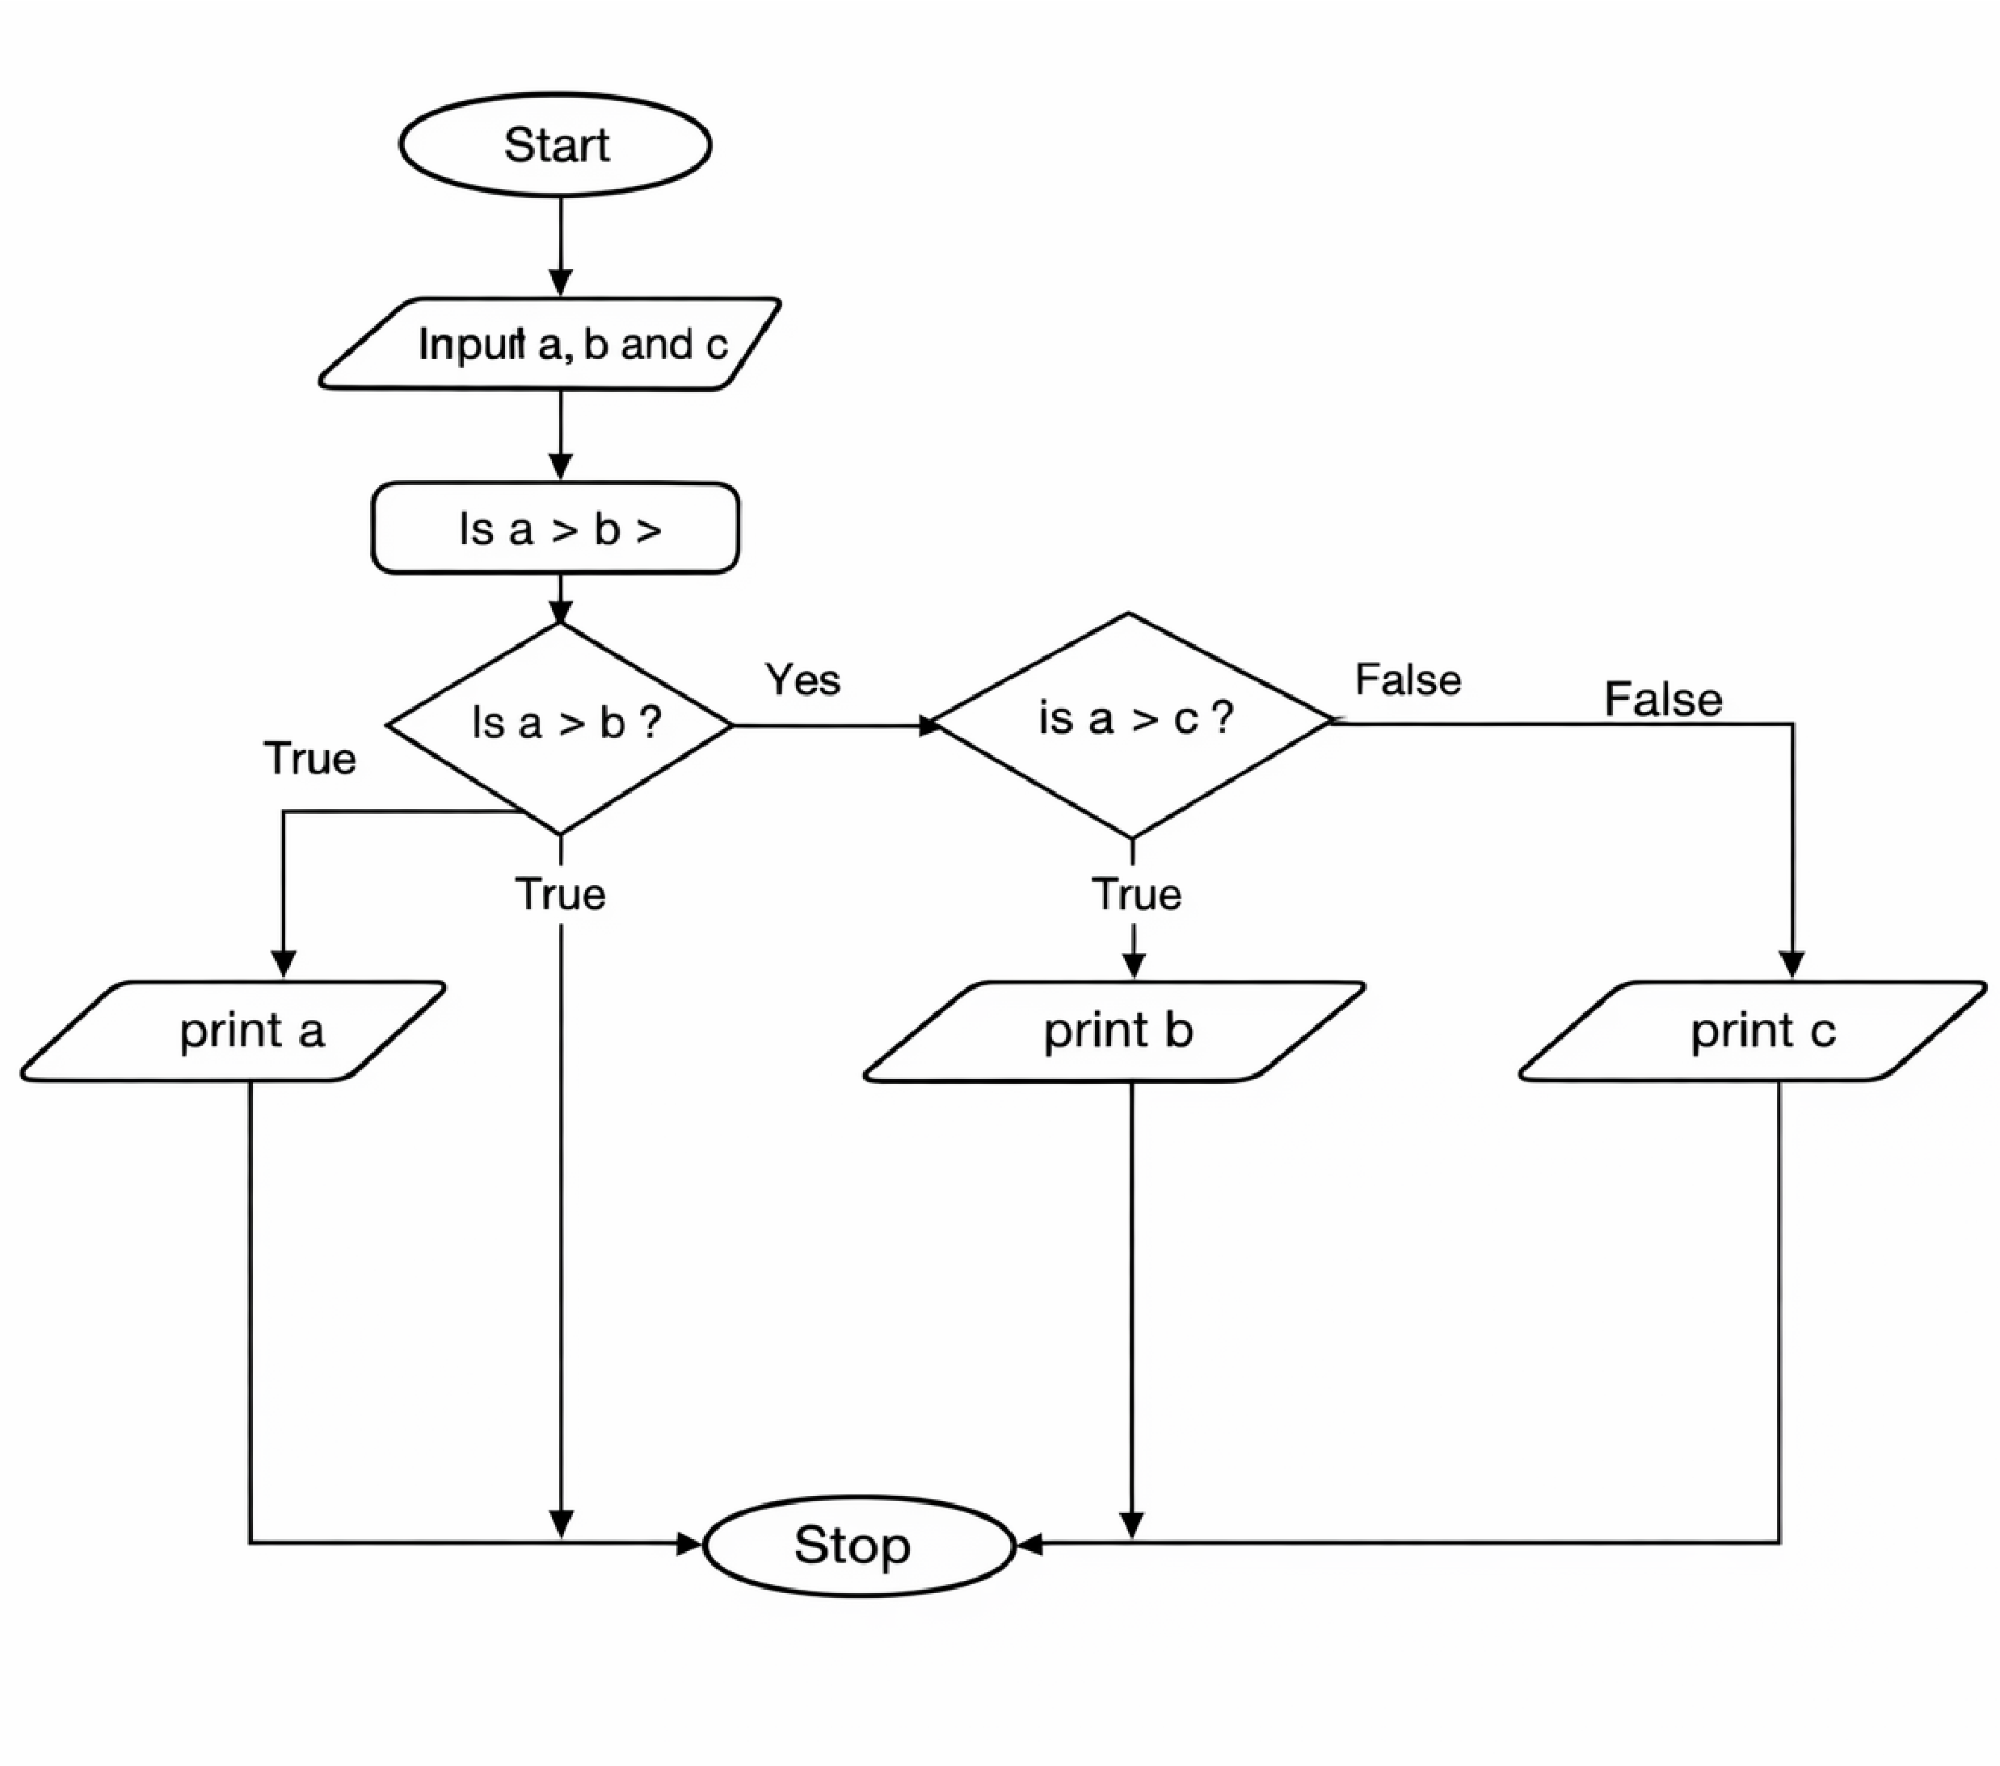
- FLOWCHART
EXECUTION
