Project Name: Resilient India AI — Energy Supply Chain Resilience & Procurement System (Problem Statement 2)

Section 1: Project Overview & Core Problem
Problem Context & Structural Vulnerability
- High Import Dependence: India relies on imports for approximately 88% of its crude oil needs, with 40% to 45% of that volume moving through a single, fragile maritime chokepoint: the Strait of Hormuz.
- Active Security Threats: Geopolitical standoffs, drone/missile interdictions in the Red Sea, and strict trade sanctions regularly create sudden oil market price spikes and force refiners to buy oil at steep spot market premiums.
- Critically Low Storage Buffer: India’s Strategic Petroleum Reserves (SPR) provide only 9.5 days of national oil consumption buffer—a safety net that vanishes quickly during a real blockade.
- The Cost of Slow Response: Traditional supply chain planning relies on manual, periodic reviews. During past energy crises, supply chains lacking automated rerouting capabilities took an average of 47 days longer to stabilize.

Proposed Solution
Resilient India AI provides a real-time intelligence and response platform. Using a multi-agent framework, continuous RAG vector search, and dynamic routing logic, the system monitors risk signals, models crisis scenarios, calculates cost surges, and generates executable procurement and rerouting plans in less than 3 seconds.

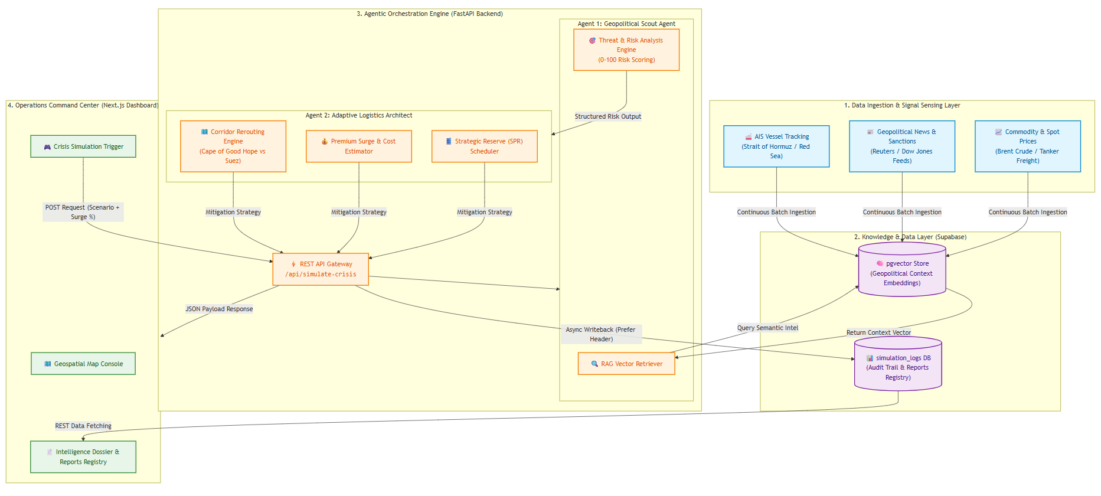
Section 2: Architecture Diagram

Section 3: Explanation of Architecture Diagram Components
The ResilientIndia AI architecture operates as a four-stage pipeline. It connects real-time data collection directly to an automated multi-agent AI backend and a visual command dashboard. This design ensures that raw geopolitical news and maritime telemetry are converted into actionable procurement decisions in under three seconds.
[ 1. Data Ingestion & Sensing ] ──> [ 2. Supabase Storage ] ──> [ 3. Multi-Agent Engine ] ──> [ 4. User Command Center ]
Component 1: Data Ingestion & Signal Sensing Layer
This layer functions as the continuous sensory inputs of the system. It continuously ingests three streams of real-world data:
- AIS Vessel Tracking Data: Ingests live telemetry from crude oil tankers navigating critical maritime chokepoints, such as the Strait of Hormuz, the Bab-el-Mandeb, and the Red Sea.
- Geopolitical News & Sanctions Feeds: Ingests structured and unstructured news feeds from sources like Reuters and Dow Jones, alongside updated maritime security notices and international sanctions registries.
- Commodity & Spot Market Prices: Monitors real-time movements in Brent crude prices, tanker charter rates, and regional insurance risk surcharges.
Component 2: Knowledge & Data Layer (Supabase Dual-Engine)
This layer acts as the centralized memory unit of the platform, combining semantic vector search with relational audit logging:
- pgvector Store: Converts raw news articles, maritime threat advisories, and historical crisis logs into vector embeddings. When a new threat occurs, semantic vector queries allow the AI engine to retrieve relevant contextual information in milliseconds.
- simulation_logs Database Table: Serves as an immutable audit ledger. Every scenario execution writes back its complete dataset—including scenario inputs, risk scores, freight surge figures, and generated agent plans—ensuring full transparency and post-crisis review capabilities.
Component 3: Agentic Orchestration Engine (FastAPI Backend)
The core decision-making brain of the platform relies on a decoupled, multi-agent AI architecture built on FastAPI:
- REST API Gateway (/api/simulate-crisis): Receives HTTP request payloads containing crisis parameters (such as corridor closure scenarios or insurance surge percentages) triggered by operators on the frontend.
- RAG Vector Retriever: Automatically queries the pgvector store to attach relevant historical context and geopolitical signals to the scenario.
- Agent 1 (Geopolitical Scout Agent): Analyzes the context and threat signals to produce a structured Risk Score (0–100 scale) and identifies the primary threat category.
- Agent 2 (Adaptive Logistics Architect): Receives the Scout Agent's output and evaluates three operational modules:
  - Corridor Rerouting Engine: Evaluates alternative maritime routes, comparing travel delays and safety factors (e.g., diverting via the Cape of Good Hope versus holding in berth).
  - Premium Surge & Cost Estimator: Calculates the additional freight, fuel, and war-risk insurance costs resulting from the disruption.
  - Strategic Reserve (SPR) Scheduler: Recommends precise drawdown schedules for India's national crude reserves to temporarily bridge supply gaps.
- Async Writeback Engine: Uses explicit database headers (Prefer: return=representation) to safely persist generated reports back to the database asynchronously without blocking the user interface.
Component 4: Operations Command Center (Next.js Dashboard)
The frontend serves as an intuitive visual command center for defense officials, refiners, and supply chain planners:
- Crisis Simulation Trigger: An interactive control panel where operators can input custom crisis scenarios and run real-time stress tests.
- Geospatial Map Console: Provides visual context of high-risk shipping lanes, blocked transit points, and alternative routes.
- Intelligence Dossier & Reports Registry: Connects directly to the simulation_logs table. Operators can click on any recorded simulation to open a Live Intercept Dossier Modal, rendering structured Markdown reports tagged with official security classifications (SECRET, CONFIDENTIAL, RESTRICTED).

Section 4: Key Capabilities & Technical Innovation
This prototype moves energy supply chain management from a reactive crisis response to a managed, anticipatory process. It delivers four core technical innovations:
1. Continuous Geopolitical Risk Intelligence (RAG Engine)
- Real-time Threat Monitoring: Traditional supply chain tools rely on periodic or weekly manual reviews. This system uses Retrieval-Augmented Generation (RAG) over a pgvector store to ingest live news feeds, AIS ship tracking data, and sanctions registries continuously.
- Automated Threat Scoring: Translates unstructured text (such as naval standoff reports or shipping warnings) into an objective, standardized Risk Score on a 0–100 scale for specific corridors like the Strait of Hormuz or the Red Sea.
2. Adaptive Procurement & Dynamic Corridor Rerouting
- Multi-Route Scenario Evaluation: When a primary chokepoint is threatened, the Logistics Agent automatically evaluates alternative maritime paths—such as diverting tankers around the Cape of Good Hope or re-anchoring cargoes.
- Crude Grade & Refinery Compatibility: Evaluates alternative crude sources (e.g., West African, Russian, or Latin American crudes) to ensure substitute cargoes match the specific chemical processing requirements of Indian refiners (like IOCL, BPCL, or HPCL).
3. Automated Cost & Financial Impact Modeling
- Freight & Insurance Premium Calculation: Quantifies the financial impact of geopolitical events by calculating spot price surges, tanker charter rate increases, and war-risk insurance surcharges.
- Strategic Petroleum Reserve (SPR) Optimization: Models precise drawdown schedules for India's underground crude caverns (at Visakhapatnam, Mangaluru, and Padur) to bridge supply gaps without exhausting emergency stockpiles prematurely.
4. Immutable Audit Ledger & Instant Reporting
- Dossier Generation: Automatically formats multi-agent reasoning into structured, timestamped Intelligence Dossiers categorized by security tags (SECRET, CONFIDENTIAL, RESTRICTED).
- Complete System Auditability: Every simulation run and API decision is saved to the simulation_logs table in Supabase, giving policymakers a complete audit trail of how risk scores and routing recommendations were calculated.
Section 5: Measurable Business & National Security Impact
1. Dramatic Response Acceleration (47 Days $→$ < 3 Seconds)
- The Benchmark: A McKinsey analysis of historical energy supply shocks found that economies lacking automated rerouting and demand-management intelligence took an average of 47 days longer to stabilize supply.
- The Impact: Resilient India AI processes real-time intelligence vectors, evaluates route options, calculates cost impacts, and generates executable procurement directives in under 3 seconds.
2. Strategic Defense of India’s 9.5-Day Energy Buffer
- The Risk: India imports roughly 88% of its crude oil needs, with 40% to 45% passing through the Strait of Hormuz. India’s Strategic Petroleum Reserves (SPR) hold roughly 5.33 million metric tonnes, providing only 9.5 days of national consumption cover if imports are completely cut off.
- The Impact: By detecting early risk signals and recommending alternative procurement channels before a full blockade occurs, the system preserves SPR buffers for true emergency scenarios rather than operational delays.
3. Financial Protection Against Spot Market Surges
- The Risk: During geopolitical escalations, uncoordinated panic buying forces refiners onto spot markets at extreme premiums, adding billions to India’s national import bill.
- The Impact: Automated scenario modeling gives procurement teams actionable alternatives hours before market prices fully adjust, saving refiners millions in spot market surge fees and war-risk insurance premiums.
4. Operational Continuity for Refiners and the Economy
- The Impact: Prevents severe refinery run-rate cuts, keeping fuel supplies steady for domestic transport, power generation, and critical industrial sectors during international energy supply crises.

