PENETRATION TESTING REPORT
FOOTPRINTING & NETWORK SCANNING PHASES
WEEK 02 | CYBERSECURITY INTERNSHIP | NETWORKWALKS

Report detail | Information
Pentester name | Kashvi Khanna
Program / Batch | B084
Report date | 13 November 2026
Modules covered | W2-PM1 – Footprinting with Multiple Kali Linux Tools  W2-PM5 – Network Scanning with Zenmap
Footprinting target | networkwalks.com (as used in the practical terminal output)
Network scanning target | Own local LAN / personal network
Authorization | Footprinting performed for educational and research purposes; network scan performed on own local network
Phases covered | Phase 1: Reconnaissance & Footprinting  Phase 2: Scanning & Network Discovery

Liability Disclaimer
The activities documented in this report were performed for educational and research purposes. All testing and scanning activities were conducted on systems and networks owned by me or for which appropriate authorization was available. The tools and techniques discussed in this report are intended for ethical cybersecurity learning and security assessment purposes only. Any unauthorized access, scanning, or misuse of these techniques may violate applicable laws and regulations. The author accepts responsibility for ensuring that all cybersecurity activities are conducted ethically, lawfully, and within the permitted scope.

1. Introduction
This report documents practical activities involving footprinting, reconnaissance and network scanning. The first activity focuses on gathering publicly available information about a domain using six Kali Linux tools. The second activity involves discovering active devices on my own local network using Zenmap (the graphical interface for Nmap).
The footprinting exercise used the domain networkwalks.com and collected publicly observable domain, DNS, web-technology and HTTP-header information. The network-scanning exercise used Zenmap on a Windows PC to identify the local network configuration, discover responding hosts, review host IP and MAC address information, and view the network topology.
The report records the commands and results available from the practical evidence. Private local IP addresses, MAC addresses and the exact LAN subnet are intentionally not reproduced in this shared draft; they can be added to a private submission copy if required.

2. Tools and Environment
Tool / Environment | Purpose
Kali Linux | Operating system used for the footprinting exercises.
WHOIS | Retrieves publicly available domain registration and name-server information.
WhatWeb | Identifies technologies and components exposed by a website.
Nslookup | Queries DNS to resolve a domain name to an IP address.
cURL (-I) | Retrieves HTTP response headers.
WAFW00F | Checks for a detectable Web Application Firewall.
DNSRecon | Enumerates DNS records and related information.
Windows Command Prompt | Used to inspect local IP configuration with ipconfig.
Zenmap / Nmap | Used for local host discovery and network topology visualisation.

3. Activities Performed

3.1 Footprinting and Reconnaissance
The domain networkwalks.com was examined using six Kali Linux tools. Each tool provided a different view of the domain's publicly observable infrastructure.

3.1.1 WHOIS
Command: whois networkwalks.com
The WHOIS output displayed domain registration information, including the registrar (GoDaddy.com, LLC), domain creation date (6 November 2019), registry expiry date (6 November 2027). The WHOIS results also showed that the registrant information was privacy protected through Domains By Proxy, LLC. The domain’s DNSSEC status was reported as unsigned. Four name servers were listed: NS6135.HOSTGATOR.COM, NS6136.HOSTGATOR.COM, NS29.DOMAINCONTROL.COM and NS30.DOMAINCONTROL.COM.
Why it matters: WHOIS information can help build an initial picture of domain administration and DNS hosting. Registration data should be treated as informational and may be privacy-protected or subject to change.
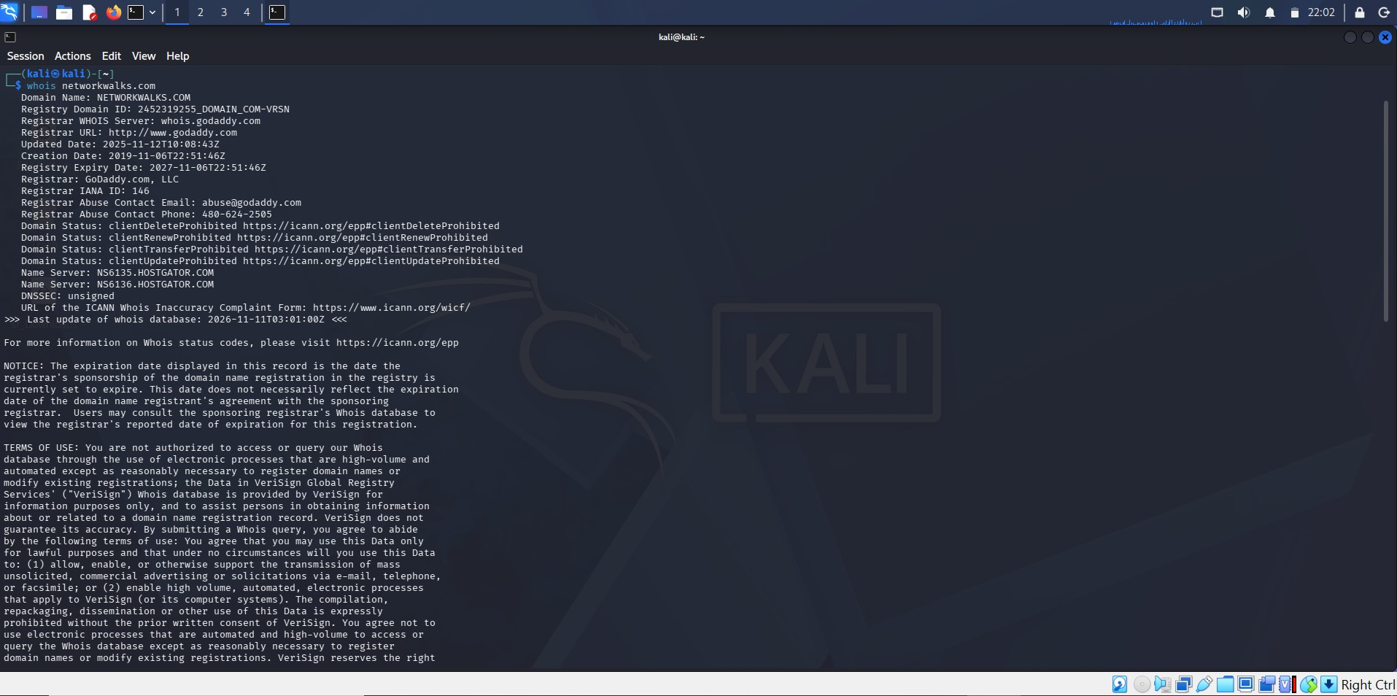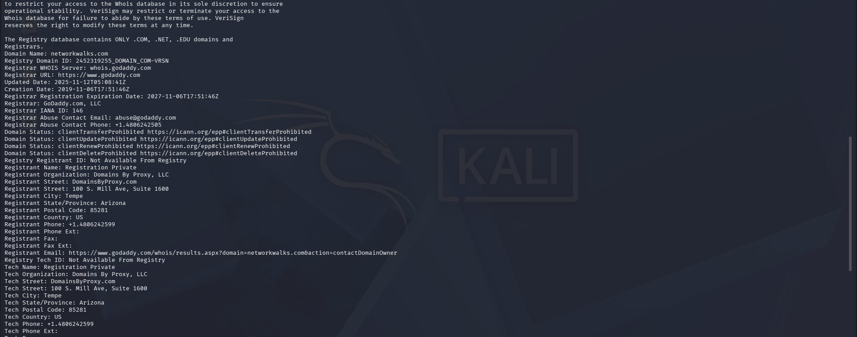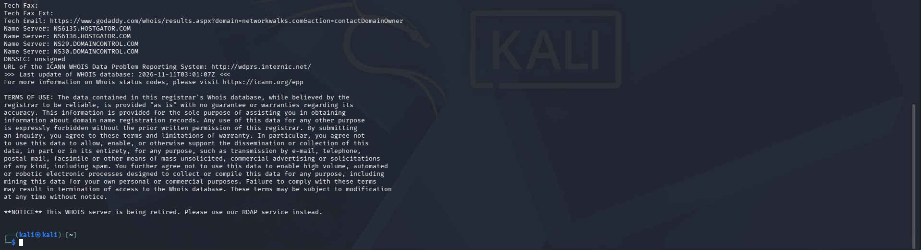

3.1.2 WhatWeb
Command: whatweb networkwalks.com
The output identified Apache as the web server, WordPress 7.1.4 as the CMS, WordPress Download Manager 3.3.76, Bootstrap 7.1.4 and jQuery 3.7.1. The website title was identified as "Networkwalks Academy". The website redirected HTTP requests to HTTPS and returned a successful HTTPS response (200 OK).
Why it matters: Technology fingerprinting can help defenders understand what software components are exposed and what should be reviewed for updates. A detected product or version is not proof of a vulnerability.
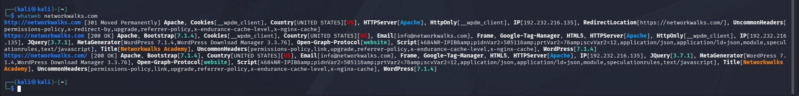

3.1.3 Nslookup
Command: nslookup networkwalks.com
The DNS query returned a non-authoritative answer and resolved networkwalks.com to 192.232.216.135. The configured DNS server shown in the output was 8.8.8.8.
Why it matters: DNS resolution links a domain name to address information used by network clients. A non-authoritative answer is typically supplied by a resolver rather than directly by the domain’s authoritative name server.
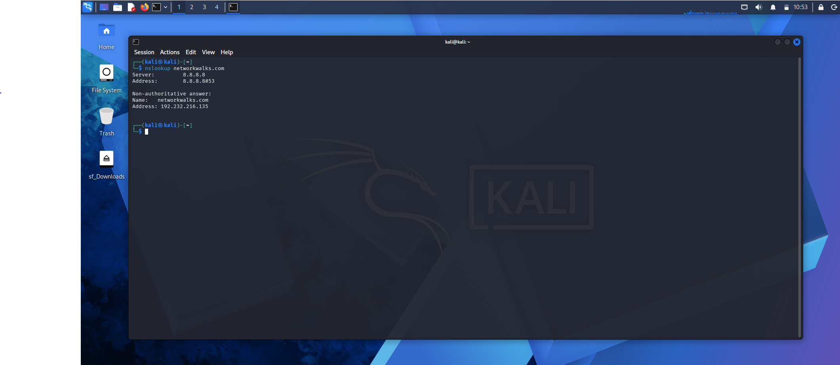

3.1.4 cURL – HTTP Headers
Command: curl -I https://networkwalks.com
The cURL command returned HTTP/1.1 200 OK and identified Apache as the web server. The response headers included Content-Type: text/html; charset=UTF-8, Referrer-Policy: no-referrer-when-downgrade, X-Endurance-Cache-Level: 0 and X-nginx-cache: WordPress. The Link header also contained references to the WordPress REST API endpoint (/wp-json/).
Why it matters: HTTP response headers provide information about server responses and some application behaviour. Reviewing them can support defensive configuration checks.
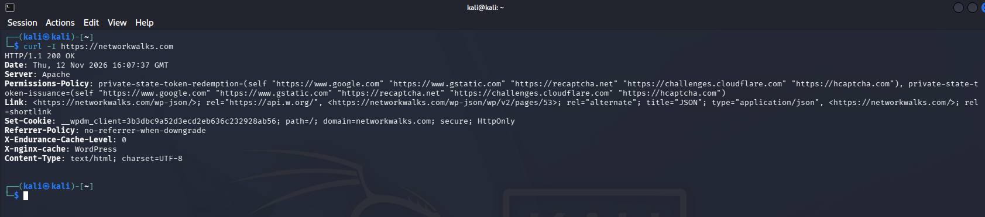

3.1.5 WAFW00F
Command: wafw00f networkwalks.com
The tool reported that https://networkwalks.com is behind ModSecurity (SpiderLabs) WAF. The output reported two requests.
Why it matters: Identifying a WAF can help understand one layer of the website’s defensive architecture. Detection does not establish how effective the WAF configuration is.
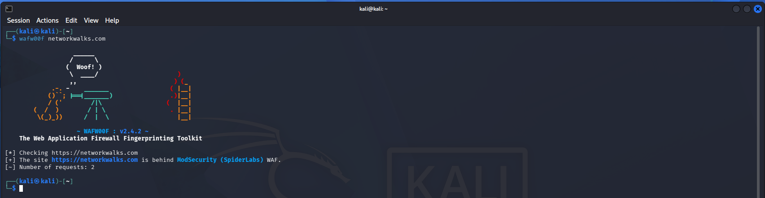

3.1.6 DNSRecon
Command: dnsrecon -d networkwalks.com
The enumeration output reported SOA, NS, MX, A, TXT and SRV information. It identified name servers, mail-related information, SPF/TXT data and SRV records for autodiscovery. The tool reported eight records found. The output also displayed DNSSEC query and DNS server version information.
Why it matters: DNS records can reveal how a domain’s services and infrastructure are organised. DNS information should be reviewed to ensure that records are accurate and only intended services are exposed.
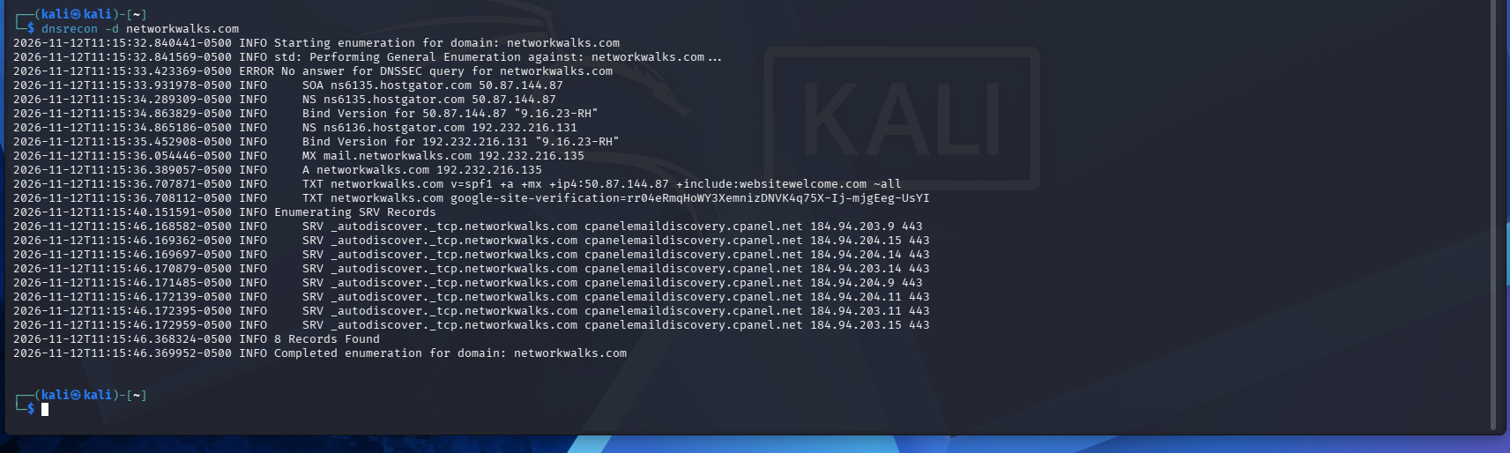

3.2 Network Scanning with Zenmap
The second practical used Zenmap on a Windows PC to perform discovery on the author's own local network. The assigned tasks included identifying the local IP address and LAN subnet, discovering live hosts, counting hosts, reviewing IP and MAC address information, and displaying the network topology.

3.2.1 Local IP and LAN subnet identification
Command: ipconfig
Windows Command Prompt was used to inspect the network adapters and identify the active Wi-Fi adapter’s IPv4 address, subnet mask and default gateway. The exact values are omitted from this shared draft to protect local network privacy.
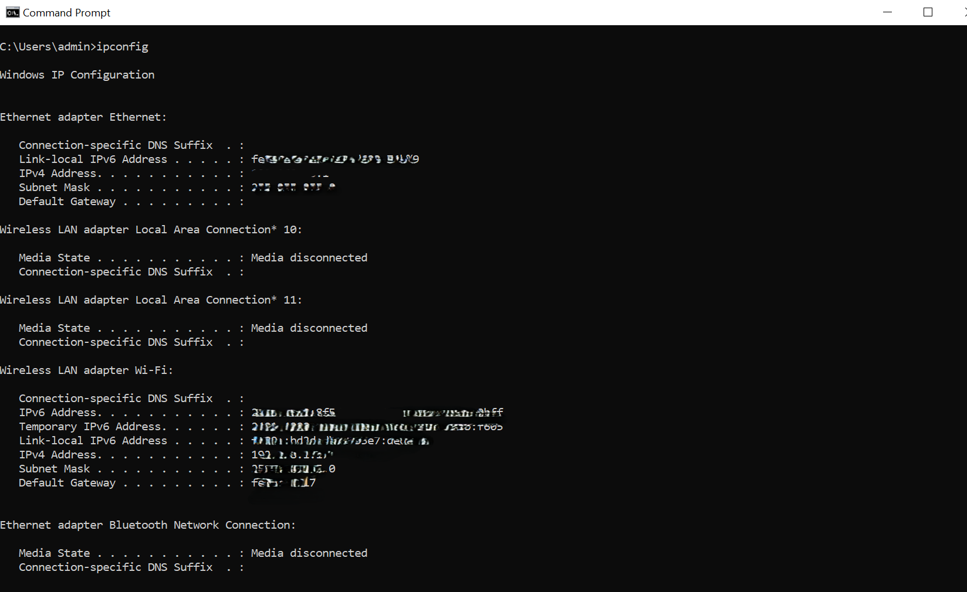

3.2.2 Host discovery
In Zenmap, the local LAN subnet was entered as the scan target and the Ping Scan profile was selected. The scan completed and reported five live hosts.
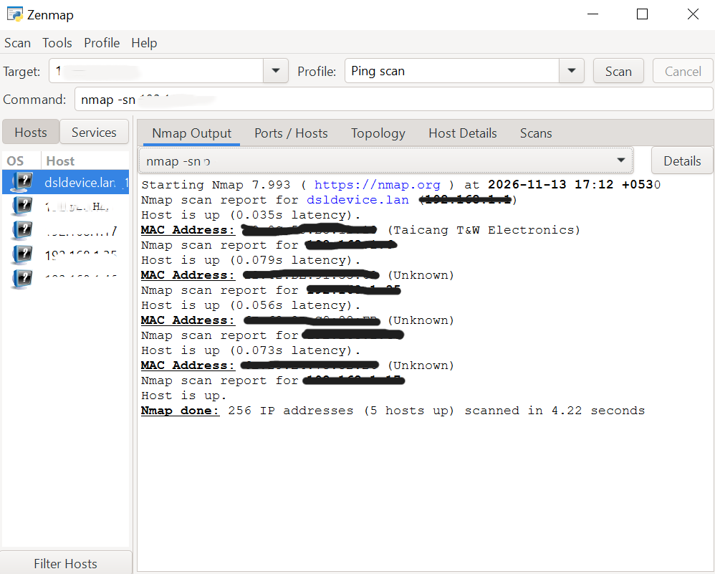

3.2.3 Live host count and address review
The Zenmap Hosts section displayed five live hosts discovered during the network scan. The Nmap output confirmed that five hosts were up out of 256 IP addresses scanned. The IP addresses and MAC address details were reviewed. The scan output also displayed vendor information for an identified MAC address, while some other devices were listed with unknown vendor information. Private network details have been redacted in this report.

3.2.4 Network topology
The Topology tab was opened to view the graphical representation of the discovered network. The resulting topology was saved as an image. The image is evidence of the topology view; it should not be described as a PDF export.
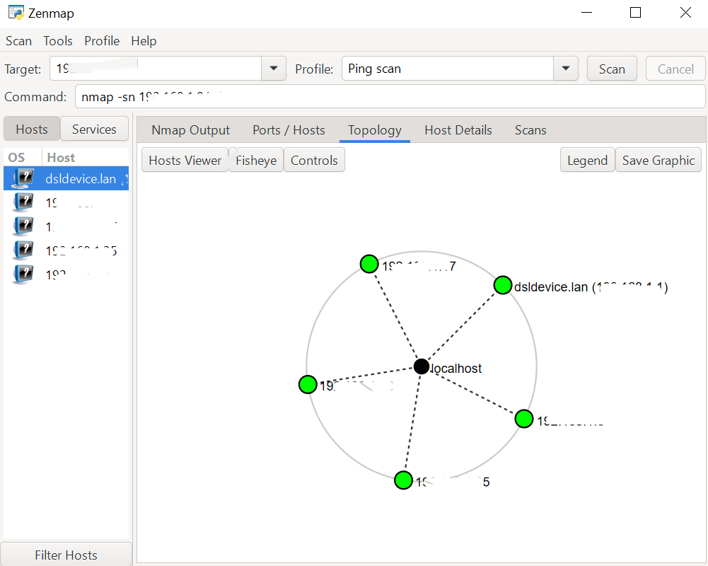

4. Results Summary
Practical | Tool / Activity | Observed result
Footprinting | WHOIS | Domain registration, registrar, four name-servers and privacy-protected registrant information retrieved.
Footprinting | WhatWeb | Apache, WordPress 7.1.4, Download Manager 3.3.76, Bootstrap 7.1.4 and jQuery 3.7.1 identified.
Footprinting | Nslookup | networkwalks.com resolved to 192.232.216.135.
Footprinting | cURL -I | HTTP 200 OK and HTTP response headers retrieved.
Footprinting | WAFW00F | ModSecurity (SpiderLabs) WAF detected.
Footprinting | DNSRecon | DNS enumeration completed; eight records reported.
Network scanning | Zenmap Ping Scan | Five live hosts discovered on local network.
Network scanning | Host details | IP and MAC address information reviewed and recorded privately.
Network scanning | Topology | Network topology viewed and saved as an image.

5. Risk Analysis / Impact
The following are information-exposure observations from reconnaissance and host-discovery activities. They are not confirmed vulnerabilities. No exploitation or vulnerability validation is documented in these two practicals.
# | Observation | Potential implication | Indicative level
1 | Website technology and version information identified by WhatWeb. | May help a reviewer identify software components that should be checked for supported versions and updates. | Low / informational
2 | Domain resolved to a public IP address. | Provides basic infrastructure information; public DNS resolution is expected for a public website. | Informational
3 | HTTP response headers and WordPress REST API references observed. | May assist technology fingerprinting; exposure should be reviewed against intended application configuration. | Low / informational
4 | WAFW00F identified ModSecurity (SpiderLabs). | Reveals the presence/type of a defensive technology but does not assess its effectiveness. | Informational
5 | DNSRecon enumerated DNS and service-related records. | Can help build an infrastructure profile; records should be reviewed for accuracy and necessity. | Low / informational
6 | Five live hosts responded on the author’s local network. | The device inventory should be compared with known/authorised devices. | Needs local review

Risk levels above are qualitative observations for learning purposes, not the result of a formal vulnerability assessment.

6. Recommendations
- Review publicly exposed website technology information and ensure supported software versions are maintained.
- Keep the CMS, plugins, frameworks and server components updated according to vendor security advisories.
- Review HTTP response headers and remove unnecessary information where appropriate without breaking application functionality.
- Review DNS records periodically and remove stale or unnecessary records.
- Maintain and monitor the WAF; validate its configuration through authorised security testing.
- Perform periodic network discovery on owned or authorised networks and compare discovered devices with an approved inventory.
- Investigate unfamiliar devices before taking action; a responding host is not automatically unauthorised.
- Maintain an updated network topology and securely store screenshots and scan outputs.
- Perform reconnaissance and scanning only within a clearly authorised scope.

7. Conclusion
The practical activities provided hands-on experience in footprinting, reconnaissance and network scanning.
Six Kali Linux tools — WHOIS, WhatWeb, Nslookup, cURL, WAFW00F and DNSRecon — were used to gather domain registration information, identify website technologies, perform DNS resolution, inspect HTTP response headers, detect Web Application Firewall technology and enumerate DNS records.
Zenmap was used to perform a Ping Scan on my own local network. The scan discovered five live hosts out of 256 scanned IP addresses. Host details were reviewed, and a graphical network topology was generated and saved.
These activities improved my understanding of reconnaissance techniques, DNS enumeration, website fingerprinting, host discovery and network topology visualisation. They also highlighted the importance of documenting technical findings accurately and conducting security assessments within an authorised scope.

8. Evidence Checklist
- WHOIS terminal output screenshot
- WhatWeb terminal output screenshot
- Nslookup terminal output screenshot
- cURL -I terminal output screenshot
- WAFW00F terminal output screenshot
- DNSRecon terminal output screenshot
- Windows ipconfig screenshot (redacted for public sharing)
- Zenmap scan output showing five live hosts
- Zenmap Hosts tab screenshot (redacted for public sharing)
- Zenmap network-topology image

9. Author and Project Information
Field | Details
Author | Kashvi Khanna
Program | Cybersecurity Internship – NetworkWalks
Week | 02
Modules | W2-PM1 and W2-PM5
Repository | footprinting-and-network-scanning

End of report.

