TASK 1: Repository Setup

Goal: Initialize Git and create first commit
Steps:
- Create a folder named git-assignment-yourfullname
- Navigate into the folder
- Initialize Git repository
- Create a file named index.txt
- Check repository status
- Stage the file
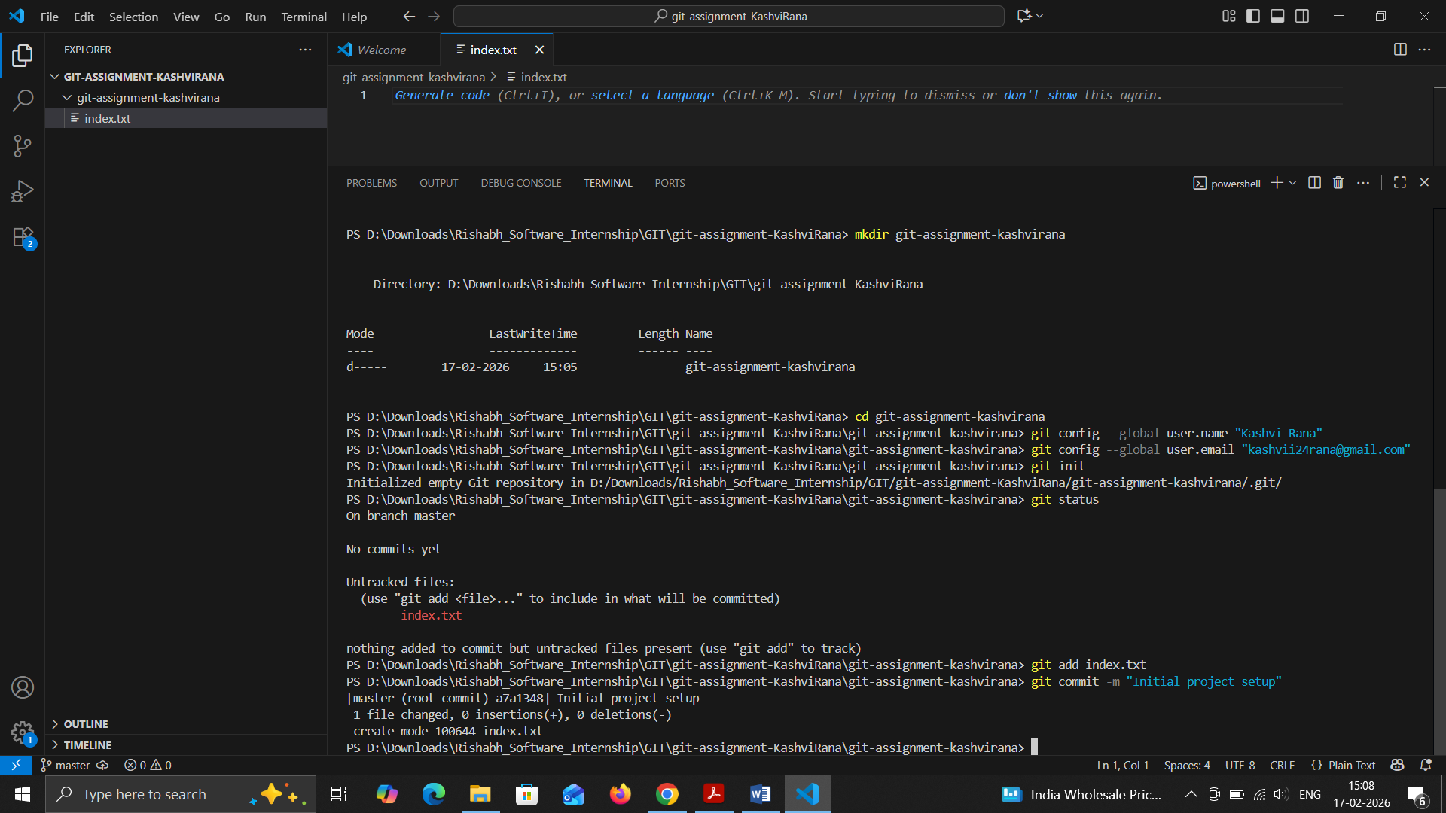
- Commit with message: Initial project setup

TASK 2: Branch Creation & Work

Goal: Work independently in a branch
Steps:
- Create a branch named feature-header
- Switch to feature-header
- Create a file named header.txt
- Stage the file
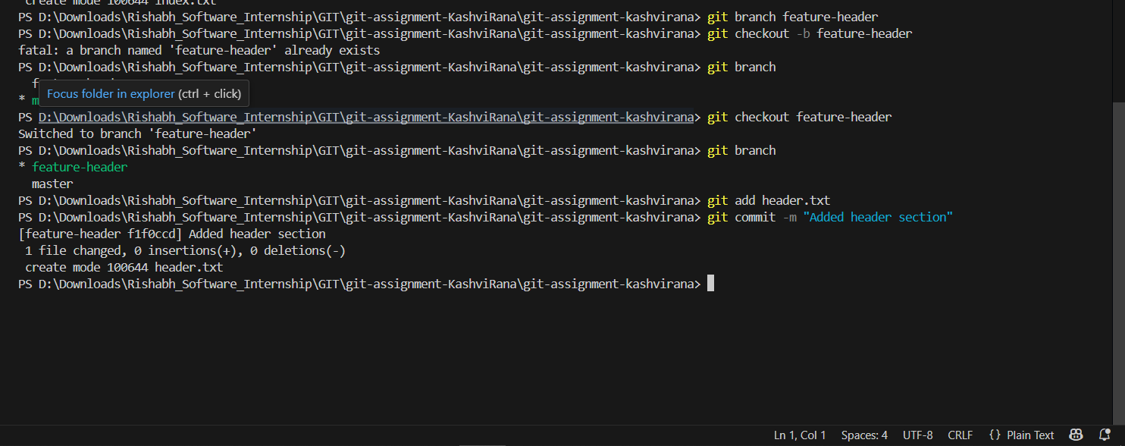
Commit with message: Added header section

TASK 3: Branch Switching Observation

Goal: Observe branch isolation
Steps:
- Switch back to master
- List files and observe
- Switch again to feature-header
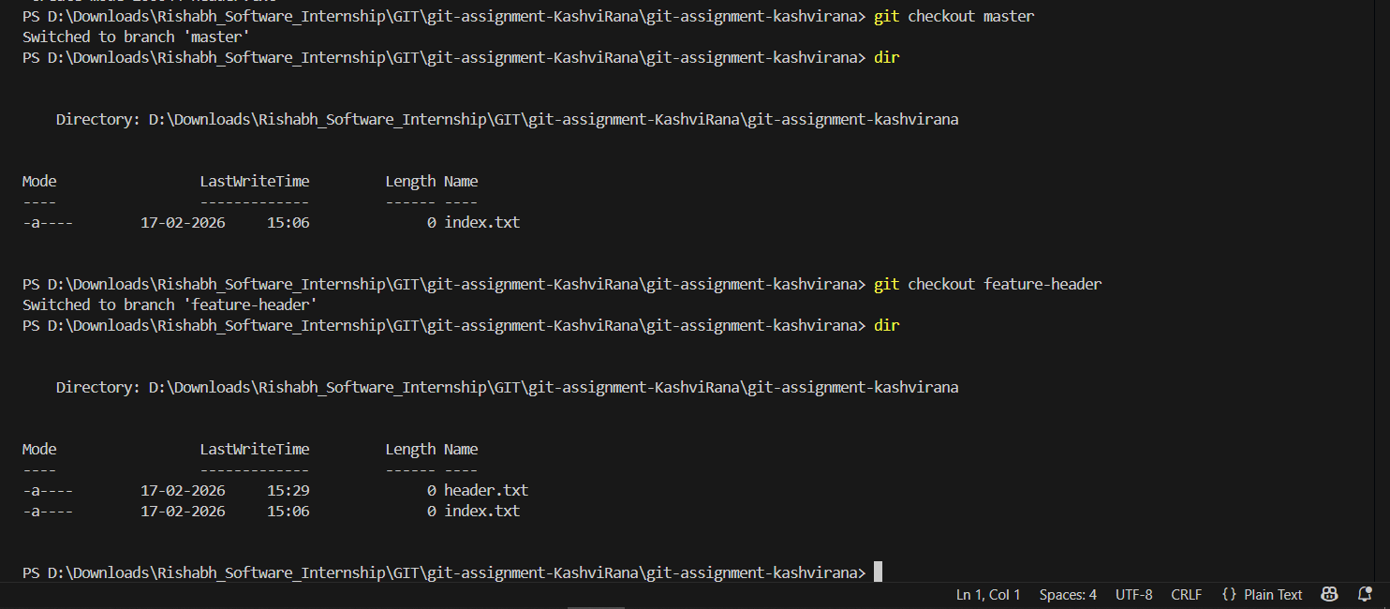
- List files and observe

TASK 4: Undo a Mistake

Goal: Safely undo file changes
Steps:
- In feature-header, modify index.txt
- Check repository status
- Undo the change using Git
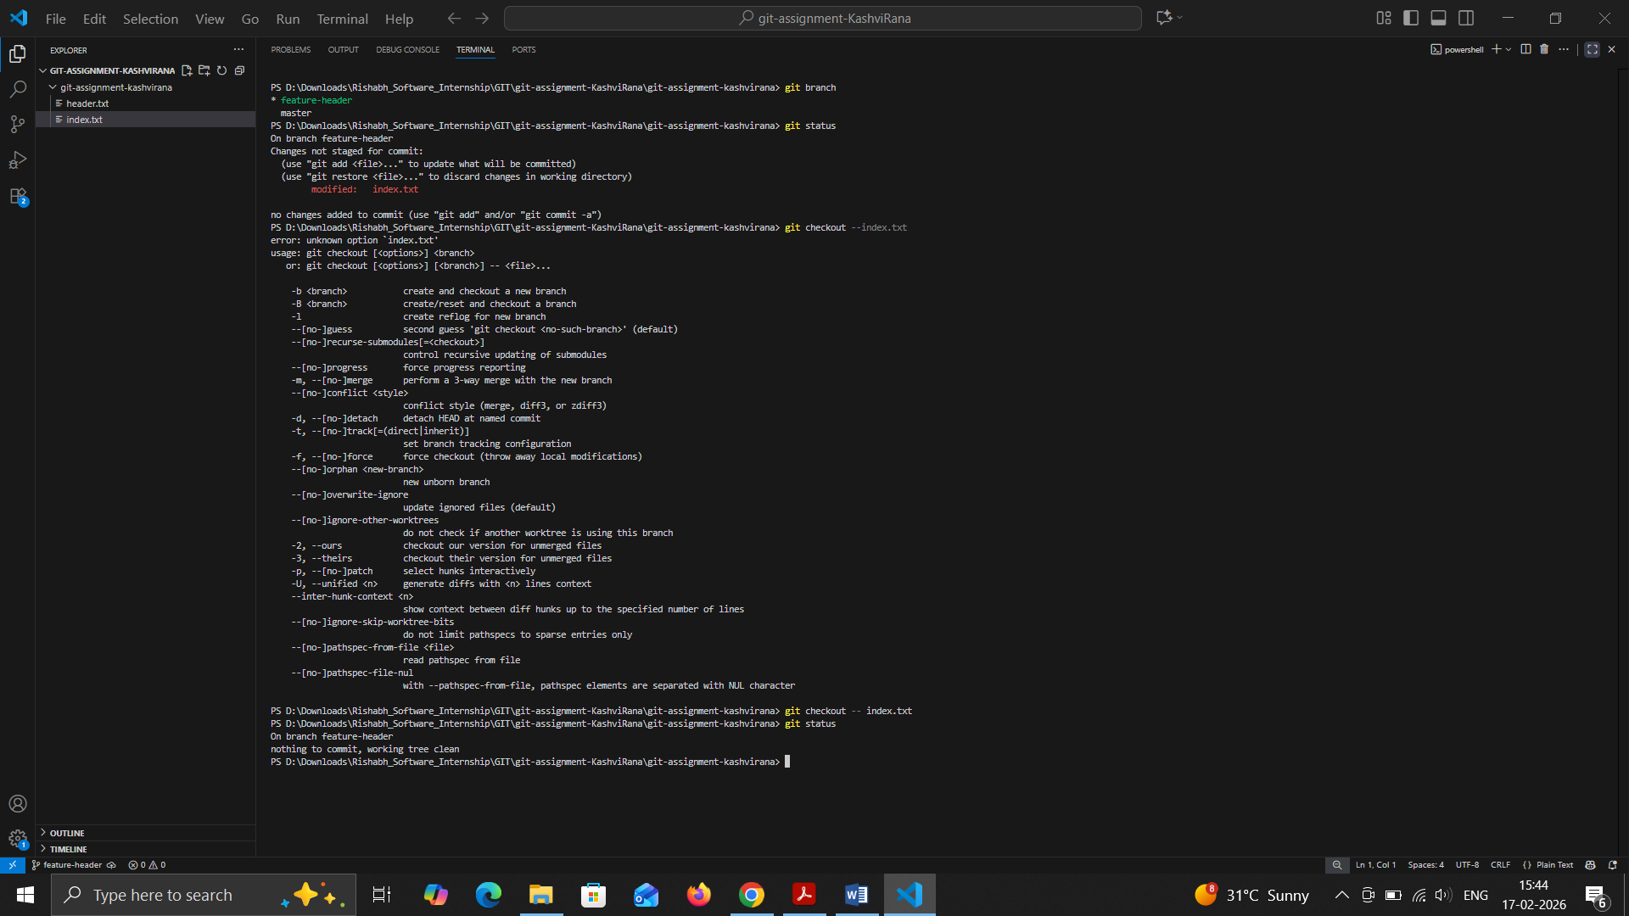
- Verify status again
TASK 5: Merge Feature Branch

Goal: Combine work into master
Steps:
- Switch to master
- Merge feature-header
- Verify merged files
- Check commit history
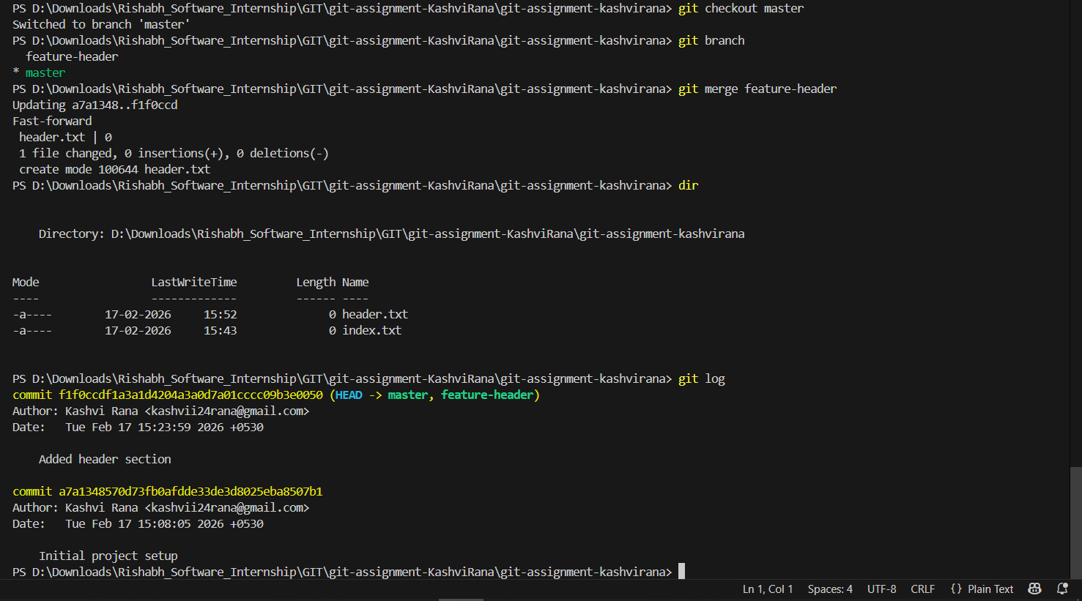

TASK 6: Checkout a Commit (Detached HEAD)

Goal: Understand commit-level navigation
Steps:
- View commit history
- Checkout any older commit
- Check current branch status
- Switch back safely to master
