• What is software? What is software engineering?

* What is Software?
  + Software is a set of instructions, data or programs used to operate computers and execute specific tasks. Software is a generic term used to refer to applications, scripts and programs that run on a device.
* What is Software engineering?
  + Software subsists of carefully-organized instructions and code written by developers on any of various particular computer languages.
  + Engineering is the application of scientific and practical knowledge to invent, design, build, maintain, and improve frameworks, processes, etc.
  + Software Engineering is an engineering branch related to the evolution of software product using well-defined scientific principles, techniques, and procedures.

• Explain types of software

* + There mainly 3 types of Software.
    - Website
    - Mobile Application
    - Desktop Application
  + Website: It is a group of World Wide Web pages usually containing hyperlinks to each other and made available online by an individual, company, educational institution, government, or organization.
  + Mobile Application: It is a type of application software designed to run on a mobile device, such as a smartphone or tablet computer.
    - Android application
    - iOS application
  + Desktop Application: It is a software program that can be run on a standalone computer to perform a specific task by an end-user.

• What is SDLC? Explain each phase of SDLC.

* + SDLC or Software Development Life Cycle is a methodology with well-defined stages that enables developers to create high-quality software.
  + SDLC – Software Development Life Cycle
  + There are mainly 7 Phases in the SDLC
    - Requirements
    - Architecture
    - Design
    - Implementation
    - Testing
    - Release
    - Maintenance
  + Requirements
    - This is the first step in the SDLC in which all the basic and important processes and requirements are given from which any developer or coder or designer or tester can derive information and make it happen for client.
    - It requires SRS (Software requirement specification), KT (Knowledge transfer) etc.
  + Architecture
    - This is the second step in the SDLC in which developer will showcase the things they are going to use like languages, use cases, diagram, flowchart etc.
    - It includes which
      * Languages
      * Test Plans
      * Use case
      * Flowchart etc
  + Design
    - This is the third step in SDLC which is taken care by UI/UX Designer
  + Implementation
    - This is the Fourth Step in the SDLC in which Developer develops the code and software with the help of languages and frameworks.
  + Testing
    - This is the Fifth step in the SDLC in which QA test the code and if it finds bug then it is given to coder again till all the bugs will not resolved by coder.
  + Release
    - This is where we release the software into the market.
  + Maintenance
    - This is the last step of the SDLC where all the stakeholder will maintain the software according to the requirements of client and circumstances.
    - There are 3 Types of maintenance
      * Corrective maintenance: Repairing the defects
      * Perfective maintenance: Adding New feature
      * Adaptive maintenance: Changing the environment of Software

• What is DFD? Create a DFD diagram on Flipkart

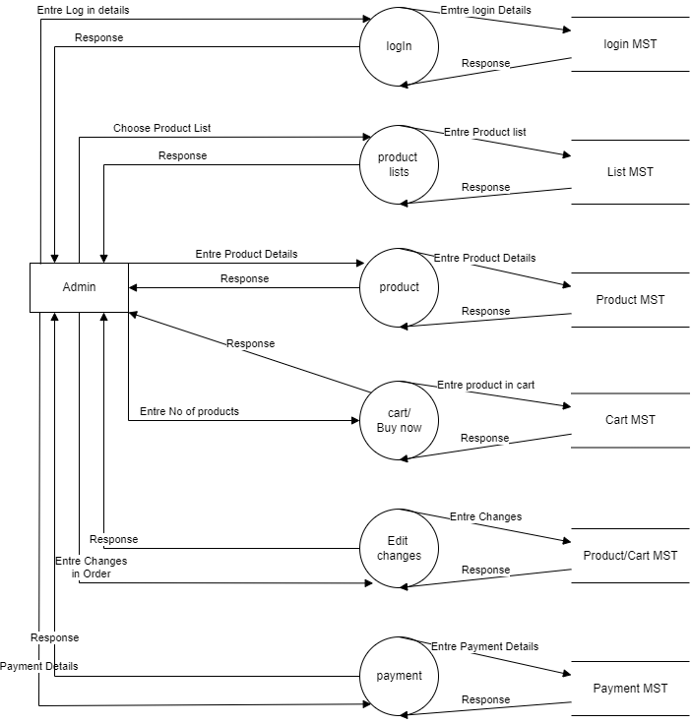

• What is Flow chart? Create a flowchart to make addition of two numbers.

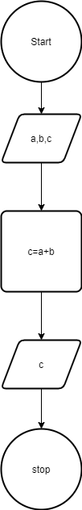

• What is Use case Diagram? Create a use-case on bill payment on paytm.

