# **Specification document**

**Project Name:** **Sporty Shoes**

**Introduction:**

This project is to develop a prototype application for sporty shoes online website.

**Vision/ Mission:** The vision / mission of this project is to digitize and optimize the online shoe buying application called Sporty_shoes.com..

**Technology used:**

* Eclipse/STS
* Java Programming language
* Thymeleaf
* Spring Boot
* Spring MVC Model
* Spring Data JPA
* GitHub
* Scrum
* Maven
* MYSQL
* JDBC

**Requirements:**

* + Admin Welcome Screen with the following Functionalities:

**Change Password Functionality:**

The Admin should be provided option to change password if required.

**Search Users Functionality:**

The Admin should be able to see all users and able to search for users based on whether the users are signed up.

**Mange Products Functionality:**

The Admin should be able to manage products such as

1. Add New Product
2. Edit Product
3. Delete Product

**Generate Purchase Report Functionality:**

The Admin should be able to generate purchase report filtered by Purchase Date and Product Category.

**Flowchart:**

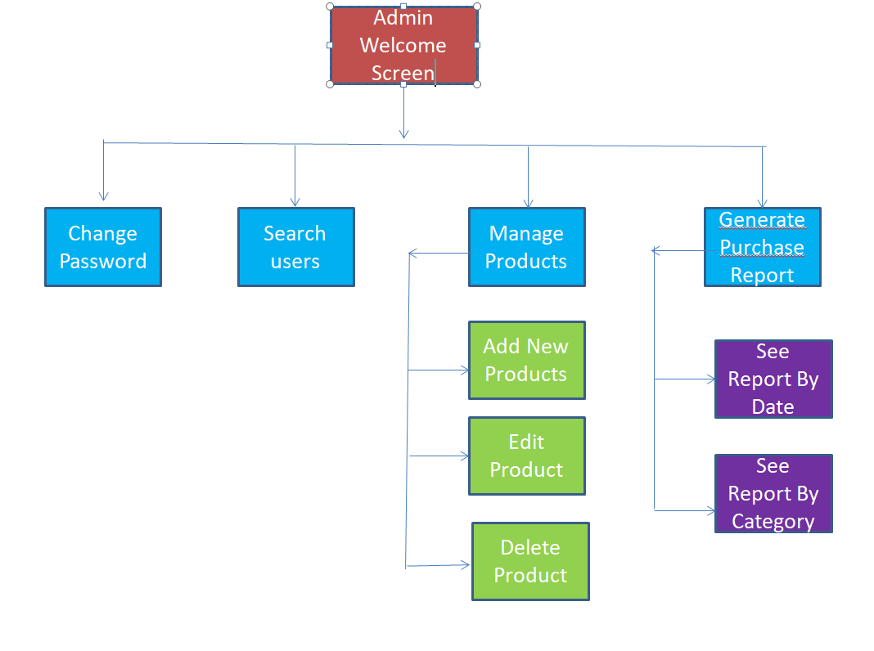

**Databases:**

**user Table:**

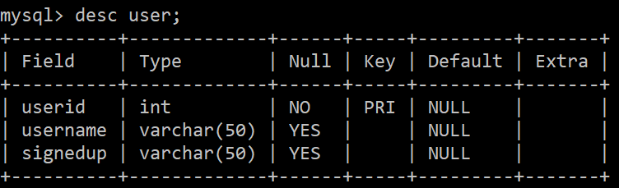

**product Table:**

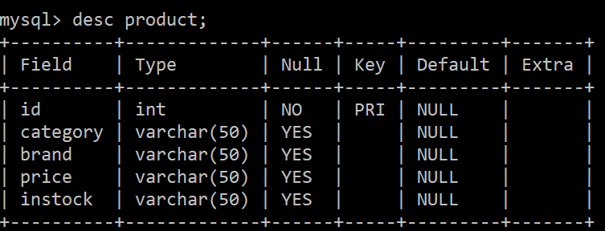

**Purchasereport Table:**

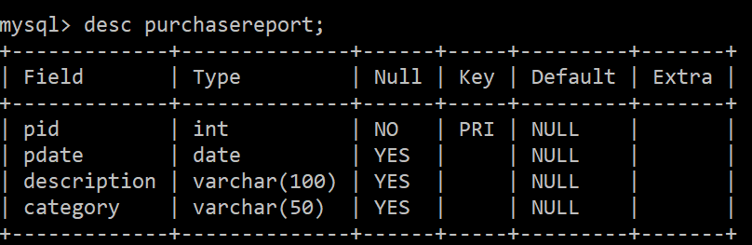

**admin Table:**

