**“SMART HELMET”**

Mini project-1 Report

*Submitted in Partial Fulfillment of the Requirements for the Degree*

Of

**Bachelor of Technology**

In

**Electronics & Communication Engineering**

**Submitted By:**

KASHYAP ADODARIYA (17BEC004)

PRATIK NAVADIYA (17BEC058)

**Under Guidance of:**

**DR. PIYUSH BHATASANA**



**Department of Electronics & Communication Engineering**

Institute of Technology, Nirma University,

Ahmedabad – 382481

November - 2019

**CERTIFICATE**

This is to certify that the Mini Project Report entitled “**SMART HELMET**” submitted by **Kashyap Adodariya (17BEC004)** and **Pratik Navadiya (17BEC058)** towards the partial fulfillment of the requirements for the award of degree in Bachelor of Technology in the field of Electronics & Communication Engineering of Nirma University is the record of work carried out by him under our supervision and guidance. The work submitted has in our opinion reached a level required for being accepted for examination. The results embodied in this mini project work to the best of our knowledge have not been submitted to any other University or Institution for award of any degree or diploma.

**Date:** 20th November 2019

|  |  |  |
| --- | --- | --- |
| **Name of Guide:** Dr.Piyush Bhatasana |  |  |
| **Head of Department**  Department of Electronics & Communication Engg.  Institute of Technology Nirma University  Ahmedabad |  |  |

**Undertaking for Originality of the Work (for all students)**

We, **Kashyap Adodariya** and **Pratik Navadiya**, Roll No.17BEC004 & 17BEC058, give undertaking that the Mini Project entitled “**SMART HELMET**” submitted by me, towards the partial fulfillment of the requirements for the degree of Bachelor of Technology in the field of Electronics & Communication Engineering of Nirma University, Ahmedabad, is the original work carried out by me and I give assurance that no attempt of plagiarism has been made. I understand that in the event of any similarity found subsequently with any other published work or any project report elsewhere; it will result in severe disciplinary action.

__________________

Signature of Student

Date: _______________

Place: _______________

Endorsed by:

(Signature of Internal Guide)

**Acknowledgement**

I must acknowledge the strength, energy and patience that almighty **GOD** bestowed upon me to start & accomplish this work with the support of all concerned, a few of them I am trying to name hereunder. I would like to express my deep sense of gratitude to my Supervisor, **Dr. Piyush Bhatasana,** Professor, Electronics & Communication Engineering Department for his valuable guidance and motivation throughout my study. I would like to express my sincere respect and profound gratitude to **Dr. Dhaval Pujara**, Professor & Head of Electronics & Communication Engineering Department for supporting and providing the facilities for my mini project work. I would also like to thank all my friends who have helped me directly or indirectly for the completion of my project work. No words are adequate to express my indebtedness to my parents and for their blessings and good wishes. To them I bow in the deepest reverence.

KASHYAP ADODARIYA

PRATIK NAVADIYA

Abstract

A smart helmet is used to provide safety. It is used to stop starting of vehicles without wearing helmet. To avoid accidents and encourage people to wear helmet, proposed design is to be introduced and includes, Arduino (Atmega328) microcontroller, interface of GSM technology (Arduino GSM Shield) that is used to give information by sending message and it includes GPS location tracker by which we can send its perfect location and also for the case if there is an accident. It also checks, whether the helmet is weared or not and it controls the speed limit by using the accelerometer. In this report, we discuss all component description and suitable result for the same.

Index

|  |  |  |  |
| --- | --- | --- | --- |
| **Chapter No.** | Title | | **Page No.** |
|  | Acknowledgement | | **3** |
|  | Abstract | | **4** |
|  | Index | | **5** |
|  | List of Figures | | **6** |
|  | List of Tables | | **6** |
|  | **List of Acronyms** | | **7** |
| **1** | Introduction | | **8** |
|  | 1.1 | Introduction | 8 | |
|  | 1.2 | Motivation of the project | 9 | |
|  | 1.3 | Objective of the project | 9 | |
|  | 1.4 | Challenges of the project | 10 | |
|  |  |  |  | |
| **2** | Literature Review | | **11** |
|  | 2.1 | Review | 11 | |
|  | 2.2 | work till date | 11 | |
|  |  |  |  | |
| **3** | **Component description** | | **13** |
|  | 3.1 | Arduino Uno | 13 | |
|  | 3.2 | Accelerometer | 16 | |
|  | 3.3 | GPS GY-GPS6MV2 | 18 | |
|  | 3.4 | GPRS/GSM 900A | 20 | |
|  | 3.5 | 433 MHz RF Transmitter Module | 22 | |
|  |  |  |  | |
| **4** | **Flow chart and block diagram of the project** | | **24** |
|  | 4.1 | Block diagram | 24 | |
|  | 4.2 | Flow chart | 24 | |
|  |  |  |  | |
| **5** | **Result** | | **25** | |

**LIST OF FIGURES**

|  |  |  |
| --- | --- | --- |
| **Figure No:** | **Name of the Figure:** | **Page no.** |
| Fig. 1.1 | Comparison of total accident with motorcycle accident | 9 |
| Fig. 2.1 | Literature survey of motorcycle road accident | 11 |
| Fig. 3.1 | Arduino Uno | 13 |
| Fig. 3.2 | Architecture of ATmega328 | 14 |
| Fig. 3.3 | ADXL 335 accelerometer | 16 |
| Fig. 3.4 | Operational block diagram of ADXL335 accelerometer | 16 |
| Fig. 3.5 | Accelerometer sensor MEM mechanism | 17 |
| Fig. 3.6 | GPS GY-GPS6MV2 | 18 |
| Fig. 3.7 | **GPS Signal Time Difference** | **20** |
| Fig. 3.8 | GPRS/GSM SIM900A | 20 |
| Fig. 3.9 | 433MHz Transmitter and Receiver | 23 |
| Fig. 4.1 | Block diagram | 24 |
| Fig. 4.2 | Flow chart | 24 |
| Fig. 5.1 | Result of accelerometer | 25 |
| Fig. 5.2 | Result of GPS and GSM | 25 |
| Fig. 5.3 | Final [implementation](https://www.google.com/search?rlz=1C1CHBF_enIN845IN845&sxsrf=ACYBGNQJmmvxoCFA5N2YQweembHFSDFHMQ:1574230276715&q=implementation&spell=1&sa=X&ved=2ahUKEwj3tMDjkPjlAhXYXCsKHfF6CrQQkeECKAB6BAgPECc) | 26 |

**LIST OF TABLE**

|  |  |  |
| --- | --- | --- |
| **SR number** | **Title** | **Page number** |
| 3.1 | Specification and features of Arduino Uno: | 15 |
| 3.2 | Specification of accelerometer | 17 |
| 3.3 | Specification of GPS GY-GPS6MV2 | 19 |
| 3.4 | Specification of GPRS/GSM SIM900A | 22 |
| 3.5 | AT command of GPRS/GSM SIM900A | 22 |

**LIST OF ACRONYMS**

|  |  |
| --- | --- |
| GSM | Global System for Mobile |
| GPS | Global Positioning System |
| GPRS | General Packet Radio Service |
| DC | Direct current |
| SMS | Short Message Service |
| PWM | Pulse width modulation |
| USB | Universal Serial Bus |
| ICSP | In Circuit Serial Programming |
| FTDI | Future Technology Devices International |
| DFU | Device Firmware Update |
| AREF | Analogue Reference |
| AVR | Alf and Vegard's RISC processor |
| IOREF | Input output Reference |
| EEPROM | Electrically Erasable Programmable Read-Only Memory |
| SRAM | Static random access memory |
| RX | Receiver pin |
| TX | Transmitter pin |
| TTL | Transistor-transistor logic |
| SS | Slave Select |
| MOSI | Master Out Slave In |
| MISO | Master IN Slave out |
| SCK | Serial Clock |
| SPI | Serial Peripheral Interface |
| SDA | Serial Data |
| TWI | Two Wire Interface |
| MEMS | Micro-Electro-Mechanical Systems |
| SIM | Subscriber Identification Module |
| CS | Coding scheme |
| TCP/IP | Transmission Control Protocol/Internet Protocol |
| DBG_TXD | Debug transmitter directives |
| DBG_RXD | Debug receiver directives |
| **ASK** | Amplitude Shift Keying |
| **OOK** | Of Hook Keying |
| **RF** | Radio frequency |

**Chapter 1: Introduction**

* 1. **Introduction**

Nowadays India has highest number of road accident deaths in the world, as per a WHO (world health organization) report. According to a survey of India there are around 698 accidents occurring due to bike crashes per year. The reasons for the accidents may be many such as high speeding, and rash driving, etc. In some cases, the person injured in Accident may not be directly responsible for the accident, it may be the fault of some other rider, but at the end of the day it's both the drivers involved in the accidents who are going to suffer.

If accident are one reason, then another reason for deaths is lack of immediate First Aid and Emergency Medical Services. According to the same survey nearly half the injured people die due to lack of treatment in proper time, late arrival of ambulance, no person at place of accident to give information to the ambulance emergency services. So we have find solution to this problem come up with the idea of smart helmet such that it gives immediate responses or messages from GSM or GPRS. Because after all time matters a lot, if everything is done in time, at least we can save half the lives that are lost due to bike accidents.

There are many people prefer two wheelers as compared to other form of vehicle due to simplicity and low cost in India. There is considerable morbidity and mortality due to two wheeler road traffic accidents. Riders are at the risk of suffering a traumatic brain injury if they are in an accident. Hence Helmets are of crucial importance to avoid deaths due to severe head injuries. So to avoid accidents and encourage people to wear helmet, proposed design is to be introduced that includes,

1. Microcontroller (Arduino UNO)
2. GSM
3. GPRS
4. ACCELEROMETER

So here proposed system require Arduino (Atmega328) microcontroller, interfacing of GSM technology (Arduino GSM Shield) to give information by sending message and also include GPRS location in the message which are sending to registered number will have perfect location about where and when the accident occurred.

**1.2 Motivation of the project:**

The motivation of this project comes from the real-world challenges that we face daily on the roads.

There are many road accidents increasing a day by day and in countries like India where bikes are more prevalent many people die to carelessness carried in wearing helmets. In present day scenario there are more death due to two-wheeler road accidents. So all people motivated to our project Despite of the fact that helmets are available everywhere, people are motivate those are not wearing helmet. In the event of road accidents, the message is sent to the emergency contact through GSM and GPRS.

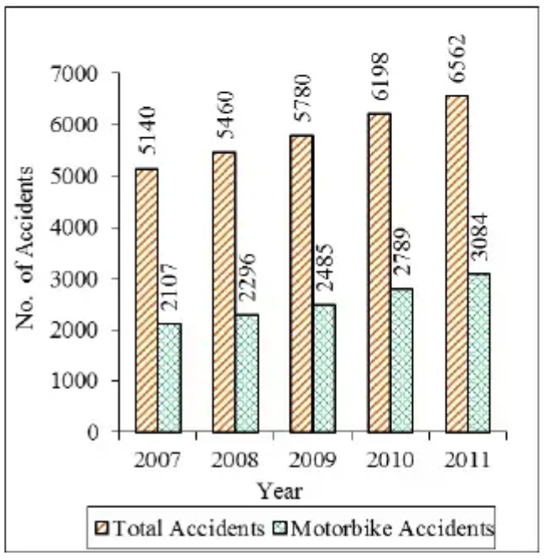

Figure: 1.1 Comparison of total accident with motorcycle accident [4]

* 1. **Objective of the project:**
* To measure the force of impact by using accelerometer
* We design the GPS and GPRS based immediate responses of emergency services.
* We check whether the helmet wearing or not.
* We controlled the speed limit by using the accelerometer.

**1.4 Challenges of the project:**

* Person rides the bike even in the areas where mobile network lacks, so GSM network is required for sending SMS. It is expensive.
* When the helmet is dropped down accidentally, the system treats it as an accident.
* Sometime not proper location given due to the Cloudy Weather.
* Power consumption and Durability are important challenges of the project.

**Chap 2: Literature Review**

**2.1 Review**

* 1.25 million People die in road crashes each year, on average 3,287 deaths a day.
* More than half of all road traffic deaths occur among young adults ages 15-44.
* 10% occur in India which is overtake china.
* 80,000 people killed due to rush driving, not wearing helmet etc.

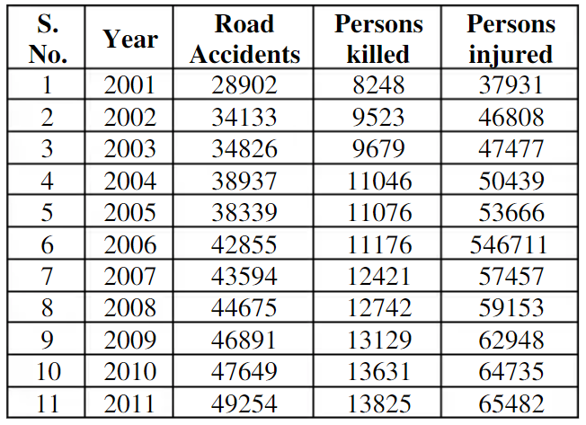

Figure: 2.1 Literature survey of motorcycle road accident [3]

In this table we discuss the number of road accident and how many persons killed and persons injured in the different year.

* 1. **Work till date**

**1) Jennifer William, Kaustubh Padwal, Nexon Samuel, Akshay Bawkar, “Smart helmet Helmet” International Journal of Scientific & Engineering Research, Volume 7, Issue 3, March-2016.**

* In this research paper the accelerometer used for the balancing of the bike rider. If the bike will tilt than the threshold value will consider that the accident occurred and through the GSM & GPS the message will be send to the family member or ambulance with location. But Limitation of this project is, If tilting of helmet is done more than threshold level even if accident is not occurred then message will send which is inconvenient.

1. **HajerSalim, Malathi B. N, “Accident notification system by using two modem GPS and GSM” International Journal of Applied Information Systems (IJAIS) Foundation of Volume 8– No.3, February 2015.**

* The main purpose of this project to find the location where the accident has occurred. But limitation of project is, In some place where there is no network available then it is difficult to send the message.

1. Statistics suggest that most of the road accidents that take place are that of two wheelers viz. Motor-bikes and scooters.
2. **Dr. Himadri Nath Saha** proposes a mechanism by using the parameters such as flex sensor, breathe analyzer, impact sensor, Bluetooth for accident detection and shows how important the alarm by using SVM Ms. Rekha. M, Ms. Bharathi. K proposes the technology detects amount of alcohol in blood if the limit is above the legal limit then the vehicle won’t move. P. Tharangai Thamil, S. Vanitha proposes to determine the detection of rash driving using accelerometer and sensors [3]. Amrutha Madhusan proposes the system which aims at reducing the loss of people lives in road accidents and performs such tasks as accident detecting and sending of the location to the nearby hospital [4]. Prabha project provides an accelerometer which is used in a car alerting application so the risky driving can be detected. Aboli Ravindra Wakure proposes the system with the accelerometer sensor for car security system. Also proposed about the air bags and alcohol sensor.

**Chapter 3: Component Description**

* 1. **Arduino Uno**

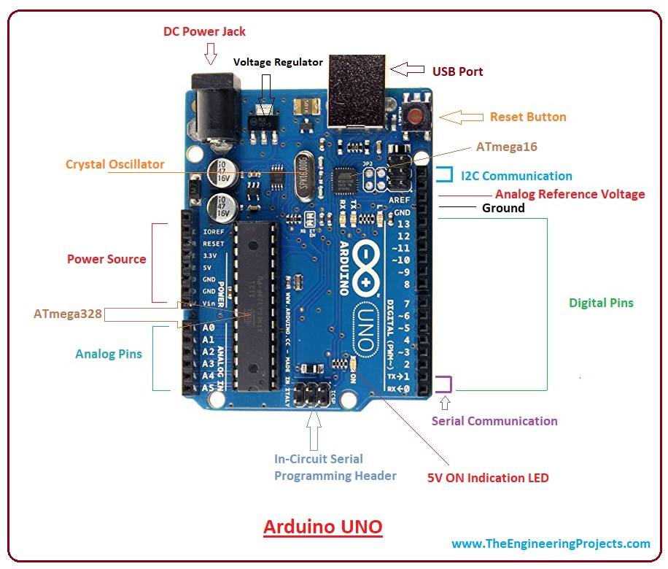

Figure 3.1 Arduino Uno [8]

* Arduino platform offers open source hardware and software that is easy to use and is used widely for hobby projects and prototyping. The Arduino Uno is a microcontroller board based on the ATmega328 (datasheet). It has 14 digital input/output pins (of which 6 can be used as PWM outputs), 6 analog inputs, a 16 MHz ceramic resonator, a USB connection, a power jack, an ICSP header, and a reset button.
* It contains everything needed to support the microcontroller; simply connect it to a computer with a USB cable or power it with a AC-to-DC adapter or battery to get started. The Uno differs from all preceding boards in that it does not use the FTDI USB-to-serial driver chip. Instead, it features the Atmega16U2 (Atmega8U2 up to version R2) programmed as a USB-to-serial converter. Revision 2 of the Uno board has a resistor pulling the 8U2 HWB line to ground, making it easier to put into DFU mode.
* Revision 3 of the board has the following new features:

1. Pin out: added SDA and SCL pins that are near to the AREF pin and two other new pins placed near to the RESET pin, the IOREF that allow the shields to adapt to the voltage provided from the board. In future, shields will be compatible both with the board that use the AVR, which operate with 5V and with the Arduino Due that operate with 3.3V. The second one is a not connected pin, which is reserved for future purposes.
2. Stronger RESET circuit.
3. ATmega 16U2 replace the 8U2. "Uno" means one in Italian and is named to mark the upcoming release of Arduino 1.0. The Uno and version 1.0 will be the reference versions of Arduino, moving forward. The Uno is the latest in a series of USB Arduino boards, and the reference model for the Arduino platform; for a comparison with previous versions, see the index of Arduino boards.

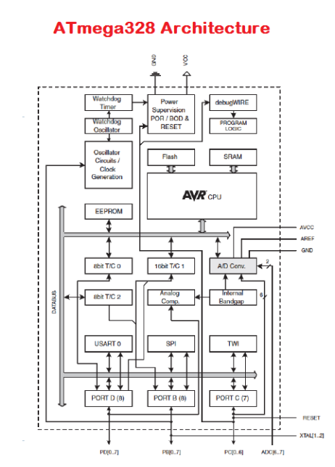

Figure 3.2 Architecture of ATmega328 [8]

* **Specification and features of Arduino Uno:**

|  |  |
| --- | --- |
| Microcontroller | ATmega328 |
| Operating voltage | 5V |
| Input voltage | 7-12V |
| Digital I/O Pins | 14(of which 6 provide PWM) |
| Analog input pins | 6 |
| DC current per I/O pin | 40mA |
| DC current for 3.3V pin | 50mA |
| Flash memory | 32KB |
| SRAM | 2KB |
| EEPROM | 1KB |
| Clock speed | 16MHz |

Table 1.1 Specification and features of Arduino Uno [8]

* **Input and output:**
* Serial: 0 (RX) and 1 (TX). Used to receive (RX) and transmit (TX) TTL serial data. These pins are connected to the corresponding pins of the ATmega8U2 USB-to-TTL Serial chip.
* External Interrupts: 2 and 3. These pins can be configured to trigger an interrupt on a low value, a rising or falling edge, or a change in value.
* PWM: 3, 5, 6, 9, 10, and 11. Provide 8-bit PWM output with the analogWrite () function.
* SPI: 10 (SS), 11 (MOSI), 12 (MISO), 13 (SCK). These pins support SPI communication using the SPI library.
* LED: 13. There is a built-in LED connected to digital pin 13. When the pin is HIGH value, the LED is on, when the pin is LOW, it's off. The Uno has 6 analog inputs, labelled A0 through A5, each of which provide 10 bits of resolution (i.e. 1024 different values). By default they measure from ground to 5 volts, though is it possible to change the upper end of their range using the AREF pin and the analogReference () function. Additionally, some pins have specialized functionality:
* TWI: A4 or SDA pin and A5 or SCL pin. Support TWI communication using the Wire library. There are a couple of other pins on the board:
* AREF. Reference voltage for the analog inputs. Used with analogReference ().
* Reset. Bring this line LOW to reset the microcontroller. Typically used to add a reset button to shields which block the one on the board.
  1. **Accelerometer**

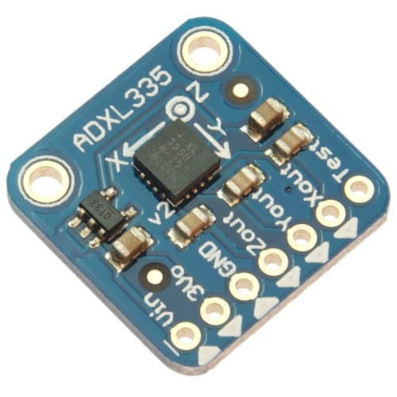

Figure 3.3 ADXL 335 accelerometer [6]

An accelerometer is an electromechanical device that will measure acceleration force. It shows acceleration, only due to cause of gravity i.e. g force. It measures acceleration in g unit. On the earth, 1g means acceleration of 9.8 m/s2 is present. On moon, it is 1/6th of earth and on mars it is 1/3rd of earth. Accelerometer can be used for tilt-sensing applications as well as dynamic acceleration resulting from motion, shock, or vibration.

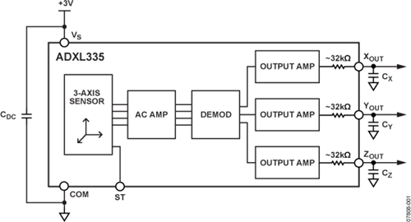

Figure 3.4 Operational block diagram of ADXL335 accelerometer [6]

* **Specification**

|  |  |
| --- | --- |
| **Parameter** | **Range/Type** |
| Measurement range | ±3.6g |
| Cross-axis sensitivity | ±1% |
| Sensitivity Xout, Yout, Zout | 270-330mV/g |
| 0g voltage at Xout, Yout | 1.35-1.65V |
| 0g voltage at Zout | 1.2-1.8V |
| **Frequency Response** |  |
| Bandwidth Xout, Yout | 1600Hz |
| Bandwidth Zout | 550Hz |
| Sensor Resonant | 5.5kHz |
| Operating temp. range | -40 to +85 ºC |

Table 3.2 Specification of accelerometer [6]

* **ADXL335 module**
* The ADXL335 gives complete 3-axis acceleration measurement.
* This module measures acceleration within range ±3 g in the x, y and z axis.
* The output signals of this module are analog voltages that are proportional to the acceleration.
* It contains a polysilicon surface-micro machined sensor and signal conditioning circuitry.
* **Working Mechanism**

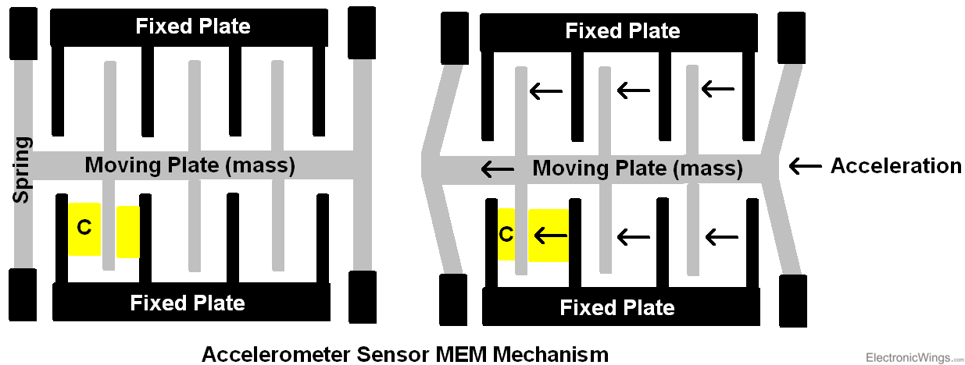

Figure 3.5 accelerometer MEM Mechanism [6]

* As we can see from the above figure, basic structure of accelerometer consists fixed plates and moving plates (mass).
* Acceleration deflects the moving mass and unbalances the differential capacitor which results in a sensor output voltage amplitude which is proportional to the acceleration.
* Phase-sensitive demodulation techniques are then used to determine the magnitude and direction of the acceleration.
* We can calculate angle of inclination or tilt by using X, Y, Z’s value. Also, we can calculate Roll, Pitch and Yaw angles with respect to X, Y and Z axis. So first we need to convert 10-bit ADC values into g unit.
* As per ADXL335 datasheet maximum voltage level at 0g is 1.65V and sensitivity scale factor of 330mV/g.

**Axout** = (((X axis ADC value * Vref) / 1024) – 1.65) / 0.330

**Ayout** = (((Y axis ADC value * Vref) / 1024) – 1.65) / 0.330

**Azout**= (((Z axis ADC value * Vref) / 1024) – 1.65) / 0.330

* 1. **GPS GY-GPS6MV2**

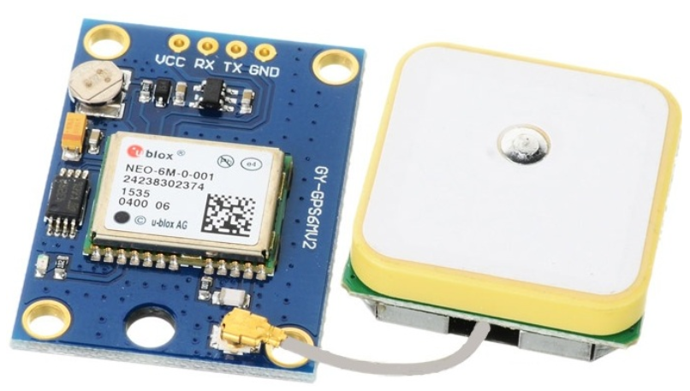

Figure 3.6 GPS GY-GPS6MV2 [7]

GPS receivers are generally used in smartphones, fleet management system, military etc. for tracking or finding location. Global Positioning System (GPS) is a satellite-based system that uses satellites and ground stations to measure and compute its position on Earth. GPS is also known as Navigation System with Time and Ranging (NAVSTAR) GPS. GPS receiver needs to receive data from at least 4 satellites for accuracy purpose. GPS receiver does not transmit any information to the satellites. This GPS receiver is used in many applications like smartphones, Cabs, Fleet management etc.

* **Specification**

|  |  |
| --- | --- |
| **Parameter** | **Range/type** |
| Receiver type | 50 channels  GPS L1 freq., C/A code |
| **Sensitivity** |  |
| Tracking and navigation | -160dbm |
| Cold start | -146dbm |
| Hot start | -155dbm |
| Max. navigation update rate | 5Hz |
| Horizontal position accuracy | 2.5m |
| Velocity accuracy | 0.1m/s |
| Heading accuracy | 0.5 degrees |
| **Operational limits** |  |
| Dynamics | ≤ 4g |
| Altitude | 50,000 m |
| Velocity | 1. m/s |

Table 3.3 Specification of GPS GY-GPS6MV2 [7]

# **GPS Receiver Calculates its Position and Time**

GPS receiver receives information signals from GPS satellites and calculates its distance from satellites. This is done by measuring the time required for the signal to travel from satellite to the receiver.

Distance = speed × time

Speed = Speed of Radio signal which is approximately equal to the speed of light i.e.3*10^{8}

Time = Time required for a signal to travel from the satellite to the receiver.

By subtracting the sent time from the received time, we can determine the travel time. To determine distance, both the satellite and GPS receiver generate the same pseudo code signal at the same time.

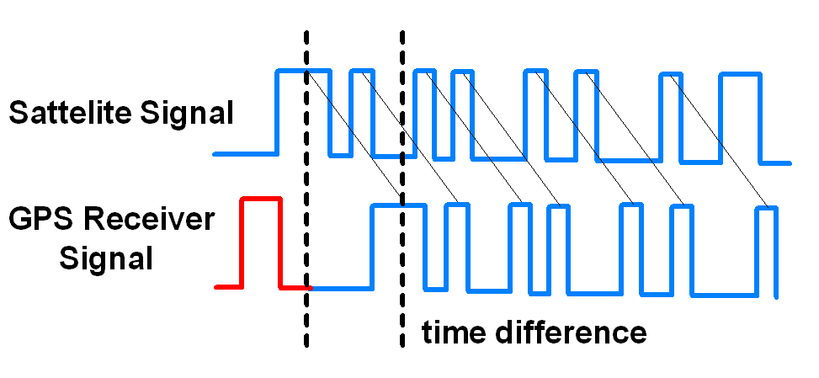

Figure 3.7 GPS Signal Time Difference [7]

The satellite transmits the pseudo code; which is received by the GPS receiver. These two signals are compared and the difference between the signals is the travel time. Now, if the receiver knows the distance from 3 or more satellites and their location (which is sent by the satellites), then it can calculate its location by using [Trilateration](http://electronics.howstuffworks.com/gadgets/travel/gps1.htm) method.

**3.4 GPRS/GSM SIM900A**

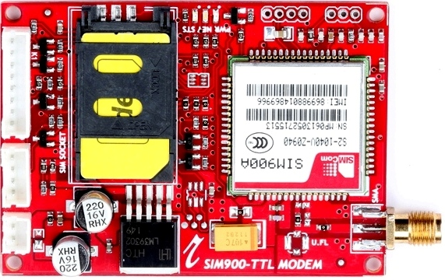

Figure 3.8 GPRS/GSM SIM900A [5]

SIM900A Modem can work with any GSM network operator SIM card just like a mobile phone with its own unique phone number. SIM900A [GSM](https://en.wikipedia.org/wiki/GSM)/[GPRS](https://en.wikipedia.org/wiki/General_Packet_Radio_Service) modem is plug and play modem with RS232 serial communication supported. Hence Advantage of using this modem will be that its RS232 port can be used to communicate and develop embedded applications.

Applications like SMS Control, data transfer, remote control and logging can be developed. SIM900 modem supports features like voice call, SMS, Data/Fax, GPRS etc. SIM900A modem uses AT commands to work with supported [features](http://www.simcom.eu/index.php?m=termekek&prime=1&sub=40&id=0000000155). Note that to be connected to a cellular network, the modem requires a SIM card provided by a network provider.

SIM900A is a dual-band GSM/GPRS engine that works on frequencies EGSM 900MHz and DCS 1800MHz. SIM900A features GPRS multi-slot class 10/ class 8 (optional) and supports the GPRS coding schemes CS-1, CS-2, CS-3 and CS-4.

* **Specification**

|  |  |
| --- | --- |
| **Parameter** | **Range/type** |
| Frequency bands | Dual-Band: EGSM900,DCS1800 |
| Temperature range | -30ºC to +80ºC |
| Coding scheme | CS-1,CS-2,CS-3,CS-4 |
| Data GPRS | * GPSS downlink transfer. Max 85.6 kbps * GPRS data uplink transfer 42.8 kbps. * Integrated TCP/IP Protocol. * Support packet broadcast control channel. * Serial port: 1200bps to 115200bps. |
| Speech codec modes | full rate, echo cancellation, en hanced full rate etc. |
| Audio Feature | Speech code mode:   * Half rate * Full rate * Enhance full rate * Adaptive multi rate * Echo cancellation * Noise separation |
| Serial port and Debug port | 8 wire modem interface with status and control lines, unbalanced, asynchronous  2 wire null modem interface DBG_TXD and DBG_RXD |

Table 3.4 Specification of GPRS SIM900A [5]

* **To use SMS service following AT commands are used:**

|  |  |  |
| --- | --- | --- |
| **Command** | **Description** | **Response** |
| AT+CMGF=<index>  index- 0: PDU       1: Text | Select message format | OK |
| AT+CMGS=”9881xxxxxx” | Send message | ”Type message here” press ‘ctrl+z’ to end msg or ‘ESC’ to exit without sending  OK |
| AT+CMGR=<index> | Read message at that index | +CMGR: “Message Header”  Message Body  OK |
| AT+CMGD=<index> | Delete message at that index | OK (if present at that index) |
| AT+CMGDA=”DEL ALL” | Delete all SMS | OK |

Table 3.5 AT command of GPRS/GSM SIM900A [5]

# **433 MHz RF Transmitter Module**

There are occasions where communication will be required between two devices, either in a duplex/transceiver based operation (where both devices can transmit and receive at the same time) or in a simplex-based operation where communication is one way (Receiving device cannot transmit and the transmitting device cannot receive).

Several options exist for implementing any of the two communication modes mentioned above and the selection of a particular option usually depends on the specification of the project, especially the distance between the devices and cost. For short range, low-budget communication between two microcontrollers, one of the most preferred medium used is Radio Frequency (RF) communication using the 433MHz RF transmitter and receiver modules.

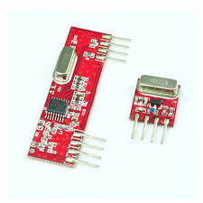

Figure 3.9 433MHz Transmitter and Receiver [9]

These modules are very popular among makers and DIY enthusiasts due to their low cost and ease of use. We are used in all forms of short-range, simplex-based communication between two microcontrollers with one of the microcontroller serving as the transmitter while the other serves as the receiver. These modules are **ASK** (Amplitude Shift Keying) or **OOK** (Of Hook Keying) type RF modules, that means they usually draw no power when transmitting a Logic “zero” and as such consumes a significantly low amount of power. This low power consumption makes them very useful in battery-based implementations.

* **Specification** **of RF Transmitter and Receiver**:
* Working voltage: 3V – 12V
* Working current: max Less than 40mA max, and min 9mA
* Resonance mode: (SAW)
* Modulation mode: ASK
* Working frequency: 433.92MHz
* Transmission power: 25mW
* Frequency error: +150kHz (max)
* Velocity: less than 10Kbps
* Transmission range: 90m (in open space)

**Chapter 4: Flow chart and Block diagram**

**4.1 Block diagram:**

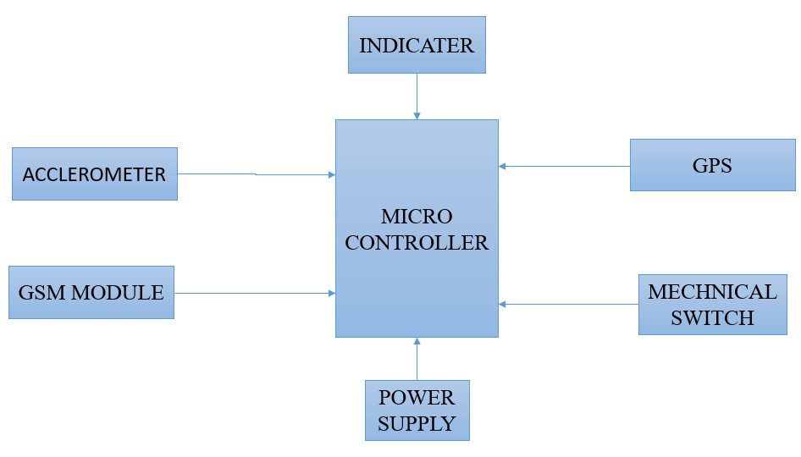

Figure 4.1 block diagram

**4.2 Flow chart:**

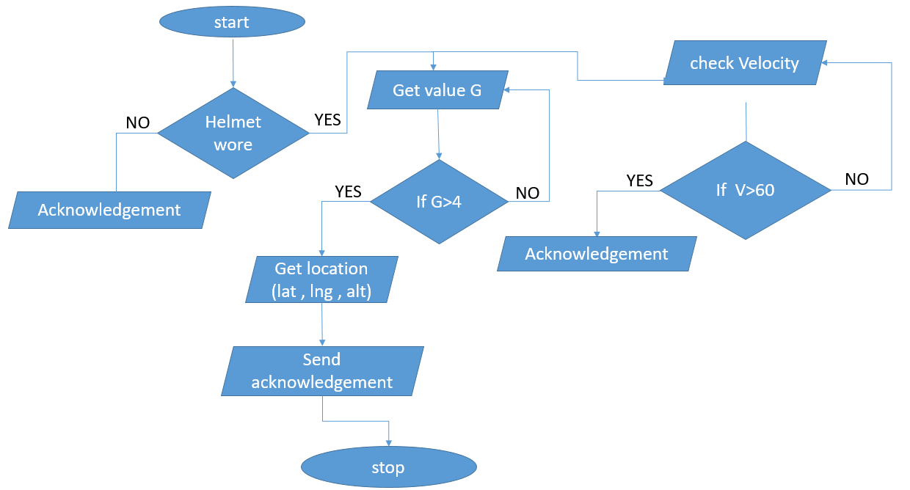

Figure 4.2 flow chart

**Chapter 6: Result**

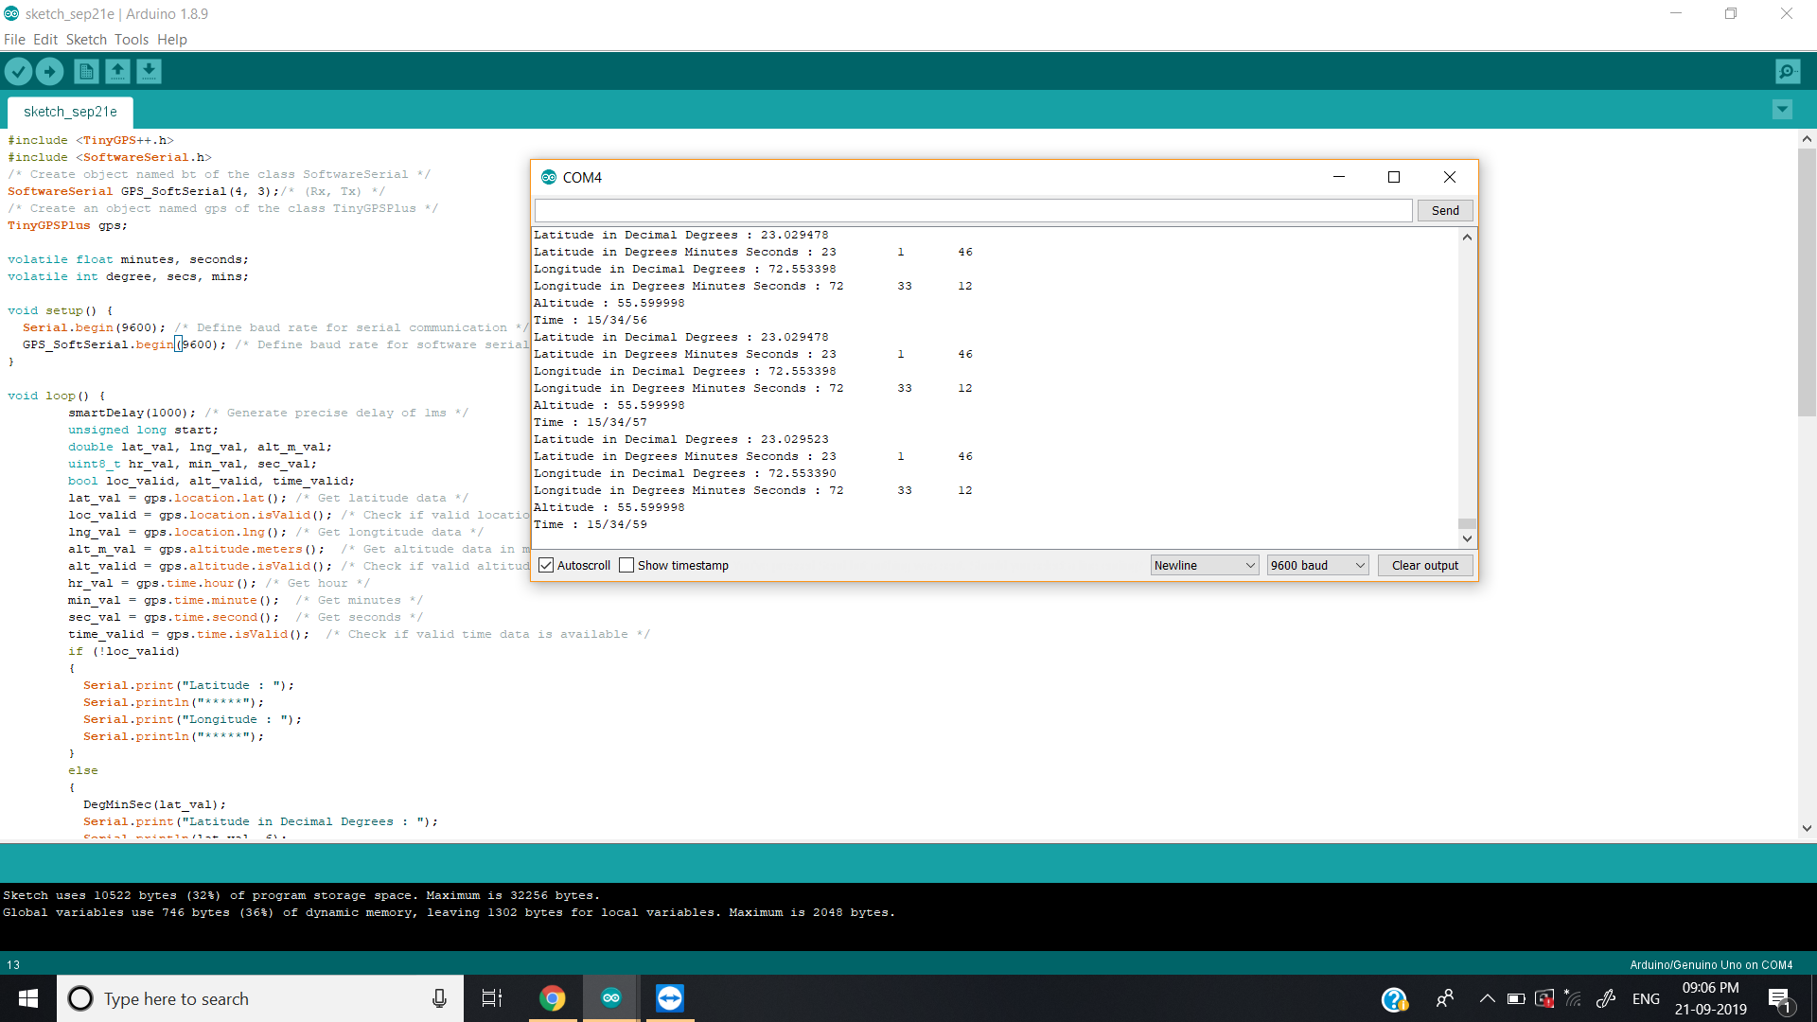

Figure 5.1 Result of accelerometer

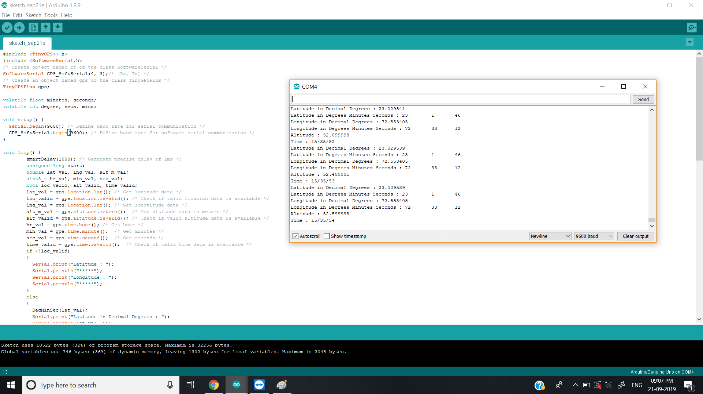

Figure 5.2 Result of GPS and GSM

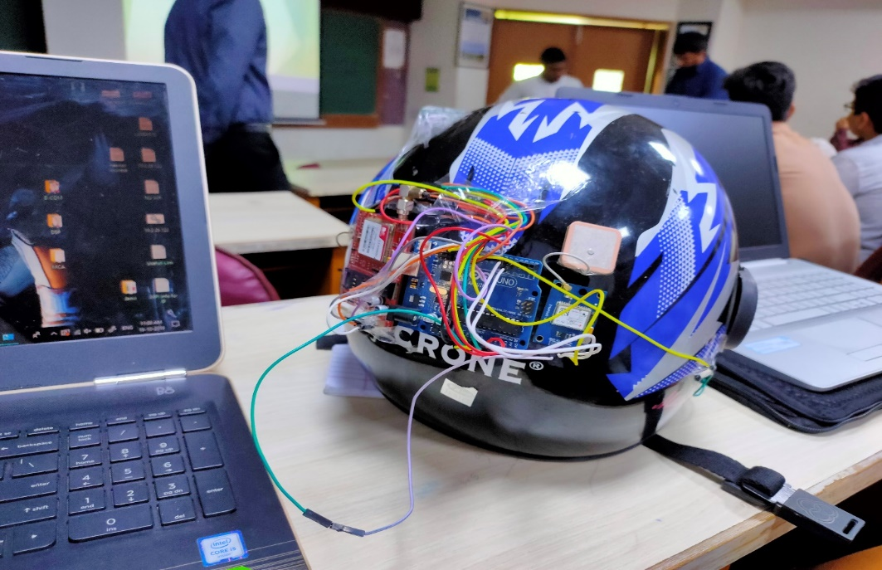

Figure 5.3 Final [implementation](https://www.google.com/search?rlz=1C1CHBF_enIN845IN845&sxsrf=ACYBGNQJmmvxoCFA5N2YQweembHFSDFHMQ:1574230276715&q=implementation&spell=1&sa=X&ved=2ahUKEwj3tMDjkPjlAhXYXCsKHfF6CrQQkeECKAB6BAgPECc)

* **Conclusion :**

In this project, we designed smart helmet, which is used to provide safety of human. To avoid accidents and encourage people to wear helmet, proposed design is to be introduced and includes, Arduino (Atmega328) microcontroller, interface of GSM technology (Arduino GSM Shield) that is used to give information by sending message and it includes GPS location tracker by which we can send its perfect location and also for the case if there is an accident. It also checks, whether the helmet is weared or not and it controls the speed limit by using the accelerometer.

### **References:**

1. R Prudhvi Raj, Kanth Sri Krishna, K BhargavAdityaBharath, "“Smart-tec Helmet” Electrical and Electronics Engineering GITAM University Rushikonda Visakhapatnam India", A dvance in Electronic and Electric Engineering, vol. 4, pp. 493-498, 2014.
2. Rashmi Vashisth, Sanchit Gupta, Aditya Jain, Sarthak Gupta, Prashant Rana Sahil, "Implementation and analysis of smart helmet", 2017 4th International Conference on Signal Processing Computing and Control (ISPCC).
3. P. THARANGAI THAMIL, S. VANITHA, "Survey on Rash Driving Detection Using Acceleration and Orientation Sensors", vol. 4, no. 3, March 2015, ISSN 2278 – 0882.
4. MHRD "A survey on Road Accident Detection and Reporting", vol. 7, no. 4, April 2016.
5. Electronicwings, 101, Parijat Building, Baner Pashan Link Road, Pashan, Pune, 411021. Accessed on: Nov.20, 2019. [Online]. Available:https://electronicwings.com/sensors-modules/sim900a-gsmgprs-module.
6. Electronicwings, 101, Parijat Building, Baner Pashan Link Road, Pashan, Pune, 411021. Accessed on: Nov.20, 2019. [Online]. Available : <https://www.electronicwings.com/sensors-modules/adxl335-accelerometer-module>
7. Electronicwings, 101, Parijat Building, Baner Pashan Link Road, Pashan, Pune, 411021. Accessed on: Nov.20, 2019. [Online]. Available : <https://www.electronicwings.com/sensors-modules/gps-receiver-modules>
8. Accessed on: Nov.20, 2019. [Online]. Available : <https://www.arduino.cc/en/Tutorial/HomePage>
9. Accessed on: Nov.20, 2019. [Online]. Available : <https://lastminuteengineers.com/433mhz-rf-wireless-arduino-tutorial/>