**String**

* String represents a sequence of characters as an object of the class.
* String stores the characters as a sequence of bytes with the functionally of allowing access to the single-byte character.
* **character:** A character array is simply an array of characters that can be terminated by a null character.

**Functions: Cstring Library**

**Copying**:

[**memcpy**](https://cplusplus.com/reference/cstring/memcpy/)

Copy block of memory (function )

[**memmove**](https://cplusplus.com/reference/cstring/memmove/)

Move block of memory (function )

[**strcpy**](https://cplusplus.com/reference/cstring/strcpy/)

Copy string (function )

[**strncpy**](https://cplusplus.com/reference/cstring/strncpy/)

Copy characters from string (function )

**Concatenation**:

[**strcat**](https://cplusplus.com/reference/cstring/strcat/)

Concatenate strings (function )

[**strncat**](https://cplusplus.com/reference/cstring/strncat/)

Append characters from string (function )

**Comparison**:

[**memcmp**](https://cplusplus.com/reference/cstring/memcmp/)

Compare two blocks of memory (function )

[**strcmp**](https://cplusplus.com/reference/cstring/strcmp/)

Compare two strings (function )

[**strcoll**](https://cplusplus.com/reference/cstring/strcoll/)

Compare two strings using locale (function )

[**strncmp**](https://cplusplus.com/reference/cstring/strncmp/)

Compare characters of two strings (function )

[**strxfrm**](https://cplusplus.com/reference/cstring/strxfrm/)

Transform string using locale (function )

**Searching**:

[**memchr**](https://cplusplus.com/reference/cstring/memchr/)

Locate character in block of memory (function )

[**strchr**](https://cplusplus.com/reference/cstring/strchr/)

Locate first occurrence of character in string (function )

[**strcspn**](https://cplusplus.com/reference/cstring/strcspn/)

Get span until character in string (function )

[**strpbrk**](https://cplusplus.com/reference/cstring/strpbrk/)

Locate characters in string (function )

[**strrchr**](https://cplusplus.com/reference/cstring/strrchr/)

Locate last occurrence of character in string (function )

[**strspn**](https://cplusplus.com/reference/cstring/strspn/)

Get span of character set in string (function )

[**strstr**](https://cplusplus.com/reference/cstring/strstr/)

Locate substring (function )

[**strtok**](https://cplusplus.com/reference/cstring/strtok/)

Split string into tokens (function )

**Other**:

[**memset**](https://cplusplus.com/reference/cstring/memset/)

Fill block of memory (function )

[**strerror**](https://cplusplus.com/reference/cstring/strerror/)

Get pointer to error message string (function )

[**strlen**](https://cplusplus.com/reference/cstring/strlen/)

Get string length (function )

**Advantage:**

**Disadvantage:**

**Application:**

Spell Checkers

Spam filters

Search engines

Digital forensics

Information retrieval systems

**Difference between string and character**

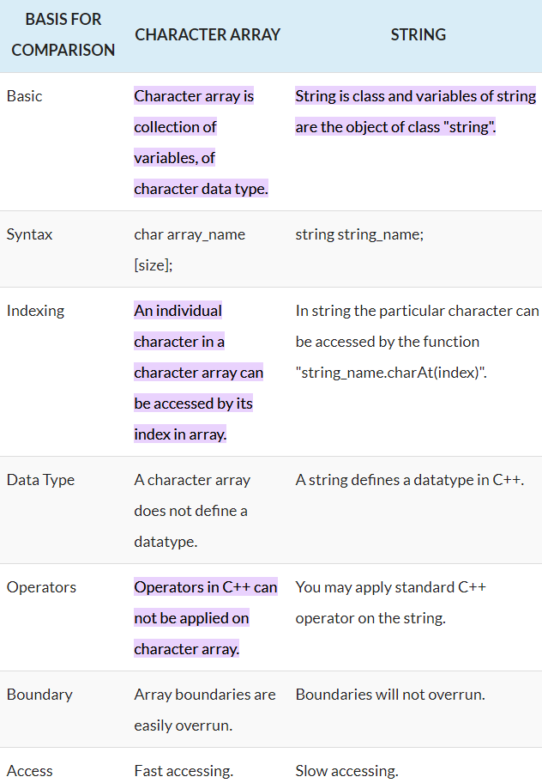

**\*\*\*\*\*\*\*\*\*\*\*\*\*\* Operation on String \*\*\*\*\*\*\*\*\*\*\*\*\*\*\*\*\*\*\*\***

**Input functions:**

**getline**: used to store a stream of characters as entered by the user in the object memory.

**Push**_**back**: used to input a character at the end of the string

**Pop**_**back**: Used to delete the last character from the string

**Capacity**: This function returns the capacity allocated to the string, which can be equal to or more than the size of the string.

**Resize**: This function changes the size of the string, the size can be increased or decreased.

**Length**: This function finds the length of the string.

**Shrink**_**to**_**fit**: This function decreases the capacity of the string and makes it equal to the minimum capacity of the string.

**Begin**: this function returns an iterator to the beginning of the string.

**End**: This function returns an iterator to the end of the string.

**Rbegin**: This function returns a reverse iterator pointing at the end of the string.

**Rend**: This function returns a reverse iterator pointing at beginning of the string.

**copy**(“char array”, len, pos): This function copies the substring in the target character array mentioned in its arguments.

**Swap**:

At:

**Front:**

**Back:**

**Append:**

**Find:**

**Find_first_of**

**Find_last_of**

**Substr:**

**Erase:**

**Replace:**

**Compare:**

**Two pointer**

**Palindrome based problems**

**Sliding window technique**

Sliding window technique is useful for solving problems in array or string, especially it is considered as a technique that could reduce the time complexity from O(n²) to O(n).

The Sliding Window algorithm is one way programmers can move towards simplicity in their code.

**Frequency based problems**