**Lab6**

# Compare the performance of using memcpy, pinned memory, and UVM (also with different hints of UVM). You can simply use the code of the previous assignments (e.g., MatrixMul or VectorAdd) with timing measurements and replace their memory allocation method. Make sure you also include the time spent on memcpy for a fair comparison, since pinned memory and UVM do not need that. Rather, their data transfer overhead is amortized on each memory access or each page miss.

**Also, you should test with data sets of different sizes (e.g., 32B, 64B, ..., 2GB) for this experiment.**

#include <time.h> #include <stdio.h> #include <stdlib.h>

global void VecAdd(const float *A, const float *B, float* C, long unsigned int n) { long unsigned int ID = blockIdx.x * blockDim.x + threadIdx.x;

if (ID < n)

C[ID] = A[ID] + B[ID];

}

int main (int argc, char *argv[]){ float *A_h, *B_h, *C_h;

float *A_d, *B_d, *C_d;

int blockSize, gridSize;

long unsigned int VecSize, Limit = (1 << 25); // Limit 32MB. //maximum = 256 MB (32 MB * 4 bytes)

FILE *fp = fopen("results.csv", "w"); fprintf(fp,"Method, Size, Time\n");

printf("\nCudaMemcpy Test\n");

for(VecSize = 8; VecSize <= Limit; VecSize *= 2){ clock_t start = clock(); //Starts

A_h = (float*) malloc( sizeof(float) * VecSize ); B_h = (float*) malloc( sizeof(float) * VecSize ); C_h = (float*) malloc( sizeof(float) * VecSize );

for (long unsigned int i=0; i < VecSize; i++) { A_h[i] = 1.0f;

B_h[i] = 2.0f;

}

cudaDeviceSynchronize();

cudaMalloc(&A_d, sizeof(float) * VecSize); cudaMalloc(&B_d, sizeof(float) * VecSize); cudaMalloc(&C_d, sizeof(float) * VecSize);

cudaMemcpy(A_d, A_h, sizeof(float) * VecSize, cudaMemcpyHostToDevice); cudaMemcpy(B_d, B_h, sizeof(float) * VecSize, cudaMemcpyHostToDevice);

cudaDeviceSynchronize(); blockSize = 32;

gridSize = (int)ceil((float)VecSize/blockSize);

VecAdd<<<gridSize, blockSize>>>(A_d, B_d, C_d, VecSize); cudaMemcpy(C_h, C_d, sizeof(float) * VecSize, cudaMemcpyDeviceToHost); cudaDeviceSynchronize();

free(A_h); free(B_h); free(C_h);

cudaFree(A_d); cudaFree(B_d); cudaFree(C_d);

cudaDeviceSynchronize(); clock_t end = clock(); //Ends

printf("\nPinned Memory(cudaHostAlloc) Test\n"); for(VecSize = 8; VecSize <= Limit; VecSize *= 2){

clock_t start = clock(); //Starts cudaDeviceSynchronize();

cudaHostAlloc(&A_h, sizeof(float) * VecSize, cudaHostAllocDefault); cudaHostAlloc(&B_h, sizeof(float) * VecSize, cudaHostAllocDefault); cudaHostAlloc(&C_h, sizeof(float) * VecSize, cudaHostAllocDefault);

for (long unsigned int i=0; i < VecSize; i++) { A_h[i] = 1.0f;

B_h[i] = 2.0f;

}

cudaHostGetDevicePointer(&A_d, A_h, 0);

cudaHostGetDevicePointer(&B_d, B_h, 0);

cudaHostGetDevicePointer(&C_d, C_h, 0); cudaDeviceSynchronize();

blockSize = 32;

gridSize = (int)ceil((float)VecSize/blockSize); VecAdd<<<gridSize, blockSize>>>(A_d, B_d, C_d, VecSize); cudaDeviceSynchronize();

cudaFreeHost(A_h); cudaFreeHost(B_h); cudaFreeHost(C_h);

A_d = NULL; B_d = NULL; C_d = NULL;

cudaDeviceSynchronize(); clock_t end = clock(); //Ends

//Measure Data

double elasped_secs = (((double) end - (double) start) / CLOCKS_PER_SEC) * 1000000; printf("Size: %ld, Time: %f us\n", sizeof(float) * VecSize, elasped_secs);

fprintf(fp,"%s, %ld, %f\n", "CudaMemcpy", sizeof(float) * VecSize, elasped_secs);

}

printf("\nUnified Virtual Memory(cudaMallocManaged) Test\n"); for(VecSize = 8; VecSize <= Limit; VecSize *= 2){

clock_t start = clock(); //Starts

cudaDeviceSynchronize();

cudaMallocManaged(&A_h, sizeof(float) * VecSize); cudaMallocManaged(&B_h, sizeof(float) * VecSize); cudaMallocManaged(&C_h, sizeof(float) * VecSize);

for (long unsigned int i=0; i < VecSize; i++) { A_h[i] = 1.0f;

B_h[i] = 2.0f;

}

cudaDeviceSynchronize(); blockSize = 32;

gridSize = (int)ceil((float)VecSize/blockSize);

VecAdd<<<gridSize, blockSize>>>(A_h, B_h, C_h, VecSize); cudaDeviceSynchronize();

cudaFree(A_h);

cudaFree(B_h); cudaFree(C_h);

cudaDeviceSynchronize(); clock_t end = clock(); //Ends

//Measure Data

double elasped_secs = (((double) end - (double) start) / CLOCKS_PER_SEC) * 1000000; printf("Size: %ld, Time: %f us\n", sizeof(float) * VecSize, elasped_secs);

fprintf(fp,"%s, %ld, %f\n", "cudaMallocManaged", sizeof(float) * VecSize, elasped_secs);

}

fclose(fp);

return 0;

}

Observation:



1200000

1000000

800000

600000

400000

200000

0

CudaMemcpy

cudaHostAlloc

cudaMallocManaged

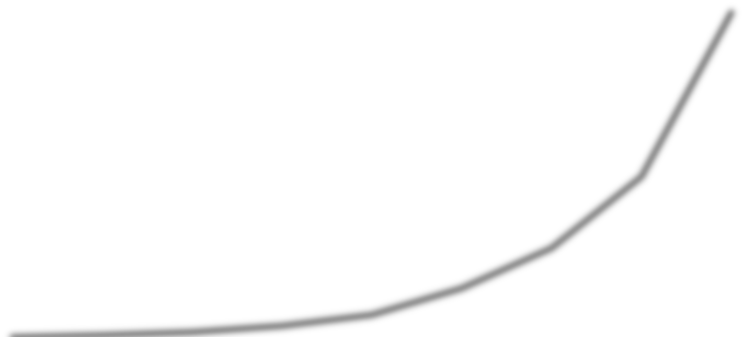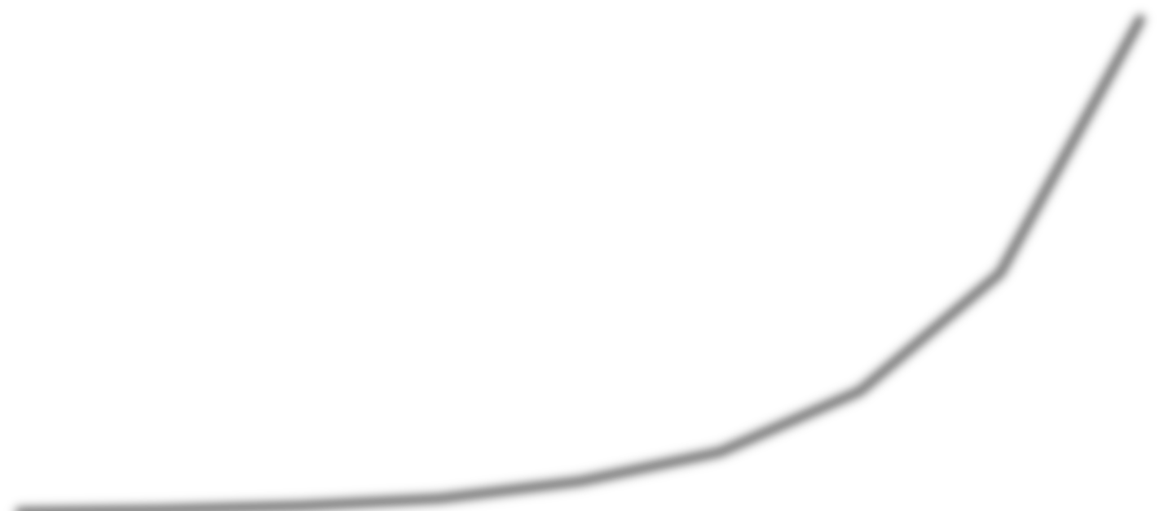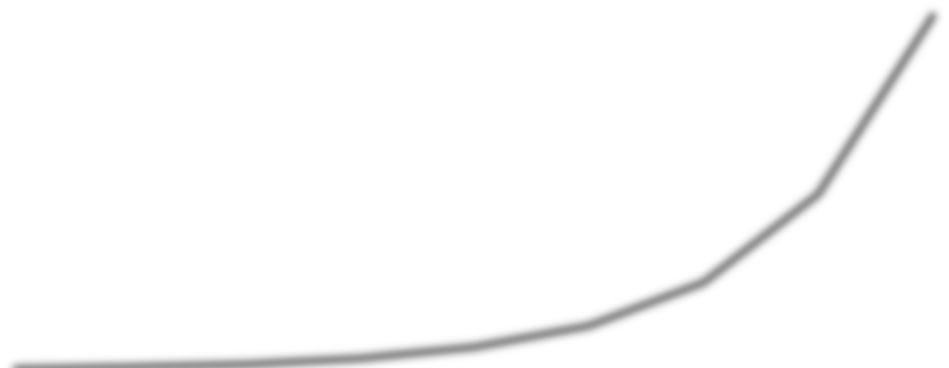

1200000

1000000

800000

600000

400000

200000

0

CudaMemcpy

cudaHostAlloc

cudaMallocManaged

32

64

128

256

512

1024

2048

4096

8192

16384

32768

65536

131072

262144

524288

1048576

2097152

4194304

8388608

16777216

33554432

67108864

134217728

524288

1048576

2097152

4194304

8388608

16777216

33554432

67108864

134217728

**Output Table**

|  |  |  |  |  |
| --- | --- | --- | --- | --- |
| **Size (bytes)** | **Size** | **CudaMemcpy (Memcpy Method)** | **cudaHostAlloc (Pinned Memory Method)** | **cudaMallocManaged (Unified Virtual Memory Method)** |
| 32 | 32 Bytes | 73669 | 1429 | 1129 |
| 64 | 64 Bytes | 1413 | 1161 | 1016 |
| 128 | 128 Bytes | 1198 | 1112 | 964 |
| 256 | 256 Bytes | 1344 | 1113 | 871 |
| 512 | 512 Bytes | 1129 | 1095 | 954 |
| 1024 | 1KB | 1136 | 1090 | 958 |
| 2048 | 2 KB | 1158 | 1104 | 933 |
| 4096 | 4 KB | 1182 | 1168 | 889 |
| 8192 | 8 KB | 1325 | 1229 | 975 |
| 16384 | 16 KB | 1360 | 1287 | 1191 |
| 32768 | 32 KB | 1645 | 1370 | 1235 |
| 65536 | 64 MB | 1848 | 1519 | 1520 |
| 131072 | 128 KB | 1952 | 1967 | 2027 |
| 262144 | 256 KB | 2984 | 2837 | 2802 |
| 524288 | 512 KB | 6170 | 5055 | 4698 |
| 1048576 | 1 MB | 12412 | 10026 | 8822 |
| 2097152 | 2 MB | 22419 | 16944 | 15810 |
| 4194304 | 4 MB | 41976 | 32801 | 30352 |
| 8388608 | 8 MB | 75276 | 65556 | 57874 |
| 16777216 | 16 MB | 158646 | 124417 | 109865 |
| 33554432 | 32 MB | 283186 | 245548 | 215942 |
| 67108864 | 64 MB | 506180 | 481251 | 430665 |
| 134217728 | 128 MB | 1016017 | 987726 | 865884 |



2500000

2000000

2215625

1988805

1500000

1757376

Total

1000000

500000

0

cudaHostAlloc

cudaMallocManaged

CudaMemcpy

* For the fair comparison we have taken the overall time period of memcpy method, pinned memory method, Unified Virtual Memory method.
* As per the Output, we can see that time taken for memory

allocation and then free them takes higher time in memcpy method then in pinned Memory method (cudaHostAlloc) and then in Unified memory method (cudaMallocManaged).

* For this observation, the graph is plotted between size of allocation from 32 bytes to 128 Megabytes and different methods for allocation.