|  |  |  |  |  |
| --- | --- | --- | --- | --- |
| **Validation Accuracy** | | | | |
| **Dimensions Reduced to** | **32** | **64** | **128** | **256** |
| Architecture 1:-  (64-32-16) | 98.23 | 98.55 | 98.39 | 98.13 |
| Architecture 2:-  (32-16-8) | 97.99 | 98.18 | 97.86 | 97.73 |
| Architecture 3:-  (128-64-32) | 98.03 | 98.36 | 98.41 | 97.89 |

TASK-3

1 Hidden Layers

TASK-4

|  |  |  |  |  |
| --- | --- | --- | --- | --- |
| **Validation Accuracy** | | | | |
| **Dimensions Reduced to** | **32** | **64** | **128** | **256** |
| Architecture 1:-  (64-32-16) | 98.23 | 98.55 | 98.39 | 98.13 |
| Architecture 2:-  (32-16-8) | 98.16 | 98.88 | 98.35 | 97.89 |
| Architecture 3:-  (128-64-32) | 98.18 | 98.47 | 97.97 | 97.89 |

3 Hidden Layers

Best Architecture based on Validation Accuracy is 64-32-16.

TASK-4

CM & Test Accuracy for Best Architectures [3 Hidden layer AutoEncoder]

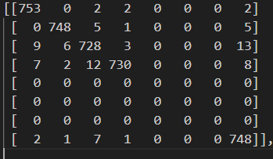 32 Acc:97.25

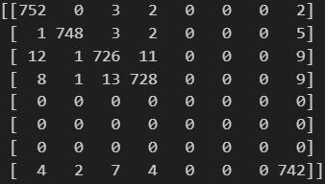 64 Acc: 97.39

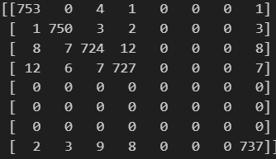 128 Acc :97.26

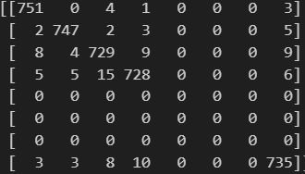 256 Acc :97.23

TASK-3

CM & Test Accuracy for Best Architectures [1 Hidden layer AutoEncoder]

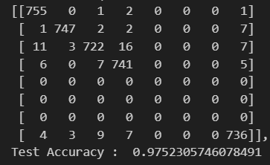 256

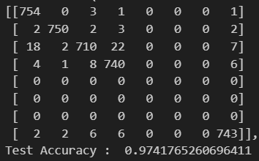 128

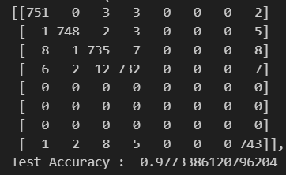 64

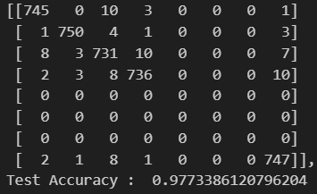 32

TASK-2

Single Hidden layer Encoder

Training Images

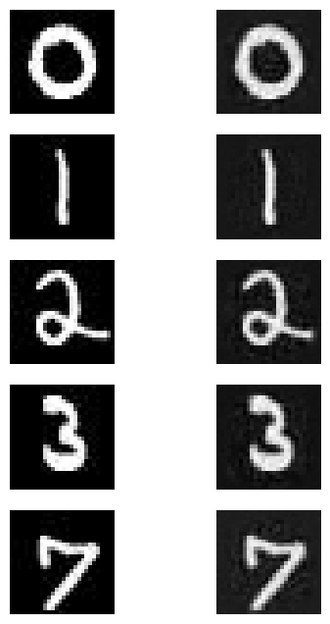 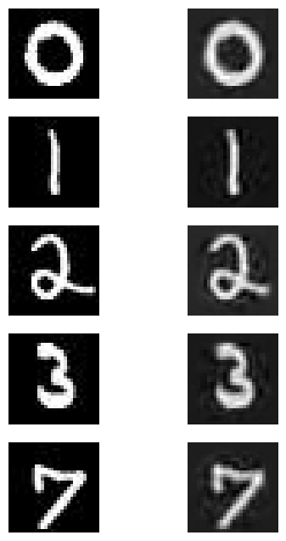 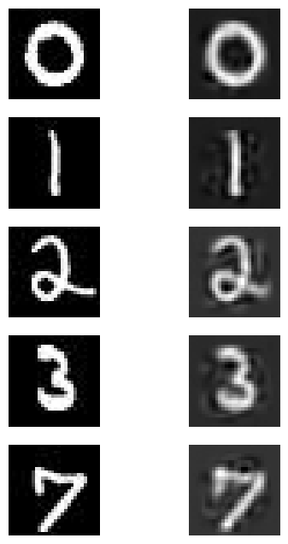 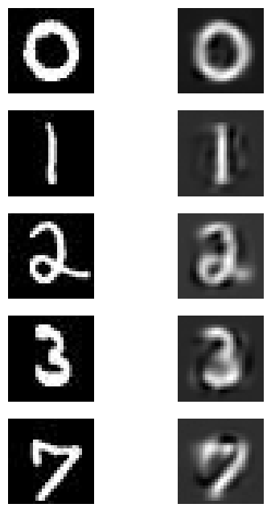

256 128 64 32

Validation Images

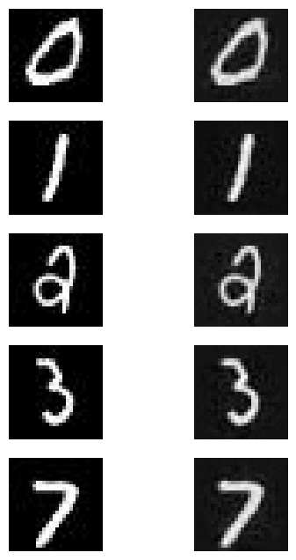 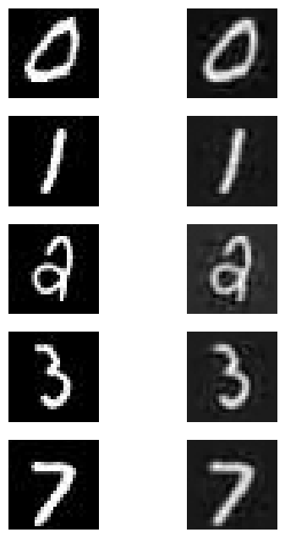 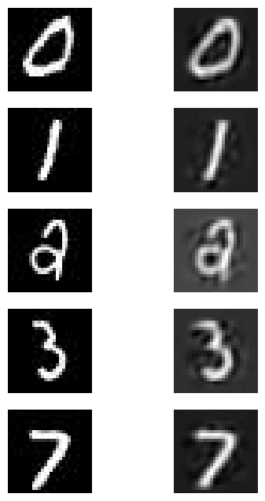 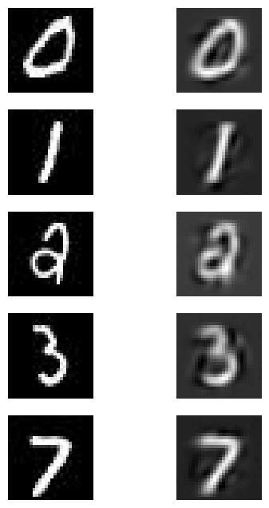

Test Images

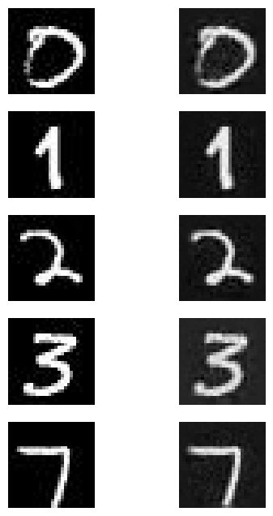 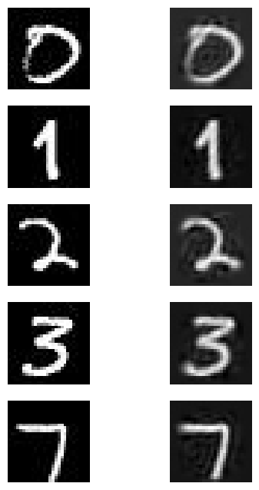 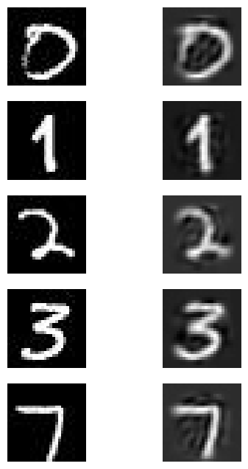 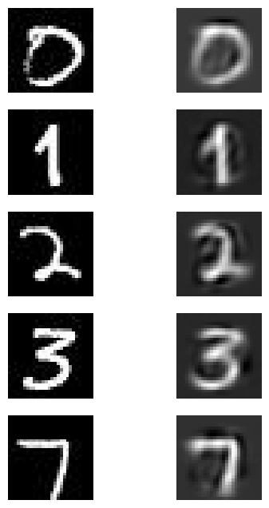

3 Hidden Layer Encoder

Training Images

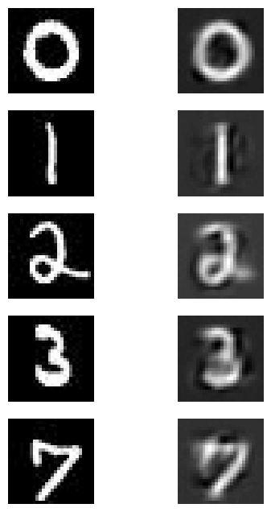 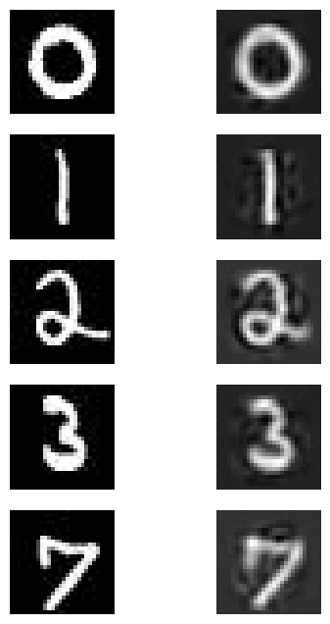 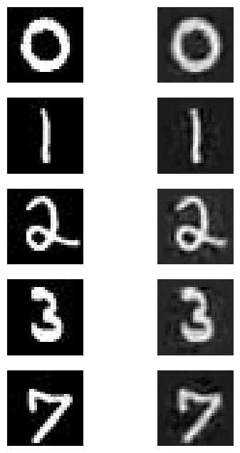 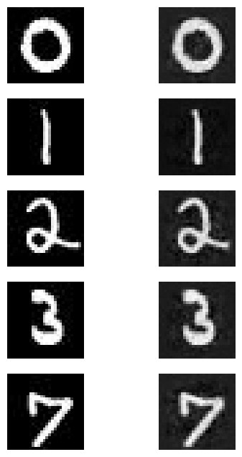

32 64 128 256

Validation Images

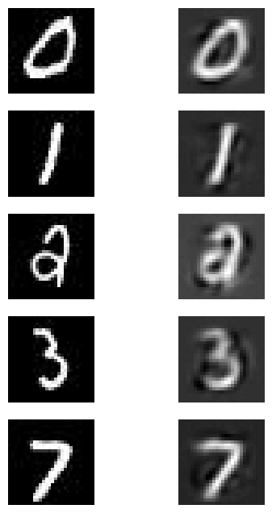 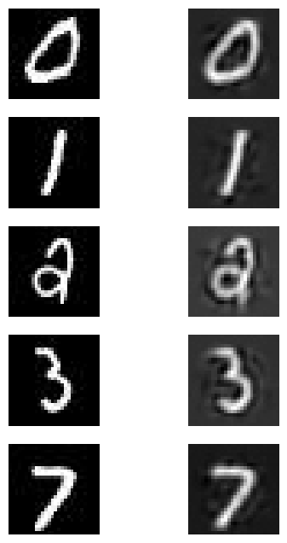 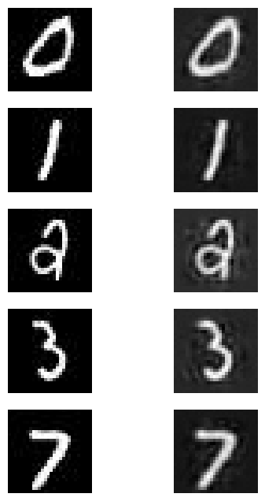 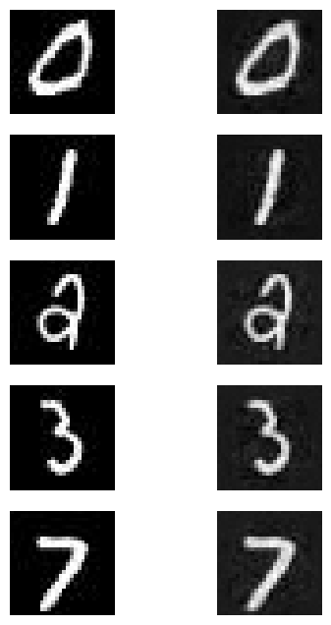

Testing Images

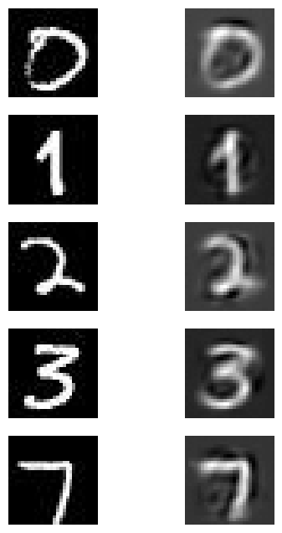 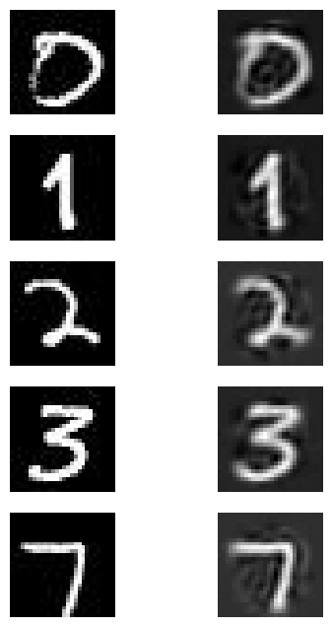 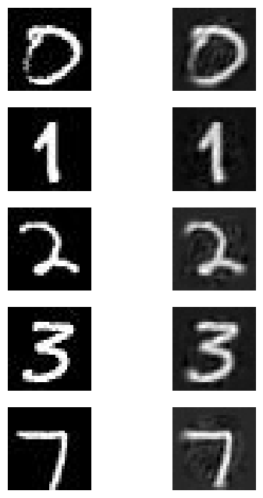 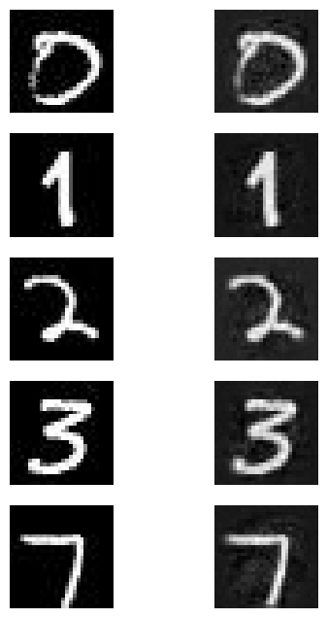

TASK 2

3 hidden layer Auto Encoder :

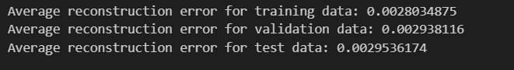 256

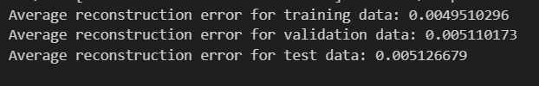 128

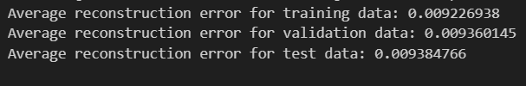 64

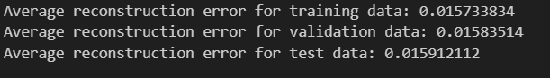 32

1 Hidden Layer Auto Encoder

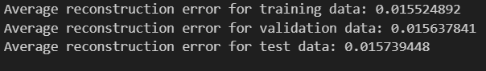 32

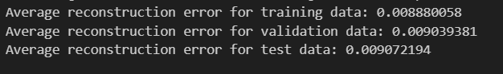 64

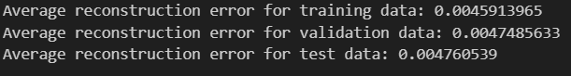 128

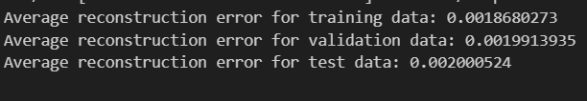 256

TASK 5

Based on Test accuracy best architecture of 1 Hidden layer Autoencoder was found to be the one with 64 neurons in hidden layer.

20% Noise in Input

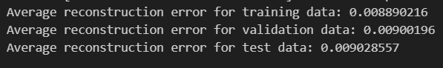

Training Validation Testing

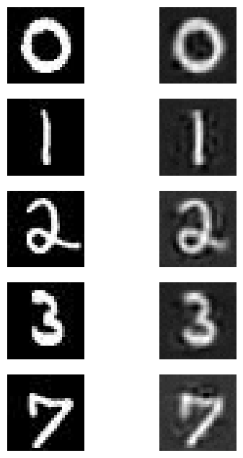 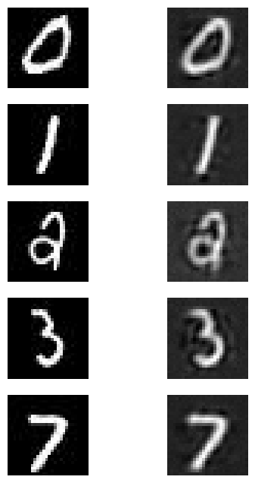 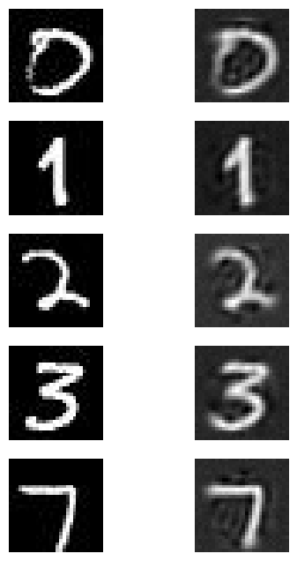

|  |  |
| --- | --- |
| **Test Dataset** | |
| **Architectures** | **64** |
| 64-32-16 | 97% |
| 32-16-8 | 98.3% |
| 128-64-32 | 97.78% |

**Classification Accuracy**

**20% noise**

|  |  |
| --- | --- |
| **Validation Dataset** | |
| **Architectures** | **64** |
| 64-32-16 | 98% |
| 32-16-8 | 98.1% |
| 128-64-32 | 98.2% |

40% Noise in Input

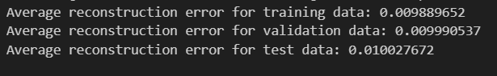

Training Validation Testing

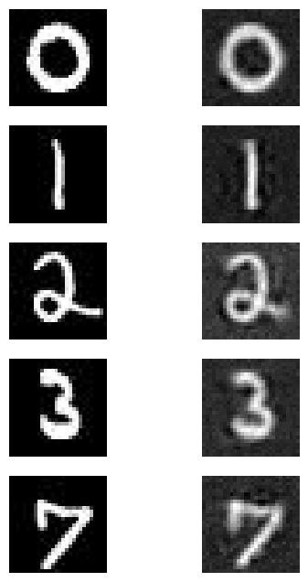 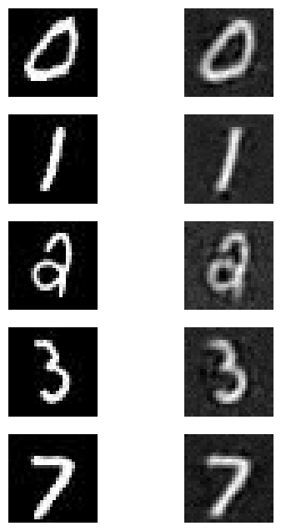 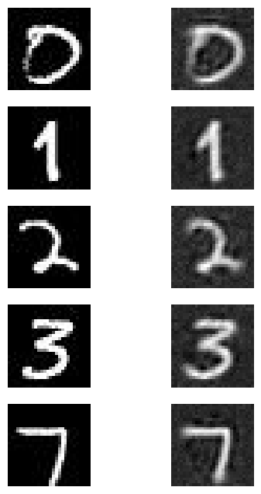

**Classification Accuracy**

|  |  |
| --- | --- |
| **Validation Dataset** | |
| **Architectures** | **64** |
| 64-32-16 | 98.10% |
| 32-16-8 | 97.78% |
| 128-64-32 | 98.34% |

|  |  |
| --- | --- |
| **Test Dataset** | |
| **Architectures** | **64** |
| 64-32-16 | 97.54% |
| 32-16-8 | 97.42% |
| 128-64-32 | 97.86% |

