|  |  |  |  |
| --- | --- | --- | --- |
| Architecture | Training Accuracy | Validation Accuracy | Confusion Matrix |
| 1 | 95.2 | 72 | [12 2 0 3 3]  [ 3 11 0 4 2]  [ 3 3 8 2 4]  [ 1 1 0 16 2]  [ 1 4 1 1 13] |
| 2 | 96 | 76 | [[12 2 0 3 3]  [ 4 11 4 1 0]  [ 3 1 13 1 2]  [ 2 1 0 17 0]  [ 1 2 0 3 14]] |
| 3 | 100 | 84 | [[17 0 1 1 1]  [ 0 12 3 5 0]  [ 1 1 18 0 0]  [ 1 0 0 19 0]  [ 2 2 0 0 16]] |

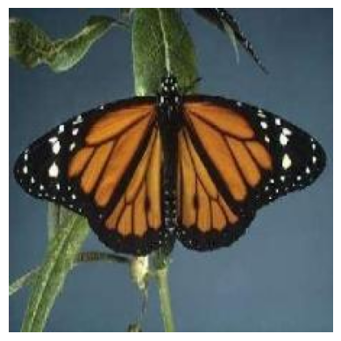

OG

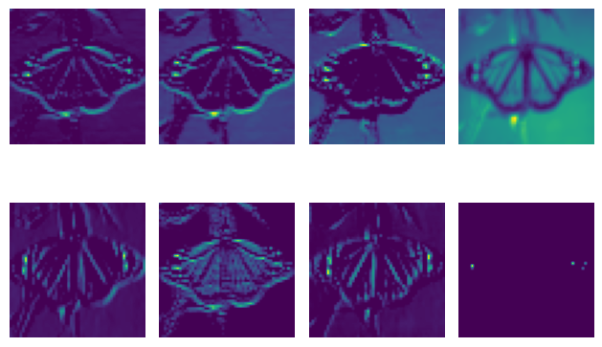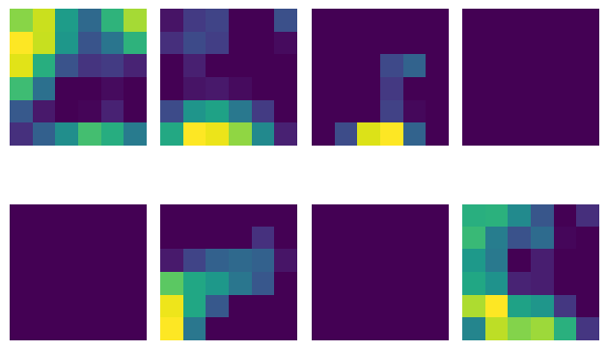

1st Conv Layer 4th Conv Layer

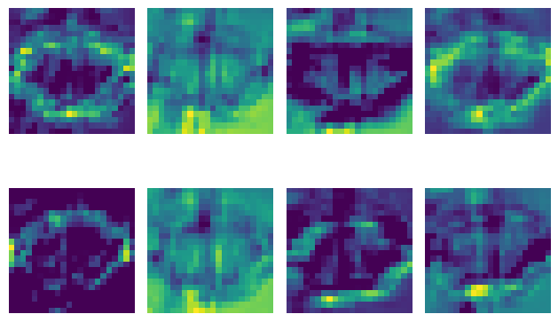 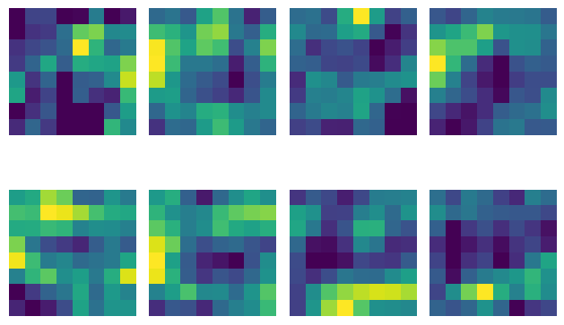

2nd Conv Layer 3rd Conv Layer

VGG Results

1. Training Accuracy : 98%
2. Validation Accuracy : 96%
3. Testing Accuracy :96%

[[17 3 0 0 0]

[ 0 20 0 0 0]

[ 0 0 20 0 0]

[ 0 0 0 20 0]

[ 0 1 0 0 19]] Test Confusion Matrix