EC302 

COURSE: DIGITAL CIRCUITS

**DIGITAL CLOCK**

horizontal line

# 

# C:\Users\KASHYAP\Downloads\IMG-20181030-WA0008.jpg

# MADE BY :

# KASHYAP ADODARIYA (17BEC004)

# 

# 

# Index

|  |  |  |
| --- | --- | --- |
| Sr.no. | Title | Page no. |
| 1. | Introduction | 3 |
| 2. | Module structure | 4 |
| 3. | **Circuit diagram** | 5 |
| 4. | Description of circuit diagram | 6 |
| 5. | Component used | 7 |
| 6. | Conclusion | 14 |

# Introduction

This project is automatic electronics circuit ,which consists of several components like Seven segment display, 4026 counter ic ,555 timer ic ,switches etc…

The circuit shown in report which design in PROTEOUS circuit designing software. In controlling, several push buttons are used to set different times. Section the minute section increases its count by one. Similarly, for each cycle of 00 to 59 in minute section the hour section increases its count by one. In this way when the clock reaches 23 hrs. 59 mines, each of the section resets to 00 giving us a display 00.00 popularly known as the 0th hour.

We know that 60 seconds equal to 1 minute and 60 minutes equal to 1hour. Hence, the minute section is drive timer and hour section by the minute section. Minute section has been designed to give a count from 00to 59 after which it resets to 00. And the hour section to give a count from 00 to 23 hours after which it resets to 00. For each cycle of

00 to 59 in second.

Module structure

The entire project has been divided into four modules. They are as follows:

* Second section:  
  Using two counter ICs (IC 7490) in such a way that this portion produces output from 00 to 59 continuously with a frequency of 1 Hz (1pps).Using Driver IC (IC 7447) and seven-segment display the counts. Both the ICs are of common anode type.  
  Checking the output of the circuit.
* Minute section:  
  Repeating the same circuit as that of the second section, but here the output should count from 00 to 59 with a frequency of 1Hz.for 1 ppm.   
  Checking the output.
* Hour section:  
  Designing the circuit in such a way so that the output resets to 00automatically displaying 23.59.59.Here the counting proceeds with a frequency of one pulse per hour.  
  Checking the output.
* Assembling the three sections together.  
   Checking the output the final circuit

Circuit diagram

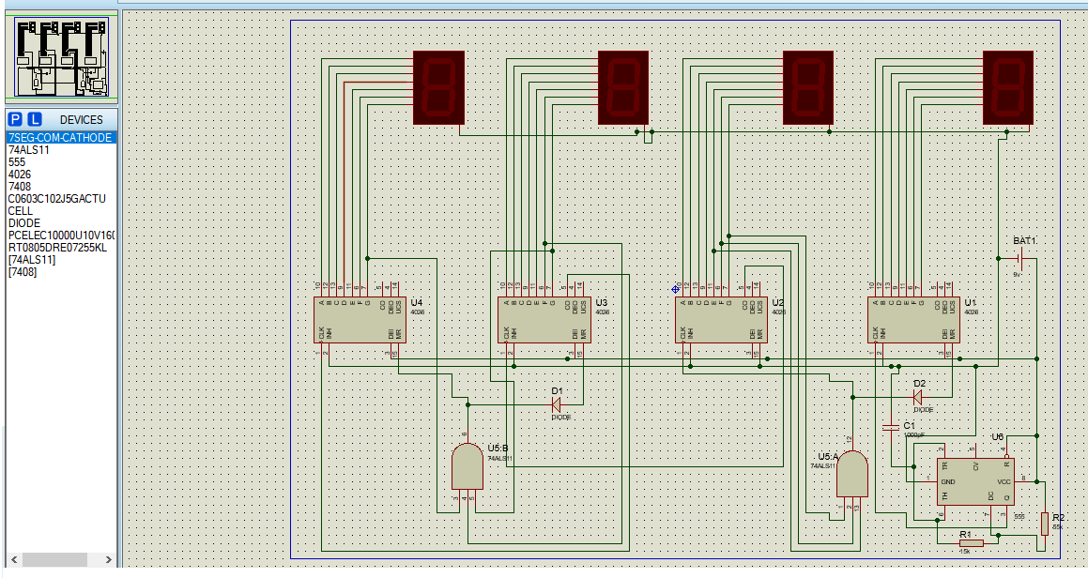

Description of circuit diagram

Circuit starts with 555 timer to generate clock. Here we have used the timer as 1-minute clock.

Next, output from pin 3 is given as input to pin 1 of 4026 counter ic , which have separate 7 pins for seven segment display.so such a way each ic is connected to each digit seven segment display. Same way another such combination of one seven segment and 4026 IC is connected to earlier first digit combination.

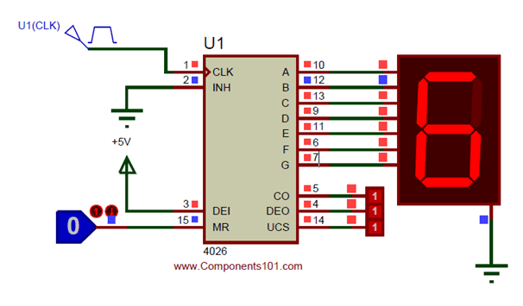

Fig: single combination of seven segment & 4026 ic

Now, push button switches are connected for the purpose of set reset operations of minute section of clock.

From here onward, 4026 ics are connected for hour outputs

COMPONENTS

|  |  |
| --- | --- |
| Components Name | no. |
| 4026 IC counter with 7 segment decoder | 4 |
| 7 segment common cathode display | 4 |
| 7408 IC And gate | 1 |
| 555 IC timer | 1 |
| Resistor (55k,15k) | 3 |
| Capacitors | 1 |
| Didoes (npn) | 2 |
| Push button | 3 |
| Battery | 1 |
| Jumper cable |  |

Resistors

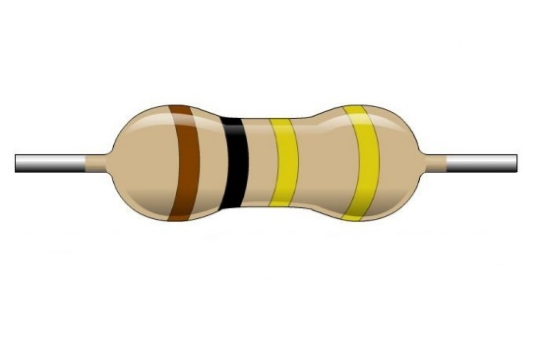

General description:

* Type : Carbon thin film Resistors
* Power rating : ¼ W

Features of resistors:

* High quality performance
* Non flammable
* Easily available in any range
* Too high and too low value can be supplied on case to case basis

Capacitor

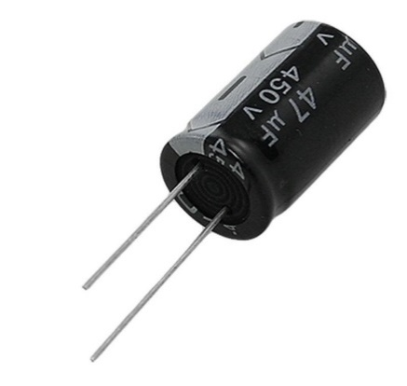

General description:

* Type: electrolytic capacitor
* Anode: aluminum
* Dielectric: aluminum oxide

Use of capacitor in our project:

Timer 555 depends on RC combination for time R*C being the time constant. Values of R and C are designed to get required time range.

4026 IC

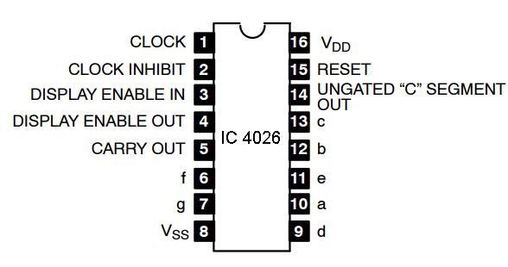

Features:

* Counter for 7-Segment display
* Can drive a common cathode 7-Segment display directly
* Easy to interface with  timer or micron rollers (TTL compatible)
* Can be easily cascaded with more IC to display higher range of number
* Maximum Clock Frequency: 6Mhz

### CD4026 Pin ****Configuration****

|  |  |  |
| --- | --- | --- |
| **Pin Number** | **Pin Name** | **Description** |
| 1 | Clock (CLK) | The counting happens when this clock pulse goes high , this pin is normally connected to 555 timer or other uC to produce a pulse |
| 2 | Clock Inhibit (INH) | Connected to the Ground (low) of the circuit, to enable clock pin |
| 3 | Enable Input (DEI) | This pin is connect to +5V (high) to enable the output pins (Out A to Out G) |
| 4 | Enable Output (DEO) | This is an output which always stays high, this pin will be only if more than one CD4026 IC is used (cascaded) |
| 5 | Divide by 10 (CO) | This is the carry over output pin; it produces a pulse after counting till 9. This pin will be only if more than one CD4026 IC is used (cascaded) |
| 6,7,9,10,11,12,13 | Out A,B,C,D,E, F,G | These are the decoded output pins which should connected to 7-Segment display. |
| 8 | Ground | The ground pin should be connected to ground of circuit |
| 14 | Not 2 out (UCS) | This is Ungated C segment pin. This is an output pin which will be rarely used when division is required. |
| 15 | Reset | This input pin when made high (+5V) will reset the count to 0. |
| 16 | Vcc | This pin powers the IC, typically +5V is used. |

555 IC

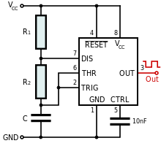

General description:

* Type: astable timer
* Specifications

|  |  |
| --- | --- |
| **Supply voltage (VCC)** | **4.5 to 15 V** |
| Supply current (VCC = +15 V) | 10 to 15 mA |
| **Output** current (maximum) | 200 mA |
| Maximum Power dissipation | 600 mW |
| **Power consumption** (minimum operating) | 30 mW@5V, 225 mW@15V |

* Formula

555 oscillator cycle time

Seven segment display

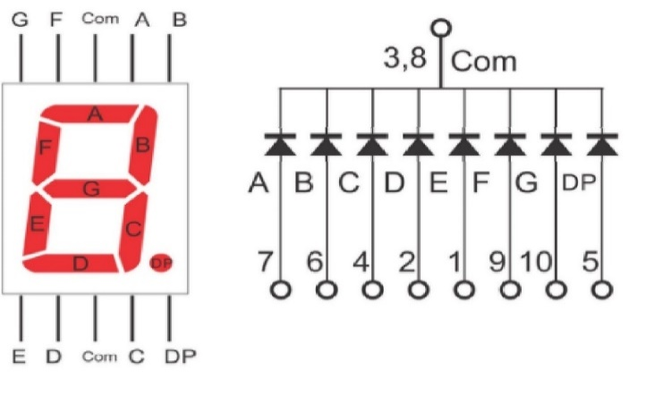

General description:

* Common cathode

|  |  |  |
| --- | --- | --- |
| **Pin Number** | **Pin Name** | **Description** |
| 1 | E | Controls the left bottom LED of the 7-segment display |
| 2 | D | Controls the bottom most LED of the 7-segment display |
| 3 | Com | Connected to Ground/Vcc based on type of display |
| 4 | c | Controls the right bottom LED of the 7-segment display |
| 5 | DP | Controls the decimal point LED of the 7-segment display |
| 6 | b | Controls the top right LED of the 7-segment display |
| 7 | a | Controls the top most LED of the 7-segment display |
| 8 | Com | Connected to Ground/Vcc based on type of display |
| 9 | f | Controls the top left LED of the 7-segment display |
| 10 | g | Controls the middle LED of the 7-segment display |

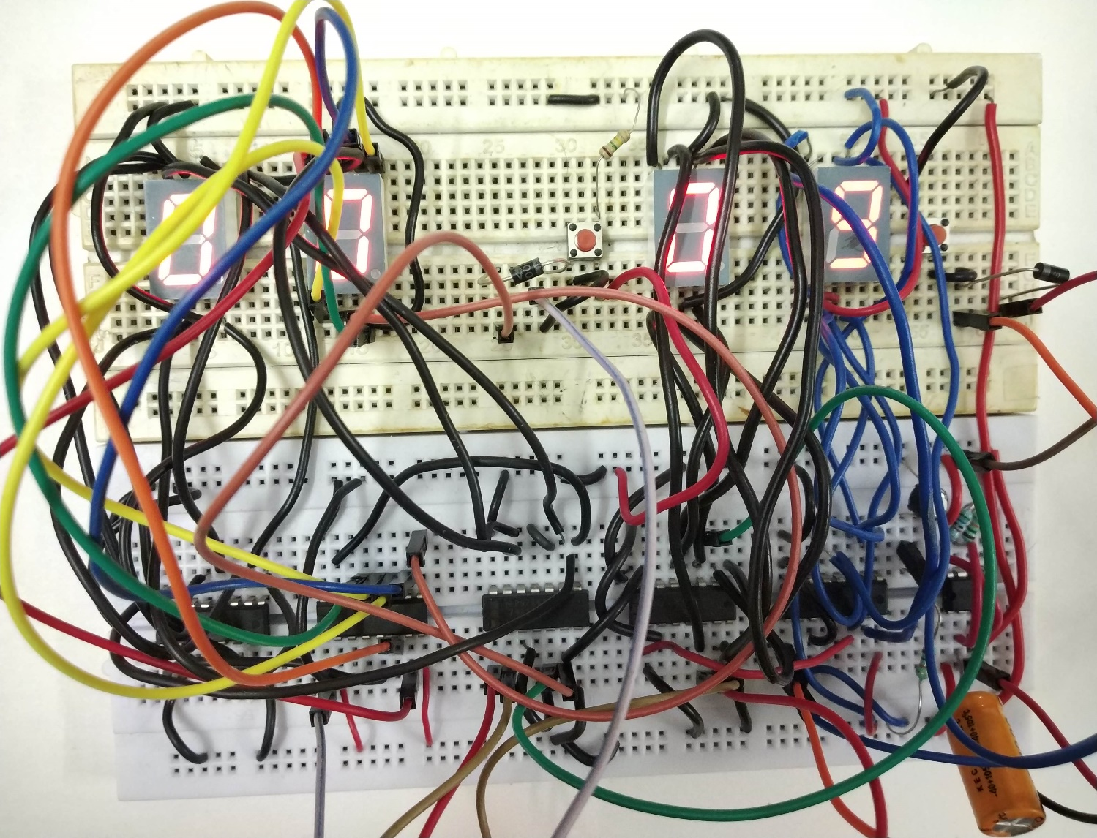

conclusion

The circuit was purely designed with the basic knowledge on both

combinational and sequential circuit designing. Combinational Logic circuit

is a type of logical circuit where the output is a pure function of the present

input only, while sequential logic circuit depends not only on the present

Input but also on the history of the output. CLCs used in this project are a

BCD to 7segment decoder, to display the output digitally. On the Other hand,

counters, the most common type of a sequential digital logic Circuit are used

for recording the number of events occurring in a specified Interval of time.

The most significant error that needs to be highlighted is the

Malfunctioning of the breadboard. Continuity test was made to ensure that The

connections were really connected . The output shows that the Digital Clock

behaved as expected.

It was However noticed that there is sometimes a skipping situation

in the incrimination of minutes and hours. The connections have been

rechecked multiple times, but there was no error found. We want to improve

this part as we continue to do research about this project.