
Smart Energy Monitoring and Optimization
Using machine learning model
"An efficient machine learning model designed to monitor energy consumption, optimize usage, and help users reduce electricity bills
effectively"
Created by:
Saloni Maind --2203031050729
Sarathi pradhan –2203031050505
Parmar kashyapsinh –2203031050435
Bhumesh Suthar --2203031050855

Overview
•Project Brief
•Flow Diagram
•Hardware diagram
•Hardware Overview
•Required platform
•Conclusion

“ SMART ENERGY MONITORING & OPTIMIZATION SYSTEM USING AI/ML MODEL.”
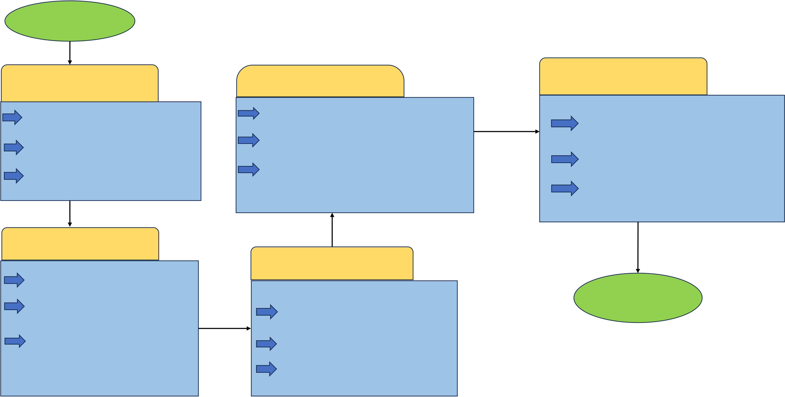
Start
Hardware Setup | Electricity Bill Generation | System Integration

Arduino board connected to relays | Calculate power consumption per device. | Real-time monitoring via Python
controlling devices (LED, DC Motor, Bulb) | Multiply by cost/unit for bill generation. | script interfacing with Arduino.
Sensors (e.g., ACS712) attached for
 |  | User Interface (web app or GUI)
current measurements.
 | Save/display results in a user-
 |  | displaying: Live data
Power supply integration for devices |  | Usage suggestions Electricity bills.
 | friendly format (CSV).
Data Collection
Arduino sketch periodically reads | AI ANALYSIS | END
current, voltage, and ON/OFF status. | Preprocessing logged data using
Data transmission to a laptop via Serial
communication. | Python.Clustering for usage patterns.
Python script logs data into a CSV file | Regression for consumption prediction.
with columns:
Timestamp, Device ID, Power | Optimization suggestions (e.g.,
Consumption,
 | turning off idle devices)."
ON/OFF Status.

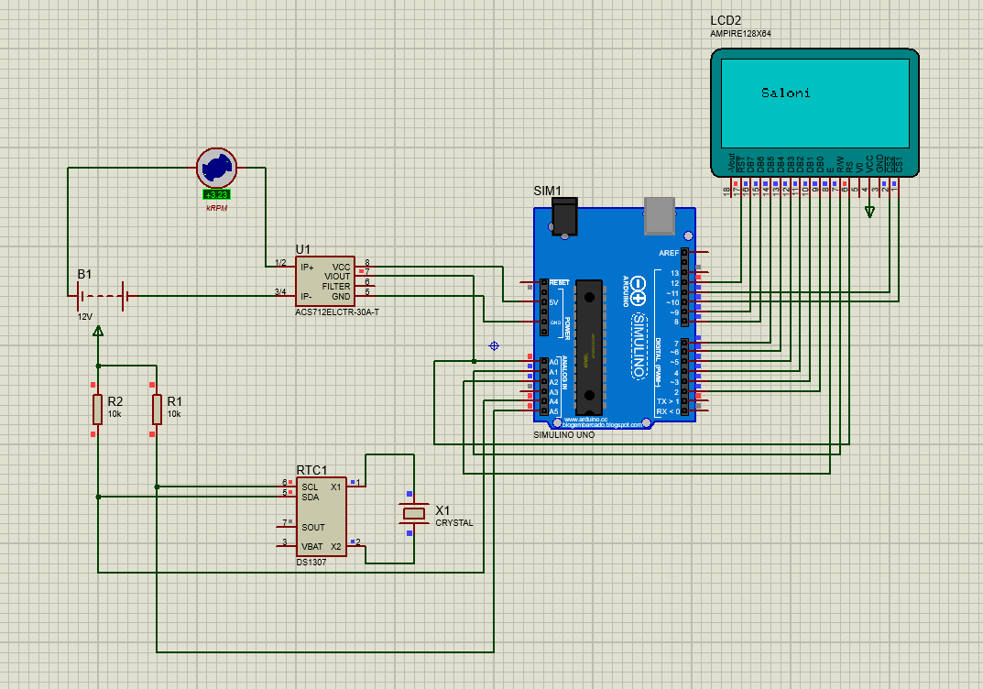

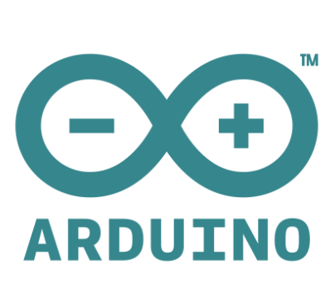 |  | 
 |  | 
 |  | 

Hardware Setup
Smart Meters  Install smart meters to track real-time energy consumption for each  appliance. | Sensors  Integrate sensors to capture data on factors like temperature and  humidity.

Data Collection |  |  |  | 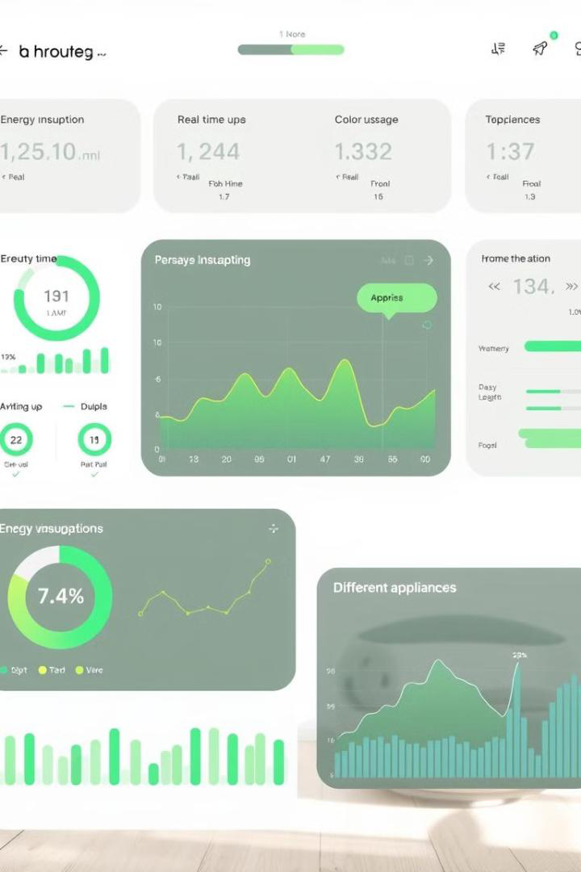
1 | Continuous Monitoring | 2 | Data Storage | 
Collect energy data at regular |  |  | Store data securely and | 
 |  |  | efficiently in a centralized
intervals, capturing detailed
 |  |  | database for analysis.
usage patterns.

CSV Logging |  |  | 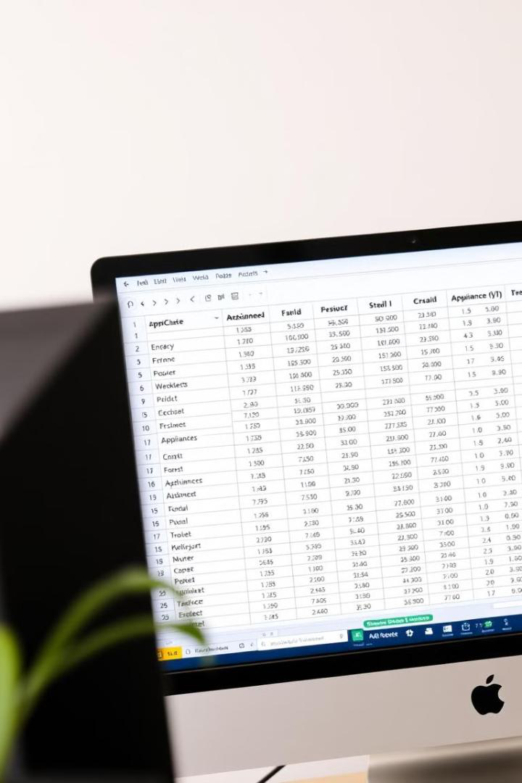
Timestamp | Appliance | Energy Consumption | 
 |  | (kWh)
2023-11-10 10:00:00 | Refrigerator | 0.25 | 
2023-11-10 10:15:00 | Washing Machine | 1.50 | 

AI Analysis & Suggestions |  | 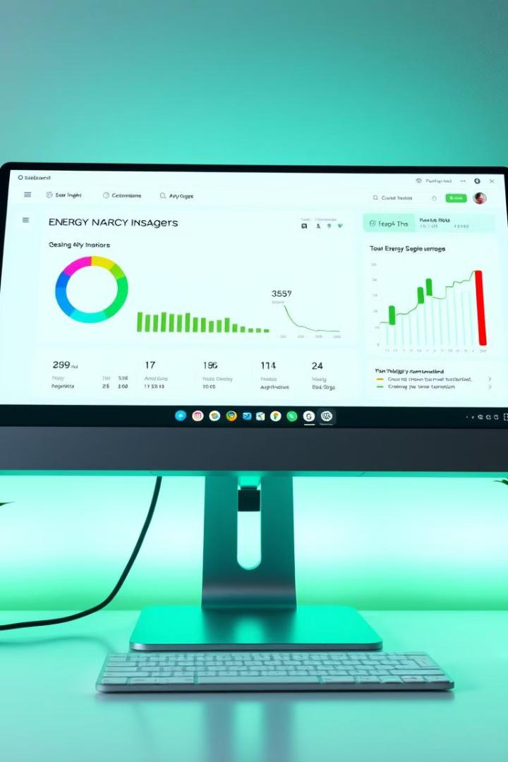
 | 
Energy Waste Detection | Usage Prediction
Analyze data to identify areas where energy | Forecast future energy consumption based
is being wasted, such as appliances left on | on historical trends and user behavior.
unnecessarily.

Optimization Suggestions
Provide personalized recommendations to
optimize energy usage and minimize costs.

Electricity Bill Generation |  | 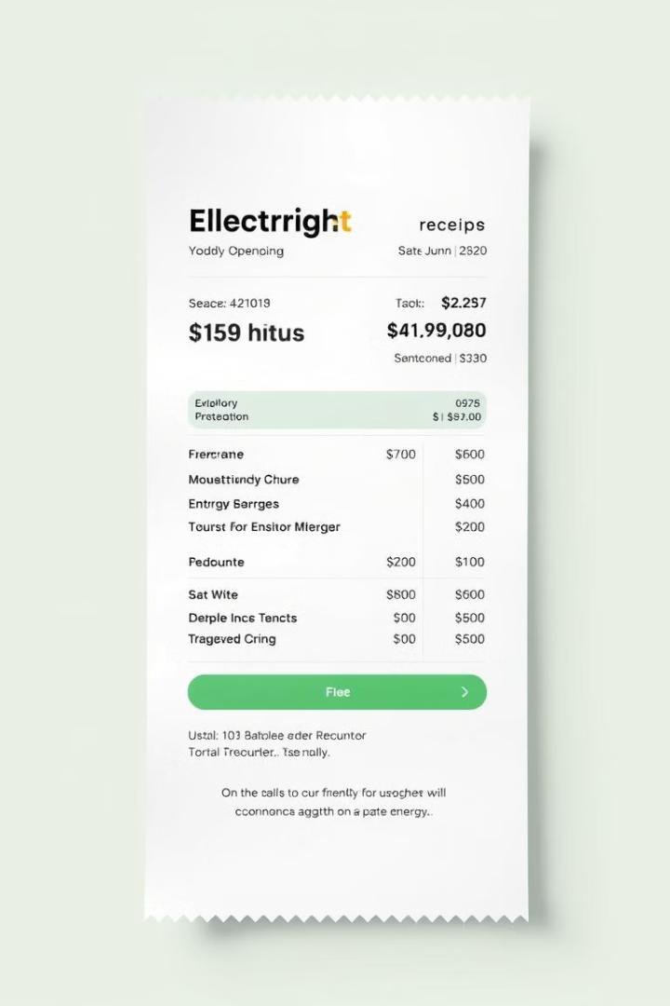
$200 | $150
Baseline Bill | Optimized Bill
The average electricity bill before | Savings achieved through smart energy
optimization measures. | monitoring and optimization.




System Integration
1 | Smart Appliances

2 | Smart Home Hub
3 | Energy Monitoring System

 | Conclusion  This smart energy monitoring system is a game-changer for optimizing energy consumption and empowering users to make informed decisions, leading to significant cost savings and environmental benefits.

