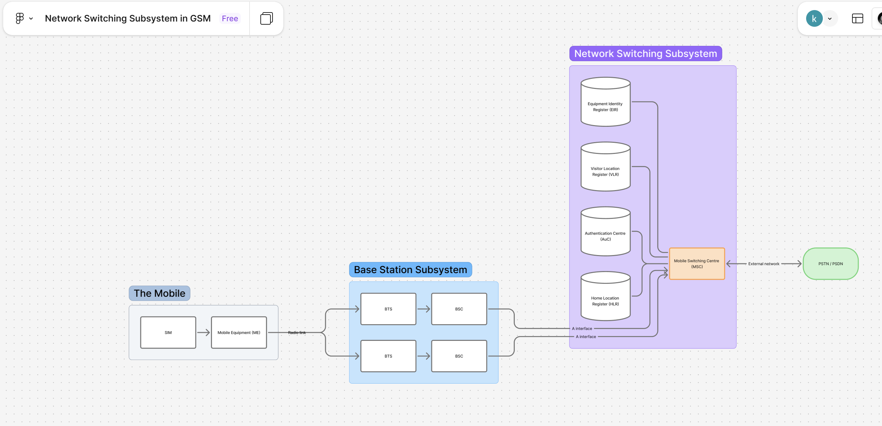
Figma Link:
https://www.figma.com/board/ceuTh0kjTZgM6MiRGb2W8i/Network-Switching-Subsystem-in-GSM?node-id=0-1&t=gt0itB3ZpVXnoTDE-1

