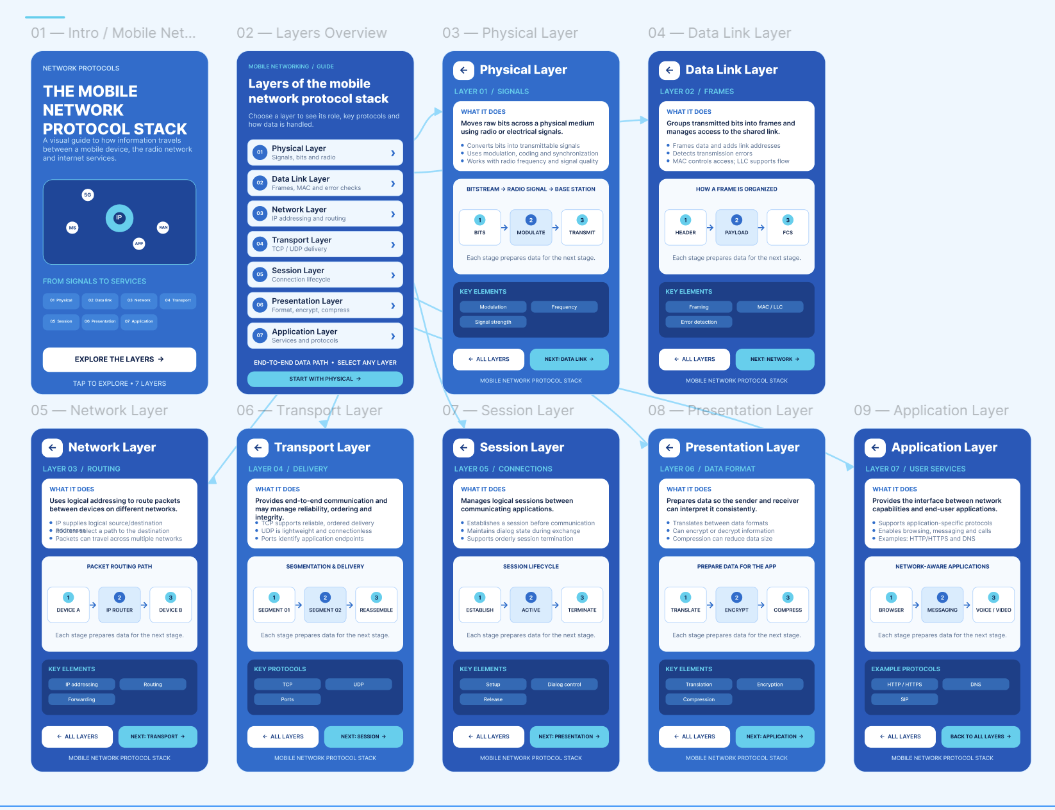

Figma Link: https://www.figma.com/design/jfhUnyWQTgEDFea8dr7Bfc/ITA03-Question-4-%E2%80%94-Mobile-Network-Protocol-Stack?node-id=7-2&t=HaS1OSL8uPyMm8pd-1

