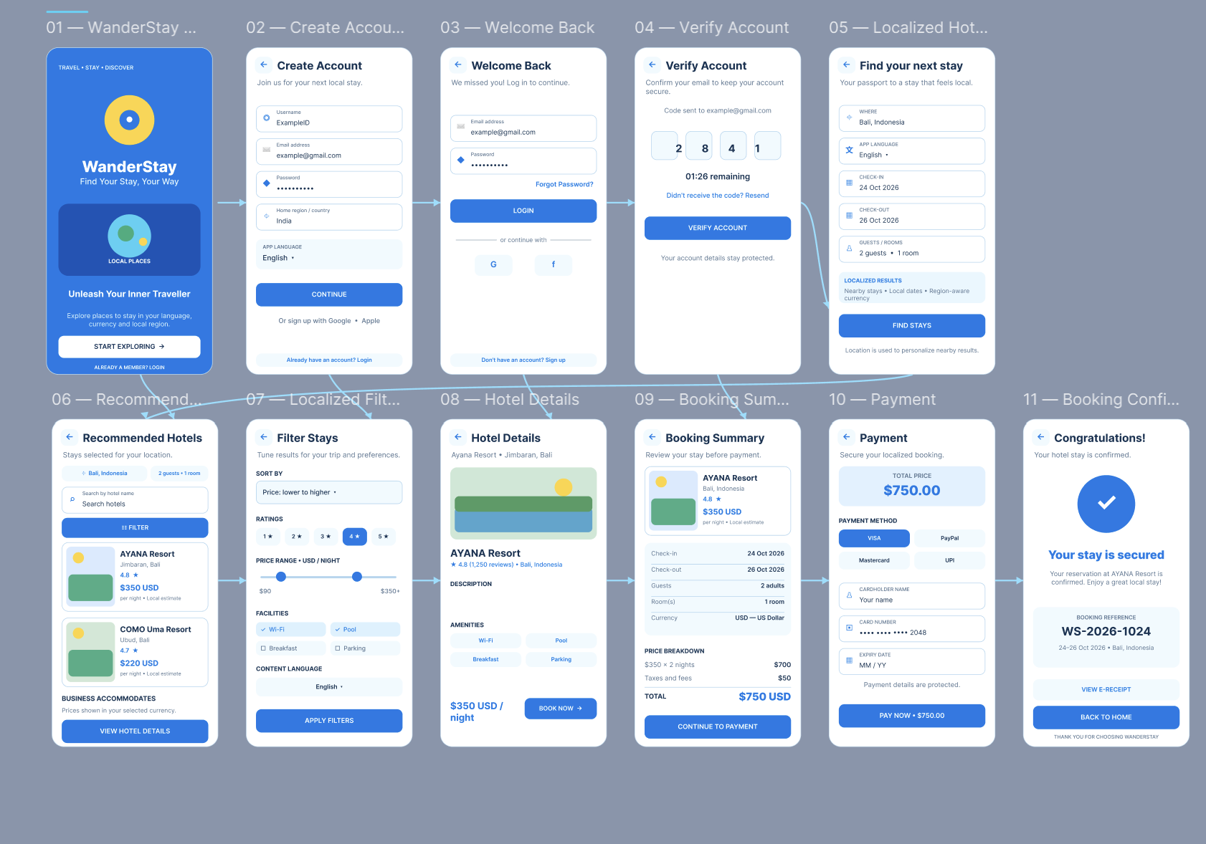

Figma Link: https://www.figma.com/design/bilXbsUO15a72iPTA6d7rq/ITA03-Question-5-%E2%80%94-Localization-Wireframe?node-id=0-1&t=PuRHTfJdmKT7XPJn-1

