Climate and Soil based Crop prediction System

Mentor Name:J Nulyn Punitha

Team Details:

|  |  |  |
| --- | --- | --- |
| **S No** | **Team members** | **Registration numbers** |
| 1 | V Bindu Sree | 99220040217 |
| 2 | V Kasiamarnath Reddy | 99220040222 |
| 3 | V Heamanth Kumar | 99220040220 |
| 4 | M R Palpandi | 9922006005 |
| 5 | R Pothirag | 9922006010 |

Problem statement:

Agriculture involves several issues such as declining soil fertility, water scarcity, climate change impacts like extreme weather events, pest and disease outbreaks, limited access to modern farming techniques and technology for small-scale farmers, unsustainable agricultural practices contributing to environmental degradation, and the need for innovative and sustainable farming methods to enhance productivity while minimizing negative environmental impacts and ensuring food security for a growing global population.

Introduction:

* This project introduces Crop Recommendation System that employs machine

learning techniques to predict and suggest suitable crops for farmers.

* Leveraging machine learning algorithms, the system analyzes historical climate data, soil properties, and crop performance metrics to predict and recommend crops resilient to changing climates.
* This innovative system aims to empower farmers with informed decision- making, optimizing crop selection for increased yield and sustainable agricultural practices through an interactive web page.

Features:

* **Real-Time Analysis:** Delivers crop recommendations instantly after inputting the data, aiding quick decision-making.
* **Increased Productivity**:Helps farmers choose the most suitable crops for their conditions, potentially increasing yield and productivity.
* **Accurate Recommendations**:Provides highly accurate crop recommendations based on multiple input factors like rainfall, soil type, temperature, and humidity.

Literature Survey:

|  |  |  |  |  |
| --- | --- | --- | --- | --- |
| **S no** | **Title** | **Year** | **Author** | **summary** |
| 1 | Crop recommendation system using Machine learning | Feb 12  2021 | Dhruvi Gosai, Chintal Raval, RikinNayak, Hardik Jayswal, Axat Patel | * This IoT and ML-driven system for Indian agriculture optimizes crop production by sensor-based soil testing, ensuring proper fertilizer use. * Utilizing machine learning algorithms, convolutional neural networks, it offers crop suggestions. * And as the data acquired is less hence the model can’t predict accurately as the overfitting of the data occurs hence the inaccurate |

Literature survey:

|  |  |  |  |  |
| --- | --- | --- | --- | --- |
| **S no** | **Title** | **Year** | **Author** | **Summay** |
| 2 | Integration of Weather Attributes for Improved Crop Recommendation: A Machine Learning Approach | September 5,  2020 | Laura K. Thompson, Benjamin H. Lee | * Explores the integration of weather attributes into crop recommendation models, employing machine learning techniques for enhanced accuracy. * Examines how incorporating real-time weather data, including temperature, precipitation, and humidity, improves the precision of crop recommendations. * It wont discuss about any other important soil attributes for the crop recommendation |

Methodology:

* **Data processing**:Gather data on various factors affecting crop growth, such as rainfall, soil type, temperature, and humidity..
* **Data Preprocessing:**Clean and preprocess the data to ensure it is suitable for analysis. This includes handling missing values normalizing data, and feature engineering.
* **Model Training & Evaluation:**Train machine learning algo rithms using data. Optimize model parameters and evaluate performance using metrics like accuracy, precision, recall, and F1-score.

Methodology:

* **System Integration**:Create a frontend interface for users to input data and receive crop recommendations.
* **User Input:** Design a user-friendly interface where farmers can input local environmental factors (rainfall, soil type, temperature, humidity
* **Recommendation Engine:**Use the trained model to analyze the input data and generate crop recommendations.

IMPLEMENTATION

* Backend Development:

Develop a robust backend system using a suitable programming language and framework to handle data input and processing.

Ensure the backend can communicate with the machine learning model to generate crop recommendations

Frontend Development:

Create a user-friendly interface for users to input environmental factors like rainfall, soil type, temperature, and humidity. Design the frontend to provide clear and easy-to-understand crop recommendations based on the inputs.

IMPLEMENTATION

* Integration with Flask:

Use Flask to create APIs that connect the frontend interface with the backend system, facilitating seamless data exchange. Implement Flask routes to handle user input, process data, and return crop recommendations.

Deployment:

Deploy the system on a cloud platform to ensure accessibility, scalability, and reliability for users.

Output:

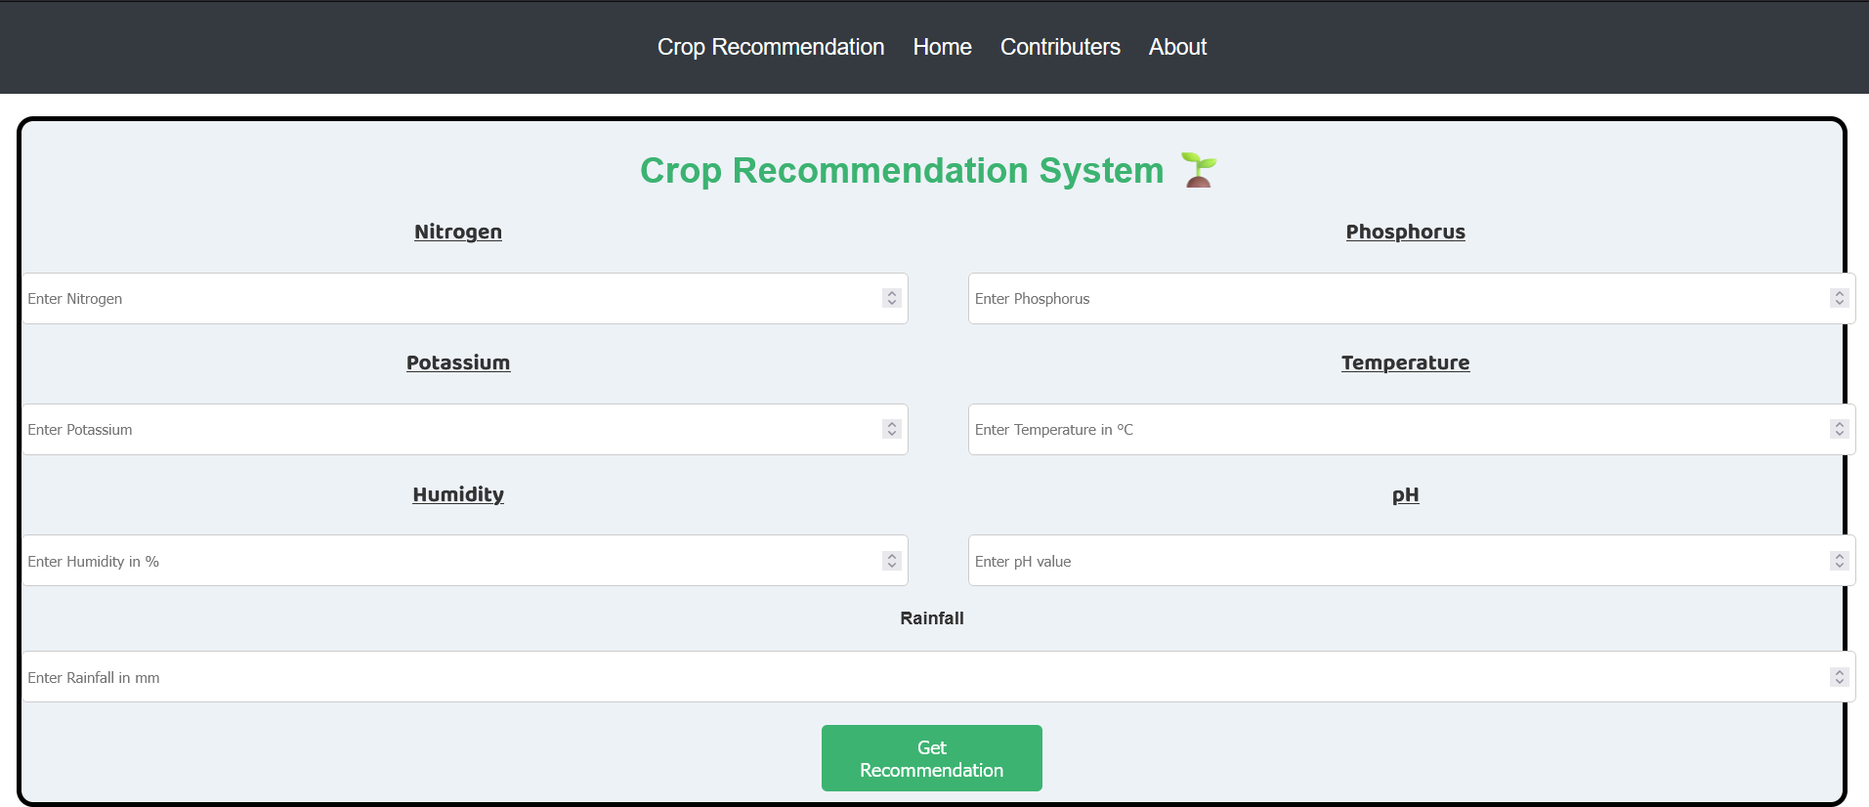

Output:

