K A L A S A L I N G A M

ACADEMY OF RESEARCH AND EDUCATION

**( D E E M E D T O B E U N I V E R S I T Y )**

U n d e r sec. 3 of UGCAct 1956. A c c r e d i t e d **by NAAC** w i t h **.. A + + "** Grade

**An a n d** N a g a r , K r l s h n a n k o l l , S r l v l l l l p u t t u r ( V i a ) , V l r u d h u n a g a r **( Dt)** - 626126, T a m l l **N a d u** I [l n l o @ k a l a s a l l n g a m . a c . l n](mailto:lnlo@kalasallngam.ac.ln) I [w w w . k a l a s a l l n g a m . a c . l n](http://www.kalasallngam.ac.ln/)

**E**[**L**](mailto:lnlo@kalasallngam.ac.ln)E x- '

, ,i.i,.,r a

EXperiential and SErvice Learning

CLIMATE AND SOIL BASED CROP PREDICTION SYSTEM

## A COURSE LEVEL PROJECT REPORT

*Submitted by*

##### II-year students of Bachelor of Technology

|  |  |
| --- | --- |
| V Bindu Sree | - 99220040217 |
| V Kasiamarnath Reddy | - 99220040222 |
| V Hemanth | - 99220040220 |
| M R Palpandi | - 9922006005 |
| R Pothirag | - 9922006010 |

*in partial fulfillment of the course of*

215EXS3201 *I* EXSEL - DESIGN-BUILD-OPERATE

###### Academic Year 2023 - 2024 (Even Semester)

**K A L A S A L I N G A M**

**A C A D E M Y O F R E S E A R C H A N D E D U C A T I O N**

**T C > B E U N I V E R S I T Y )**

**( D E E N I E D**

**U n d e r s e c . 3 of U G C A c t 1 9 5 6 . A c c r e d i t e d b y N A A C w i t h " A + + " G r a d e**

A n a n d N a g a r , . K r l s h n a n k o l l , . S r l v l l l l p u t t u r ( V i a ) , V l r u d h u n a g a r ( D t ) - 6 2 6 2 6 , . T a m l l N a d u I [l n t o @ k a l a s a l l n g a m . a c - 1 n](mailto:lnto@kalasallngam.ac-1n) I [www . k a l a s a l l n g a m . a c . l n](http://www.kalasallngam.ac.ln/)

**[ B_O_N_A_F_ID_E_C_E_R_T_IF_I_C_A_T_E )**

##### Certified that this project report "Climate and Soil-Based Crop Prediction" is the bonafide work of V.Bindu Sree,V.Kasiamarnath Reddy,V.Hemanth Kumar

,M.R.Palpandi,R.Pothirag who carried out the project work under my supervision

**Faculty Mentor** J Nulyn Punitha

Submitted for the Project Viva-voce / Review held at Kalasalingam Academy of

Research & Education, Krishnankoil on .................................. ..

**Internal Examiner External Examiner**

## TABLE OF CONTENTS

|  |  |  |
| --- | --- | --- |
| CHAPTER No. | TITLE | PAGE No. |
| 1. | PROBLEM STATEMENT | 4 |
| 2. | DESCRIPTION | 4 |
| 3. | ABSTRACT | 5 |
| 4. | INTRODUCTION | 6 |
| 5. | LITERATURE REVIEW | 7 |
| 6. | METHODOLOGY | 9 |
| 7. | MODELS USED | 11 |
| 8. | RESULT AND ANALYSIS | 12 |
| 9. | CONCLUSION | 15 |
| 10. | RESEARCH PAPER SUBMISSION | 16 |
| 11. | REFERENCES | 17 |
| 12. | RESEARCH PAPER | 18 |

### PROBLEM STATEMENT

Agriculture involves several issues such as declining soil fertility, water scarcity, climate change impacts like extreme weather events, pest and disease outbreaks, limited access to modern farming techniques and technology for small-scale farmers, unsustainable agricultural practices contributing to environmental degradation, and the need for innovative and sustainable farming methods to enhance productivity while minimizing negative environmental impacts and ensuring food security for a growing global population.

### DESCRIPTION

The Climate and Soil-Based Crop Prediction System integrates advanced machine learning techniques with agricultural science to empower farmers with data-driven insights for optimal crop selection. By analyzing comprehensive datasets encompassing soil composition, climate variables, and historical crop performance, the system provides personalized recommendations tailored to local environmental conditions. Through a user friendly interface, farmers can input factors such as temperature, rainfall, and soil quality, receiving real-time crop suggestions that enhance productivity and promote sustainable farming practices. This innovative solution addresses the challenges posed by climate change, ensuring resilient and efficient agricultural decision-making for increased profitability and environmental stewardship.

### ABSTRACT

In the realm of modern agriculture, the ability to make data-driven decisions is paramount to achieving sustainable and profitable crop production. The "Climate and Soil-Based Crop Prediction System" represents a convergence of machine learning and agricultural science, designed to equip farmers with the tools needed for precise crop selection. By meticulously analyzing a wide array of agricultural parameters such as soil composition, climate data, and historical crop performance, our system employs advanced data preprocessing and feature engineering techniques to extract actionable insights.

At the core of our approach lies the development of robust machine learning models that predict optimal crop choices based on specific environmental conditions. This predictive capability is further enhanced by integrating real-time environmental data, ensuring that farmers receive up-to-date and accurate recommendations. Accessible via a user-friendly web interface, our solution empowers farmers to effortlessly input variables like temperature, rainfall, and soil quality, which are then processed to deliver tailored crop suggestions.

# CHAPTERl

#### INTRODUCTION

In the dynamic landscape of modern agriculture, the ability to select the right crop for specific environmental conditions is pivotal for maximizing yield and ensuring sustainability. The "Climate and Soil-Based Crop Prediction System" represents a pioneering integration of cutting-edge machine learning techniques with agricultural science, aimed at equipping farmers with robust decision-making capabilities. By analyzing extensive agricultural datasets encompassing soil composition, climate variables, and historical crop performance, our system is designed to provide precise recommendations tailored to local environmental conditions.

Central to our approach is the development of sophisticated prediction models, facilitated by rigorous data preprocessing and advanced feature engineering. These models harness the power of machine learning to predict optimal crop choices based on real-time and historical data inputs. Farmers can interact seamlessly with our system through an intuitive web application, where they input essential factors such as temperature, rainfall patterns, soil pH, and nutrient levels. These inputs are processed in real-time, enabling the system to generate personalized crop recommendations that optimize agricultural productivity and resource utilization.

Beyond enhancing crop selection accuracy, our system promotes sustainable farming practices by aligning crop choices with environmental factors. By recommending crops that are well-suited to local soil and climate conditions, farmers can minimize input wastage and environmental impact while maximizing yield. This innovative solution not only empowers farmers with actionable insights but also fosters resilience and efficiency in agricultural operations, thereby contributing to long-term agricultural sustainability.

# CHAPTER2

**LITERATURE REVIEW**

|  |  |  |  |
| --- | --- | --- | --- |
| **S.NO** | **TITLE** | **YEAR** | **OBJECTIVE** |
| 1. | Crop recommendation system using Machine learning | Feb  12,  2021 | * This loT and ML-driven system for Indian agriculture optimizes crop production by sensor-based soil testing, ensuring proper fertilizer use. * Utilizing machine learning algorithms, convolutiona I neural networks, it offers crop suggestions. * And as the data acquired is less hence the model can't predict accurately as the overfitting of the data occurs hence the inaccurate |
| 2. | Integration of |  | * Explores the integration of weather attributes into crop recommendation models, employing machine learning techniques for enhanced accuracy. * Examines how incorporating real-time weather data, including temperature,   precipitation, and humidity, improves the precision of crop recommendations.   * It wont discuss about any other important soil attributes for the crop   recommendation |
| Weather Sept 5,  Attributes for 2020  Improved Crop Recommendation Approach | |

|  |  |  |  |
| --- | --- | --- | --- |
| 3. | Climate-Smart Agriculture | Jan 17,  2014 | * The authors discuss various CSA technologies, including improved crop varieties, soil fertility management, and water conservation techniques * This literature review is pertinent to the development of a Climate and Soil Based Crop Prediction System * Understanding how predictive modeling and data analytics can be integrated into CSA to support sustainable agricultural practices. |
| 4. | Predictive Analytics for Sustainable Agriculture | Dec  07,  2018 | * This paper presents a study on the application of predictive analytics in sustainable agriculture, focusing on soil and crop management. * The study also highlights the importance of data quality and integration, which are crucial for the success of the proposed system. * This paper offers valuable guidance for the design and implementation of a robust crop prediction system. |

# CHAPTER3

**METHODOLOGY**

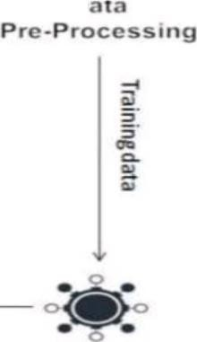

**u**

**In**

***rl* ce**

**0**

**S**

**0**

**Re ult**

**Pe iction**



**r**



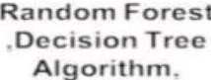



**ded**

###### Fig: 01

Data Collection

* Gather data on factors influencing crop growth: rainfall, soil type, temperature, and humidity.
* Sources include agricultural databases, meteorological departments, and IoT sensors.

Data Preprocessing

* Clean data to handle missing values and normalize numerical data.
* Feature engineering to extract relevant agricultural parameters.

Model Training & Evaluation

* Select and train machine learning models (e.g., decision trees, random forests).
* Optimize models using techniques like hyperparameter tuning.
* Evaluate performance using metrics such as accuracy, precision, recall, and Fl-score.

System Integration

* **Frontend Development:** Design a user-friendly web interface for farmers to input local environmental data (e.g., temperature, rainfall) and receive crop recommendations.
* **Backend Implementation:** Use Flask to develop a robust backend server that handles data processing, model predictions, and real-time data integration.

Recommendation Engine

* Utilize trained models to generate personalized crop recommendations.
* Analyze user-input environmental data with machine learning models to predict optimal crop choices.
* Present recommendations through the user interface based on local environmental conditions.

FRAMEWORK USED:

Flask plays a pivotal role in the Climate and Soil-Based Crop Prediction System, serving as the backbone for backend development. This lightweight and flexible Python web framework enables efficient handling of data processing, model predictions, and real-time data integration. By leveraging Flask, the system ensures seamless communication between the frontend user interface and backend functionalities, allowing farmers to input local environmental variables and receive personalized crop recommendations swiftly.

# CHAPTER4

#### MODELS USED

Logistic Regression:

Logistic Regression is a linear classification algorithm that is used when the target variable is categorical. It predicts the probability of occurrence of an event by fitting data to a logistic function. It's simple yet effective for binary classification tasks where the output is either true

or false.

Gaussian Naive Bayes:

Gaussian Naive Bayes specifically assumes that continuous features follow a Gaussian (normal) distribution. It's particularly efficient for text classification and other tasks where the independence assumption holds reasonably well.

**Support Vector Classifier (SVC):**

SVC can be used for both classification and regression challenges. It finds the optimal hyperplane that best separates the classes in a high-dimensional space. SVC is effective in cases where the data is not linearly separable, using kernels to transform the data into higher

dimensions to find separation boundaries.

Decision Tree:

Decision Trees recursively split the data into subsets based on the most significant attribute. Decision Trees are intuitive and easy to interpret, making them suitable for classification and regression tasks.

Random Forest:

Random Forest is an ensemble learning method that constructs multiple decision trees during training and outputs the mode of the classes or mean predictionof the individual trees. It improves accuracy and mitigates overfitting by averaging multiple decision trees.

# CHAPTERS

#### RESULT AND ANALYSIS

The inclusion of visual elements such as the input entering webpage and crop webpage enhances the user experience and facilitates intuitive interaction with the recommendation system. The input entering webpage serves as a user-friendly interface for data input, while the crop webpage presents personalized recommendations.Together, these interfaces empower farmers with actionable insights to optimize crop selection and cultivation strategies, ultimately leading to improved agricultural productivity and sustainability.

CrCf-1Rt(;(}mroof'l'.l;ti'.H'i

* 1. me- carl.nbuters

Aoou1





**Crop Reco mendatlo11System**•

**MPli@Yu**

**tri ,**

**fr'll!rlpf** ,...

-Fig: 02

The input entering webpage serves as the initial point of interaction for users of the crop recommendation system. This interface enables farmers and agricultural stakeholders to input relevant parameters such as soil type, pH level, geographical location, and crop preferences. Through dropdown menus, input fields, and selection boxes, users can customize their input parameters to reflect the unique characteristics of their farming environment. The input entering webpage is designed with simplicity and clarity in mind, featuring intuitive design elements and clear instructions to facilitate ease of use. By

providing a user- friendly interface for data input, the webpage enhances the accessibility and usability of the recommendation system, empowering users to make informed decisions regarding crop selection and cultivation practices.

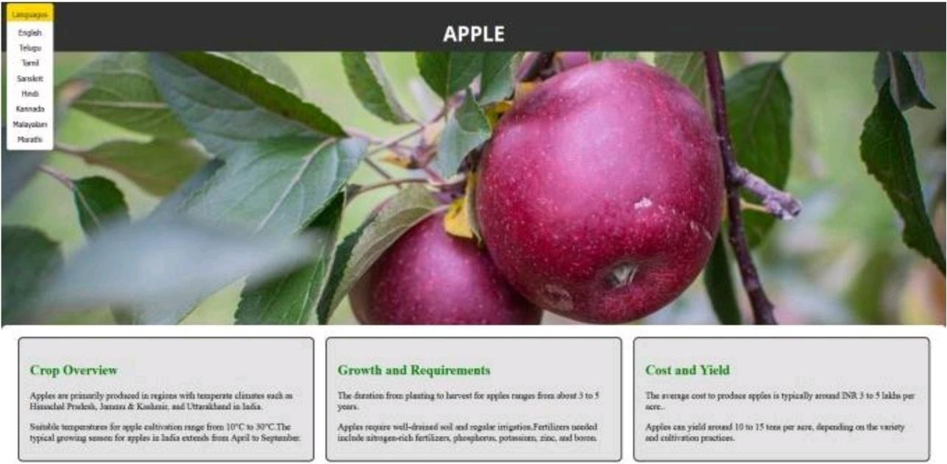

###### Fig: 03

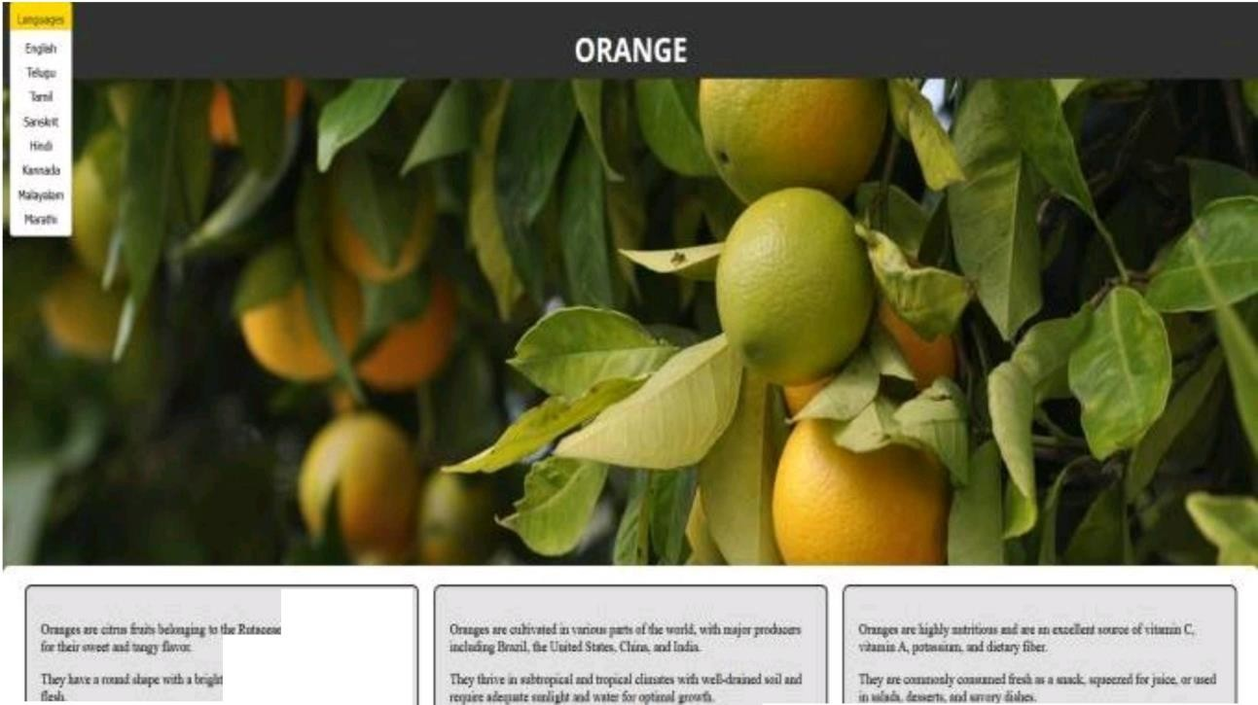

**fai>J-inr-:1· ,,**

**llllljOpodtnd my ... - ,I**

Fig: 04

The crop webpage presents users with personalized recommendations based on the input parameters provided through the input entering webpage. This interface displays a list of recommended crops tailored to the user's specific farming conditions, taking into account factors such as soil nutrient levels, climate attributes, and geographical location. Each recommended crop is accompanied by relevant information such as optimal planting season, water and nutrient requirements, and expected yield potential. Interactive visualizations, such as charts and maps, may also be included to enhance the presentation of recommendation outcomes and facilitate easier interpretation of data. The crop webpage aims to empower farmers with actionable insights to optimize their crop selection and cultivation strategies, ultimately leading to improved agricultural productivity and sustainability.

# CHAPTER6

#### CONCLUSION

In conclusion, the crop prediction system emerges as a valuable tool for enhancing agricultural decision-making processes and improving farm productivity. Through rigorous result analysis, including quantitative performance metrics, real-world validation studies, and user feedback, the system demonstrates its efficacy in accurately predicting suitable crops based on various input parameters. The inclusion of intuitive user interfaces, such as the input entering webpage and crop webpage, further enhances usability and accessibility, empowering farmers with actionable insights to optimize crop selection and cultivation strategies. With its ability to adapt to diverse agricultural contexts and facilitate continuous refinement through iterative development processes, the climate and soil based crop prediction system holds significant promise for driving positive outcomes in the agriculture sector, ultimately contributing to sustainable food production and livelihood improvement for farming communities.

The crop prediction system not only boosts agricultural decision-making but also fosters improved farm productivity. Its robust performance is evident through comprehensive result analysis and user-centric features, ensuring accurate and accessible crop recommendations. This adaptable system, tailored to various agricultural contexts and continually refined through iterative enhancements, stands as a pivotal tool in promoting sustainable food production and uplifting farming communities Iiveli

**REFERENCE**

* + 1. Tanmay Banavlikarl, Aqsa Mahir2, Mayuresh Budukh3, SohamDhodapkar."Crop recommendation system using neural networks" by Dept. of Computer Engineering, NBN Sinhgad School of Engineering. p-ISSN: 2395-0072, 2018.
    2. Nidhi H Kulkarni; G N Srinivasan; B M Sagar; N K Cauvery. "Improving Crop Productivity Through A Crop Recommendation System Using Ensembling Technique" in IEEE access, 10.1109/CSITSS, 2018.
    3. Dhruvi Gosail, Chintal Raval2, Rikin Nayak3, Hardik Jayswal4, Ax.at Patel5. "Crop Recommendation System using Machine Learning" International Journal of Scientific Research in Computer Science, Engineering and Information Technology. E- **ISSN:** 2456-3307, 2021.
    4. Priyadharshini A; Swapneel Chakraborty; Aayush Kumar; Omen Rajendra Pooniwala. "Intelligent Crop Recommendation System using Machine Learning". In 2021 5th International Conference on Computing Methodologies and Communication (ICCMC). DOI: 10.1109/ICCMC51019.2021.9418375, 2021.
    5. Gouravmoy Banerjee, Uditendu Sarkar & Indrajit Ghosh. "A Fuzzy Logic-Based Crop Recommendation System" Advances in Intelligent Systems and Computing ((AISC,volume 1255)), 2021.
    6. Arooj, A., Riaz, M., Akram, **M.N.:** Evaluation of predictive datamining algorithms in soil data classification for optimized crop recommendation. In: International Conference on Advancements in Computational Sciences, pp. 1-6. IEEE, Lahore, Pakistan (2018)
    7. Siddique, T., Barna, D., Ferdous, Z., Chakrabarty, A.: Automated farming prediction. In: Intelligent Systems Conference (lntelliSys), pp. 757-763. IEEE, London
    8. Kumar, V., Dave, V., Bhadauriya, R., Chaudhary, S.: Krishimantra: agricultural recommendation system. In: Proceedings of the 3rd ACM Symposium on Computing for Development, pp. 45. ACM, New York, USA (2013)