_index.tsx means that it is a private file and shouldn’t be imported

Remix doesn’t need to use react router stuff like prevent default?

We could use action to send the form to another route but we wont

- I need an ORM? Yes I used Prisma

- I also noticed that this app is TIGHTLY coupled to its backend. I can’t test in postman

Y=Remember to use npx prisma

Next thing to do on this project is make a POST

GET uses loader

POST uses action

Prevent default with remix’s Form instead of html form



add 2 second pause before resolving promise object

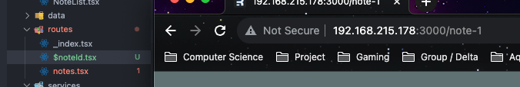

Dynamic routing adds appends the id to the end - somehow