Exp. 1 Design an LED flasher

Circuit Diagram: 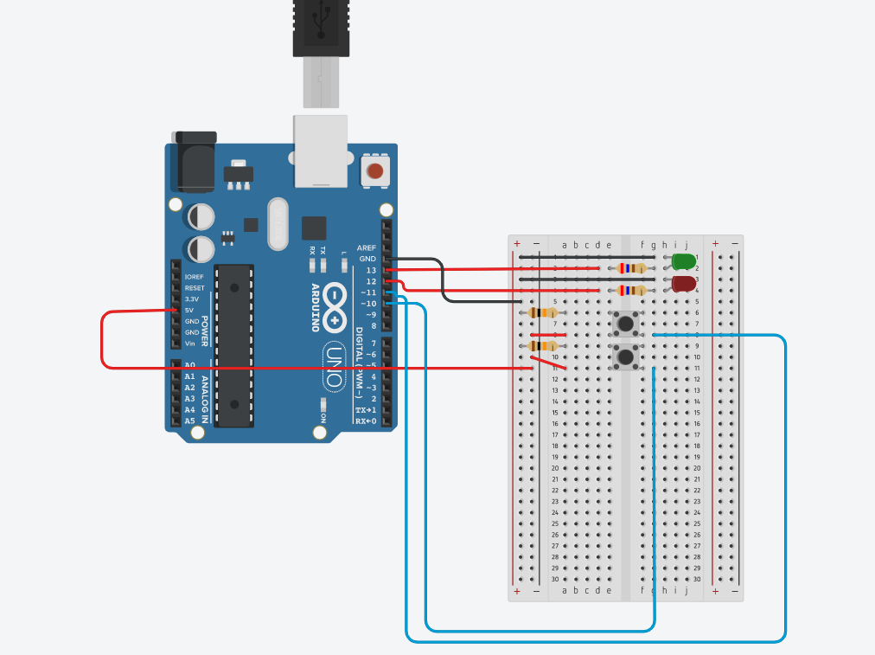

Theory

Concept Used :

Knowing, how to use button in Arduino.

Learning & Observations:

We can make program to use button with other function such as

Button door bell, button light, button sound, and etc.

Problems & Troubleshooting:

Having some problem on program when run Arduino code in app

Precautions

You have to connect resistor when you put led on breadboard

You must check that you connect equipment properly

Learning Outcomes

To understand, how to complementary the device and can adapt to other program