Kasidit Malawai 653040439-4

1. **The website is divided into categories that are beautiful and easy to the eyes.**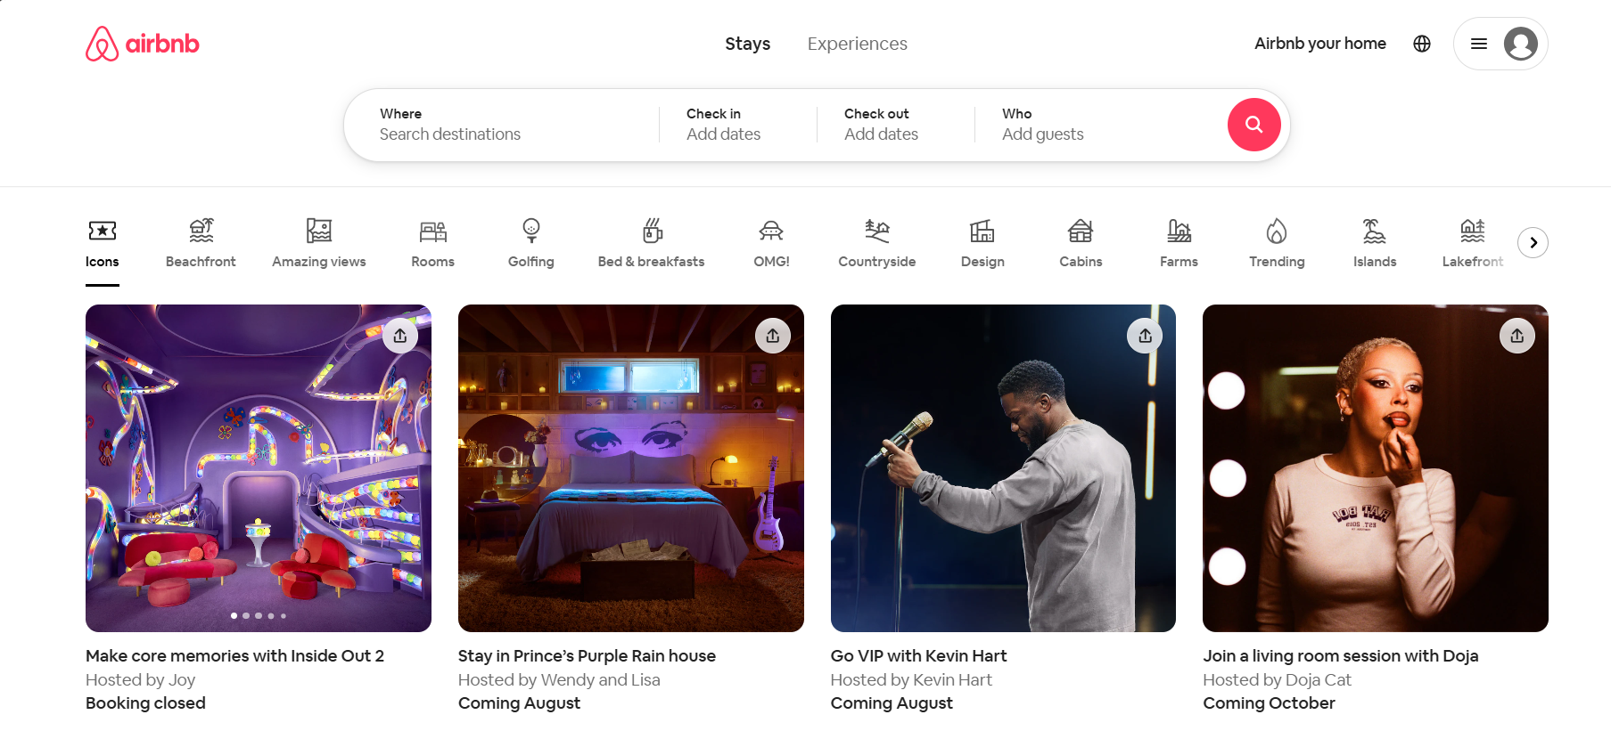
2. **The importance of the content is emphasized in bold type. Make it easy for readers.**

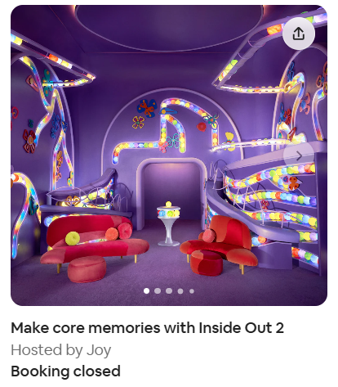

1. **The colors of background and contents are well contrasted.**

