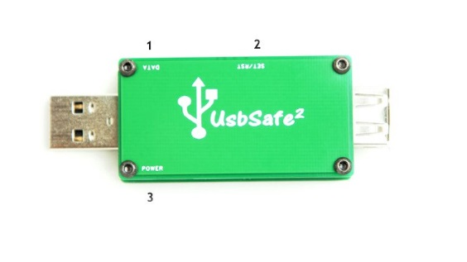

1) D2/Data LED 2) Set/Reset button 3) D1/Power LED

## UsbSafe²

**Power control**. At insertion to a USB port the Power LED will blink x number times corresponding to the set mode (1-5). This can also be displayed at any time by a short press (<1s) on Set/Reset button. (Note that when button is pressed and/ or Power LED is displaying current mode the actual function of the fuse can be affected.)

To set new current mode long press (>3s) Set/Reset button until Power LED lit up constantly.

When an overload or short-circuit with more than 10ms duration is detected the output of the fuse will shut down and the Power LED will be turned on constantly. Reset fuse by either press Set/Reset button or remove and insert the fuse to USB port outlet.

**Data control.** Disable data by holding Set/Reset button pressed during insertion to a Usb outlet. Hold button pressed until green Data LED is disabled. Repeat procedure to enable data. When data is disabled d+ and d- are connected together by 100 ohm.

**OVP.** Over voltage protection is managed entirely by hardware. When OVP is enabled all LEDs are off, the fuse and its output are also disabled.

-Specification



Setting saved at power loss.

Max operating ambient temperature 35C° / 95F°. Indoor use only

Operating voltage.4,75V-5.5V. Max input voltage 16V

Over voltage protection enabled at 6.5V.

Max load/switch current 2.5A. Max power consumption 15mA

Response time ~10ms.