Student Performance Analytics System
EWB Courses | Python with AI

1. Project Title
Item | Details
Project Title | Student Performance Analytics System
Student Name | Kasim Baasith A
College / Department | Info Institute of Engineering – B.Tech Information Technology
Course | Python with AI – EWB Courses
Submission Date | 12th Oct 2026

2. Objective
Calculating student marks, grades and results manually is slow and easy to get wrong. The objective of this project is to build a Python program that reads student data from a file and automatically produces useful results: total and average marks, grades, pass/fail status, subject-wise performance, department-wise performance and the top-performing students.
The project solves the problem of quickly understanding how a class is performing, which students need attention, and which subjects are strong or weak.

3. Technologies Used
- Python 3 – core programming language (functions, loops, conditions)
- NumPy – numerical calculations such as sum, mean, max, min and comparisons
- Pandas – loading the CSV, DataFrame operations, sorting, filtering and groupby
- VS Code – code editor used to write and run the program
- Git & GitHub – version control and project submission

4. Dataset Description
The dataset is stored in students.csv and contains 25 student records with no missing values.
Column | Description
Student_ID | Unique ID of the student (S001 – S025)
Name | Name of the student
Department | CSE, IT, ECE, EEE or MECH
Maths, Science, English, Computer, Tamil | Marks out of 100 in each of the five subjects
Attendance | Attendance percentage
The program adds four calculated columns: Total, Average, Grade and Result. The processed data is saved to student_results.csv.

5. Implementation
- Data loading: The CSV file is read with pd.read_csv(). The columns, number of records and missing values are displayed to check the data.
- Total and average: The five subject columns are converted to a NumPy array. np.sum(axis=1) gives each student's total and np.mean(axis=1) gives the average.
- Grading: The function get_grade() assigns a grade using the average marks (rule below).
- Pass/Fail: The function get_status() uses np.all() – a student passes only if the marks are 40 or above in every subject.
- Loops: A for loop goes through each student to assign Grade and Result. Another for loop goes through each subject to calculate highest, lowest, average and pass count.
- Analysis: Pandas functions (idxmax, idxmin, nlargest, value_counts, groupby) answer the questions: who has the highest average, which subject is best, how many passed, and which department performs best.
- Output: Results are printed with clear headings so they can be understood without reading the code.
Grading rule (based on average marks):
Average Marks | Grade | Remark
90 and above | A+ | Outstanding
80 – 89.99 | A | Excellent
70 – 79.99 | B | Good
60 – 69.99 | C | Satisfactory
50 – 59.99 | D | Needs improvement
Below 50 | F | Fail grade
Pass condition: A student is marked Pass only if the marks are at least 40 in all five subjects; otherwise Fail.

6. Key Features
Function | Purpose
load_data() | Reads the student CSV file into a DataFrame
calculate_total_and_average() | Calculates total and average marks using NumPy
get_grade() | Applies the grading rule
get_status() | Applies the pass/fail condition
assign_grades_and_status() | Loops through students to assign grade and result
subject_analysis() | Highest, lowest, average and pass count for each subject
top_performers() | Finds the top N students by average
department_analysis() | Department-wise average and pass count
low_attendance_students() | Lists students with attendance below 75%
7. Output / Screenshots
The program is run in VS Code using the command python main.py. The screenshots below show the complete output.
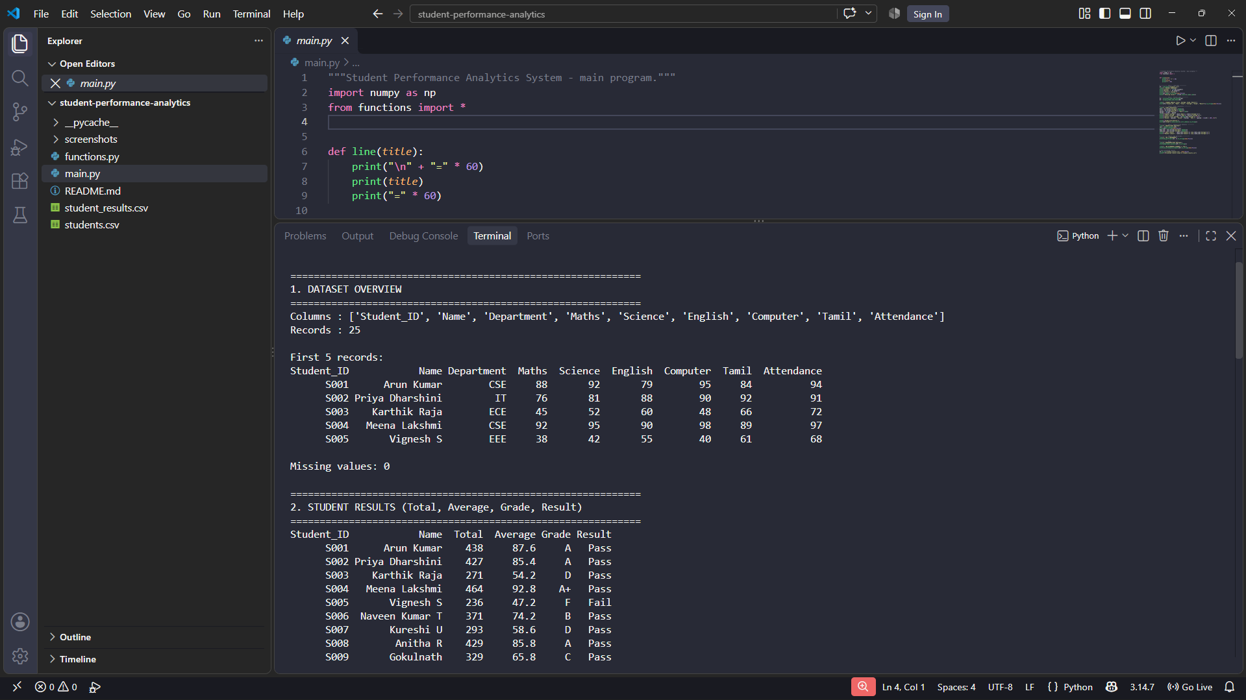
Figure 1: Dataset overview and student results (first part)
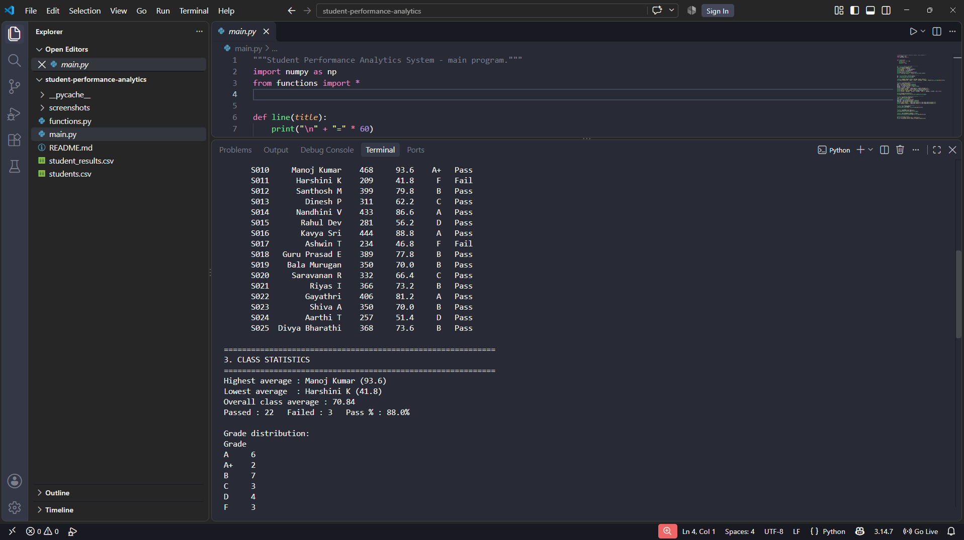
Figure 2: Student results (remaining records), class statistics and grade distribution
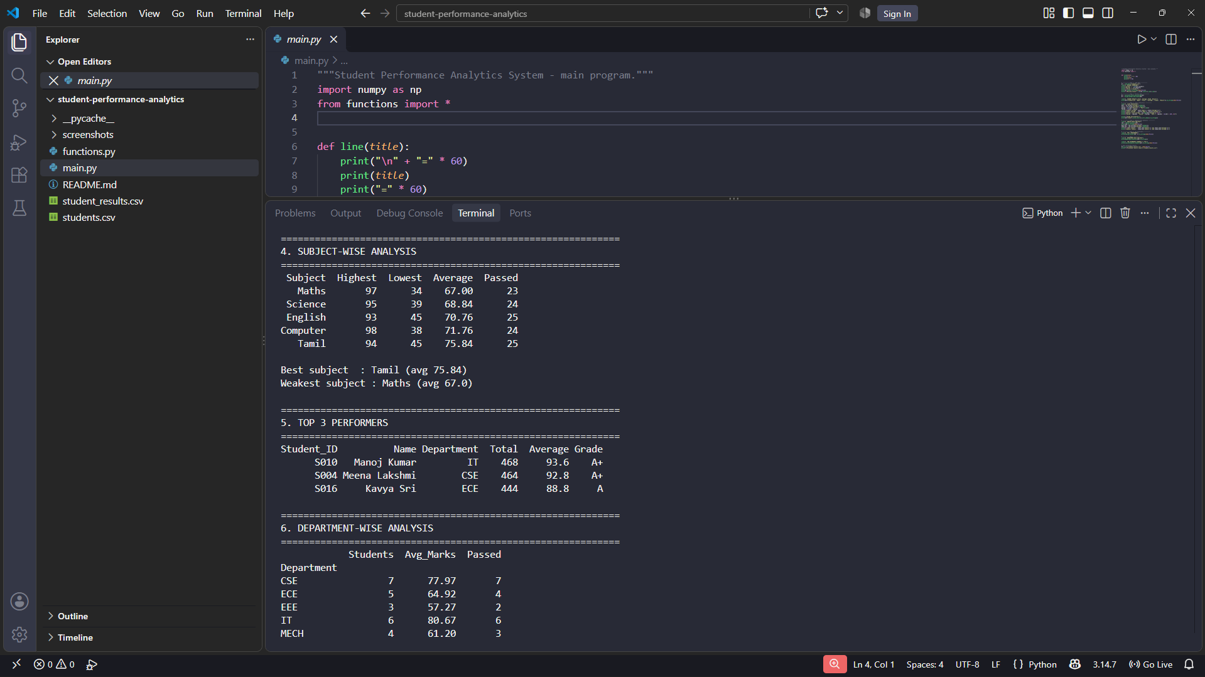
Figure 3: Subject-wise analysis, top 3 performers and department-wise analysis
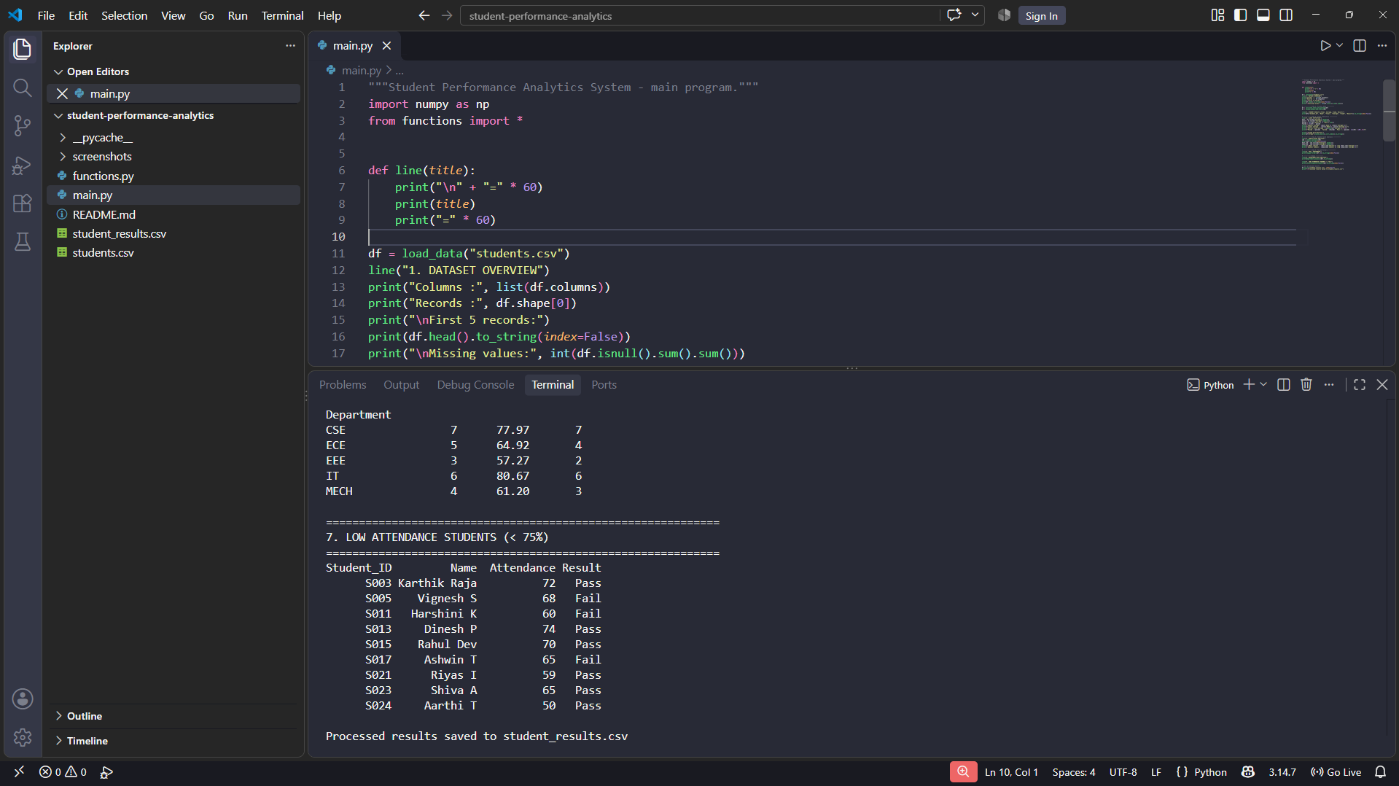
Figure 4: Department-wise analysis and low attendance students

8. Final Outcome
The project successfully analysed the performance of 25 students and produced the following results:
- Highest average: Manoj Kumar (93.6); lowest average: Harshini K (41.8)
- Overall class average: 70.84
- 22 students passed and 3 failed (pass percentage 88%)
- Best subject: Tamil (average 75.84); weakest subject: Maths (average 67.00)
- Top 3 performers: Manoj Kumar, Meena Lakshmi and Kavya Sri
- Best department by average marks: IT (80.67); lowest: EEE (57.27)
- 9 students have attendance below 75%
The program runs without errors and presents all results in a clear, readable format.

9. Challenges & Learning
Challenge | Solution / Learning
Deciding a clear pass condition | Defined that a student must score at least 40 in every subject, and implemented it with np.all().
Choosing between NumPy and Pandas | Used NumPy for calculations (sum, mean, max, min) and Pandas for loading, sorting, filtering and groupby.
Output too long to read | Divided the output into numbered sections with headings and separator lines.
Keeping code organised | Moved reusable logic to functions.py and kept main.py only for running and displaying results.
What I learned: writing reusable functions, using loops with DataFrames, applying NumPy for numerical work, analysing data with Pandas, and publishing a project on GitHub with a README.

10. GitHub Repository
<PASTE YOUR GITHUB REPOSITORY LINK HERE>

