Login Page Using “Branch” :

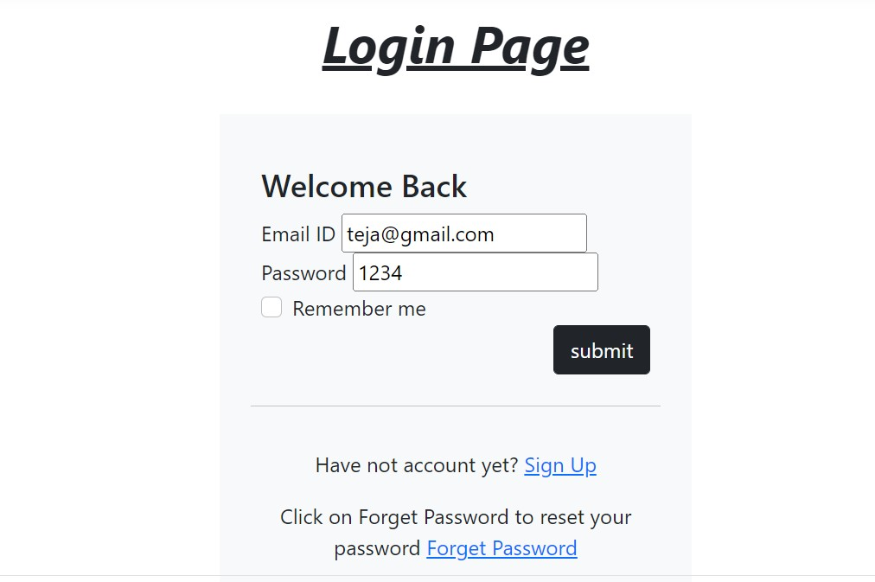

Dashboard Design Using “Layout” :

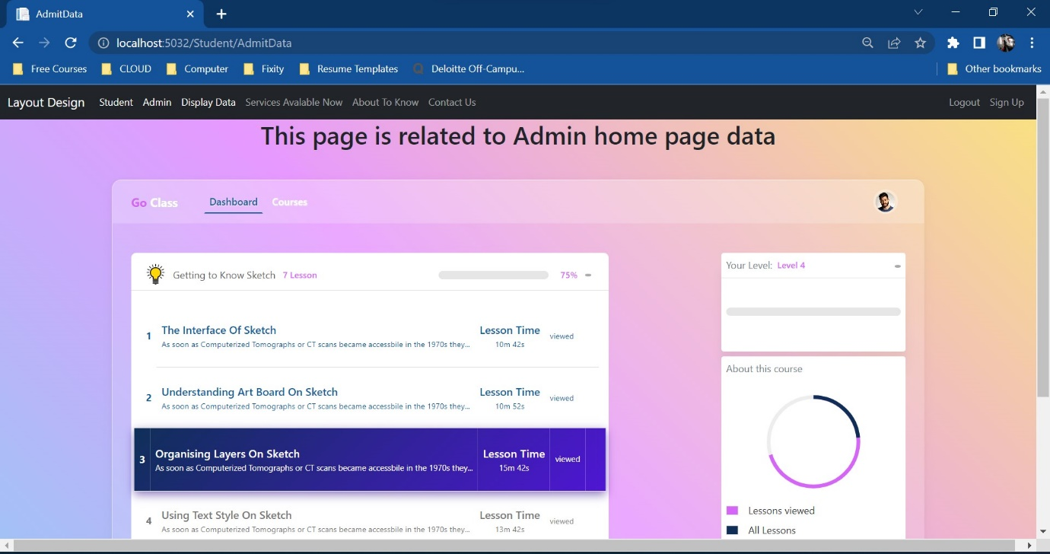

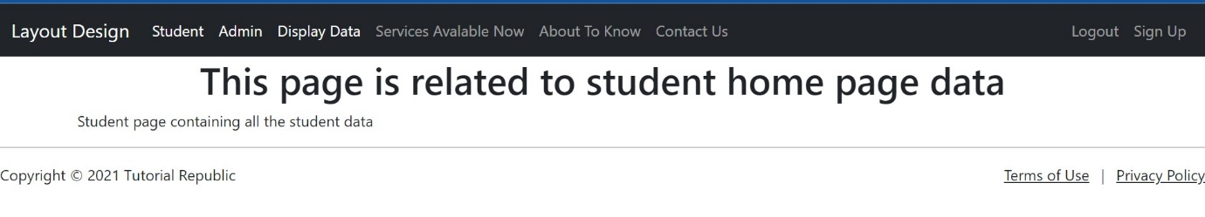

Table Display :

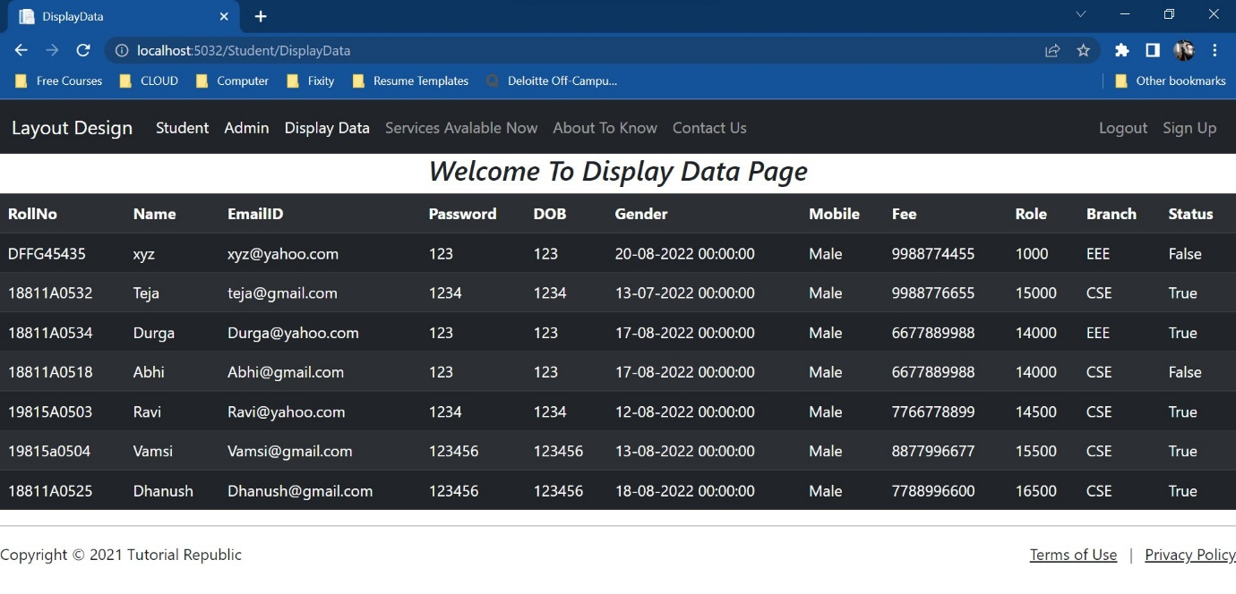

Registration Page Using Checkbox:

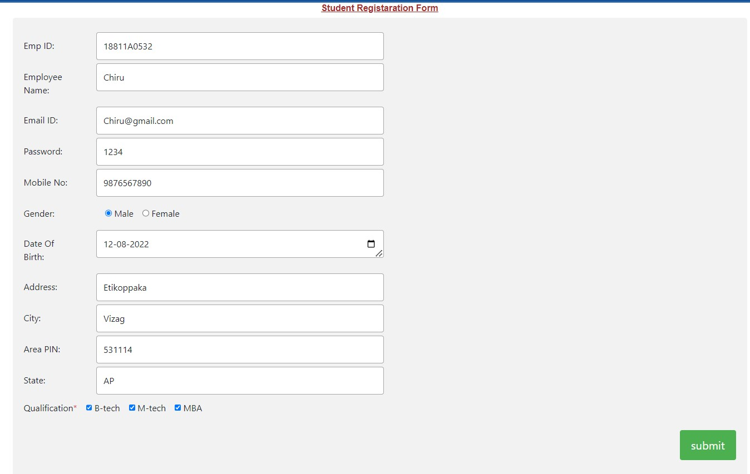

Checkbox Values In Database:

