Касимов ПР 23/1
Лабораторная работа №7
Тема: Отладка отдельных модулей программного проекта.
Организация обработки исключений.
Цель: создать программный проект в среде Visual Studio на языке C#, реализовать организацию обработки исключений для обеспечения надежной работы приложения, а также разработать функционал для оформления предзаказов с использованием базы данных MS SQL Server.
Ход работы:
Листинг кода DataBaseHelper.cs:
using System;
using System.Data.SqlClient;
using System.Collections.Generic;
using PublishingApp.Models;

namespace PublishingApp
{
public class DatabaseHelper : IDisposable
{
private string connectionString =
@"Data Source=LuM1e\SQLLUM1E;Initial Catalog=Publ;Integrated Security=True;Connect Timeout=30";

public List<Book> GetBooks()
{
var books = new List<Book>();

using (var connection = new SqlConnection(connectionString))
{
connection.Open();
string query = @"
SELECT p.id_Publication, p.Name, p.Author,
a.Surname + ' ' + a.Name AS AuthorName,
p.ReleaseYear, p.VolumeOfSheets, p.Circulation
FROM Publications p
LEFT JOIN Authors a ON p.Author = a.id_Author
ORDER BY p.Name";

using (var command = new SqlCommand(query, connection))
using (var reader = command.ExecuteReader())
{
while (reader.Read())
{
books.Add(new Book
{
Id = (int)reader["id_Publication"],
Title = reader["Name"].ToString(),
AuthorId = reader["Author"] != DBNull.Value ? (int)reader["Author"] : 0,
AuthorName = reader["AuthorName"].ToString(),
ReleaseYear = (int)reader["ReleaseYear"],
Pages = (int)reader["VolumeOfSheets"],
Circulation = (int)reader["Circulation"]
});
}
}
}

return books;
}

public List<Office> GetOffices()
{
var offices = new List<Office>();

using (var connection = new SqlConnection(connectionString))
{
connection.Open();
string query = "SELECT id_Office, Office, Address, Phone FROM Offices ORDER BY Office";

using (var command = new SqlCommand(query, connection))
using (var reader = command.ExecuteReader())
{
while (reader.Read())
{
offices.Add(new Office
{
Id = (int)reader["id_Office"],
Name = reader["Office"].ToString(),
Address = reader["Address"].ToString(),
Phone = reader["Phone"].ToString()
});
}
}
}

return offices;
}

public int CreateCustomer(Customer customer)
{
using (var connection = new SqlConnection(connectionString))
{
connection.Open();

string query = @"
INSERT INTO Customers (Name, Type, Address, Phone)
VALUES (@Name, 1, @Address, @Phone);
SELECT SCOPE_IDENTITY();";

using (var command = new SqlCommand(query, connection))
{
command.Parameters.AddWithValue("@Name", customer.Name);
command.Parameters.AddWithValue("@Address",
string.IsNullOrEmpty(customer.Address) ? (object)DBNull.Value : customer.Address);
command.Parameters.AddWithValue("@Phone",
string.IsNullOrEmpty(customer.Phone) ? (object)DBNull.Value : customer.Phone);

return Convert.ToInt32(command.ExecuteScalar());
}
}
}

public int CreateOrder(Order order)
{
using (var connection = new SqlConnection(connectionString))
{
connection.Open();

string query = @"
INSERT INTO Orders (Type, Publication, Office, Customer,
DateOfAdmission, DateOfCompletion, Price)
VALUES (1, @Publication, @Office, @Customer,
@DateOfAdmission, @DateOfCompletion, @Price);
SELECT SCOPE_IDENTITY();";

using (var command = new SqlCommand(query, connection))
{
command.Parameters.AddWithValue("@Publication", order.BookId);
command.Parameters.AddWithValue("@Office", order.OfficeId);
command.Parameters.AddWithValue("@Customer", order.CustomerId);
command.Parameters.AddWithValue("@DateOfAdmission", order.OrderDate);

if (order.CompletionDate.HasValue)
command.Parameters.AddWithValue("@DateOfCompletion", order.CompletionDate.Value);
else
command.Parameters.AddWithValue("@DateOfCompletion", DBNull.Value);

command.Parameters.AddWithValue("@Price", order.Price);

return Convert.ToInt32(command.ExecuteScalar());
}
}
}

public Order GetOrderDetails(int orderId)
{
using (var connection = new SqlConnection(connectionString))
{
connection.Open();

string query = @"
SELECT o.id_Order, o.DateOfAdmission,
o.Price,
p.Name AS BookTitle,
c.Name AS CustomerName,
ofc.Office AS OfficeName
FROM Orders o
LEFT JOIN Publications p ON o.Publication = p.id_Publication
LEFT JOIN Customers c ON o.Customer = c.id_Customer
LEFT JOIN Offices ofc ON o.Office = ofc.id_Office
WHERE o.id_Order = @OrderId";

using (var command = new SqlCommand(query, connection))
{
command.Parameters.AddWithValue("@OrderId", orderId);

using (var reader = command.ExecuteReader())
{
if (reader.Read())
{
return new Order
{
Id = (int)reader["id_Order"],
BookTitle = reader["BookTitle"].ToString(),
CustomerName = reader["CustomerName"].ToString(),
OfficeName = reader["OfficeName"].ToString(),
OrderDate = (DateTime)reader["DateOfAdmission"],
Price = (decimal)reader["Price"]
};
}
}
}
}

return null;
}

public void Dispose() { }
}
}
Листинг кода Author.cs:
using System;
using System.Collections.Generic;
using System.Linq;
using System.Text;
using System.Threading.Tasks;

namespace PublishingApp.Models
{
public class Author
{
public int Id { get; set; }
public string Surname { get; set; }
public string Name { get; set; }
public string FullName => $"{Surname} {Name}";
}
}
Листинг кода Book.cs:
using System;

namespace PublishingApp.Models
{
public class Book
{
public int Id { get; set; }
public string Title { get; set; }
public int AuthorId { get; set; }
public string AuthorName { get; set; }
public int ReleaseYear { get; set; }
public int Pages { get; set; }
public int Circulation { get; set; }
public decimal Price => Pages * 1.5m;
}
}
Листинг кода Customer.cs:
using System;

namespace PublishingApp.Models
{
public class Customer
{
public int Id { get; set; }
public string Name { get; set; }
public string Address { get; set; }
public string Phone { get; set; }
}
}

Листинг кода Office.cs:
using System;

namespace PublishingApp.Models
{
public class Office
{
public int Id { get; set; }
public string Name { get; set; }
public string Address { get; set; }
public string Phone { get; set; }
public override string ToString() => Name;
}
}
Листинг кода Order.cs:
using System;

namespace PublishingApp.Models
{
public class Order
{
public int Id { get; set; }
public string OrderName { get; set; }
public int BookId { get; set; }
public int OfficeId { get; set; }
public int CustomerId { get; set; }
public DateTime OrderDate { get; set; }
public DateTime? CompletionDate { get; set; }
public decimal Price { get; set; }
public string BookTitle { get; set; }
public string CustomerName { get; set; }
public string OfficeName { get; set; }
}
}
Результаты работы программы:

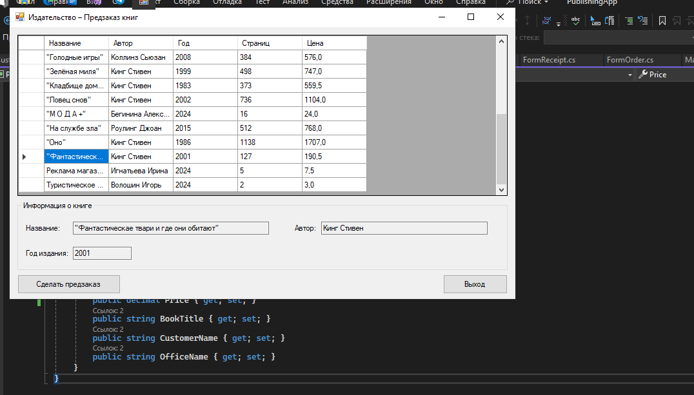
Рис. 1 — Информация о книге

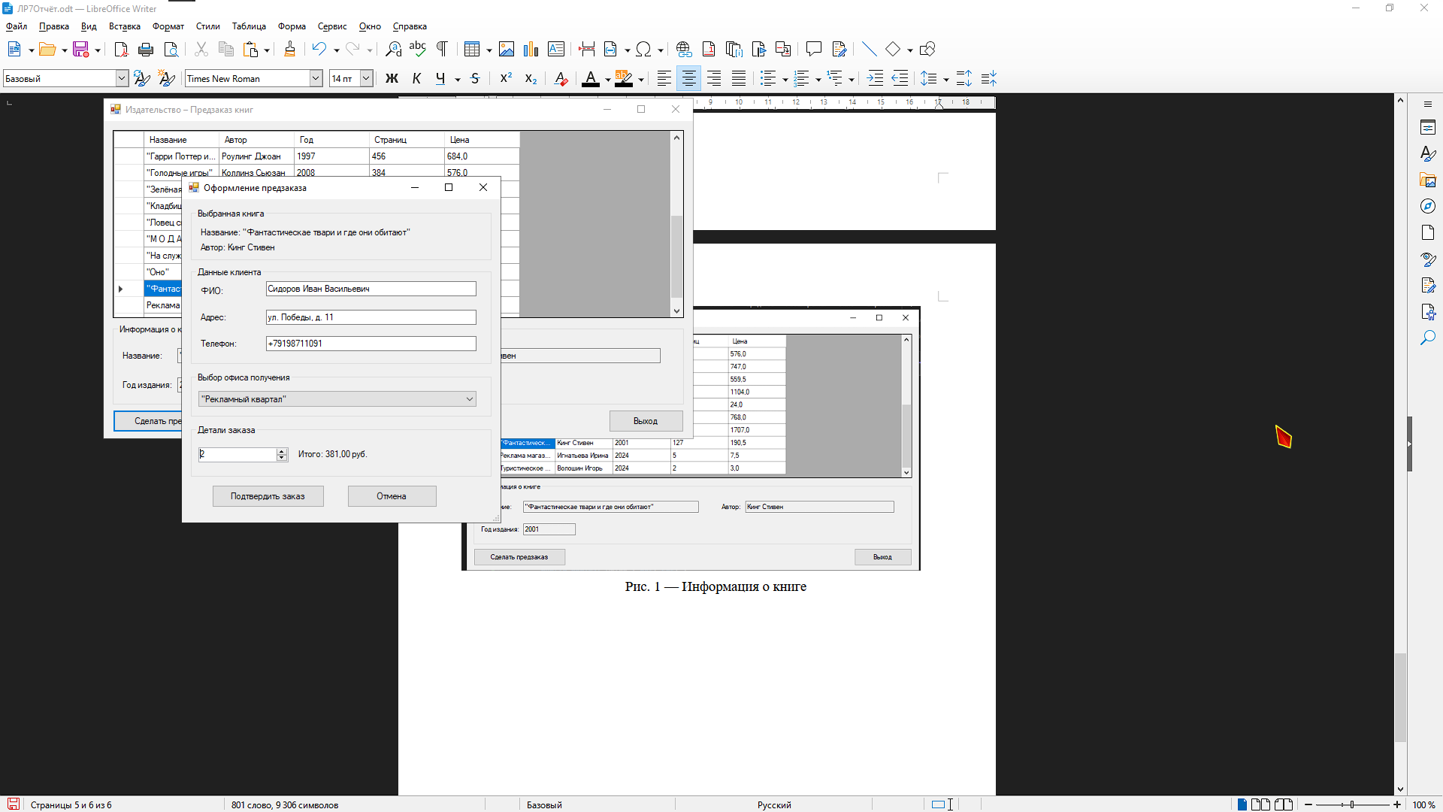

Рис. 2 — Предзаказ

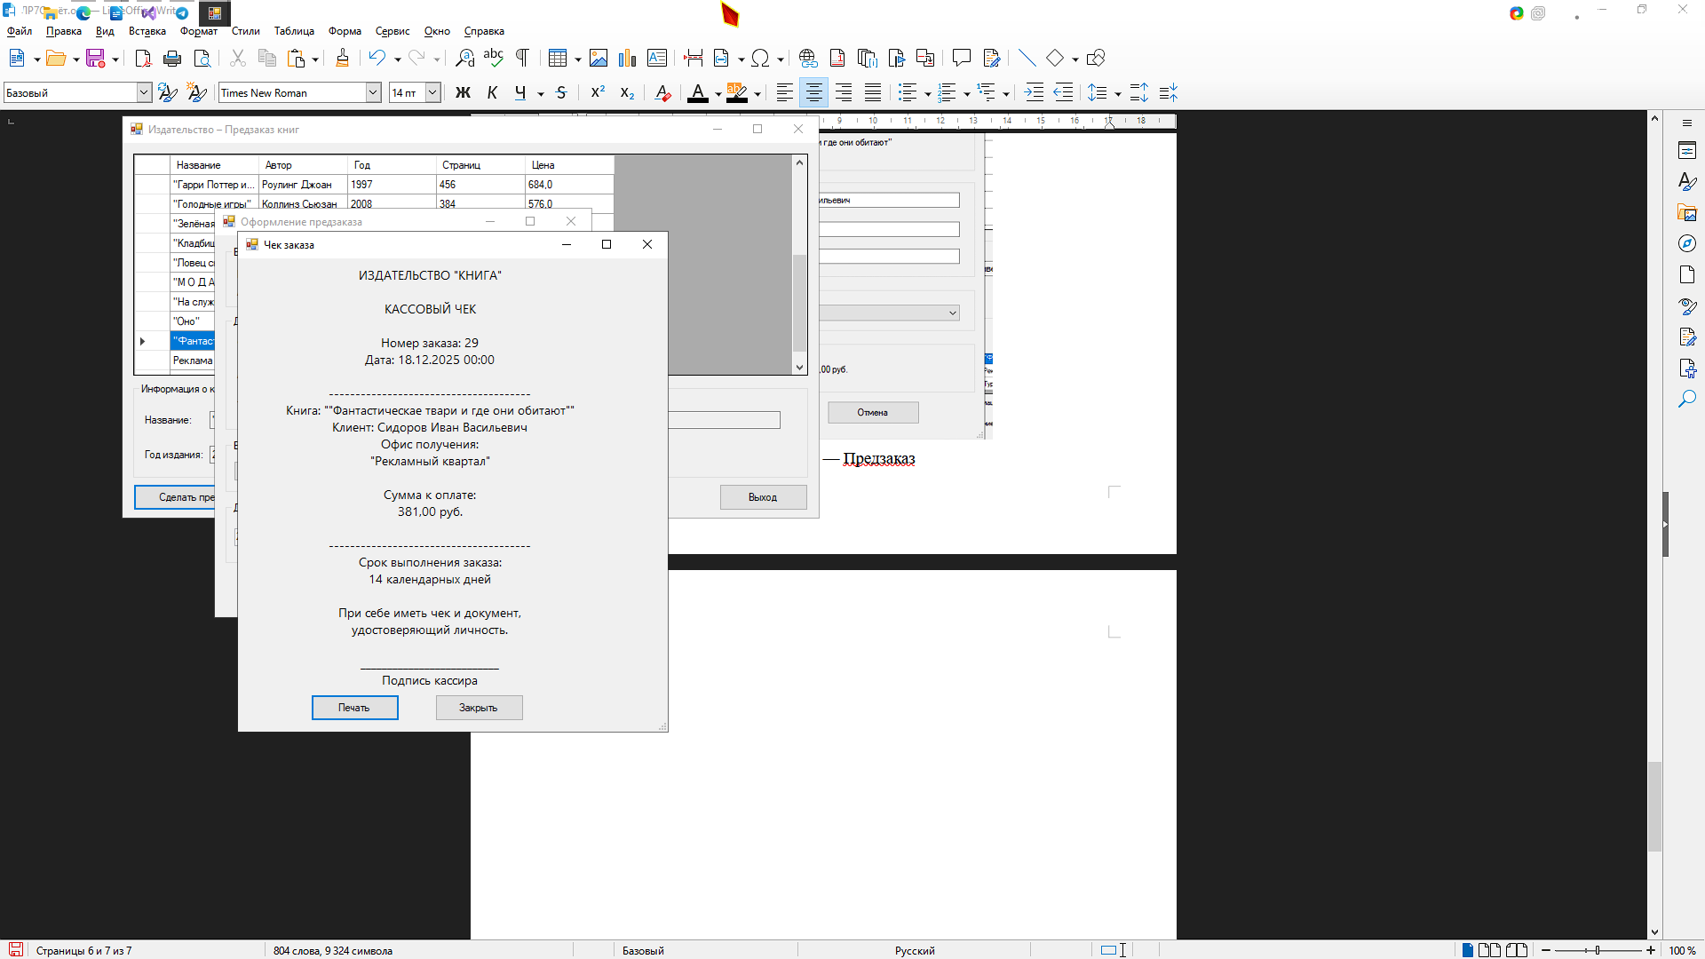
Рис. 3 — Чек заказа

