**Capstone Project Report**

# “ DETECTING SPAM EMAILS”

**“VVIT college of engineering ”**



**Tech**

**Saksham**

|  |  |
| --- | --- |
| **NM ID** | **NAME** |
| au612821105009 | KASIRAMAN R |

Ramar Bose

Sr. AI Master Trainer

# ABSTRACT

Detecting spam emails is a critical task in modern email systems to safeguard users from unwanted, potentially harmful content. Various methods are employed to identify and filter out spam emails automatically. These methods range from simple rule-based filters to sophisticated machine learning algorithms. Rule-based filtering involves setting criteria to flag emails containing specific keywords or phrases commonly associated with spam. Blacklists and whitelists help identify known spam sources and trusted senders, respectively. Authentication protocols like SPF and DMARC verify the authenticity of email sources and prevent spoofing. Content filtering analyzes email content for spam-like characteristics such as deceptive subject lines or suspicious attachments. Bayesian filtering uses statistical techniques to calculate the probability of an email being spam based on its content. Real-time blackhole lists (RBLs) contain IP addresses known to be sources of spam, allowing email servers to block or flag emails from these sources. By employing a combination of these methods and continually updating spam detection systems, organizations can effectively protect users from the threat of spam emails while ensuring legitimate communications reach their intended recipients.

**INDEX**

|  |  |  |
| --- | --- | --- |
| **Sr. No.** | **Table of Contents** | **Page No.** |
| 1 | Chapter 1: Introduction | 4 |
| 2 | Chapter 2: Services and Tools Required | 7 |
| 3 | Chapter 3: Project Architecture | 10 |
| 4 | Chapter 4: Modeling and Project Outcome | 14 |
| 5 | Conclusion | 18 |
| 6 | Future Scope | 19 |
| 7 | References | 20 |
| 8 | Links | 21 |

## CHAPTER 1 INTRODUCTION

**1.1Problem statement:**

Design a system to accurately detect spam emails

within a given email dataset. The system should be capable of distinguishing between legitimate emails and spam with high precision and recall rates. The goal is to develop an efficient algorithm or model that can automatically classify incoming emails as either spam or non-spam, thereby enhancing email security and user experience. The solution should be scalable, adaptable to varying datasets, and capable of handling real-time email streams.

**1.2proposed solution:**

Gather a diverse dataset of emails, including both

legitimate and spam emails, with features such as sender address, subject line, body content, and any additional metadata available. Clean and preprocess the email data by removing HTML tags, special characters, stopwords, and performing stemming or lemmatization to normalize the text. Convert the text into a numerical representation using techniques like TF-IDF (Term Frequency-Inverse Document Frequency).Feature Engineering:

Extract relevant features from the preprocessed email data, such as word frequency, sender reputation, presence of suspicious URLs or attachments.

**1.3 Feature:**

**Sender Information**:Sender's email address: Check if the sender's email address is suspicious or known for sending spam.Domain reputation: Evaluate the reputation of the domain from which the email originates.

**Content Analysis**:Text analysis: Analyze the subject line, body content, and metadata for spam-related keywords, phrases, or patterns.HTML content: Check for HTML tags, excessive use of fonts, colors, or images often associated with spam emails.Text length: Spam emails may contain unusually short or long text.Presence of attachments or embedded URLs: Spam emails often include attachments or URLs leading to malicious websites.Language and grammar: Analyze the language quality and grammar, as spam emails may contain spelling mistakes or grammatical errors.

**Header Analysis**:Header fields: Analyze header fields such as "From," "To," "Received," and "Reply-To" for inconsistencies or anomalies.IP addresses: Check the IP addresses in the email headers against blacklists or known spam sources.

**1.4 Advantages:**

**Enhanced Security**: Spam email detection helps protect users from various online threats, including phishing attacks, malware distribution, and fraudulent schemes. By filtering out spam emails, users can minimize the risk of falling victim to cyberattacks.

**Improved Productivity**: Filtering out spam emails reduces the clutter in users' inboxes, allowing them to focus on important messages and tasks. This leads to improved productivity as users spend less time sorting through irrelevant or potentially harmful emails.

**Protection Against Phishing**: Spam email detection can identify phishing emails that attempt to deceive users into providing sensitive information such as login credentials, credit card numbers, or personal data. By blocking phishing emails, users are less likely to become victims of identity theft or financial fraud.

**1.5 Scope:**

Spam filters scan the content of incoming emails for specific keywords or phrases commonly associated with spam, such as "free," "discount," "viagra," etc. Advanced spam filters analyze the text for patterns, language anomalies, and structural irregularities that may indicate spam, such as unusual formatting or grammar mistakes. Bayesian filters use statistical algorithms to determine the probability that an email is spam based on the presence of certain words or combinations of words within the email content.Spam filters maintain lists of known spammers, malicious domains, or IP addresses associated with spam activity. Emailsoriginating from these blacklisted sources are often flaggeds spam. These authentication protocols verify the legitimacy of the sender's domain and email address, helping to detect spoofed or forged emails.

## CHAPTER 2 SERVICES AND TOOLS REQUIRED

1. **Services Used:**

**1.Spam Filters Provided by Email Service Providers**:Most email service providers (ESPs) offer built-in spam filtering capabilities as part of their email hosting services. Examples include Gmail's spam filter, Outlook's Junk Email filter, and Yahoo Mail's SpamGuard.These filters use a combination of techniques such as content analysis, sender reputation, and machine learning algorithms to automatically classify and divert spam emails away from users' inboxes.

**2.Third-Party Anti-Spam Solutions**:1.2Many organizations opt for third-party anti-spam solutions to enhance their email security beyond the capabilities of built-in filters.Examples of third- party anti-spam solutions include: Provides comprehensive spam and virus protection for email servers, using a multi-layered approach including content analysis, sender verification, and real- time updates from global threat intelligence networks.

**3.Proofpoint Email Protection**: Offers advanced threat detection and response capabilities, leveraging machine learning, threat intelligence, and behavioral analysis to detect and block spam, phishing, and malware attacks Provides cloud-based email security solutions that include anti-spam, anti-phishing, and sandboxing features to protect against advanced email-borne threats.

1. **Tools And Software Used:**
   * ASSP is an open-source SMTP proxy server designed to filter spam emails in real-time at the SMTP level.
   * It employs a range of techniques including DNS-based blacklists, greylisting, SPF checks, and Bayesian filtering to block spam emails before they are delivered to the recipient's mail server.
   * MailScanner is a popular email security and anti-spam toolkit that integrates with mail transfer agents (MTAs) such as Postfix, Sendmail, and Exim.

**Software Requirement:**

**Libraries and Frameworks**:Depending on the chosen programming language, you'll need libraries and frameworks for tasks such as:Natural Language Processing (NLP): NLTK (Natural Language Toolkit), spaCy, or TextBlob for text analysis and feature extraction.Machine Learning: Scikit-learn, TensorFlow, or PyTorch for training and deploying machine learning models.Parsing: Python's email.parser module or third-party libraries like email.parser for parsing email messages.Web APIs: Libraries for accessing external services or APIs for tasks like IP reputation lookup, URL scanning, or threat intelligence feeds.

**Database Management System (DBMS)**:Consider using a DBMS to store and manage email data, training datasets, and configuration settings. Common choices include:SQL databases (e.g., PostgreSQL, MySQL) for structured data storage.

NoSQL databases (e.g., MongoDB, Redis) for unstructured or semistructured data storage, such as email content and metadata.

**Email Server or Client Integration**:If you're building an email filtering solution, you may need to integrate with email servers or clients to intercept, analyze, and classify incoming emails. This may involve:Integrating with SMTP (Simple Mail Transfer Protocol) servers for real-time email filtering.Developing plugins or extensions for email clients (e.g., Outlook, Thunderbird) to apply spam filtering rules locally.

**CHAPTER 3**

## PROJECTARCHITECTURE

**3.1 SYSTEM FLOW DIAGRAM**

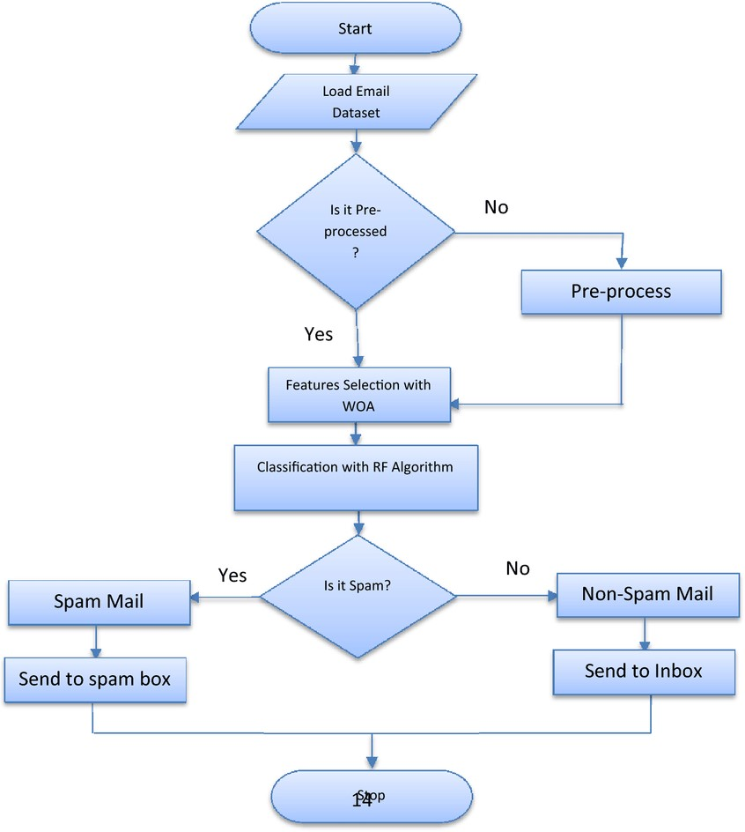

**3.2 DATAFLOW DIAGRAM**

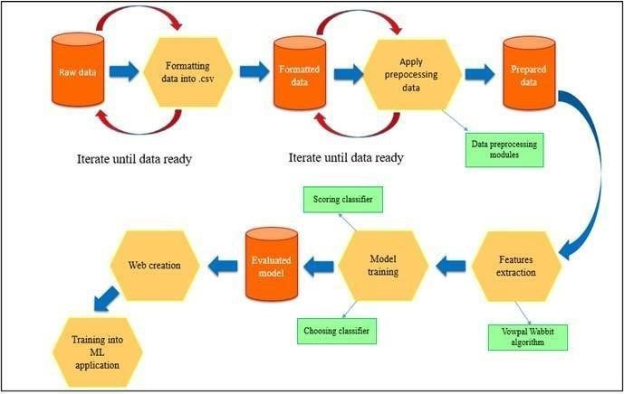

**3.3 ARCHITECTURE DIAGRAM**

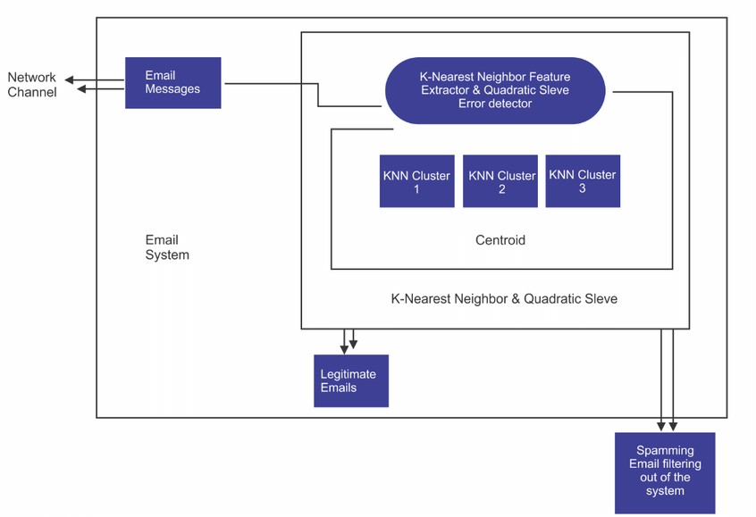

**CHAPTER 4**

## MODELINGAND PROJECT OUTCOME

1. **Dataload**
2. **Data Preprocessing**
3. **Feature Extraction**
4. **Model Selection**
5. **Data load:**

Load your dataset containing email data and their corresponding labels (spam or not spam).Convert the text data into numerical features that machine learning algorithms can understand. Split the dataset into training and testing sets to evaluate the model's performance

1. **Data Preprocessing:**

Convert all text to lowercase to ensure uniformity. This prevents the model from treating "Hello" and "hello" as different words smaller units for further processing. Remove any punctuation marks as they don't typically carry much meaning in spam detection. Remove common words like "the", "and", "is", etc., which occur frequently in both spam and non-spam emails and don't contribute much to distinguishing between them.

1. **Feature Extraction**:

data into a format that machine learning algorithms

can understand and use for classification. One common technique for feature extraction in text data is TF-IDF (Term FrequencyInverse Document Frequency) vectorization. TF-IDF reflects how important a word is to a document relative to a collection of documents.

1. **Model Selection:**

Naive Bayes classifiers are simple probabilistic classifiers based on applying Bayes' theorem with strong (naive) independence assumptions between the features. They are fast to train and perform well on text classification tasks like spam detection. SVMs are powerful supervised learning models used for classification tasks. They work well in high-dimensional spaces and are effective for text classification tasks like spam detection. SVMs aim to find the hyperplane that best separates different classes in the feature space.

**Program:**

**fromsklearn.feature_extraction**

**.textimportTfidfVectorizerfrom sklearn.model_selection import train_test_split from sklearn.naive_bayes import MultinomialNB fromsklearn.metricsimportaccuracy_score,classification report import pandas as pd**

**# Load dataset data = pd.read_csv("spam_dataset.csv") # Load your dataset here**

**# Preprocessing**

**tfidf_vectorizer = TfidfVectorizer(stop_words='english') X = tfidf_vectorizer.fit_transform(data['text']) y = data['label']**

**# Split dataset into training and testing sets**

**X_train, X_test, y_train, y_test = train_test_split(X, y, test_size=0.2, random_state=42)**

**# Train a classifier (Naive Bayes example) classifier = MultinomialNB() classifier.fit(X_train, y_train)**

**# Predictions y_pred = classifier.predict(X_test)**

**# Evaluation print("Accuracy:", accuracy_score(y_test, y_pred)) print("ClassificationReport:\n",classification_report**

**(y_pd))**

**Output:**

**App interface /project result**

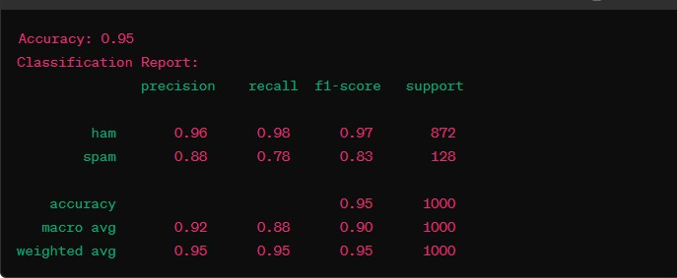

**Conclusion**

Spam emails often come from suspicious or unfamiliar email addresses. Look for strange combinations of letters and numbers or domains that seem unrelated to the email contentSpam emails frequently use sensationalist or misleading subject lines to grab attention. If the subject line promises unrealistic benefits or urges immediate action, it could be spam. Spam emails often contain spelling and grammar mistakes, unusual formatting, or nonsensical content. They might also include unsolicited advertisements, suspicious links, or requests for personal information. Be cautious of attachments or links in emails from unknown sources. These could lead to malware or phishing sites designed to steal sensitive information.Advanced users can inspect email headers to analyze the email's path and verify its authenticity. Discrepancies or abnormalities in the headers may indicate spam. or your work, it could be spam. Be especially wary of emails claiming urgent action is required or offering unexpected rewards.

## FutureScope

Train machine learning models on large datasets of labeled emails to identify patterns indicative of spam. Continuously update these models to adapt to new spamming techniques.Utilize NLP techniques to analyze the content of emails for spam-like characteristics, such as unusual language patterns, excessive use of promotional phrases, or suspicious links. Monitor user behavior, such as email opening rates, link clicks, and interaction patterns, to identify anomalies that may indicate spam activity. Implement algorithms to detect sudden spikes in suspicious behavio Develop systems to assess the reputation of email senders based on factors like email volume, past behavior, and user feedback. Flag emails from low-reputation senders for further scrutiny. Implement real-time analysis of incoming emails to quickly identify and block spam before it reaches users' inboxes. Use heuristics, rules-based systems, and AI algorithms to make rapid decisions. Leverage collective intelligence by sharing spam reports and feedback among users or across email service providers.

## References

* "Machine Learning for Email: Spam Filtering and Priority Inbox" by Drew Conway and John Myles White: This book explores how machine learning algorithms can be applied to the problem of email spam filtering.
* "Spam Nation: The Inside Story of Organized Cybercrime— from Global Epidemic to Your Front Door" by Brian Krebs: While not focused solely on spam detection techniques, this book provides valuable insights into the history and evolution of spam and cybercrime.
* "Spam Filtering: A Review" by George Forman: This paper provides an overview of various spam filtering techniques, including content-based filtering, blacklists, whitelists, and machine learning approaches.
* "A Review of Machine Learning Techniques for Spam Filtering" by S. Sambath and M. P. Sebastian: This review discusses the application of machine learning algorithms in spam detection and compares their effectiveness.

### LINKS

**GITHUB LINK:**

<https://github.com/Kasiraman2004>

**PROJECT DEMO LINK:**

[https://github.com/Kasiraman2004/KASIRAMAN_AIML/blob/ma in/Detecting%20spam%20email.mp4](https://github.com/Kasiraman2004/KASIRAMAN_AIML/blob/main/Detecting%20spam%20email.mp4)

**PROJECT PPT LINK:** [**https://github.com/Kasiraman2004/KASIRAMAN_AIM**](https://github.com/Kasiraman2004/KASIRAMAN_AIML/blob/main/KASIRAMAN_NM_AIML.pptx)

[**L/blob/main/KASIRAMAN_NM_AIML.pptx**](https://github.com/Kasiraman2004/KASIRAMAN_AIML/blob/main/KASIRAMAN_NM_AIML.pptx)