**Django Task-2**

1. **Task Description**

Build a Django Function which can make a shadow sentence after taking input of character length.

1. **Task Output Screenshot**

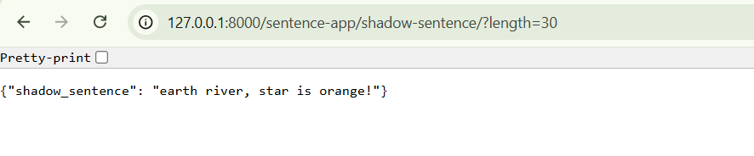

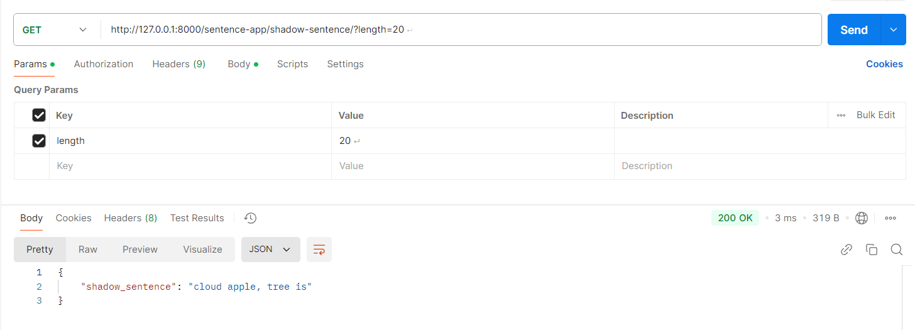

1. **Widget/Algorithm Used In Task**

**Widgets/Tools Used:**

* **Django Framework**: To create the web app and handle HTTP requests.
* **Python String Methods**: For text processing and punctuation handling.
* **Random Library**: To select substitute words (random.choice).
* **JsonResponse**: For structured JSON output.
* **Query Parameters**: To handle input length (request.GET.get).
* **Django URL Dispatcher**: To map the function to a URL.
* **Django Dev Server**: For local testing and debugging.

**Algorithm/Logic:**

* I**nput Handling:** Fetch the length parameter from the query string.
* **Word Pool:** Use a predefined set of words (word_pool) for substitution.
* **Shadow Word Selection:** Match each word in the input sentence to a word in the pool of identical length. If no match is found, the original word is retained.
* **Sentence Assembly:** Construct the shadow sentence while retaining punctuation and trimming to the specified character length.