**Django Task-3**

1. **Task Description**

Use JWT token authentication for login signup.

1. **Task Output Screenshot**

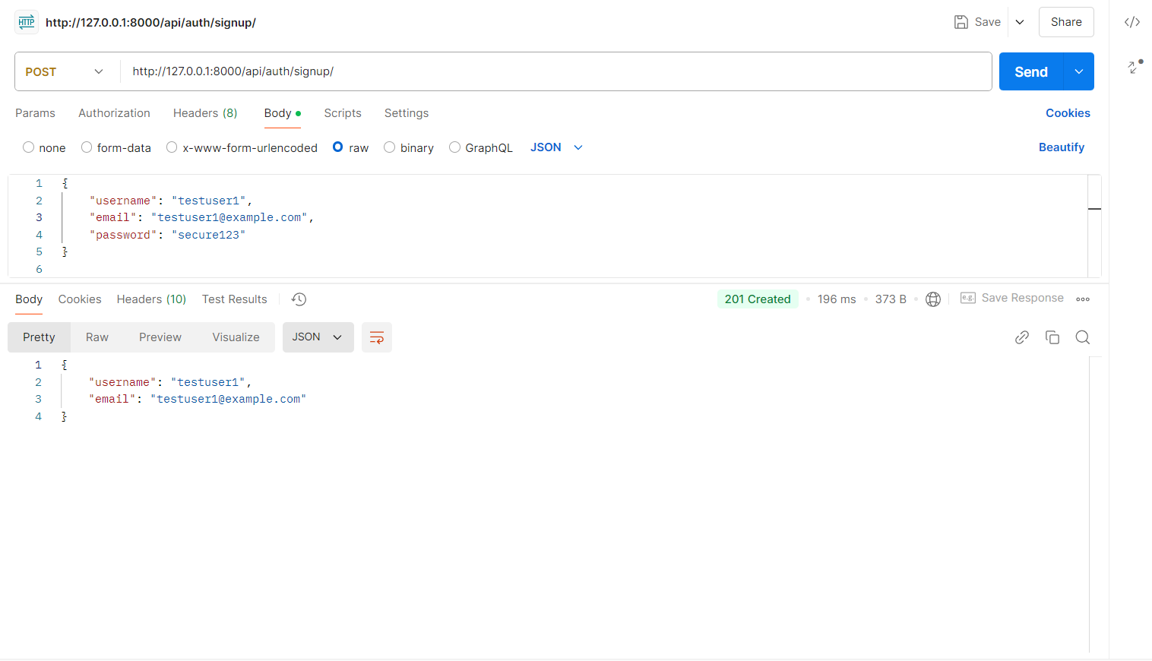

*[signup]*

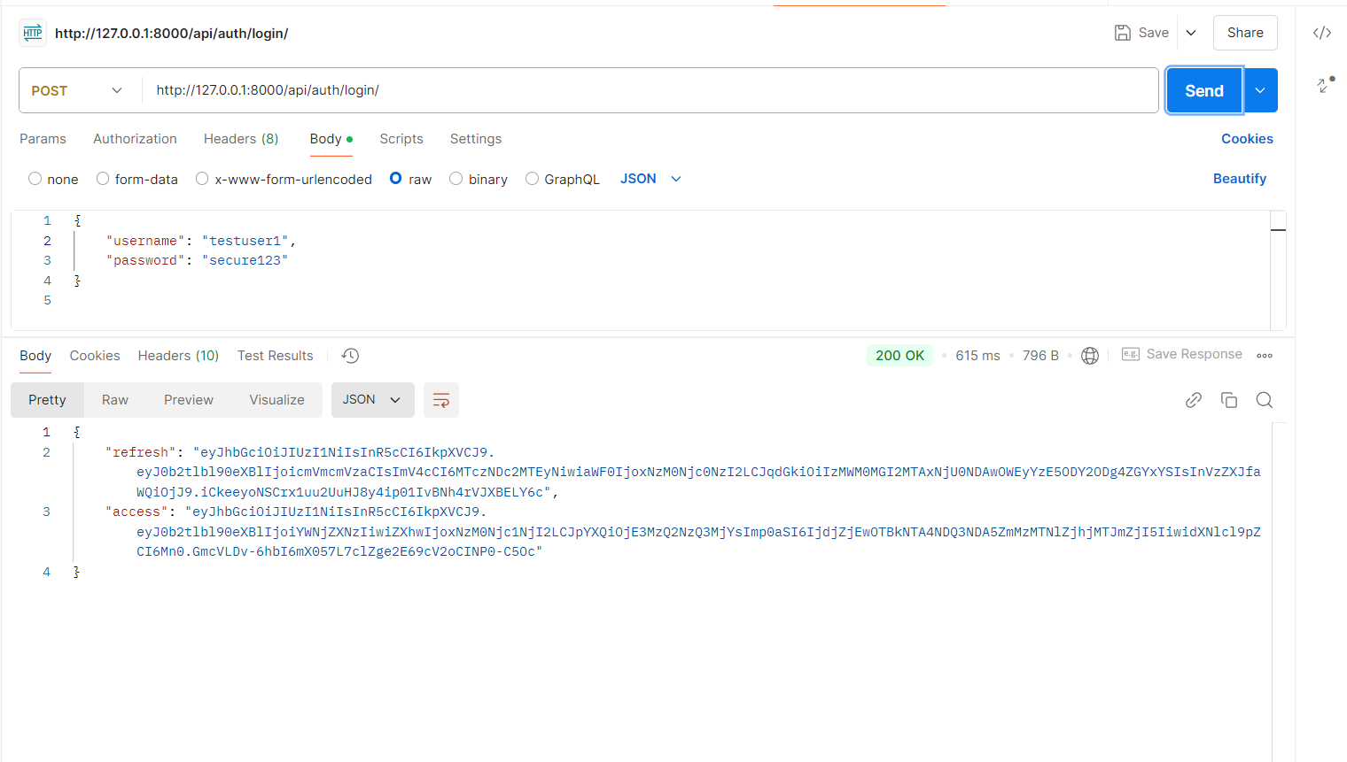

*[login]*

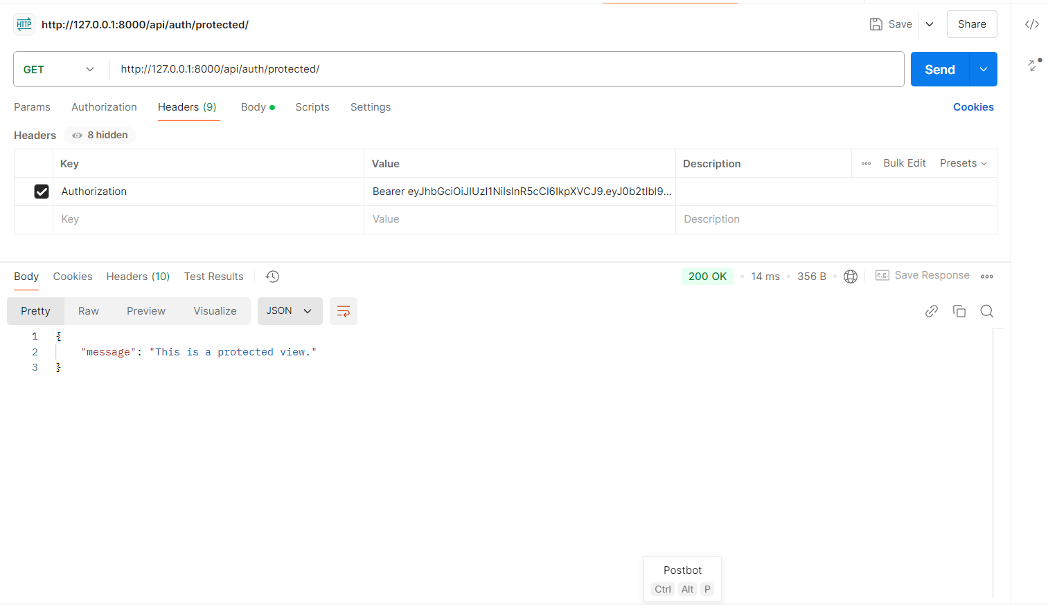

*[Protected]*

1. **Widget/Algorithm Used in Task**

**Algorithm Description**:

* **Signup Endpoint (/signup/)**: Registers a new user by accepting username, email, and password.
* **Login Endpoint (/login/)**: Authenticates a user and provides access and refresh tokens.
* **Protected Endpoint (/protected/)**: Allows access only with a valid JWT access token.
* **Django**:
  + - * Backend framework for building the API endpoints.
* **JWT Authentication**:
  + - * Provided by the rest_framework_simplejwt library.
      * Utilizes the HS256 algorithm for token signing.
      * Ensures secure, token-based authentication.

**Tools/Libraries Used:**

* **Postman:** Used to simulate HTTP requests to the Django REST Framework API.
* **Django REST Framework:** Provides tools to create RESTful APIs.
* **rest_framework_simplejwt:** Handles JWT token creation, rotation, and validation.