**Django Task-4**

1. **Task Description**

Build a Post api which also returns the serialized data with count of data saved.

1. **Task Output Screenshot**

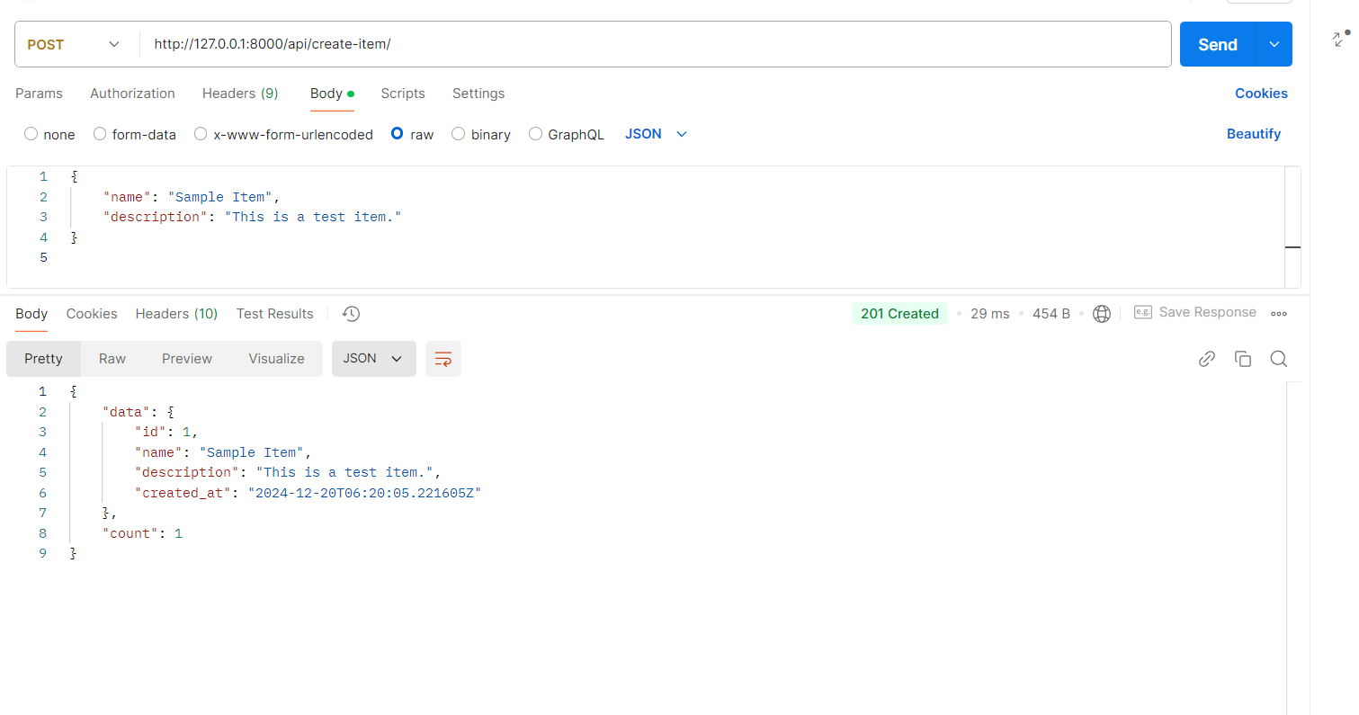

1. **Widget/Algorithm Used in Task**

**Algorithm Description**:

* **Model**: Defined a Django model (Item) to represent the database structure.
* **Serializer**: Created a Django REST Framework serializer (ItemSerializer) to handle data validation and transformation.
* **APIView**: Used the APIView class to handle HTTP POST requests, validate incoming data, and save it to the database.
* **Count Calculation**: Utilized Django’s ORM (Item.objects.count()) to calculate the total number of saved records in the database.

**Tools/Libraries Used:**

* **Postman:** Used to simulate HTTP requests to the Django REST Framework API.
* **Django REST Framework:** Provides tools to create RESTful APIs.