**Django Task-5**

1. **Task Description**

Built a django app which converts any image to a black and white image and saves to db.

1. **Task Output Screenshot**

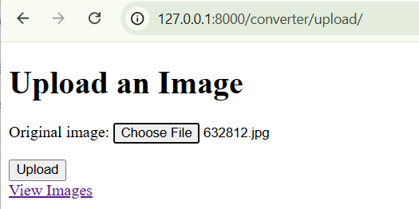

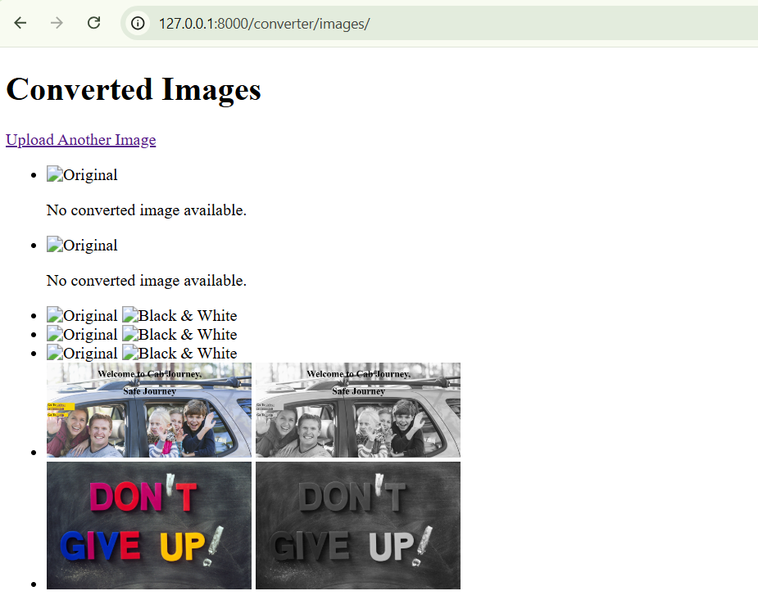

1. **Widget/Algorithm Used in Task**

**Algorithm Description**:

* **Image Conversion to Black-and-White:** The Pillow library (PIL.Image) was used to process the image.
* **Steps include:**
  + - * Opening the uploaded image using Image.open.
      * Converting the image mode to grayscale using .convert('L').
      * Saving the processed image in the converted folder.

**Widget Used:**

* **FileField in Django Forms**: Used to upload the original image through a form.
* **Django ImageField in Models**: To store the uploaded and processed images in the database.
* **Template Tags in HTML**:
  + - {% for %}: Looping through the image list.
    - {% static %}: Including static files for rendering.

**Tools/Libraries Used:**

* **Django**: For web application framework.
* **SQLite**: As the default database.
* **Pillow (PIL)**: For image manipulation.