**Title:** What language is that?

**Name(s):**

Student number(s) 65011328

email address(es): [65011328@kmitl.ac.th](mailto:65011328@kmitl.ac.th), [kasitphoom47@gmail.com](mailto:kasitphoom47@gmail.com)

**Collaborator(s):** -

**Aim:** To identify which language is that of the given letter or sentence.

**Methods:**

1. Tools:
   1. A computer / laptop which has rust installed
   2. Visual Studio Code for IDE
2. Step in the experiment
   1. Planning
      1. Read through the instructions and given text file containing various sentence from many languages.
      2. Read roughly to detect some known languages for easier to find the information in next step (b).
      3. Plan how the program should operate.
   2. Find the information
      1. Find some information of the language of the letter.
   3. Coding
      1. Proceed the steps after planning in (1)(iii) then code with trial and error.
   4. Checking the result
      1. Run the code and look roughly that the result are expected or not. Then add *panic!()* in the code so that we check that no letter is left over.
3. Difficulty
   1. Due to some misunderstood of the instruction. Some steps or functions or tables are not necessary so that it make some confusion.
   2. Making the code to provide the counting of presence of the language in each line have some difficult as there has to reset every time enter a new line.
4. 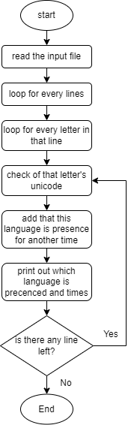Flow chart

**Results:**

1. Observations
   1. The results are as expected (count and recognize by hand)
2. Actual measurements

Text: 日本人は淡白な食べ物が好き println!("enter a character:");

Result: Line 0: Chinese (8), Japanese (5), ASCII (10), English (22),

**Conclusion:**As using unicode the language can be determined easily and accurately by the program.

**Acknowledgments:**

I acknowledge that all of the code written, and all of the result are addressed by myself, and all information are correct.   
(Kasitphoom Thowongs)

**Appendix:**

**[These are the results]**

*Line 1: Chinese (8), Japanese (5), ASCII (10), English (22),*

*Line 2: Chinese (8), ASCII (4), English (15),*

*Line 3: English (14), ASCII (6), Accented Latin (1), Burmese (35),*

*Line 4: Korean (17), ASCII (6), English (7), Accented Latin (1),*

*Line 5: English (40), ASCII (7), Accented Latin (2),*