

**Homework # N**

**01286233 Web Programming**

**Software Engineering Program,**

**Department of Computer Engineering,**

**School of Engineering, KMITL**

By

65011328 Kasitphoom Thowongs

Result: <https://ict11.ce.kmitl.ac.th/u65/65011328/homework/hw2/CodesHW2_65011328.html>

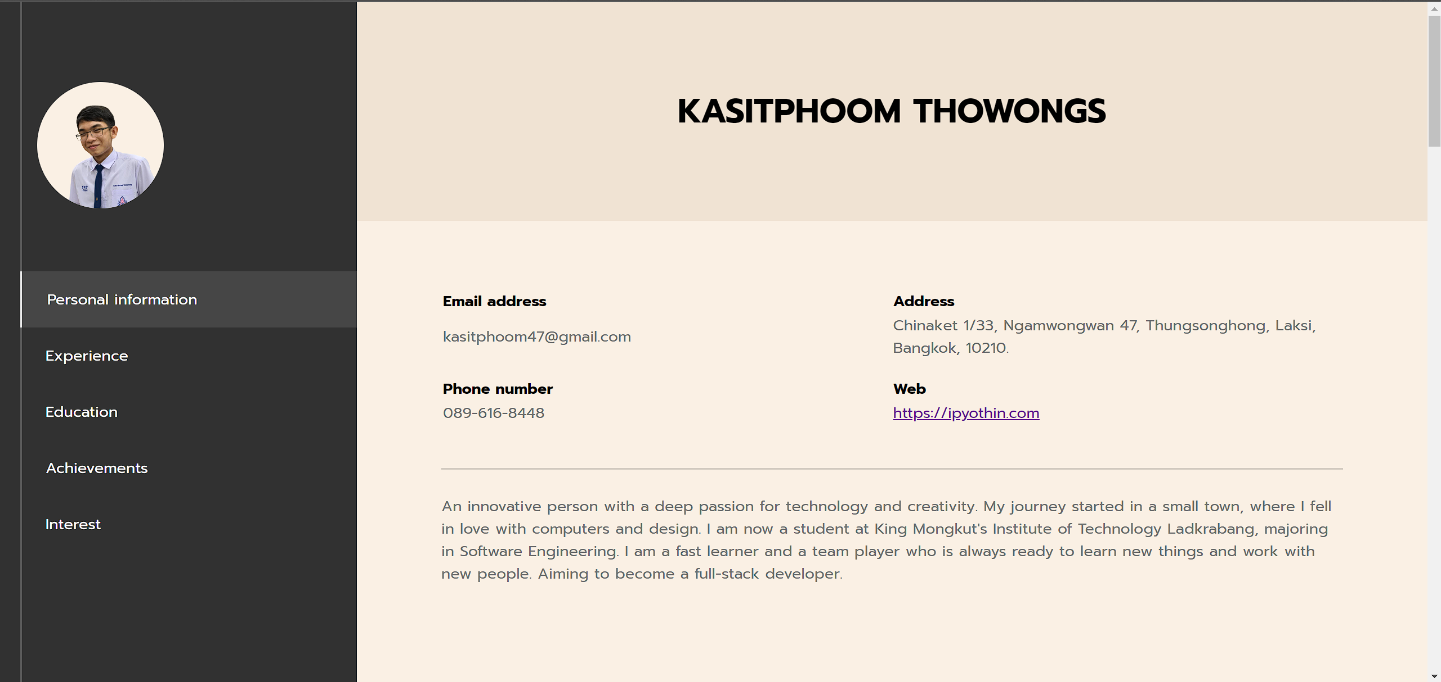

Responsive Design

(Ipad and mobile)

