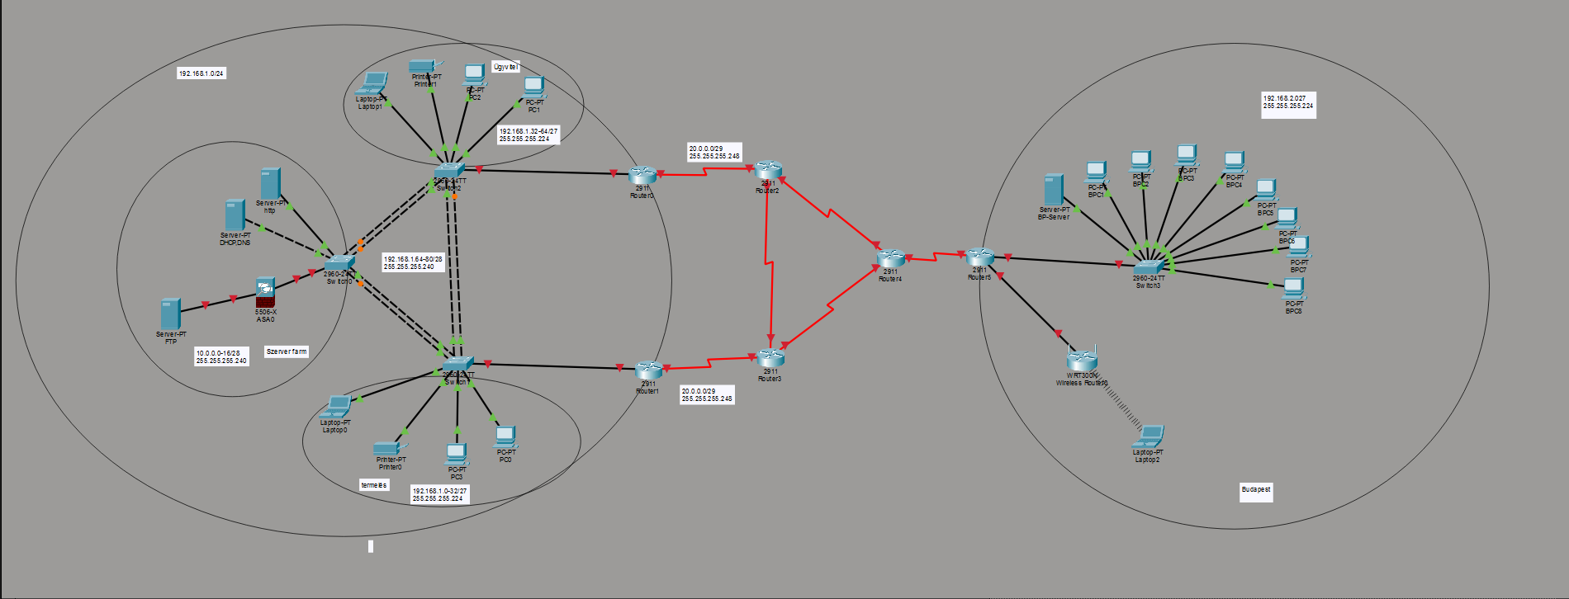

NYÍREGYHÁZA
HR1 | G0/0.10 | 192.168.1.1/27 | 255.255.255.224
HR1 | G0/0.20 | 192.168.1.33/27 | 255.255.255.224
HR1 | G0/0.30 | 192.168.1.65/28 | 255.255.255.240
HR1 | G0/0.77 | 192.168.1.81/28 | 255.255.255.240
HR2 | G0/0.10 | 192.168.1.2/27 | 255.255.255.224
HR2 | G0/0.20 | 192.168.1.34/27 | 255.255.255.224
HR2 | G0/0.30 | 192.168.1.66/28 | 255.255.255.240
HR2 | G0/0.77 | 192.168.1.82/28 | 255.255.255.240
SW1 | VALN77 | 192.168.1.83/28 | 255.255.255.240
SW2 | VALN77 | 192.168.1.84/28 | 255.255.255.240
SW3 | VALN77 | 192.168.1.85/28 | 255.255.255.240
TPRI1 | VLAN10 | 192.168.1.3/27 | 255.255.255.224
TLAP1 | VLAN10 | DHCP | DHCP
TPC1 | VLAN10 | DHCP | DHCP
TPC2 | VLAN10 | DHCP | DHCP
ÜPRI1 | VLAN20 | 192.168.1.35/27 | 255.255.255.224
ÜLAP1 | VLAN20 | DHCP | DHCP
ÜPC1 | VLAN20 | DHCP | DHCP
ÜPC2 | VLAN20 | DHCP | DHCP
DHCP,DNS | VLAN30 | 192.168.1.67/28 | 255.255.255.240
HTTPS | VLAN30 | 192.168.1.68/28 | 255.255.255.240
ASA1 | G1/1 | 192.168.1.86/28 | 255.255.255.240
ASA1 | G1/2 | 10.0.0.1/29 | 255.255.255.248
FTP | DMZ | 10.0.0.2/29 | 255.255.255.248

ISP
HR1ISP1 | SE0/3/0 | 20.0.0.1/30 | 255.255.255.252
ISP1HR1 | SE0/3/0 | 20.0.0.2/30 | 255.255.255.252
HR2ISP2 | SE0/3/0 | 21.0.0.1/30 | 255.255.255.252
ISP2HR2 | SE0/3/0 | 21.0.0.2/30 | 255.255.255.252
ISP1ISP2 | SE0/2/0 | 22.0.0.1/30 | 255.255.255.252
ISP2ISP1 | SE0/2/0 | 22.0.0.2/30 | 255.255.255.252
ISP1ISP3 | SE0/3/1 | 22.0.0.1/30 | 255.255.255.252
ISP3ISP1 | SE0/3/0 | 22.0.0.2/30 | 255.255.255.252
ISP2ISP3 | SE0/3/1 | 23.0.0.1/30 | 255.255.255.252
ISP3ISP2 | SE0/3/1 | 23.0.0.2/30 | 255.255.255.252
ISP3HR3 | SE0/2/1 | 24.0.0.1/30 | 255.255.255.252
HR3ISP3 | SE0/3/1 | 24.0.0.2/30 | 255.255.255.252

BUDAPEST
HR3 | G0/0 | 192.168.2.0/27 | 255.255.255.224
HR3 | G0/1 | 192.168.3.0/24 | 255.255.255.0
BPC1-8 | Fa0/1-8 | DHCP | DHCP | 192.168.2.1
BP-SERVER | Fa0/24 | 192.168.2.3 | 255.255.255.0 | 192.168.2.1
FREE-WIFI

