Investigation into Fractal growth of ZnSO₄ Crystals
with dependence on voltage and concentration

Kaspar Snashall 12301580 with Mary Brosnan, September 26th – October 3rd 2014

In the experiment Zn crystals were grown via electolysis with varying voltage and current^{[1,2]}.
It was found that certain concentrations and voltages gave rise to different forms of crystals. Ranging from dense and dendritic to a more fractal form. A few particular cases gave rise to interesting changes in shapes during growth (Disscusion).

The following is a brief introduction into the ideas and terminology in this paper. Fractals can be defined as shapes, who can with a simple algoirthm create self similar shapes where by zooming in or out on the shape or on another area reveals a similar shape. There are many types of fractals some of the best known are the Mandelbot (fig.1 a) and Koch snowflake (fig.1 b). Althought the madelbrot may look complex it comes from a very simple formular. Fractals are very important in may areas of science and often occur in many natural plants and geologcal formations^{[4]}.
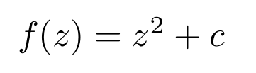

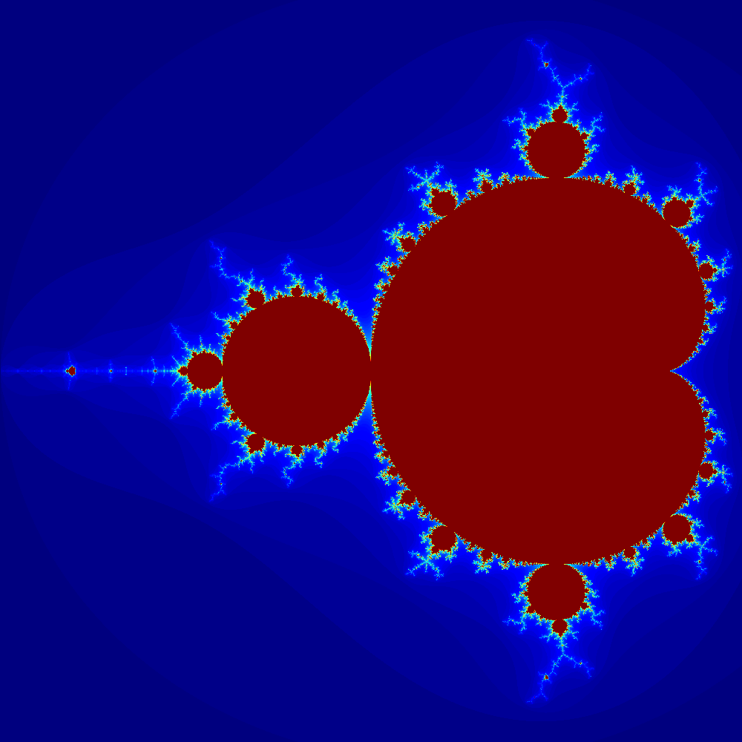

(a)
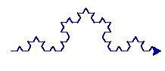

(b)
Fig.1 a.The MandelBrot fractal^{[3]}. b. The Koch Snowflake^{[3]}.

DLA is a method of growth where you have N particles randomly distributed through out a plane, these particles move via a random walk. A single particle (seed) may then be fixed in the middle. When another particle bumps into the seed the particle then sticks and itself becomes sticky. As with most methods of growth this can be modeled easily as show in fig.2. These often occur in shapes made by lightning strikes known as Lichtenburg shapes.
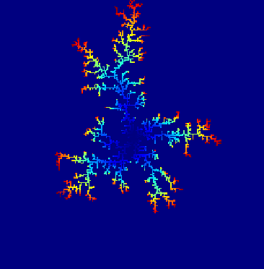
Fig.2 A typical DLA pattern^{[3]}.

It is of great interest to many ares of industry to know how crystals grow, for instance the silicon industry. It was noted in several papers in 1984-1989 that crystals shapes could changed and a transision between DLA and fractal growth could be found at differeing voltages and concentrations.^{[1.2]} .The crystals in these experiments were Zn formed by the electrolysis of ZnSo₄. Zinc was used as it is a better candidate being hcp rather then coppers fcc thus more aniosotropic.^{[2]}
Crystals produced in this way can be analyised used two different methods to find the fractal dimension defined as;
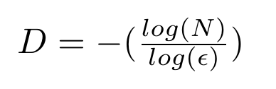

Where N is the number of new branches and ε for the scaling factor. Box counting is a method where by a shape is divided into a grid of boxes whose size and number increases fig.3(a). The dimension is dtermined via a log(s) vs log(1/s) where s is the size of the mesh.
Mass Dimension^{[1]} another method is determined by counting all the points within a radius r. The fractal dimension is then detrmined by plotting log(N(r))/log(r). When N is the number of points per radius r.
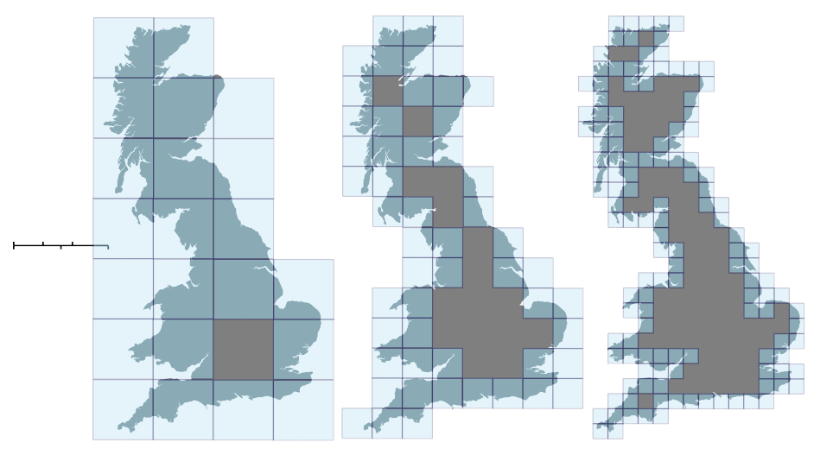
Fig.3 Box counting to determine a coast.^{[5]}

The experiment was set up in the following manner; a series of solutions of differeng concentrations were created using ZnS0₄H₂O and deionised water. The solutions where poured onto a perspex plate with a well (10cm in diameter) and an anode ring of Zn metal. A secondary plate was then placed on this, secured, and a 0.5mm graphite pencil lead (cathode) was then put through a hole in the top perspex plate. A voltage was then applied to the circuit. (fig.4)

1. D Grier et al, Morphology and Microstructure in Electronic Deposition of Zinc, Phys. Rev. Lett., 56, 1264-1267 (1986).
2. Yasuji Sawanda et al, Dendrictic and Fractal patterns in Electrolytic Metal Depositis,Phys. Rev. Lett.,56,1260-1263,(1986).
3. All graphs where created on python by Kaspar Snashall with credit to various sources online. All are avaliable at https://github.com/KasparSnashall/fractals.
4.http://en.wikipedia.org/wiki/Fractal#Natural_phenomena_with_fractal_features
5."Great Britain Box" by Prokofiev - Own work. Licensed under Creative Commons Attribution-Share Alike 3.0 via Wikimedia Commons - http://commons.wikimedia.org/wiki/File:Great_Britain_Box.svg#mediaviewer/File:Great_Britain_Box.svg

