Group: 27

Authors:

Kasper

Hansoe

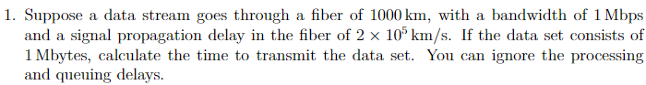

Propagation delay = Length of the fiber / Signal propagation speed

(1000km)/(2\*10^5 km/s) = 0.005 seconds = 5 milliseconds

Transmission time = Data set size/Bandwidth

Bandwidth = 1 Mbps = 1000000 bits per second

Data set size = 1 Mbyte = 1000000 bytes = 8000000 bits

8000000/1000000 = 8 seconds

Total time = transmission time + propagation delay

8+0.005 = 8.005



Propagation delay = 20 milliseconds = 0.02 seconds

Transmission time = Data set size/Bandwidth

2 kbytes = 2\* 1024 bytes = 2048 bytes = 16384 bits

10 mbps = 10000000 bits/s

16384 /10000000 = 0.0016384 seconds

Total time = 0.0016384 + 0.02 = 0.0216384 seconds

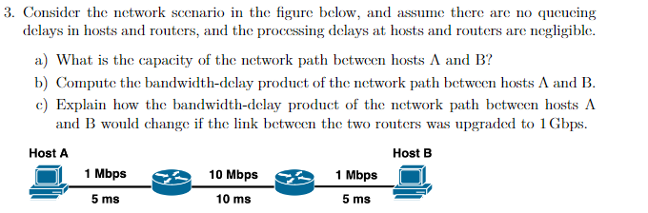

A The capacity of the network path is the link with the lowest bandwidth which is 1 mbps.

B Bandwidth delay = Bandwidth \* Delay = 1 mbps \* 20ms = 0.02 mbps = 20000 bits for one way, two way 20000\*2 = 40000bits.

C It’s the same due to the link with the lowest bandwidth remains the same at 1 mbps.



It works by using cookies which is stores data on the client which is sent by the server usually a unique id the server can use to get a saved state.



A domain name and email address both have an ip destination however the difference between a domain name and email address is that the @ splits ip address and the user in the destination.



HTTP is a protocol that is built on top of the TCP protocol which handles the retransmission and response instead of the HTTP protocol.



Because the mail clients do not need to be online to receive an email instead the clients read the emails from smtp servers which sends emails between them.



No the WWW only specify that the domain as a web address.