1.5 Design and Process Document

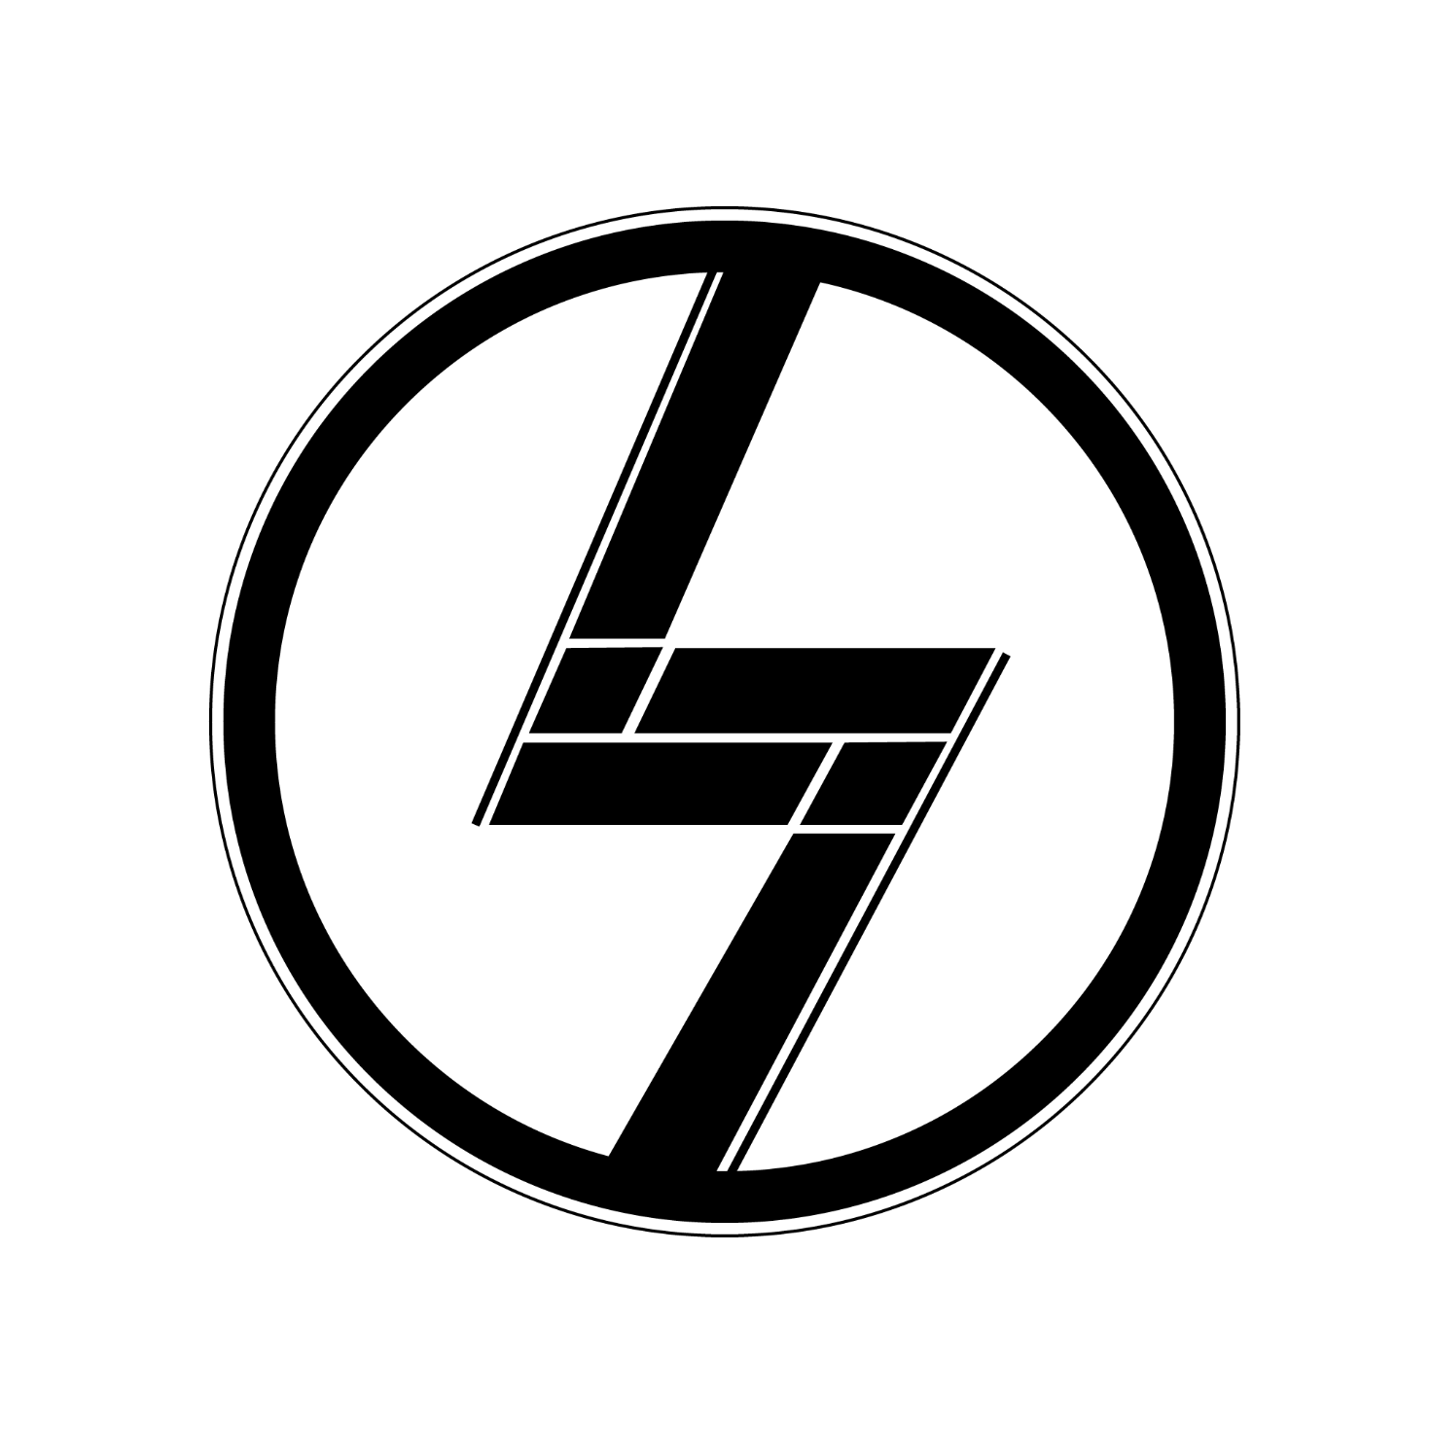**LinLines**

Content

* Mini Sketches …………………………………………………………………….. 3
* Paper Prototype …………………………………………………………………….. 4
* Style Tile …………………………………………………………………….. 5
* Design Principles ……………………………………………………………………. 6
* Interactive XD-Prototype ………………………………………………. 7
* Usability Results and Planned Changes …………………………. 8

Mini Sketches

Initial thoughts and ideas.

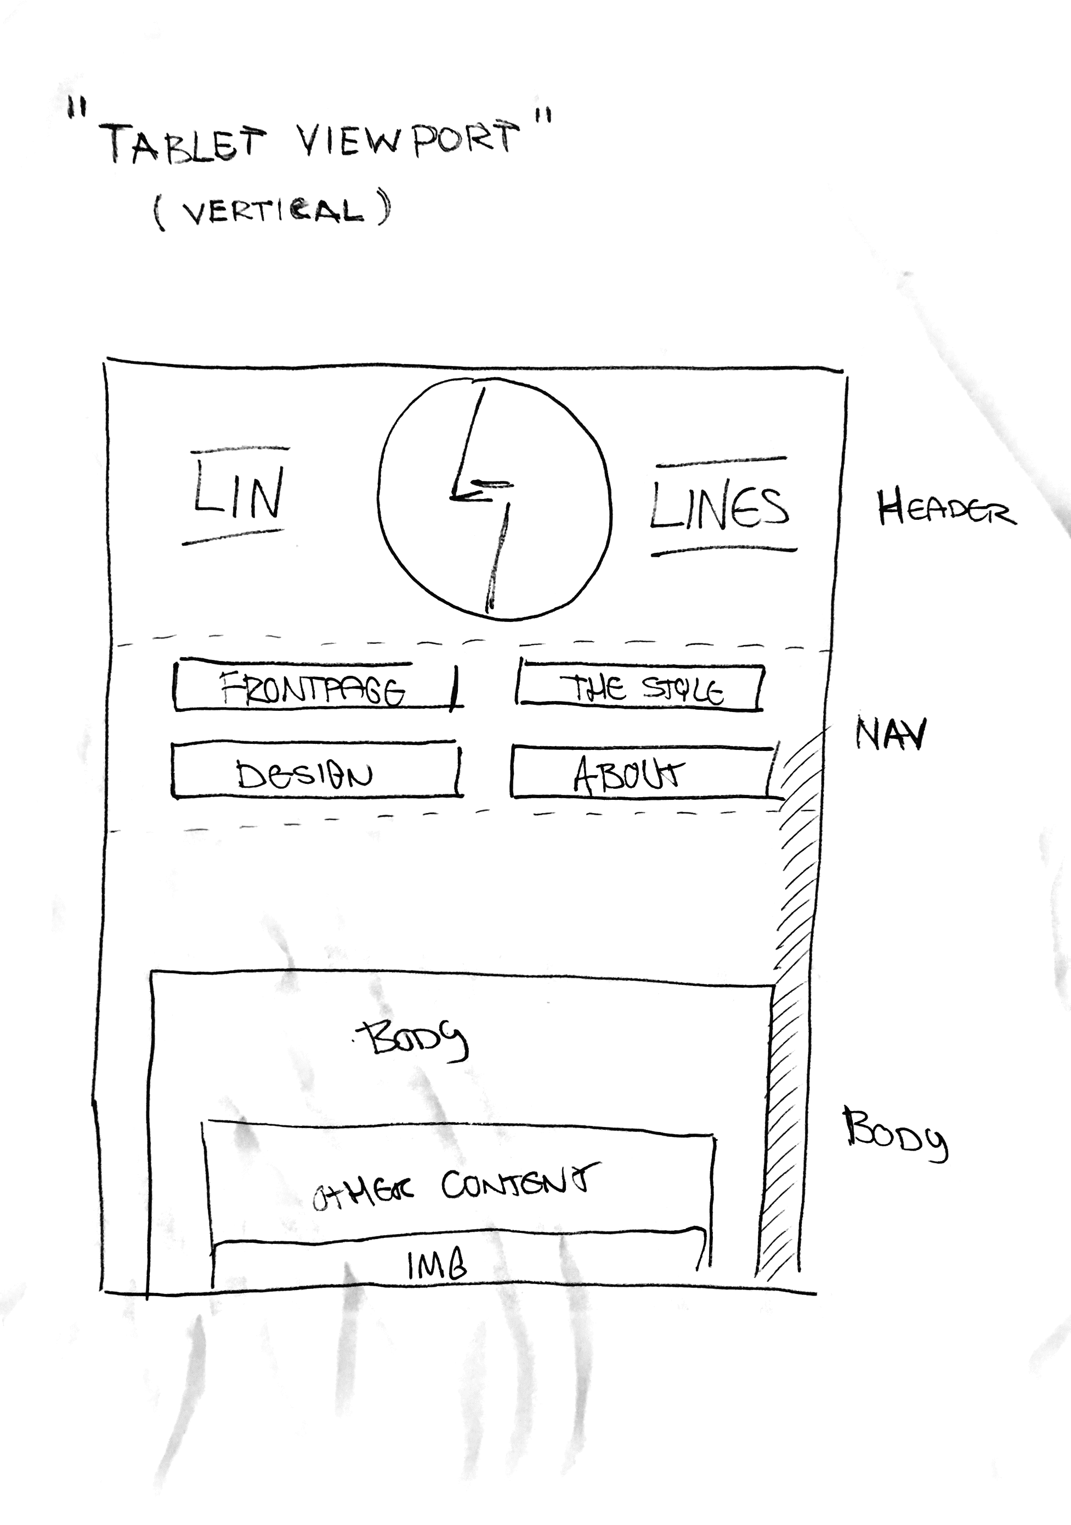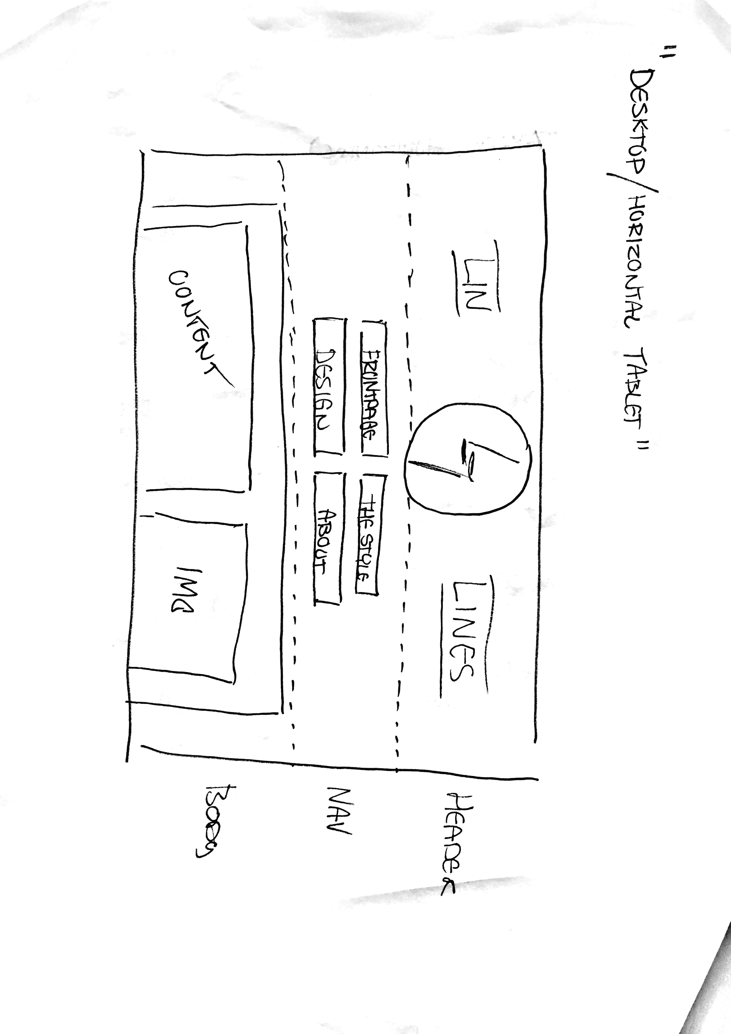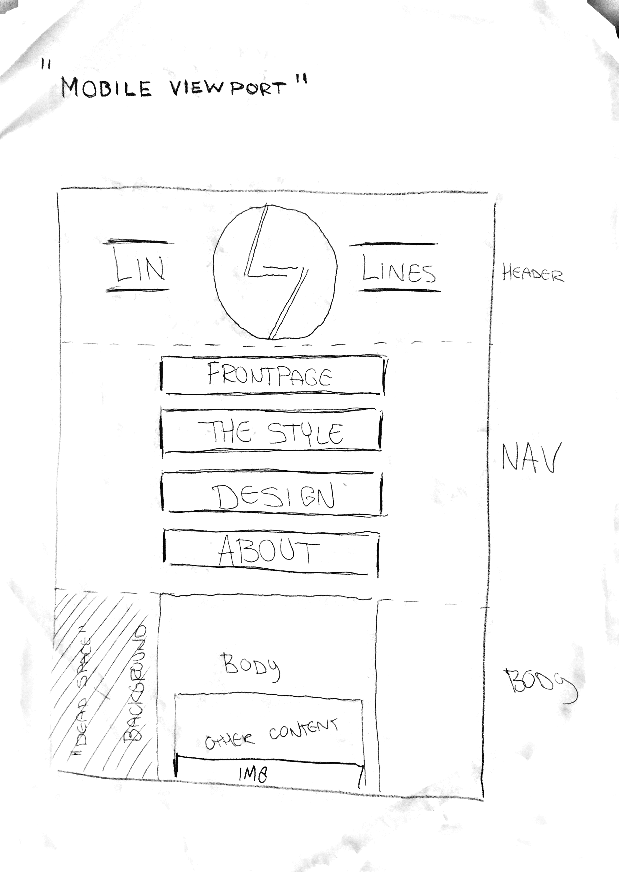

Paper Prototype.

A physical illustration of the web design and interface. Showcases only-mobile features and optimal structure and sizing for tablet/desktop.

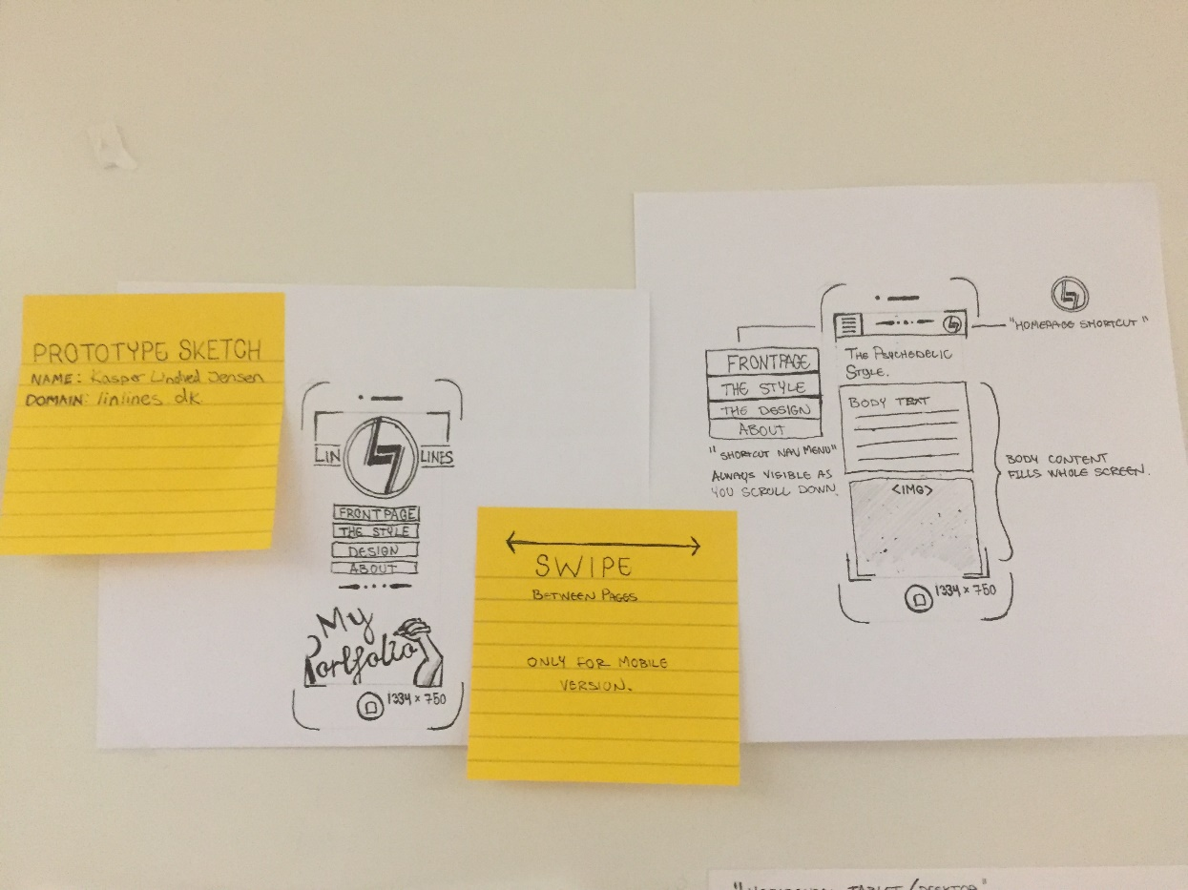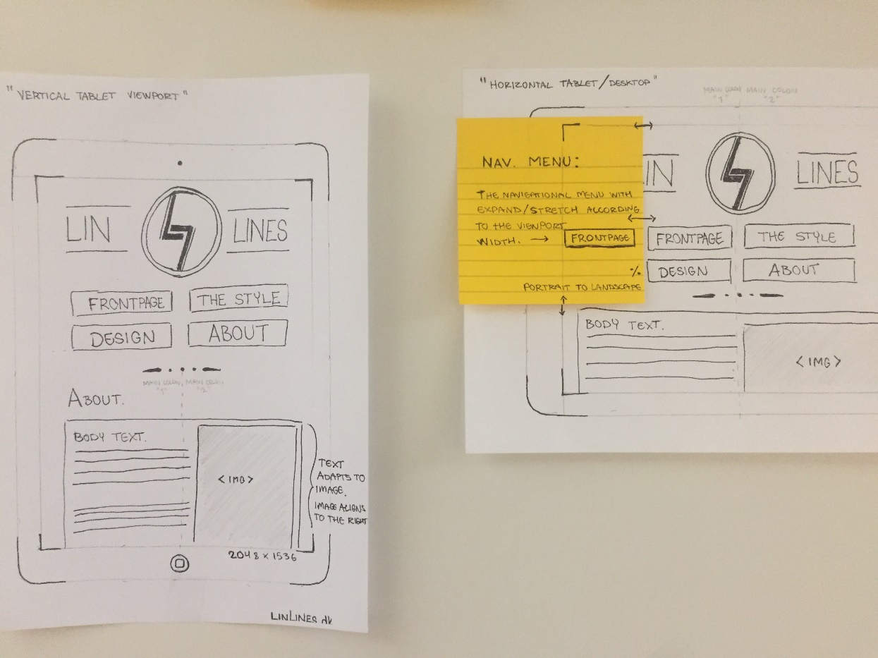

Style Tile

Featured colors, shapes, typefaces and other elements.

Ll

Font: Old Standard TT

Header

Sub header

Main body text

Design principles.

Featured concept and design terms

The essential web design puts focus on simplicity with minimalistic objects. This is to emphasize the precision and composition of the featured lines and shapes. The elements are placed with approximate symmetry, divided into squared sections. Hicks’ and Fitts’ law are applied to the navigation menu, with large and bold buttons. This comes in handy in the mobile version, as the links are easily accessible, so that the user won’t have to zoom or scroll, to navigate fast throughout the page. This also applies for the top navigation bar, which is always visible, as you scroll down the page.

C:\Users\kaspe\AppData\Local\Microsoft\Windows\INetCache\Content.Word\Lin 2.png

When it comes to gestalt laws, there’s a clear continuity throughout the page. The shapes and lines are primarily pointing in a horizontal direction, which creates the break points. The proximity of the navigation menu in relation to the header, helps the user to know, that it’s the first set of options you have, as you enter the website.

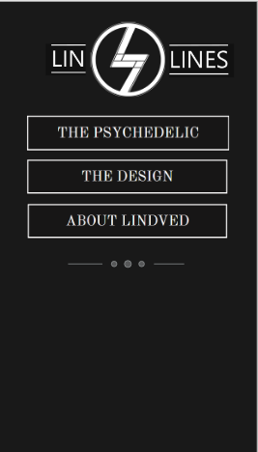The design of the logo sets the whole style of the page, as it’s made of lines in different lengths, weight and direction. The web name is spelled with capital letters, to emphasize this play on fine lines. It adds continuity and closure to the rest of the elements on the page, making them all the same style.

It also adds some contrast to the classic font, which consists of more traditional, antikva letters with serifs. It mixes the minimalistic and modern style with the detailed classic style.

Interactive XD-Prototype

I’ve created a fully functional prototype of the website in Adobe Experience Design. This was an easy tool for me to quickly manage and design the elements and changes I want to the page.

<https://xd.adobe.com/view/2e30e52d-8c91-40a4-8e2e-2abe8516665e>

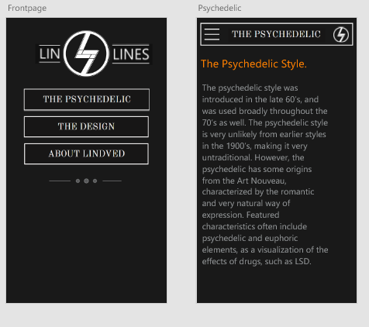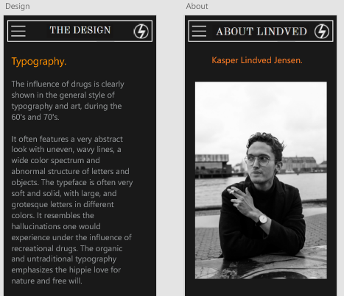

Usability Results and Planned Changes

Trunk Test

I tested my website prototype on an anonymous student at KEA. This helped me perceive the web design with fresh eyes, and really focus on the essential design.

My test person felt that the front page clearly displayed the name of the website, and liked the simplicity of the header. He commented on the continuity between the fine minimalistic lines of the LinLines logo and the navigation menu.

He said the top navigation bar and the swiping feature really helped to easily navigate through the pages. Also having an accessible shortcut to the front page, made the website feel maneuverable, and it helps the user to not feel “stuck” at any time. The user was missing a search bar, but agreed that there wasn’t really any content to search for yet. The main content is easily accessible through the front page and the top navigation bar.

Design-wise, the tester thought the “design” page was somewhat rough structured. He commented it would give a better user experience, if each page / chapter had its own section, clearly divided. However, the tester liked the size of the navigation and the font, as it presented clear legibility and readability with short, appropriate phrases.

Taken this user experience into account, I will add the following changes:

* A search bar for further navigation options
* Tweaked and improved structure in the design page
* Optimal display for landscape settings (alignment of elements)