# Design document

**— The Student Hub**

Kasper L. Jensen

Lars Ljungdahl

Linda Vorobeja

Weronika Wdowiak

Yan Li

**Design brief:**

Currently, students, as well as teachers and schools, use various platforms and social media solutions for education, announcements and discussing class affairs, such as Fronter, Facebook and Messenger. Some of these solutions work rather well for its purpose, while others are not good enough. And they have something in common which is that they all are quite limited when it comes to meet students need, so students have to have multiple accounts and check multiple places everyday in order to get study life related information and stay update. Even with all these current solutions, many students still feel lost every now and then and express their need for more help and support.

We are therefore building a platform, the Student Hub, aiming at all students as main users, with cooperation with teachers, institutes and schools. The main goal of this platform is to provide a network which is dedicated to students, which connects students so that they can share knowledge and information, support each other easily, both academically and in daily life. Considering the time limit we would start the platform with sections that are targeting the “pain points” we already know that are present, relevant and most important for students. We would later add more sections, more functions etc. to meet more/new needs from the user and improve the platform. We foresee an expansion of this product, both in scale of the project and i depth/refining of the functions, which involves a lot of work, so we decided to perform as one agency with a sole product which is the Student Hub. The agency and the product bear the same name and identity.

The Student Hub values sharing and communication. This would be reflected by the design that the process of both providing and getting information is functionally easy and visually pleasant, at any time and under any circumstance. To encourage sharing, the app should also give a vibe of openness.

As the main target audience is students, either young in actual age or young in the mind, it would be considered attractive if the app appears modern, active, fun and lively. On the other hand, the Student Hub is not merely a social app for chatting about random things, it holds useful and important information and valuable insights from users, so the app should also appear serious and credible.

As a network that aims at connecting as many students as possible, with differences in personal aesthetic preferences etc., it would probably not ideal to go with unique and strong style as first priority. It could useful to give some design choices to the user, in the form of individual settings, so that more user could feel comfortable and hopefully more willing to use this app.

**Design program:**

The basic identity elements:

* Logotype and/or trademark

As the agency and the product would bear the same name and identity, we need one logotype and/or trademark for the whole “brand”.

Some of the key characteristics of the product that we would like to express by design are: user/student-focused, young and vivid, knowledge and future, one login for all, diversity. The appearances that we would like to avoid are: fixed, dull and corporate-like.

The immediate goal of logo design is to sell the brand “Student Hub” and that the viewer should be able to recognise, at least in certain extent, what the app is for.

* + design process and what we’ve learnt[1]

Our first try with the logo design was based on the initials of “Student Hub” and combined the letters into one simple shape, which could fit into the “modern” look we were after. We would add other elements to hint community and make the shape more look like a student-figure, but these didn’t quite worked out.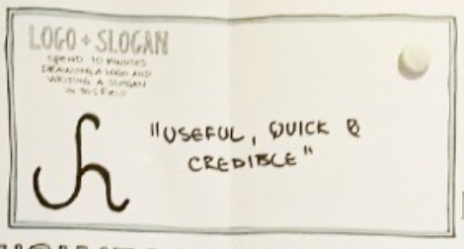

Our second approach started with graphic elements that hinted the essence of the product, instead of merely making use of the words and letters, ie. the name of the product.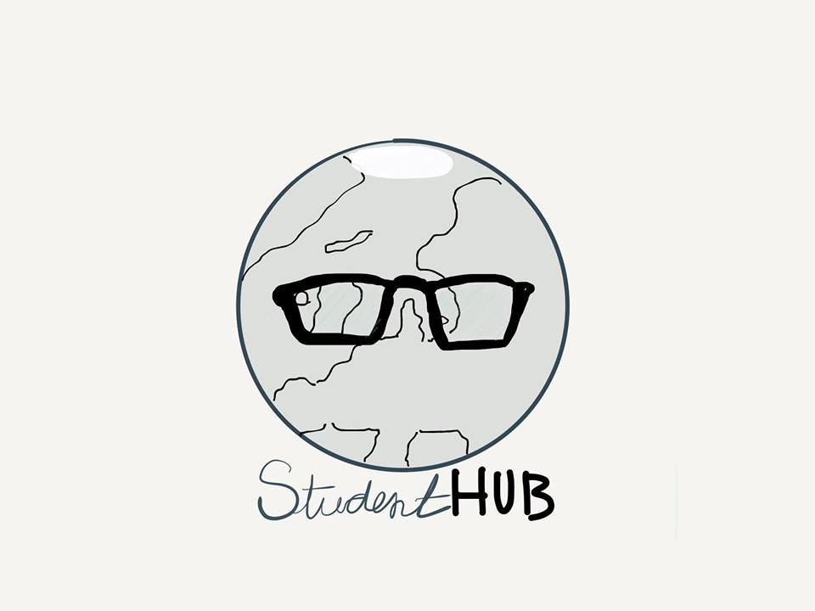

The ideas behind this design was that:

*“The logo is designed based off the unique elements that makes student hub special. The globe symbolizes the unity, which is an international social community. Denmark is placed in the center to symbolize the company’s nationality. The globe (the students) wears a pair of traditional glasses, symbolizing intelligence and typical academic appearance. It hints that the app is for smart people, who wants to share and find advanced information. By resembling a face, the globe’s North Pole acts as someone keeping their head cool. This symbolizes the way the student hub app affects your brain, making you feel relaxed and organized with an easy-to-use user interface.”*

We did some tests with this design, first covering the part of the text “Student Hub” at the bottom then showing the text. Without the text, most test subjects didn’t get what kind of product this log could represent. As the glasses are so dominant, many of them assumed it’s a business selling glasses and together with the globe they guessed that the it’s a online-store of glasses. Some test subjects based their guess on the globe, and together with the glass they thought the app was about travel and get a deeper view of the world. Other conclusions drawn from user test are: the overall round shape was not enough to hint a community and the face with glasses on was not enough to hint it’s about students.

In order to make the “student” element clearer, we tried another design.

Based on the feedback, it’s quite clear that this design could hint that the app is about students. Yet it’s not clear which services/information could a student get from this app. The letters “SH”, initials for Student Hub, presented no clear meaning for the test subjects. The “book” in the design did hint knowledge, which’s one of the key elements we wanted to express, but it’s only one of the elements. Even though the Student Hub does provide study-related materials and information, it’s not an online-course app, which this logo could represent.

In the end we decided not to use this logo and decided to work on a logo that could show that The Student Hub holds everything that’s related to students.

Another conclusion we drew from these two design approach was that it’s probably not a good idea to have a design that’s too detailed and realistic. Apart from the limited real-estate on the phone, which makes displaying such design almost impossible, such design could potentially “mislead“ the viewer regarding what the app is about, because everyone connect certain object to different things, like in the case of the globe, we were hoping to represent unity with the globe while others connected it with travel.

**Logo Development**

After some sketches and discussions, we decided on this logo, which is a combination of text and graphic and is simplified as much as possible. 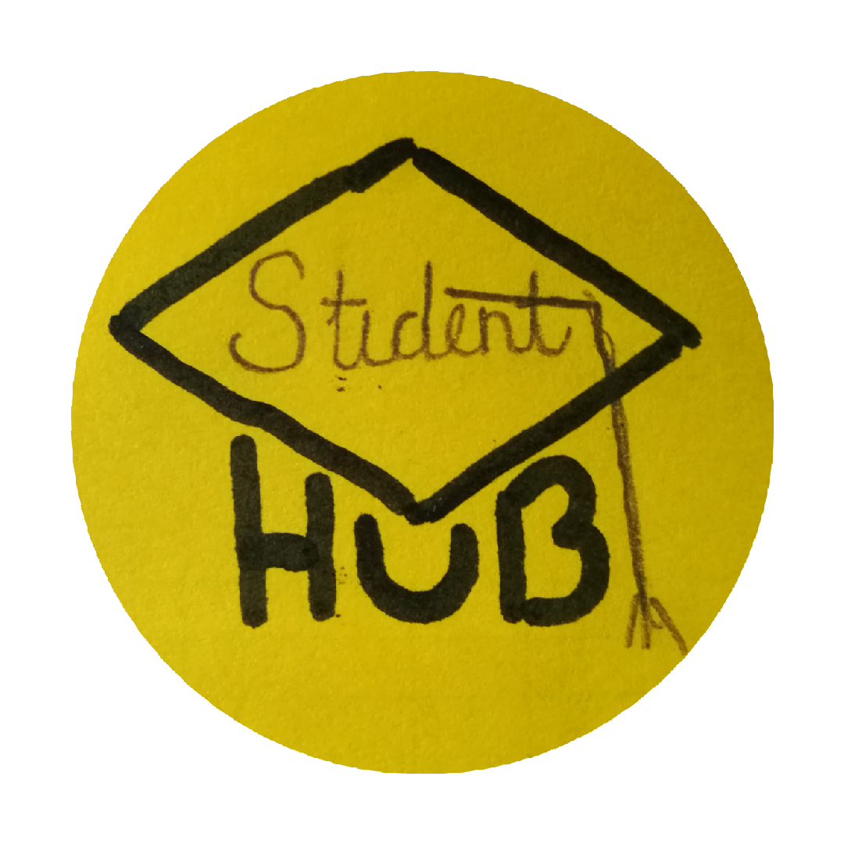

As we were trying out other design ideas, we went with either only graphics that indicates a “hub” or clear text. As we also would like to sell the brand “Student Hub”, and “Hub” is such a strong and clear word, which is commonly used for similar platforms like the Student Hub, we decided to keep the “Hub” part of the logotype.

We decided to use a graduation cap as the graphic element in our logo to hint it’s for students, as it is a timeless piece that’s associated to students. Our main consideration regarding whether or not to keep the “Student” text was that, when displaying on a phone, the limited real-estate would make displaying such a long word difficult. However, we do need to think about other applications for the logo as well, especially in much larger scale. One possible solution we came up with was the “Student” part could be written in fine lines and appear only in large scale. On smaller scales it would hardly be legible.



In the final draft of the logo, we simplified the logo, to make it more appropriate for recognizable logo. We concluded the potential “student” text in the cap to be redundant. Based on opinions from our target audience (our fellow students), the word “student” is the most likely word people will think of when seeing a graduation hat. It’s a universal object, that the entire world knows of, even though it’s not used in Scandinavia. The logo developed to be read as a graphic metaphor combined with the catchy, solid word “hub”. Though the “hub” word also acts as the lower part of the hat, it also adds symmetry that can be interpreted three dimensionally. This compliments the rectangle, forming a box-like corner, which symbolizes closure and adds strength to the overall object.





**Colors**

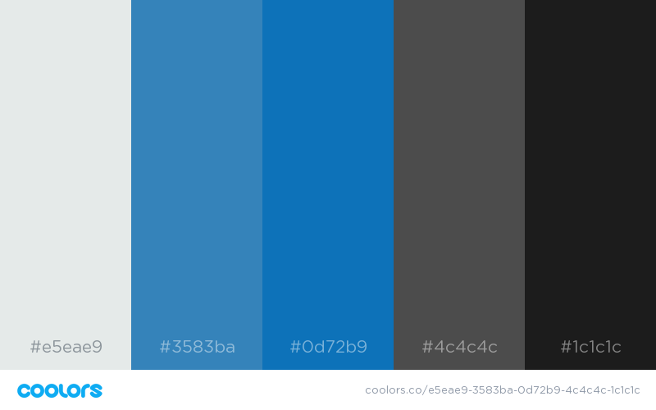

As for the color scheme, we agreed to stick with different shades blue. By conducting a user test, asking what color were most academic and calming, the majority agreed on blue. As for the logo, we considered keeping it black and white, but test results also showed that people thought it’d be too dull.

We also would like a mellow blue to represent our product, because it carries following values:

* Social color (like Facebook)
* Symbolizes the ocean (Student Hub being an ocean of knowledge)
* Cold and calming (as we try to give the user an organized feeling to their study-life)

We also decided to limit our color scheme to only few or one actual main color. Taking in consideration that we’d like to give the user a simple and organized user experience, we wouldn’t want to make too must of a color-wise contrast.

* 1. night-mode

We tested as well a “night mode” in order to improve user’s reading experience, because The Student Hub holds a lot of information to read and would most likely be used in longer time.

Some different combinations of background colour and text colour were provided and users needed to test under dimmed light in the room or no light at all. 

( The test was done in full screen mode. Due to limited space on the page the above image is only for document purpose and doesn’t reflect on the actual test.)

**Typefaces**

As for the typeface in the UI, we will have a balanced use of two fonts.

One that resembles handwriting, to give the user the feeling of human touch, and to emphasize the user-based community, that provides the actual service. The other font would be sans-serif, to keep the academic feeling of the written content.

Student (“Forte”) Hub (“Bookman Old Style”)

* Other element

We planned to design a series of icons based on the logo design. For example, a turning tassel for the potential case when the app loads slowly.

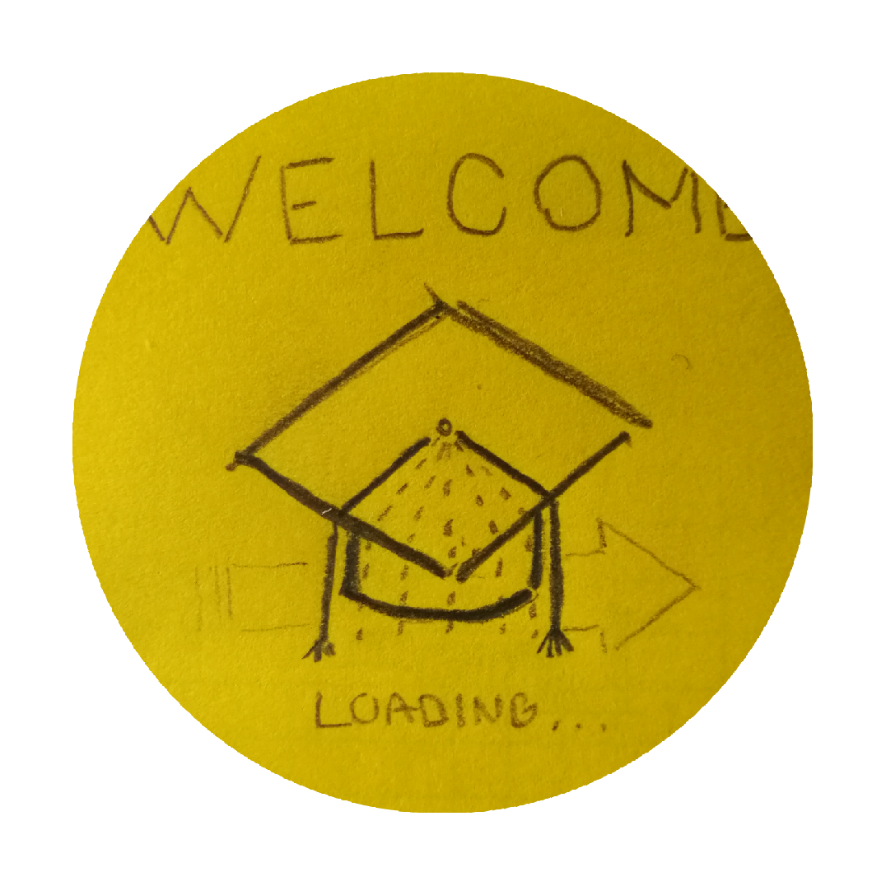

**Design guide:**

specific guidelines and examples:

1. This should probably not be part of the actual design document, but we’d like to document this process. The final logo description and analysis is on page 4.