**Freaky Friday Challenge**

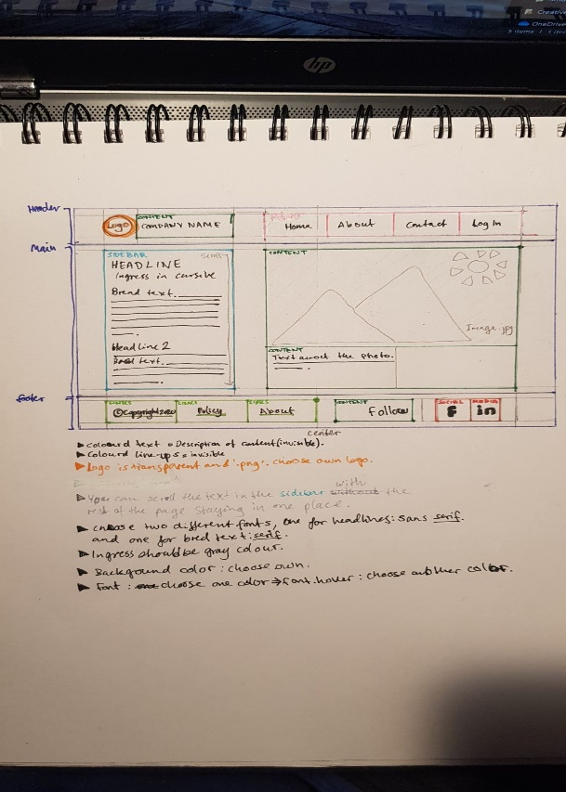***Paper prototype from my partner:***

***Feedback from partner:***

“The website was accurate based on the descriptions you received. Most items were included. The designs I asked you to choose yourself, such as background color and logo, I think they were good choices. The colors looked good together and was not too intense.

What I miss on the web page is a separate text box that says “follow” and should be connected to the Social Media icons.

Something you did that I did not include in the descriptions were effects when pressing or hovering over items. I think this was a good input as it makes the page more vibrant and dynamic and easier to navigate.”

***Link to website:*** <https://kasperrustad.github.io/FreakyFriday/>