Blogerithm

*A social blogging website where one can write blogs and explore blogs posted by other globally.*

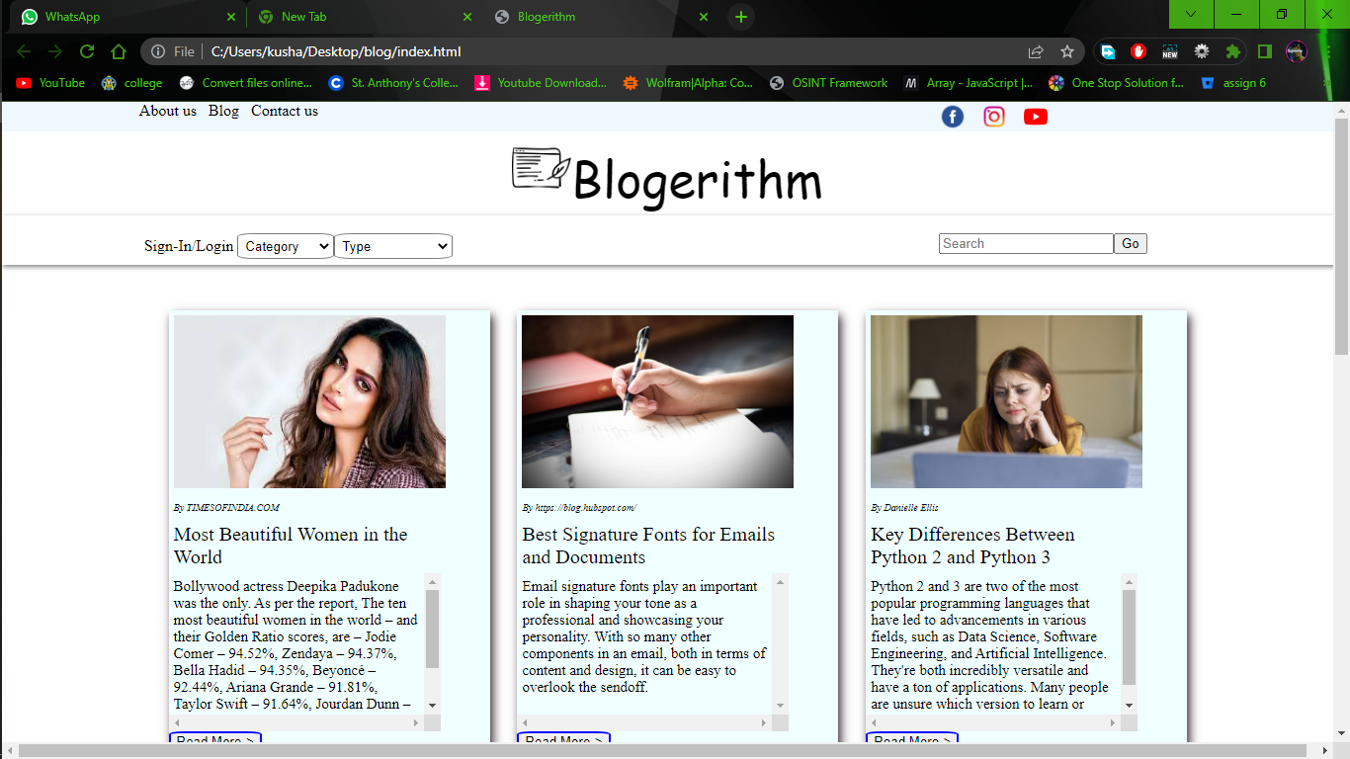

Home Page

Header bar (on top)

* About us
* Blog
* Contact us
* Social links:
  + Facebook
  + Instagram
  + YouTube

Menu bar

* Sign-up/Login
* Category
* Type
* Search bar

Blogs section

* Image
* Blog by
* Topic
* Description
* Read more

Sign-up / Login Page

* Sign-up OR Login (Buttons)
  + Sign-up
    - Name
    - Email-id
    - Create Password
    - Confirm
  + Login
    - Email-id
    - Password
    - Login(button)

Profile Page

* Edit info
* Favourite
* My Blogs
* Post
* Home (hyper link to Home Page)