VigilZone Report Update for Professor Suggestions

1. Quick Compliance Check Against Professor Suggestions
Professor suggestion | Status in last iteration | Update added
Introduction: market, problem, solution | Partially present; market research was not explicit enough. | Added dedicated market/problem/solution/novelty introduction.
AI Model | Partially present. | Added model pipeline and model novelty section.
Data/test results | Partially present as verification plan. | Added test-result table and evaluation wording.
Demo: 5-10 minutes, AI Audio Voice Overlay | Not explicit. | Added timed demo script and narration guidance.
Literature Review of other works | Present. | Clarified Table I placement and caption.
Architecture Diagram | Present. | Added updated audio-visual diagram caption and callout paragraph.
IEEE standard for AI referencing | Partially present. | Added IEEE citation rules and starter reference list.

2. Replacement / Insert-Ready Introduction

2.1 Market, Problem, Solution, Novelty, and Paper Organization
Artificial intelligence is rapidly changing how security and surveillance systems are designed. Recent market reports estimate the global AI-in-video-surveillance market in the multi-billion-dollar range, with one forecast reporting USD 6.51 billion in 2024 and USD 28.76 billion by 2030, corresponding to a 30.6% CAGR from 2025 to 2030. Other forecasts similarly show strong growth for cloud-based and AI-enabled surveillance because public agencies, private communities, and businesses increasingly need automated monitoring, fast incident awareness, and scalable evidence review. These trends show that the core challenge is no longer only whether a camera can record video; the practical challenge is whether a system can convert video, audio, model output, and operator feedback into reliable and actionable safety workflows.
The problem addressed by VigilZone is that many practical surveillance systems remain fragmented. A camera vendor may provide video preview, a model prototype may produce detections, and a dashboard may display alerts, but these pieces often do not share a durable incident model, tenant-aware authorization, evidence retention, notification state, or multimodal reasoning. Video-only detection also misses important context. A scream, glass break, siren, alarm, explosion-like sound, or off-camera crash may occur before or outside the visible scene, while video-only models can produce false positives from ordinary motion, shadows, crowds, or visually ambiguous activity. Audio-only detection has the opposite weakness: it can hear events that are not actually safety incidents in the monitored area. Therefore, a deployable surveillance platform requires not only individual AI models, but also a reliable architecture that combines audio, video, evidence, authorization, and notification delivery.
VigilZone addresses this problem through a real-time multi-tenant audio-visual anomaly detection and notification platform. The system combines a React operator dashboard, Django REST/ASGI control plane, PostgreSQL data store, Redis event and notification transport, MediaMTX/OpenCV/FFmpeg media handling, and a FastAPI AI service. The updated AI service extends the original video-first detection pipeline with BEATs-based audio event recognition and audio-video fusion. Cameras can operate in video_only, audio_only, or audio_video modes. Video lanes detect events such as persons, fire/smoke, weapons, falls, violence candidates, accidents, and zone-related signals, while the audio lane detects safety-relevant acoustic evidence such as screaming, glass break, alarms, sirens, crash-like sounds, and gunshot/explosion-like audio. A fusion layer correlates observations within a temporal window and emits explainable incident-level decisions rather than isolated frame or audio-chunk scores.
The novelty of the project is deployment-oriented multimodal incident intelligence. VigilZone does not claim to invent BEATs, YOLO, RT-DETR, CLIP, or audio-visual anomaly detection itself. Instead, its contribution is the integration of strong audio and video components into an operational platform that supports tenant isolation, incident persistence, evidence linking, notification consistency, camera configuration, modality-aware operation, and operator review. The model-layer novelty is the practical fusion design: audio confidence, video confidence, temporal alignment, normality profiles, uncertainty gating, and optional learned fusion shadow mode are combined to reduce false positives while preserving safe behavior when a camera lacks audio or a microphone is noisy.
The remainder of this report is organized as follows. Section II reviews related work in video anomaly detection, audio event recognition, and audio-visual fusion. Section III presents the VigilZone system architecture, including the frontend, backend control plane, AI/media service, data layer, and deployment topology. Section IV describes the audio-visual inference model, including BEATs audio inference, video detection lanes, temporal fusion, normality profiles, and uncertainty gating. Section V describes implementation details across the React frontend, Django backend, FastAPI AI service, Redis transport, PostgreSQL persistence, and notification layer. Section VI presents testing methodology and results for model inference, audio-video fusion, incident ingestion, evidence generation, notification delivery, and end-to-end demo workflows. Section VII discusses deployment, operational constraints, limitations, and future work toward learned fusion and AVadCLIP/MAVAD-style research extensions.

3. AI Model Section to Add

3.1 Implemented AI Model Pipeline
The implemented VigilZone AI model pipeline is a multi-lane, multimodal inference system rather than a single monolithic classifier. The video side uses the existing surveillance lanes for frame-based detection and candidate generation, including object/person detection, fire and smoke detection, weapon detection, fall candidate logic, violence candidate logic, accident detection, zone or intrusion-related logic, temporal verification, and identity-aware context where available. These lanes produce observations with labels, confidence scores, bounding boxes, timestamps, lane names, and diagnostic metadata.
The audio side uses FFmpeg-based audio extraction from camera streams or supported audio sources. Audio is converted into mono 16 kHz chunks and passed to a BEATs-based audio anomaly lane. BEATs is selected because it is a transformer-based audio representation model trained for broad audio event understanding, and published results report strong AudioSet and ESC-50 classification performance. The system maps BEATs or AudioSet-style labels into stable surveillance labels such as audio_scream, audio_glass_break, audio_alarm, audio_siren, audio_vehicle_crash, audio_gunshot_like, and audio_explosion_like. This mapping prevents raw model labels from directly becoming product incidents without domain-specific filtering.
The fusion side receives audio observations and video observations within a configurable time window. In Phase 1, deterministic temporal fusion remains the production decision path. It can increase confidence when audio and video agree, lower confidence when a modality is uncertain, create lower-confidence audio-only alerts for critical sounds, and preserve video-only behavior when audio is unavailable. In Phase 2, the system adds per-camera normality profiles and uncertainty-aware gating. Normality profiles prevent recurring background sounds such as traffic, wind, rain, or HVAC noise from repeatedly generating high-severity alerts, while protected critical labels such as screams, alarms, glass break, and gunshot/explosion-like events are not automatically learned away. A learned fusion head exists only as a shadow-mode or future-trainable component until enough labeled data is collected and validated.

3.2 Model Novelty Statement
The model contribution is not a new foundation model. The model contribution is an applied audio-visual incident model that transforms independent audio and video detections into explainable, temporal, operator-facing incident decisions. The novelty is the combination of BEATs audio event inference, existing real-time video detection lanes, configurable modality modes, time-windowed fusion, uncertainty-aware gating, per-camera normality adaptation, and incident/evidence/notification integration. This makes the system SOTA-aligned for deployment even though it does not claim benchmark SOTA on public anomaly-detection datasets.

4. Data, Test Methodology, and Results Section

4.1 Data Used for Testing
The final report should separate three types of data: functional demo data from webcam, RTSP camera, uploaded video, or controlled sample clips; audio verification data from camera microphone, safe sound clips, or WAV/MP4 test sources; and system test data from synthetic alert.created events and controlled Redis/backend payloads. If public benchmark datasets are not used, the report should state that the evaluation is a system-integration and deployment verification, not a benchmark-SOTA model comparison.

4.2 Required Test Result Table
Test ID | Scenario | Input Source | Expected Behavior | Metric / Evidence | Result
T1 | Video-only lane sanity test | Webcam, RTSP, or sample video | Video lane emits expected observation without audio dependency | AI logs, detection payload, keyframe/clip | Fill after run
T2 | Audio-only event test | Camera mic or WAV/MP4 source | Audio lane emits label, score, uncertainty, and optional WAV evidence | Audio observation JSON, WAV path | Fill after run
T3 | Audio-video fusion confirmation | Abnormal sound + relevant video event | Fusion emits higher-confidence multimodal incident with reason | Fusion payload, incident detail, evidence links | Fill after run
T4 | Background-noise suppression | Fan/traffic/rain/crowd repeated | Normality profile reduces non-critical repeated background score | Profile JSON, adjusted score trend | Fill after run
T5 | Critical sound protection | Scream/alarm/glass-break-like sound | Critical labels are not learned away | Adjusted score remains eligible | Fill after run
T6 | Duplicate event replay | Same event ID replayed | One incident and one alert only | Receipt and Alert counts | Fill after run
T7 | Notification latency | Confirmed AI event to browser | Browser receives or hydrates alert within target latency | T0-T5 latency log | Fill after run
T8 | Tenant isolation | Cross-tenant API/SSE/preview attempt | Request denied or no data returned | HTTP status/log screenshot | Fill after run
T9 | Evidence availability | Confirmed video/audio/fused incident | Incident links keyframe/video/audio evidence | Incident detail screenshot | Fill after run
T10 | Mode fallback | Disable audio or video-only camera | Video-only mode still functions normally | AI logs and frontend incident | Fill after run

5. Demo Plan: 5-10 Minutes with AI Audio Voice Overlay
Time | Demo Step | What to Show | AI Audio Voice Overlay Script
0:00-0:45 | Opening | Dashboard and one registered camera | VigilZone is a real-time audio-visual anomaly detection and notification platform for community surveillance.
0:45-1:30 | Problem and market | Intro slide or dashboard | Traditional systems separate camera preview, AI detection, evidence, and notifications. VigilZone combines them into one tenant-aware workflow.
1:30-2:30 | Architecture | Updated architecture diagram | The browser talks to Django, Django owns trust and persistence, FastAPI runs AI/media processing, Redis transports incidents, and PostgreSQL stores durable truth.
2:30-3:30 | Video-only inference | Video lane detection | This is the video lane output. The system can still operate when a camera has no microphone.
3:30-4:30 | Audio-only inference | Audio event payload | The audio lane converts audio to 16 kHz chunks and uses BEATs to identify safety-relevant sound events.
4:30-5:45 | Audio-video fusion | Fused incident | The fusion layer correlates audio and video within a time window and creates an explainable incident instead of isolated model scores.
5:45-6:45 | Notification | Notification bell and alert list | The backend persists the incident, creates per-user alerts, and delivers a real-time notification while REST remains the recovery path.
6:45-7:45 | Evidence review | Incident detail | Operators can inspect the evidence, model labels, confidence scores, and fusion reason before taking action.
7:45-8:45 | Reliability | Duplicate replay or refresh | A replayed event does not create duplicates because event receipts make Redis delivery idempotent.
8:45-10:00 | Summary | Novelty and future work | The contribution is a deployable multimodal surveillance workflow with a path toward learned fusion and AVadCLIP-style research extensions.

Recommended implementation: record the demo using OBS, Zoom, or a system screen recorder and add a prerecorded narration track. Label this as a demo narration overlay unless the production UI actually implements a voice assistant.

6. Literature Review and Table I Placement
The previous package already included a research comparison table. It should be placed immediately after the related-work overview, similar to the target UAV survey style. Use the caption: Table I. Representative Anomaly Detection and Audio-Visual Surveillance Research Work. In an IEEE paper version, place this in Section II. In the MS project report, place it after Current State of the Art or before the architecture chapter.

7. Architecture Diagram Update
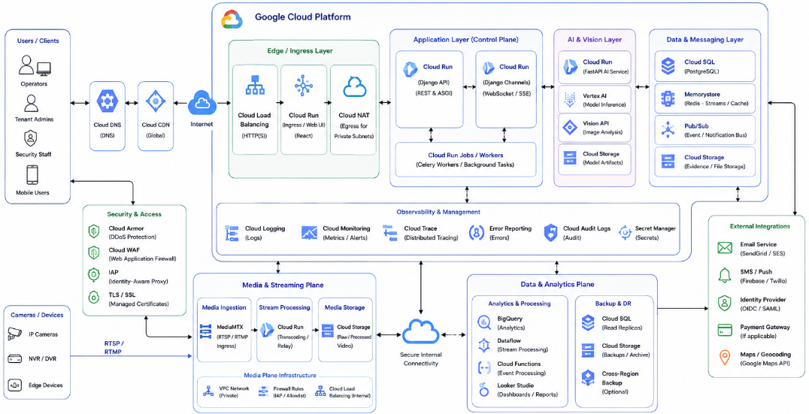
Fig. 1. Updated VigilZone cloud deployment and audio-visual runtime architecture.
The architecture figure should explicitly mention audio inference in the caption. Cameras and edge devices provide RTSP/RTMP or related streams to the media plane. Video frames and optional audio chunks are processed by the AI service. Model observations are converted into incidents through the backend control plane rather than being delivered directly to users. This preserves tenant authorization, durable persistence, notification consistency, and evidence review.

8. IEEE Standard for AI Referencing
Use IEEE numeric citations in order of first appearance. Do not mix APA-style author-year with IEEE numbering. Cite BEATs when describing the audio model backbone; cite UCF-Crime and XD-Violence when motivating video and audio-visual anomaly detection literature; cite MAVAD/AVACA and AVadCLIP when motivating fusion and future SOTA-aligned extensions; cite YOLO/RT-DETR-related sources when describing object-detection foundations; cite market reports only in the introduction; and cite the project repository or implementation appendix when describing implemented components.

8.1 Starter IEEE Reference List for AI/Anomaly Portion
[1] W. Sultani, C. Chen, and M. Shah, "Real-world anomaly detection in surveillance videos," in Proc. IEEE Conf. Comput. Vis. Pattern Recognit. (CVPR), 2018, pp. 6479-6488.
[2] P. Wu, J. Liu, Y. Shi, Y. Sun, F. Shao, Z. Wu, and Z. Yang, "Not only look, but also listen: Learning multimodal violence detection under weak supervision," in Proc. European Conf. Comput. Vis. (ECCV), 2020.
[3] S. Chen et al., "BEATs: Audio pre-training with acoustic tokenizers," in Proc. 40th Int. Conf. Machine Learning (ICML), 2023.
[4] B. Leporowski et al., "Audio-visual dataset and method for anomaly detection in traffic videos," arXiv:2305.15084, 2023.
[5] P. Wu et al., "AVadCLIP: Audio-visual collaboration for robust video anomaly detection," arXiv:2504.04495, 2025.
[6] J. Redmon, S. Divvala, R. Girshick, and A. Farhadi, "You only look once: Unified, real-time object detection," in Proc. IEEE Conf. Comput. Vis. Pattern Recognit. (CVPR), 2016, pp. 779-788.
[7] Microsoft Research, "BEATs: Audio pre-training with acoustic tokenizers official PyTorch implementation," GitHub repository. [Online]. Available: https://github.com/microsoft/unilm/tree/master/beats
[8] Grand View Research, "AI in video surveillance market size, share and trends analysis report," 2025. [Online]. Available: https://www.grandviewresearch.com/industry-analysis/artificial-intelligence-ai-video-surveillance-market-report
[9] MarketsandMarkets, "AI in video surveillance market by offering, deployment, technology - global forecast to 2030," 2024. [Online]. Available: https://www.researchandmarkets.com/report/ai-in-video-surveillance
[10] KasplatSnow, "295A: Smart community surveillance cloud-based," GitHub repository. [Online]. Available: https://github.com/KasplatSnow/295A

9. Updated Checklist for Final Report Merge
- Abstract mentions audio-visual anomaly detection, BEATs, fusion, incident workflow, and notifications.
- Introduction includes market, problem, solution, novelty, and paper organization.
- Literature review includes a Table I comparing anomaly-detection works.
- Architecture section includes updated audio-visual architecture diagram and caption.
- AI model section explains video lanes, BEATs audio lane, fusion, normality, uncertainty, and shadow learned fusion.
- Testing section includes audio-only, video-only, audio-video, notification, evidence, tenant-isolation, and duplicate-replay results.
- Demo section or appendix includes the 5-10 minute walkthrough and voice overlay plan.
- References are converted to IEEE numeric style.
- Claims avoid saying benchmark SOTA unless public benchmark testing was actually performed.
- Final limitations clearly state any model weights, datasets, hardware, or camera/audio constraints.

